Supplementary Material

Seasonal and daily activity patterns by Eleonora’s Falcon Falco eleonorae based on GPS telemetry: a contribution to the species’ movement ecology at its breeding grounds

C. KASSARA, A. EVANGELIDIS, N. TSIOPELAS, C. BARBOUTIS and S. GIOKAS

Contents
Appendix S1. Estimation of nesting site coordinates
Table S1. Summary statistics of ranging distance for six tagged falcons based on GSM data.

Table S2. Post-hoc Tukey tests between pairs of different categories of wind direction, based on their estimated marginal means according to the GLMM results.

Table S3. Moonlight conditions (i.e. illuminated fraction of the moon, ranging from 0-new moon to 1-full moon) at nights during which ranging activity was detected based on GSM data received during the breeding period.

Table S4. Wind regime statistics during the breeding period (15 July–31 October 2015–2018) in our study area.

Figure S1. The values of the smooth effect for Julian date based on the GAMM results.
Figure S2. Time budget of ranging activity for five female Eleonora’s falcons during the breeding period.

Figure S3. The location of field observations of Eleonora’s falcons according to the eBird database during the pre-breeding period (i.e. April till mid-July) in Greece and western Turkey during the last 30 years.

References
Appendix S1. Estimation of nesting site coordinates.
For each individual, but for ELEF05, we considered the GSM data received during the breeding period and used the “recurse” package (Bracis et al. 2018) to estimate the frequency of visits and the total residence time within a buffer of 50m around each GPS fix. Then, we averaged the coordinates of the GPS fixes whose frequency of visits and residence time were greater than the 3rd quantile of the obtained values. The averaged coordinates were then compared to the ones estimated by visual inspection of the distribution pattern of the GSM data. In all cases the difference between the two methods in the estimated coordinates was less than 10m. Thus, the coordinates estimated through visual inspection were considered in all subsequent analyses. To decide on the appropriate size of the buffer we tested various radii (namely, 30, 40 and 50m) and compared the resulting coordinates to the true coordinates of ELEF05. We did not consider smaller radii (i.e. less than 30m) given that the average size of the nesting site of Eleonora’s falcon has been previously estimated at 20-50m (Walter 1979), but also in order to avoid location errors related to the GPS measurement error in a rugged surface such as the nesting cliffs.

Table S1. Summary statistics of ranging distance for six tagged falcons based on GSM data. Note that different time periods are considered (see Table 1).
Breeding event | Number of GPS fixes | Mean | Standard deviation | Median | Q1 | Q3
ELEF01.2015 | 72 | 13.911 | 23.080 | 1.575 | 0.189 | 23.962
ELEF02.2016 | 66 | 34.903 | 45.610 | 13.381 | 2.076 | 51.941
ELEF02.2017 | 65 | 30.807 | 28.033 | 26.145 | 1.880 | 48.140
ELEF02.2018 | 37 | 8.421 | 13.184 | 1.656 | 0.306 | 16.102
ELEF02.2019 | 23 | 11.470 | 17.579 | 1.364 | 0.325 | 19.867
ELEF03.2015 | 100 | 14.246 | 16.149 | 8.171 | 0.893 | 25.251
ELEF04.2015 | 102 | 5.367 | 8.104 | 0.301 | 0.135 | 8.949
ELEF05.2016 | 20 | 18.617 | 25.310 | 2.923 | 1.345 | 32.854
ELEF05.2017 | 5 | 1.140 | 1.377 | 0.162 | 0.140 | 2.391
ELEF06.2016 | 1 | 0.105 | - | - | - | -
TOTAL | 491 | 16.768 | 26.140 | 3.836 | 0.308 | 24.713

Table S2. Post-hoc Tukey tests between pairs of different categories of wind direction, based on their estimated marginal means according to the GLMM results.
Contrasts | Estimate | Standard Error | p-value
South vs East | -0.74 | 0.21 | 0.002
South vs North | -0.63 | 0.24 | 0.040
South vs West | -0.93 | 0.21 | <0.000
East vs North | 0.11 | 0.17 | 0.917
East vs West | -0.19 | 0.11 | 0.339
North vs West | -0.30 | 0.16 | 0.274

Table S3. Moonlight conditions (i.e. illuminated fraction of the moon, ranging from 0-new moon to 1-full moon) at nights during which ranging activity was detected based on GSM data received during the breeding period (see Table 1).
Breeding event | Number of GPS fixes | Mean | Standard deviation | Median | Q1 | Q3
ELEF01.2015 | 1 | 0.096 | - | - | - | -
ELEF02.2016 | 7 | 0.690 | 0.166 | 0.787 | 0.672 | 0.787
ELEF02.2017 | 0 | - | - | - | - | -
ELEF02.2018 | 1 | 0.025 | - | - | - | -
ELEF02.2019 | 1 | 0.500 | - | - | - | -
ELEF03.2015 | 4 | 0.148 | 0.210 | 0.072 | 0.004 | 0.216
ELEF04.2015 | 9 | 0.297 | 0.238 | 0.223 | 0.144 | 0.420
ELEF05.2016 | 5 | 0.322 | 0.176 | 0.447 | 0.129 | 0.447
ELEF05.2017 | 2 | 0.469 | 0.133 | 0.469 | 0.422 | 0.516
ELEF06.2016 | 1 | 0.336 | - | - | - | -
TOTAL | 31 | 0.374 | 0.264 | 0.375 | 0.134 | 0.561

Table S4. Wind regime statistics during the breeding period (15 July–31 October 2015–2018) in our study area. The mean wind direction was north-northeast. Post-hoc comparisons suggested that northern and eastern winds were stronger compared to southerly and western winds (P < 0.05 between North-South, North-West, East-South, East-West, but not between North-East).
Wind direction | Wind speed (m/s)
 | Mean | Standard deviation
North | 5.287 | 3.331
East | 5.232 | 2.657
South | 4.002 | 2.564
West | 4.594 | 2.228
Total | 4.968 | 2.770

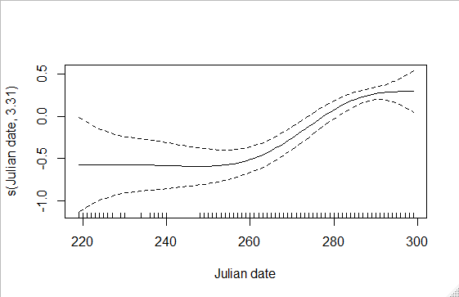
Figure S1. The values of the smooth effect for Julian date based on the GAMM results.

Figure S2. Time budget of ranging activity for five female Eleonora’s Falcons during the breeding period (morning: 06h00-11h59, afternoon: 12h00-18h59, night: 19h00-05h59 UTC).

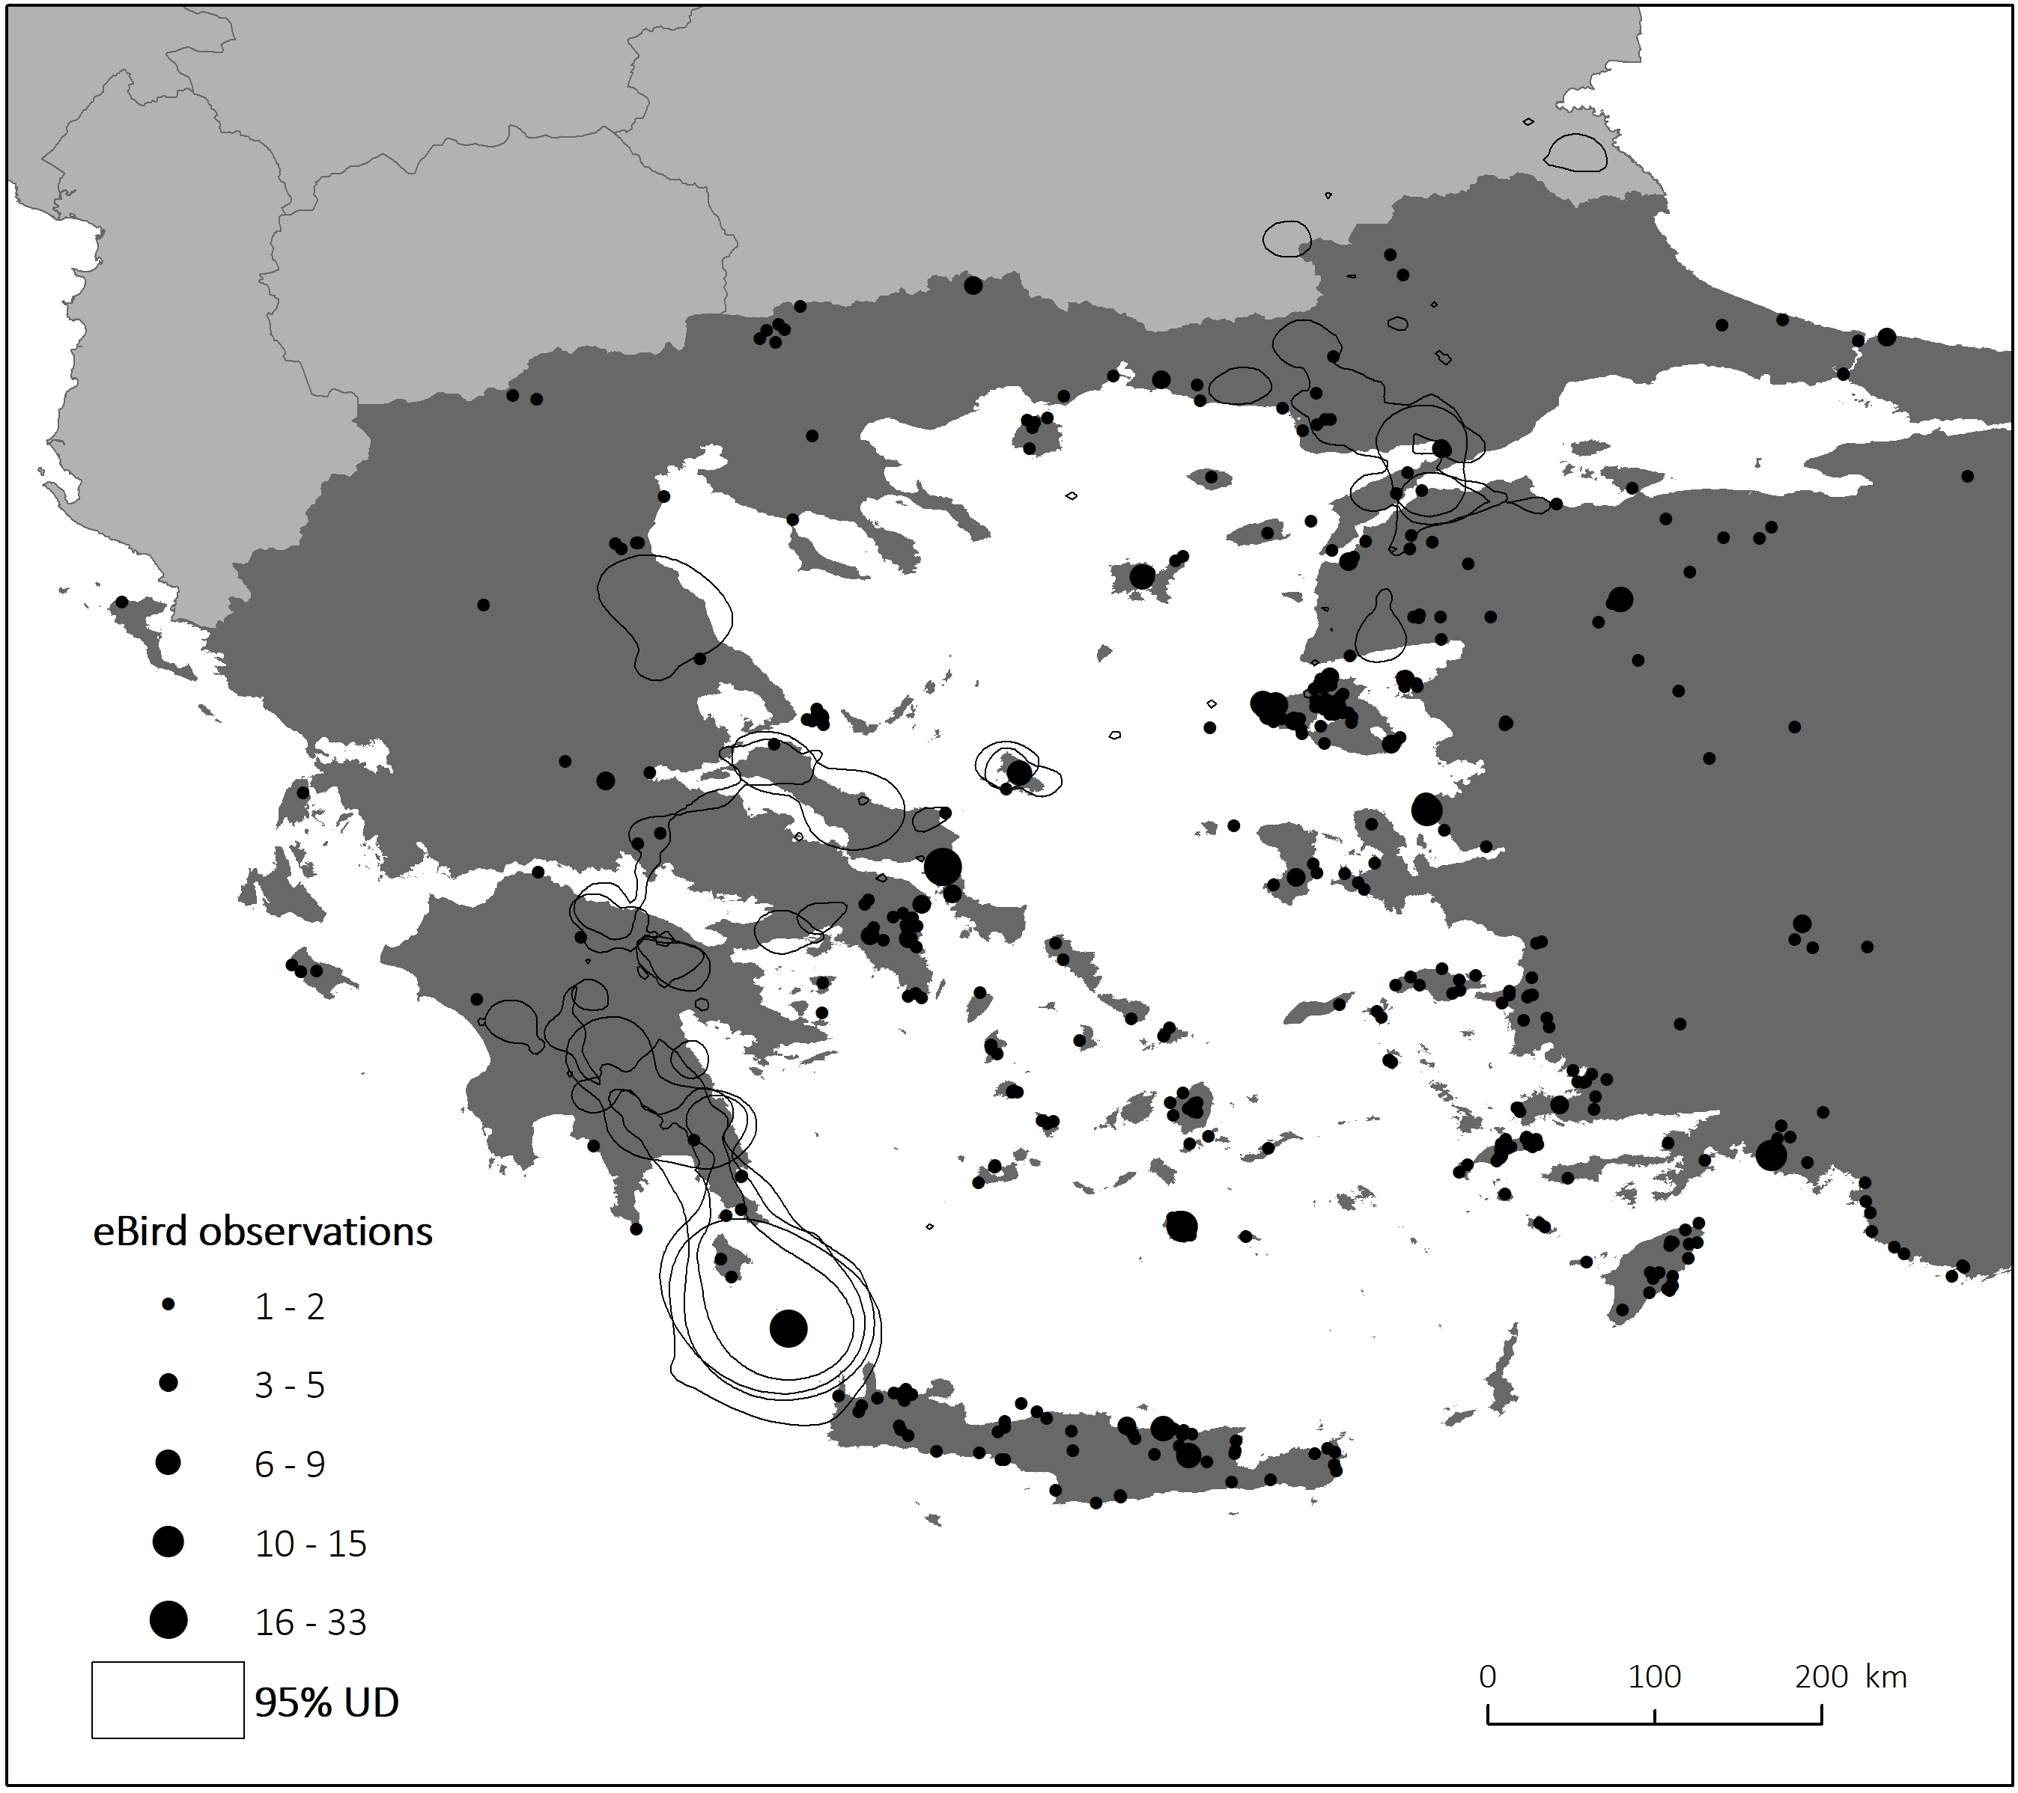
Figure S3. The location of field observations of Eleonora’s falcons according to the eBird database during the pre-breeding period (i.e. April till mid-July) in Greece and western Turkey during the last 30 years. The 95% utilization distribution areas of two tracked falcons is also depicted (see Fig. 4a).

References
Bracis, C., Bildstein, K. and Mueller, T. (2018) Revisitation analysis uncovers spatio-temporal patterns in animal movement data. Ecography 41: 1801-1811.
eBird (2020) Basic Dataset. Version: EBD_relJan-2020. Ithaca, New York: Cornell Lab of Ornithology. January 2020.
Walter, H. (1979) Eleonora's Falcon: adaptations to prey and habitat in a social raptor. Chicago and London: University of Chicago Press.

