Supplementary Material

Negros Bleeding-heart Gallicolumba keayi prefers dense understorey vegetation and dense canopy cover, and species distribution modelling shows little remaining suitable habitat

HOLLY MYNOTT, MARK ABRAHAMS and DAPHNE KERHOAS

Contents

Table S1. Estimates of fixed effects of habitat variables on Negros Bleeding-heart presence or absence from averaged Generalised Linear Model.
Table S2. Model averaging table, showing models with ΔAIC ≤ 2 which were averaged to produce final model.
Figure S1. Effect predictions for understorey and canopy cover on Negros Bleeding-heart presence, from the six top-performing Generalised Linear Models (ΔAIC ≤ 1) within the model averaging object.

Table S1. Estimates of fixed effects of habitat variables on Negros Bleeding-heart presence or absence from averaged Generalised Linear Model. Variables with a significant p-value are written in bold.

 | Coefficient | Standard Error | z-value | p-value
(Intercept) | -0.876 | 0.266 | 3.242 | 0.00119**
Ground cover (%) | -0.050 | 0.167 | 0.298 | 0.76591
Vegetation cover at 1.5 m above ground (%) | 0.904 | 0.297 | 2.999 | 0.00271**
Canopy cover (%) | 0.778 | 0.367 | 2.091 | 0.03655*
Proportion of trees grown in closed canopy forest | -0.007 | 0.063 | 0.111 | 0.912
Proportion of trees grown in non-closed canopy forest (i.e. open canopy or regenerating) | 0.012 | 0.079 | 0.144 | 0.88571
Pandan present | -0.005 | 0.051 | 0.097 | 0.92256
Rattan present | 0.130 | 0.244 | 0.528 | 0.59721
Elevation (m) | -0.007 | 0.062 | 0.115 | 0.90823
Number of trees with a DBH 0 ≤ 25 cm | 0.054 | 0.170 | 0.317 | 0.75156
Number of trees with a DBH >25 ≤ 50 cm | -0.014 | 0.092 | 0.152 | 0.87929
Number of trees with a DBH >50 cm | 0.226 | 0.274 | 0.818 | 0.41323
**P <0.01, *P <0.05

Table S2. Model averaging table, showing models with ΔAIC ≤ 2 which were averaged to produce final model.
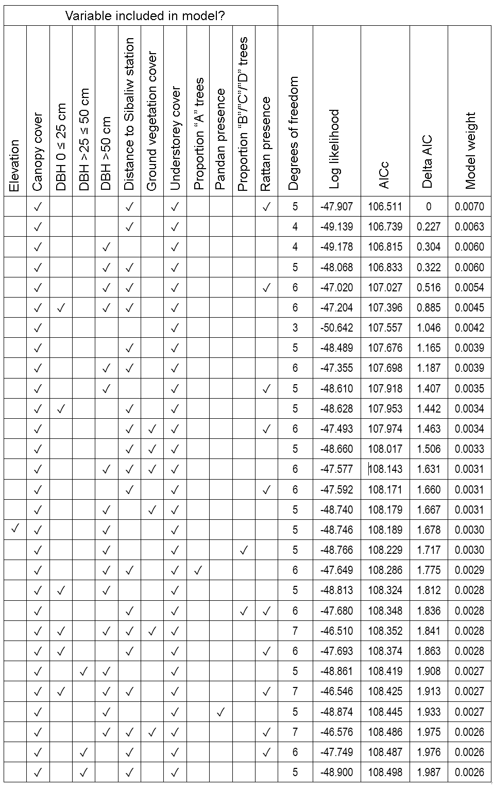

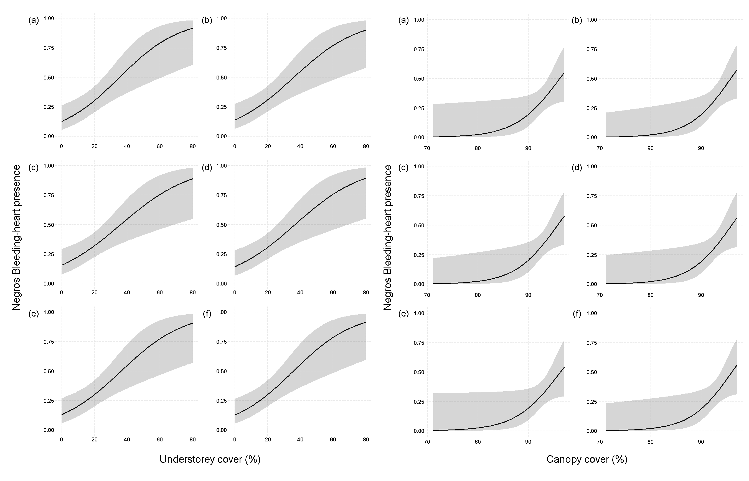
Figure S1. Effect predictions for understorey and canopy cover on Negros Bleeding-heart presence, from the six top-performing Generalised Linear Models (ΔAIC ≤ 1) within the model averaging object. ΔAIC scores for each model are as follows: (a) 0, (b) 0.227, (c) 0.304, (d) 0.322, (e) 0.516, (f) 0.885.

