Supplementary Information

A distance sampling survey of the Critically Endangered Straw-headed Bulbul Pycnonotus zeylanicus in Singapore
Wen Xuan Chiok, Elize Y. X. Ng, Qian Tang, Jessica G. H. Lee and Frank E. Rheindt

Contents
Figure S1. Histogram plots illustrating the probability density functions and radial distances recorded for the Straw-headed Bulbul Pycnonotus zeylanicus on Singapore Island (top) and Pulau Ubin (bottom).

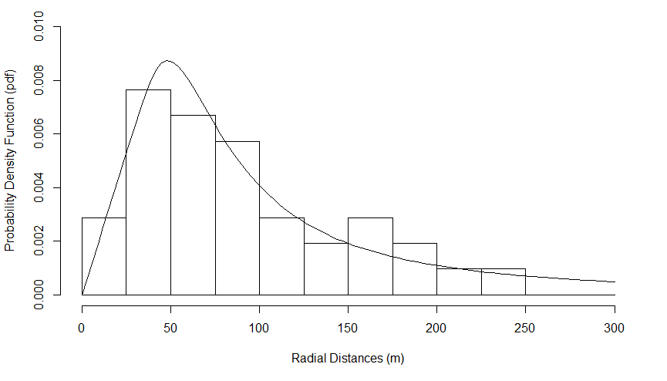
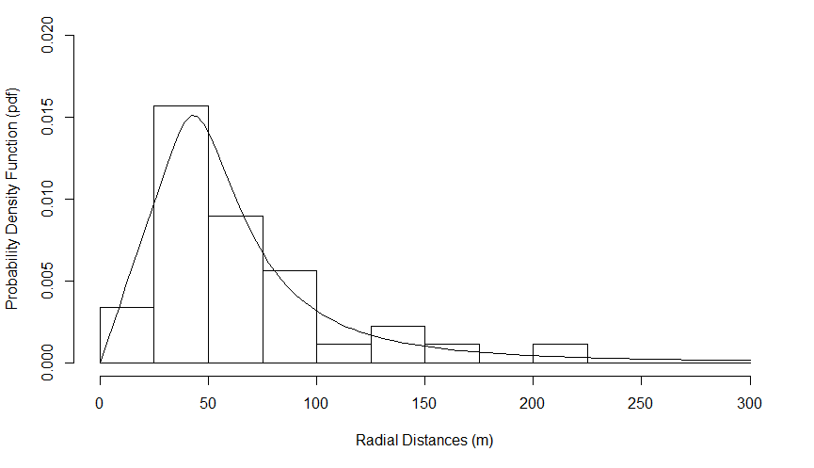
Figure S1. Histogram plots illustrating the probability density functions and radial distances recorded for the Straw-headed Bulbul Pycnonotus zeylanicus on Singapore Island (top) and Pulau Ubin (bottom).

