Supplementary Material

Drastic decline in the endemic brown shrike subspecies Lanius cristatus superciliosus in Japan

MUNEHIRO KITAZAWA, MASAYUKI SENZAKI, HIROAKI MATSUMIYA, SEIICHI HARA and HARUKA MIZUMURA

Contents
Appendix S1. The procedure of survey-site selection by interviews.
Appendix S2. The procedure of survey-site selection by aerial photographs and vegetation map.
Figure S1. Breeding habitats of brown shrike in central Hokkaido.
Table S1. Extracted vegetation classes as potential breeding sites.
Figure S2. Breeding habitats of brown shrike in central Hokkaido.
Table S2. Extracted records from the literature review.
Figure S3. The breeding range of L. c. superciliosus between a) the 1950s and 1970s and b) the 1980s and 2000s.
Appendix S1. The procedure of survey-site selection by interviews.
To select survey sites with reliable recent (i.e., 2000s-2010s) observation records of L. c. superciliosus in each study location, we conducted interviews with local birdwatchers who are well informed in local avifauna. Those interviewees were comprised of curators, well-trained bird surveyors, and local members of wildlife conservation organizations, research institutes, Wild Bird Society of Japan. The number of interviewees were four in northern Hokkaido (Sarobetsu, Hamatonbetsu, Teshio, and Fukagawa), one in Tokachi, three in central Hokkaido (Ishikari and Tomakomai), six in Nagano Prefecture, and one in Mt. Fuji. For all collected records, we arranged exact localities, observed breeding behaviors, dates and years. We finally determined study sites for the population surveys in each study location.
Appendix S2. The procedure of survey-site selection by aerial photographs and vegetation map.
Brown shrike prefers grasslands with bushes and scattered small trees as breeding habitats (Takagi 2003; Yosef and ISWG 2019: Appendix S.2-Fig. 1). To extract these potential habitats, we used aerial photographs from Google maps (https://maps.google.com) and a vegetation map (scale: 1:50,000-1:25,000) provided by the Natural Conservation Bureau of the Ministry of Environment (http://www.biodic.go.jp/trialSystem/top.html). We first extracted perennial grasslands from the vegetation map. The vegetation classes defined as perennial grasslands were listed below (Appendix S.2-Table 1). Using aerial photographs, we next checked whether the extracted grasslands have scattered trees or bushes or not (Appendix S.2-Fig. 2). In addition to these grasslands, brown shrike is known to breed in apple orchard in Nagano Prefecture (H. Matsumiya personal observation). We extracted all apple orchard in this study area by the vegetation map.
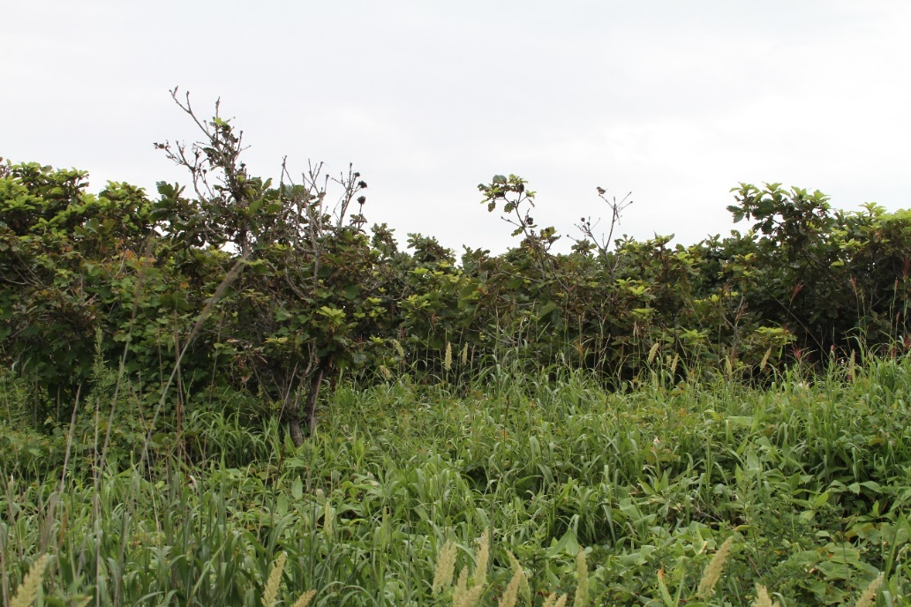
Figure S1. Breeding habitats of brown shrike in central Hokkaido. Habitats are characterized by dense perennial vegetation and scattered small trees (Quercus dentata).
Table S1. Extracted vegetation classes as potential breeding sites. IDs and categories were defined in the Natural Conservation Bureau of the Ministry of Environment (http://www.biodic.go.jp/trialSystem/top.html).

Vegetation class | Category | Subcategory
II Primary vegetation (Vaccinium vitis-idaea and Picea sp.) | 07 High perennial and windswept grassland | 02 Sasa sp. community
III Secondary vegetation (Vaccinium vitis-idaea and Picea sp.) | 09 Secondary grassland | 01 Sasa sp. community
IV Primary vegetation (Fagus crenata) | 21 Natural grassland | 01 Sasa sp. community
 |  | 02 Filipendula sp. community
 |  | 03 Calamagrostis autumnalis community
 |  | 04 Artemisia montana and Reynoutria sachalinensis community
V Secondary vegetation (Fagus crenata) | 25 Secondary grassland | 01 Sasa sp. community
 |  | 02 Miscanthus sinensis community
 |  | 05 Artemisia montana community
VIII River, wetland, pond, dune vegetation | 47 Wetland, river, pond vegetation | 04 Reed community
 | 49 Dune vegetation | 01 Rosa rugosa community
IX Planted forest and cropland vegetation | 57 Cropland | 01 Roadside and open ground vegetation
 |  | 02 Orchard
 |  | 05 Abandoned rice paddy community

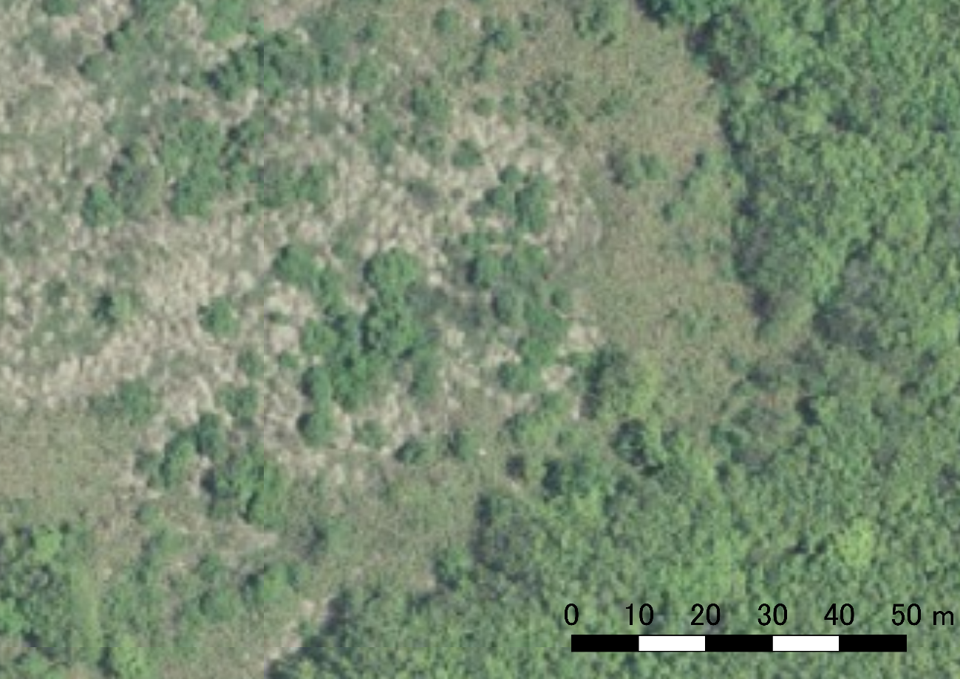
Figure S2. The aerial photograph of breeding habitats of brown shrike (the same place as Fig. S1). Brownish-green area indicates perennial vegetation, and dark green area indicates trees; trees are scattered in the perennial grassland. The photograph was obtained by Geospatial Information Authority of Japan (retrieved from https://mapps.gsi.go.jp/maplibSearch.do#1. on 06 February 2020).
Table S2. Extracted records from the literature review. Locations of recorded sites with sexagesimal scale, recorded breeding status (see below), recorded years, and references are shown. Abbreviations of recorded years: U) unavailable. Abbreviations of breeding status: A) breeding behaviors (e.g., territorial calls, nest building, or carrying food to nestlings) were observed; B) taxon was observed during the breeding season (May to August), but breeding evidence was not found; and C) the observation was recorded outside the breeding season.
Figure S3. The breeding range of L. c. superciliosus between a) the 1950s and 1970s and b) the 1980s and 2000s. Observation records with (filled cells) and without (meshed cells) breeding evidence that were obtained during the breeding season are shown. We extracted records between the 1950s and the 1970s from 42 published literature sources, the second National Survey of the Natural Environment, Breeding Bird Surveys for Tokyo Prefecture, and the Yamashina Institute for Ornithology Specimen Database. We also extracted observations obtained between the 1980s and the 2000s from 34 published literature sources, the sixth National Survey of the Natural Environment, Breeding Bird Surveys for Tokyo Prefecture, and the National Census of River Environment. The breeding range areas during the 1950s and 1970s and during the 1980s and 2000s were estimated at 49,600 km² (53 filled cells; 71 meshed cells) and 30,000 km² (23 filled cells; 52 meshed cells), respectively.

