Supplementary Material

The importance of riparian forests and tree plantations for the occurrence of the European Turtle Dove Streptopelia turtur in an intensively cultivated agroecosystem

GIANPASQUALE CHIATANTE*, ZENO PORRO and ALBERTO MERIGGI

Contents

Appendix S1. Landscape Units (LUs) definition.

Figure S1. The Landscape Units (LUs) characterizing the study area and used to select the 62 sampled cells.

Table S1. Set of the best models (A AICc ≤ 2) explaining the occurrence of the European Turtle Dove in northern Italy. The estimates (SE) are shown, as well as the AICc and the A AICc.

Figure S2. Predicted probability of occurrence of the European Turtle Dove in an intensively cultivated agroecosystem in northern Italy.

Appendix S1. Landscape Units (LUs) definition.
Methods
In order to obtain a representative sample of the study area, a stratified cluster sampling design was performed (Krebs 1999, Sutherland et al. 2004, Sutherland 2006, Barabesi and Fattorini 2013). This survey design is widely used in conservation science (Krebs 1999, Sutherland et al. 2004, Barabesi and Fattorini 2013). It suggests to subdivide the study area in homogeneous strata (hereafter referred to as Landscape Units, LUs), according to its habitat or ecological characteristics likely to induce systematic variations in population density (Sutherland 2006). To this aim, first we superimposed to the study area a grid with cells of dimension 2 x 2 km. Then, k-mean cluster analysis (Legendre and Legendre 1998) was performed using five landscape characteristics measured in the 2-km grid: (i) percentage of broad-leaved forest cover, (ii) distance from two highly natural areas (the continuous forests along the Ticino River and the ones near the Apennine slopes), (iii) density of hedgerows, (iv) density of main roads, and (v) degree of fragmentation calculated by a Modified Proximity Index (McGarigal and Marks 1994, Bani et al. 2006). The distance from the source area was calculated as the linear distance between each cell’s centroid and the boundary of the source area. Finally, one-way ANOVA analysis was performed to test the presence of significant differences between the identified LUs (Legendre and Legendre 1998). The data used for the survey design were obtained from the regional land use map DUSAF 4.0 (ERSAF 2014) and they were processed by the means of the software ArcGIS v10.2.1 (ESRI, Redlands, CA). All the analysis were performed using the statistical software R v.3.3.2 (R Core Team 2016).
Results
The k-means cluster analysis identified 10 homogeneous clusters within the study area (ESM Figure S1). The one-way ANOVA showed significant differences among the clusters, in particular for the percentage of the broad-leaved forest cover (F9,695=334.091, E<0.001), the distance from the two
source areas (F9,695=156.063, P<0.001), the density of the hedgerows (F9,695=114.941, P< 0.001), the density of the main roads (F9,695=267.075, P<0.001), and the degree of fragmentation (F9,695=240.924, P<0.001). Thus 10 LUs were identified, which were defined as follows: LU1, arable lands far from the source areas (198 cells, 28.1%); LU2, arable lands with high hedgerows density (111 cells, 15.7%); LU3, urban areas (5 cells, 0.7%); LU4, fragmented forest areas in proximity to the source areas (81 cells, 11.5%); LU5, source areas (22 cells, 8.5%); LU6, fragmented forest areas (60 cells, 8.5%); LU7, highly fragmented forest areas (40 cells, 5.7%); LU8, urban areas with broad-leaved forest patches (9 cells, 1.3%); LU9, suburban areas (22 cells, 3.1%); LU10, arable lands in proximity to the source areas (157 cells, 22.3%).
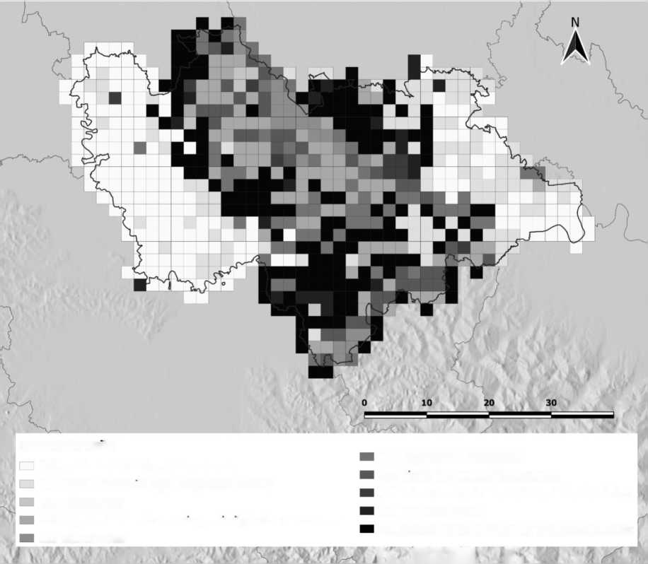Figure S1. The Landscape Units (LUs) characterizing the study area and used to select the 62 sampled cells.
40 km
Landscape Units
LU1 arable lands far from source areas
LU6 fragmented forest areas
LU2 arable lands with high hedgerows density
LU7 highly fragmented forest areas
LU3 urban areas
LU8 urban areas with broad-leaved forest patches
LU9 suburban areas
LU4 fragmented forest areas in proximity to the source areas
LU5 source areas
LU10 arable lands in proximity to the source areas
References
Bani, L., Massimino, D., Bottoni, L. and Massa, R. (2006) A multiscale method for selecting indicator species and priority conservation areas: a case study for broadleaved forests in Lombardy, Italy. Conserv. Biol. 20: 512-526.
Barabesi, L. and Fattorini, L. (2013) Random versus stratified location of transects or points in distance sampling: theoretical results and practical considerations. Environ. Ecol. Stat. 20: 215-236.
Bird ecology and conservation: a handbook of techniques (2004). Oxford, New York: Oxford University Press.
Krebs, C. J. (1999) Ecological methodology. 2nd ed. Menlo Park: Benjamin/Cummings.
Legendre, P. and Legendre, L. (1998) Numerical ecology. 2nd ed. Amsterdam: Elsevier.
McGarigal, K. and Marks, B.J. (1994) Fragstat: spatial pattern analysis program for quantifying landscape structure. Corvallis, OR, USA: Forest Science Department, Oregon State University.
R Core Team (2016) R: A language and environment for statistical computing. Wien: R Foundation for Statistical Computing.
Sutherland, W.J. (2006) Ecological census techniques: a handbook. 2nd ed. Cambridge: Cambridge University Press.
Table S1. Set of the best models (A AICc ≤ 2) explaining the occurrence of the European Turtle Dove in northern Italy. The estimates (SE) are shown,
as well as the AICc and the A AICc
 |  | Int |  | BUI |  | CER |  | MAI |  | PAD |  | POP | TRP | OAK |  | WIL | LOC |  | SHR |  | HRD | AICc A AICc
(1) | 0.10 | (0.20) | -0.46 | (0.22) | -0.64 | (0.26) | -0.46 | (0.20) | -0.59 | (0.21) | 0.69 | (0.26) |  |  | 0.46 | (0.29) |  | 0.54 | (0.35) | 0.41 | (0.19) | 194.5 | 0.00
(2) | 0.11 | (0.20) | -0.43 | (0.22) | -0.60 | (0.26) | -0.45 | (0.21) | -0.53 | (0.21) | 0.74 | (0.26) | 0.23 (0.20) |  | 0.48 | (0.29) |  | 0.59 | (0.35) | 0.40 | (0.19) | 195.2 | 0.73
(3) | 0.11 | (0.20) | -0.43 | (0.22) | -0.60 | (0.26) | -0.42 | (0.21) | -0.53 | (0.22) | 0.74 | (0.26) |  | 0.22 (0.21) | 0.44 | (0.28) |  | 0.57 | (0.35) | 0.43 | (0.19) | 195.5 | 1.06
(4) | 0.12 | (0.20) | -0.38 | (0.22) | -0.55 | (0.26) | -0.39 | (0.21) | -0.45 | (0.22) | 0.80 | (0.26) | 0.26 (0.20) | 0.25 (0.21) | 0.47 | (0.28) |  | 0.63 | (0.36) | 0.43 | (0.19) | 195.9 | 1.40
(5) | 0.08 | (0.20) | -0.47 | (0.21) | -0.67 | (0.26) | -0.49 | (0.20) | -0.62 | (0.21) | 0.69 | (0.26) |  |  |  |  |  | 0.56 | (0.34) | 0.38 | (0.19) | 196.1 | 1.67
(6) | 0.06 | (0.20) | -0.47 | (0.21) | -0.68 | (0.26) | -0.54 | (0.20) | -0.69 | (0.20) | 0.60 | ± 0.25 |  |  | 0.48 | (0.30) |  |  |  | 0.39 | (0.19) | 196.2 | 1.68
(7) | 0.10 | (0.20) | -0.45 | (0.22) | -0.62 | (0.26) | -0.45 | (0.21) | -0.56 | (0.21) | 0.72 | (0.26) |  |  | 0.46 | (0.28) | 0.11 (0.18) | 0.54 | (0.34) | 0.42 | (0.19) | 196.4 | 1.88
Int = intercept, BUI = built-up areas, CER = cereal crops, MAI = maize, PAD = paddy fields, POP = poplar plantations, TRP = other tree plantations, OAK = oak forests, WIL = willow riparian forests, LOC = black locust forests, SHR = shrublands, HRD = hedgerow density.

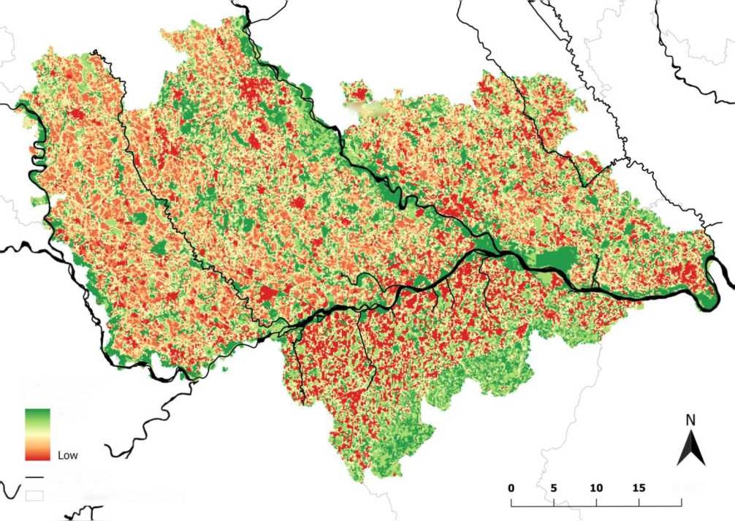Figure S2. Predicted probability of occurrence of the European Turtle Dove in an intensively cultivated agroecosystem in northern Italy.
Probability of occurrence
High
main rivers
20 km
administrative boundaries

