Supplementary Material

Modelling the potential non-breeding distribution of Spoon-billed Sandpiper Calidris pygmaea

TOM BRADFER-LAWRENCE, ALISON E. BERESFORD, GUY Q. A. ANDERSON, PYAE PHYO AUNG, QING CHANG, SAYAM U. CHOWDHURY, NIGEL A. CLARK, YURI N. GERASIMOV, RHYS E. GREEN, GEOFF M. HILTON, BAZ HUGHES, ELENA G. LAPPO, JING LI, EVGENY E. SYROECHKOVSKIY, PAVEL S. TOMKOVICH, CHRISTOPH ZOCKLER and GRAEME M. BUCHANAN

Contents

Figure S1. Response curves +/- 1 standard deviation for the variables in each model.

Figure S2. North full predicted distribution.

Figure S3. Central autumn full predicted distribution.

Figure S4. Central spring full predicted distribution.

Figure S5. South full predicted distribution.

Table S1. Spoon-billed Sandpiper sites.

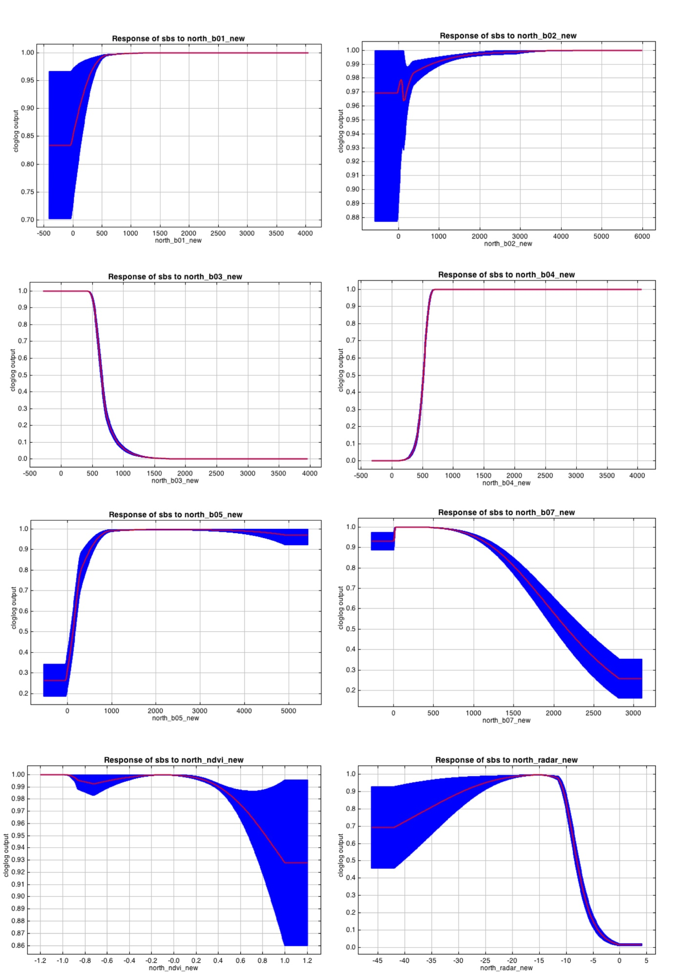

vvv
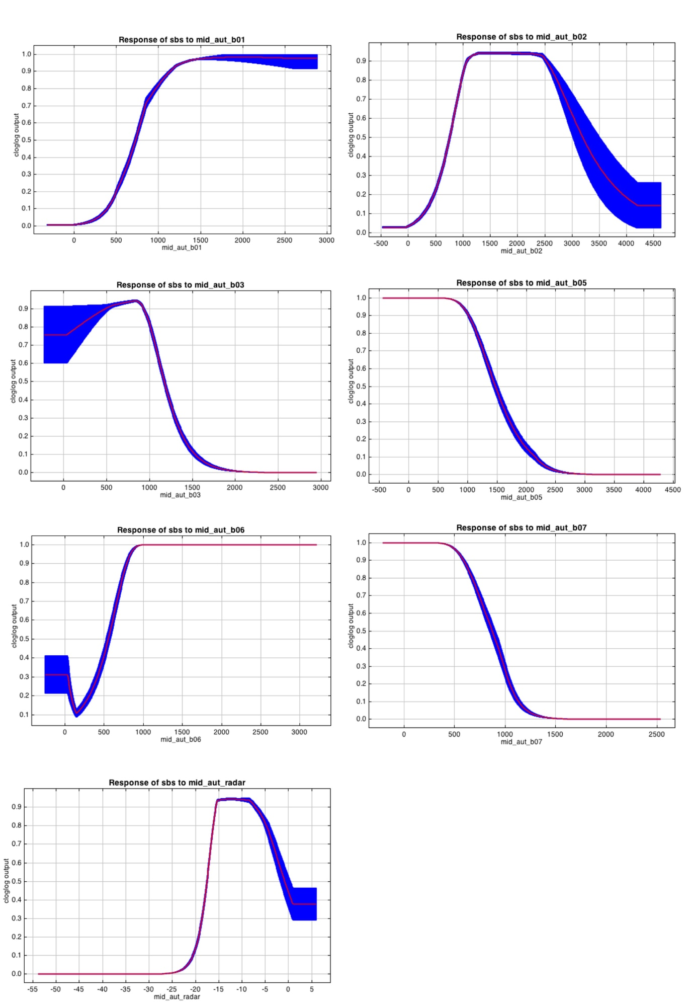

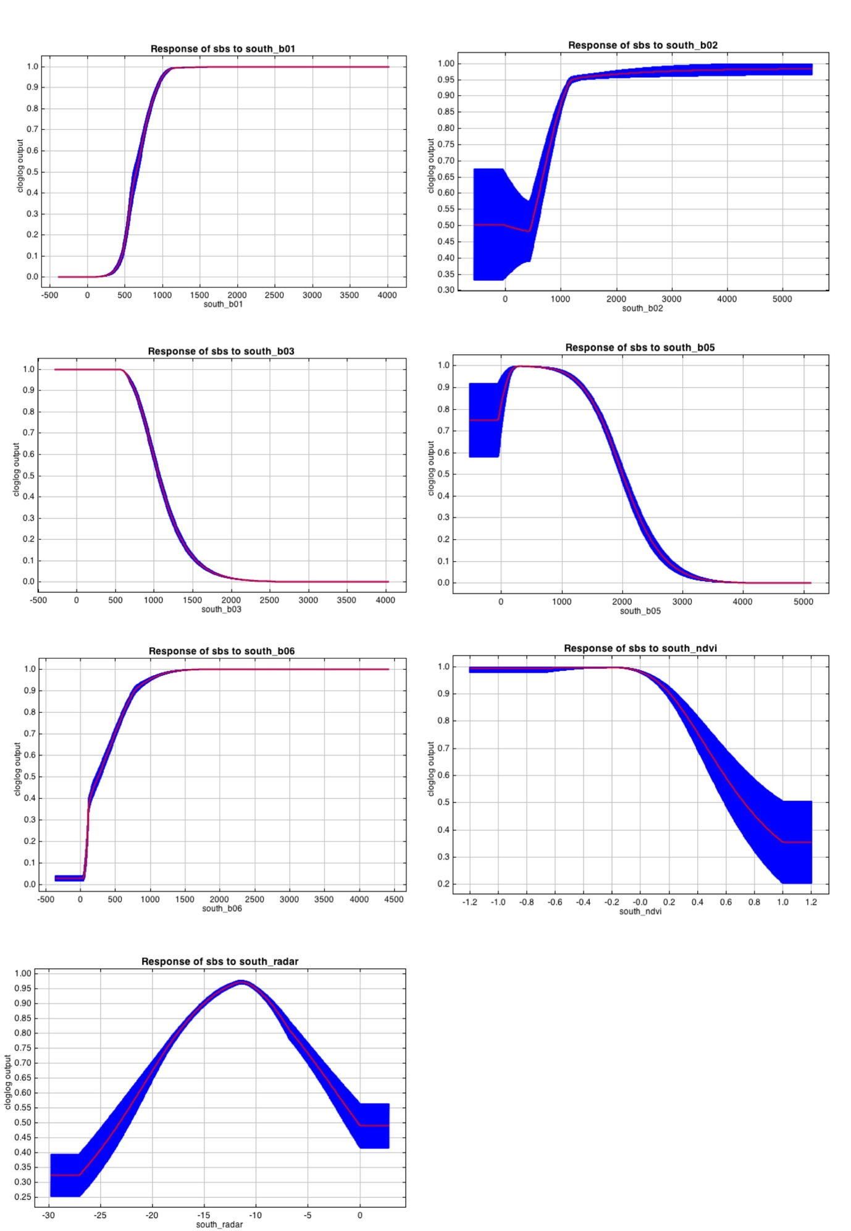

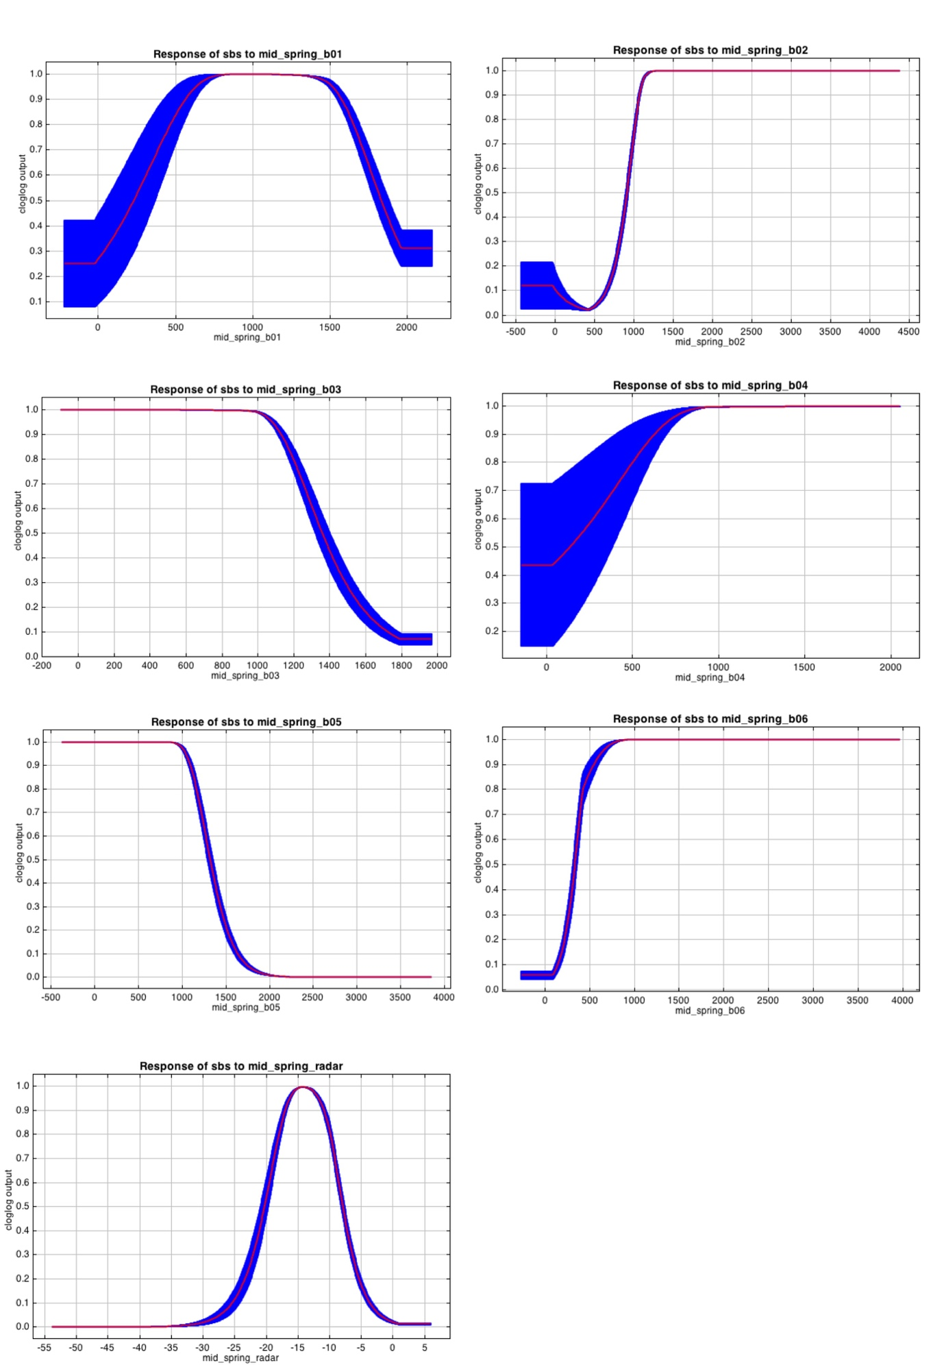

Figure S1. Response curves +/- 1 standard deviation for the variables in each model. Curves show change in predicted probability of presence for that variable when all others are held at their mean.

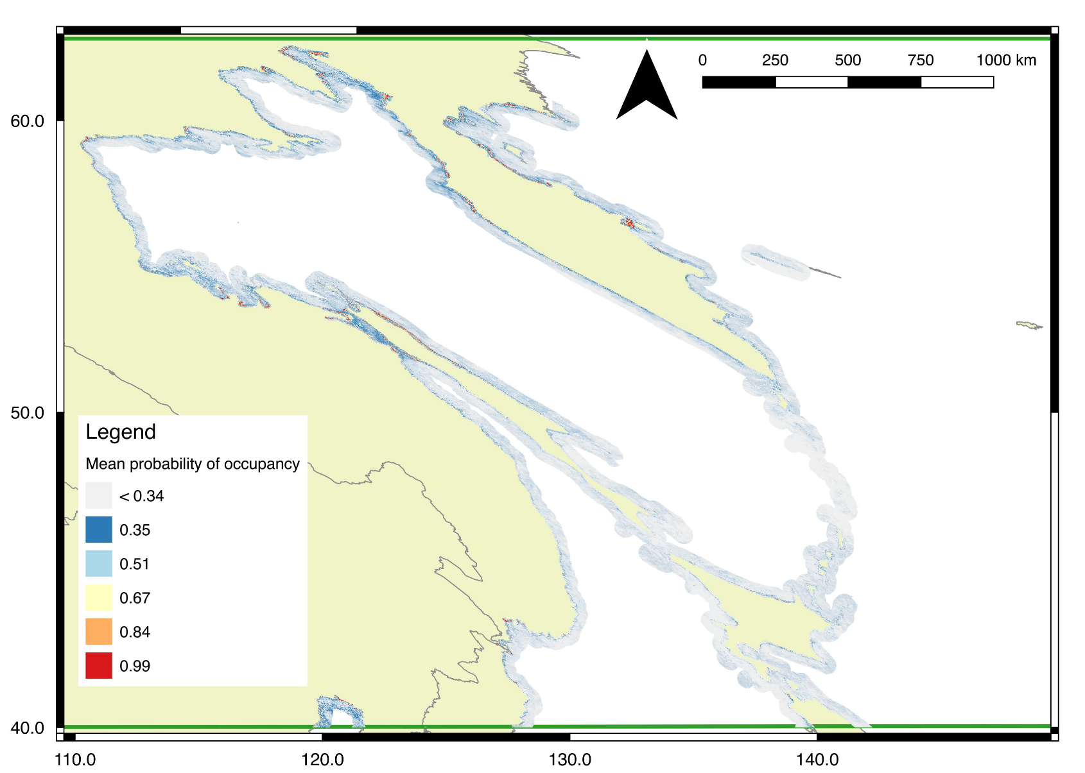
Figure S2. North full predicted distribution.

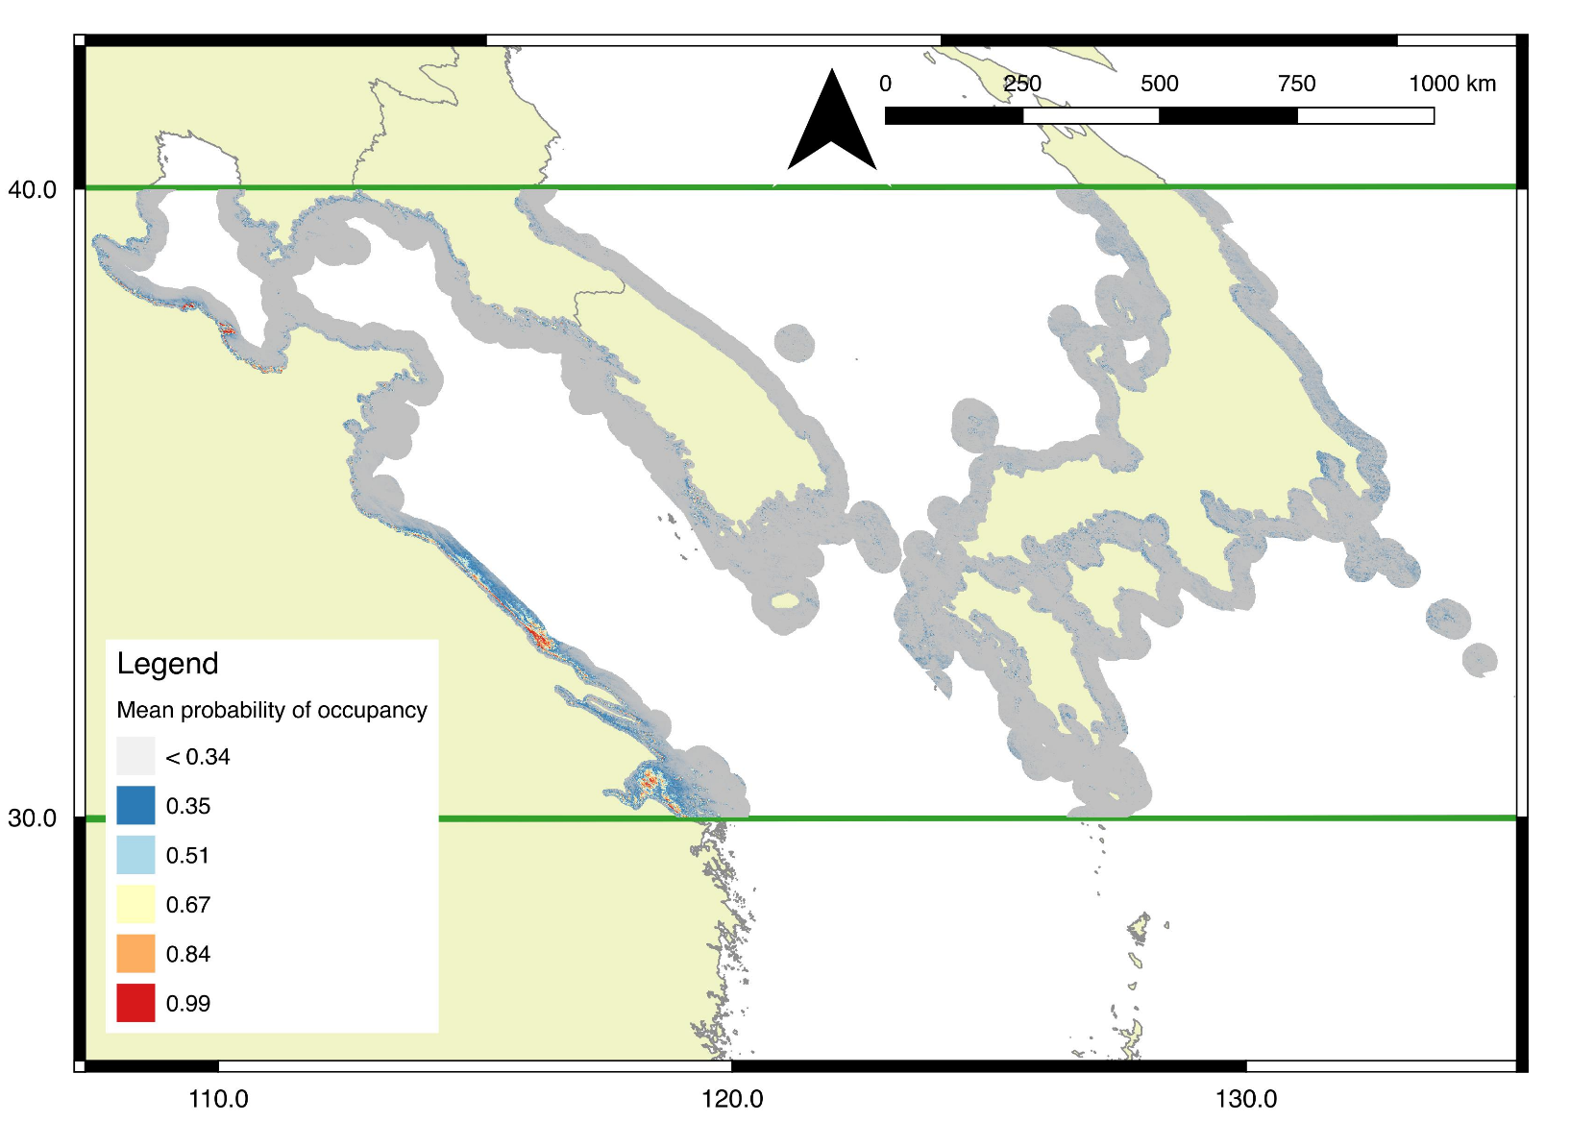
Figure S3. Central autumn full predicted distribution.

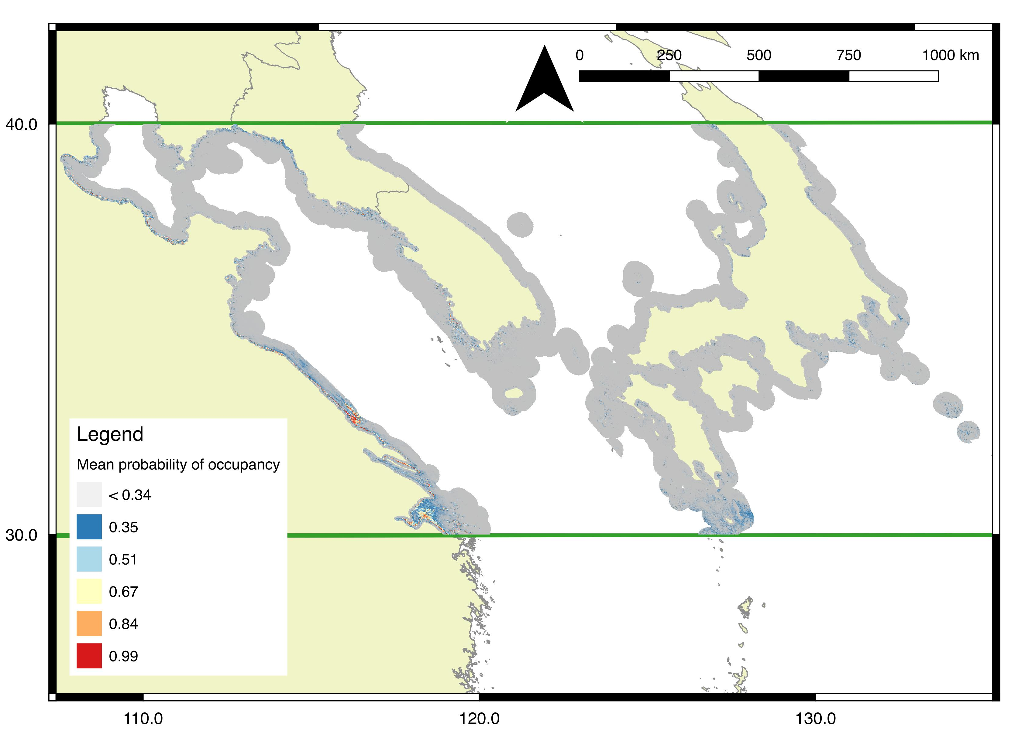
Figure S4. Central spring full predicted distribution.

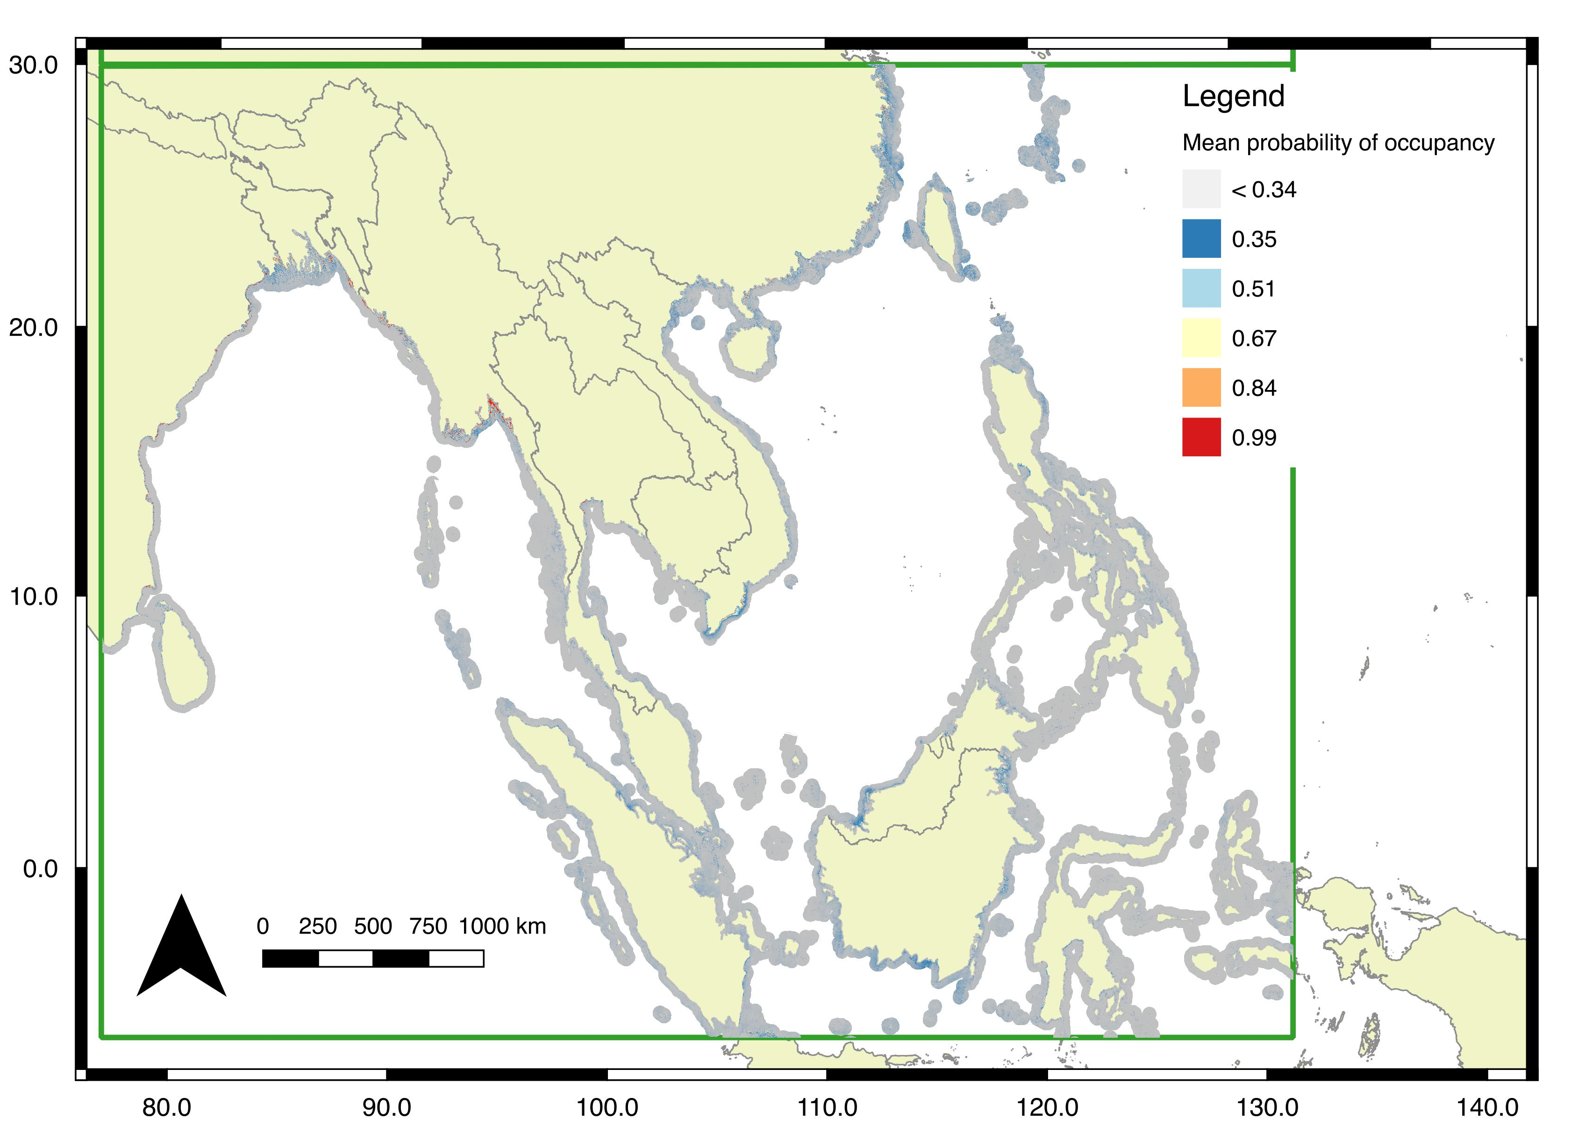

Figure S5. South full predicted distribution.

Table S1. Spoon-billed Sandpiper sites.

Region | Map identifier | Site name | Country | Site coordinates | SBS status | Months likely present | Protected area? | KBA?
North | A | Shelikhova Bay | Russia | 62.36N 163.91E | Potential | June - August | No | No
North | B | Karaginskiy and Oliutorskiy Bays | Russia | 59.33N 165.29E | Potential | June - August | No | Partial
North | C | Western Kamchatka coast | Russia | 56.95N 155.37E | Potential | June - August | Partial | Partial
North | D | Kamchatka river mouth | Russia | 56.58N 163.47E | Potential | June - August | No | Yes
North | E | Tugurski and Academy Bays | Russia | 54.11N 137.9E | Potential | June - August | No | Yes
North | F | Amur liman and Northern Sakhalin | Russia | 53.02E 141.54N | Potential | June - August | Partial | Yes
Central | G | Bohai and Laizhou Bays | China | 38.29N 118.34E | Occupied | March - June, August - October | Partial | Yes
Central | H | Jiangsu coast | China | 32.94N 121.08E | Occupied | March - June, August - October | Yes | Yes
Central | J | Yangtze Delta and Hangzhou Bay near Shanghai | China | 30.83N 121.64E | Occupied | March - June, August - October | No | Partial
Central | 1 | coast at Pyongyang | North Korea | 39.5N 125.34E | Potential | March - June, August - October | No | Yes
Central | 2 | Yonan coast | North Korea | 37.77N 126.04E | Potential | March - June, August - October | No | No
Central | 3 | Jeollanam-do coast. | South Korea | 35.22N 126.31E | Potential | March - June, August - October | Yes | Yes
South | K | Mannar | Sri Lanka | 8.93N 79.91E | Occupied | Nov - Feb | No | Yes
South | L | Fraserganj | India | 21.85N 89.31E | Occupied | Nov - Feb | No | No
South | M | Ganges-Brahmaputra Delta (Meghna river) | Bangladesh | 22.31N 92.02E | Occupied | Nov - Feb | No | Yes
South | N | Rakhine coast and Nan Thar island | Myanmar | 20.38N 93.55E | Occupied | Nov - Feb | No | No
South | P | Hainan and Leizhou Peninsula in Guangdong | China | 21.05N 110.98E | Occupied | Nov - Feb | No | Partial
South | Q | Gulf of Mottama | Myanmar | 16.86N 96.95E | Occupied | Nov - Feb | Partial | Yes
South | Q | Ayeyarwaday Delta | Myanmar | 15.97N 94.52E | Occupied | Nov - Feb | Partial | Yes
South | R | Inner gulf of Thailand | Thailand | 13.47N 100.22E | Occupied | Nov - Feb | No | Partial
South | S | Mekong Delta | Vietnam | 9.39N 106.07E | Occupied | Nov - Feb | Partial | Partial
South | T | Aceh, Sumatra | Indonesia | 5.23N 97.48E | Occupied | Nov - Feb | No | No
South | 1 | Point Calimere | India | 10.36N 79.63E | Potential | Nov - Feb | Yes | Yes
South | 2 | Khrishna river | India | 15.93N 81.07E | Potential | Nov - Feb | No | No
South | 3 | Lake Chilika and Mahanadi river | India | 20.12N 86.43E | Potential | Nov - Feb | Partial | Partial
South | 4 | Hooghly river | India | 21.59N 87.39E | Potential | Nov - Feb | No | No
South | 5 | Fujian coast | China | 25.23N 119.14E | Potential | Nov - Feb | Partial | Partial
South | 6 | South-west coast of Taiwan | Taiwan | 23.21N 120.09E | Potential | Nov - Feb | Partial | Yes
South | 7 | Manilla Bay | Philippines | 14.78N 120.66E | Potential | Nov - Feb | No | Yes
South | 8 | Mindoro and Panay | Philippines | 11.54N 122.79E | Potential | Nov - Feb | No | No
South | 9 | Brunei Bay | Brunei | 5.03N 115.33E | Potential | Nov - Feb | Partial | Yes
South | 10 | Kayan river | Indonesia | 3.52N 117.48E | Potential | Nov - Feb | No | No
South | 11 | Maludam National Park | Malaysia | 1.63N 110.97E | Potential | Nov - Feb | No | Yes
South | 12 | Mahakam river | Indonesia | 0.61S 117.38E | Potential | Nov - Feb | No | No
South | 13 | Gorontalo coast | Indonesia | 0.48N 121.74E | Potential | Nov - Feb | Partial | No
South | 14 | South Sulawesi | Indonesia | 4.01S 120.33E | Potential | Nov - Feb | No | No
South | - | Wenzhou Bay | China | 28.28N 121.15E | Potential | Nov - Feb | No | Partial

