Supplementary Material

Impact of informal timber harvesting on habitat structure and bird assemblages in a coastal forest of the Eastern Cape, South Africa
JESSICA LEAVER, JOHANN C. CARSTENS and MICHAEL I. CHERRY
Contents
Figure S1. Incidence-based species accumulation curves from harvest gaps (red), natural gaps (blue) and intact (green) sites sampled in Mqaba forest.
Figure S2. Habitat variables compared across harvest gaps.
Figure S3. Presence of a) fruit, b) flowers and c) exotic species in the understory as percentage in each abundance class.
Table S1. List of bird species recorded during bird survey in Mqaba forest, and occurrence at different habitat types sampled: harvest gaps, intact forest, and natural gaps.
Table S2. Habitat variables included in RLQ analysis, and their mean across harvest gaps, intact sites and natural gaps.
Table S3. Bird species and their ecological traits included in RLQ analysis.
Table S4. Standardized interaction coefficient estimates for interaction term from fourth corner analysis testing the relationship between bird functional traits and habitat characteristics, based on species presence/absence.

Figure S1. Incidence-based species accumulation curves from harvest gaps (red), natural gaps (blue) and intact (green) sites sampled in Mqaba forest. Values shown are based on frequency of occurrence of species across plots sampled, with 95% confidence intervals shown.

ab
a
b
b
a
b
a
a
b
bb
a
b
a
a
a
b
a
b
a
b
ab
ab
a
b
ab
b
a
Figure S2. Habitat variables compared across harvest gaps (n = 6), intact site (n = 6) and natural gaps (n = 6). Different letters indicate significant difference across groups (P < 0.05).

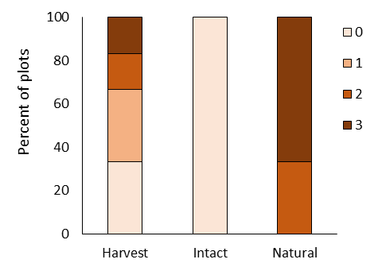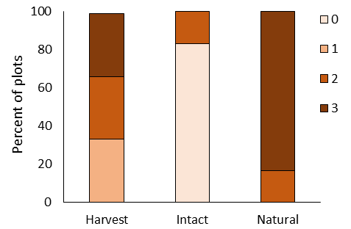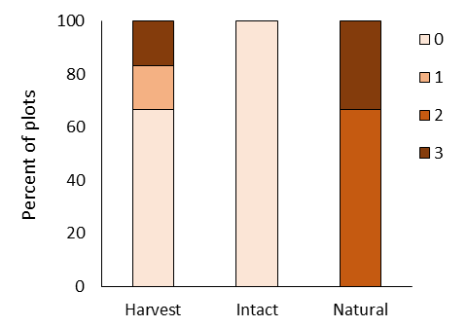
χ² = 19.93, df = 6, p = 0.003
χ² = 18.2, df = 6, p = 0.006
χ² = 17.6, df = 6, p = 0.007
a)
b)
c)
Figure S3. Presence of a) fruit, b) flowers and c) exotic species in the understory as percentage in each abundance class (0 = none; 1 = 1 – 10; 2 = 11 - 20; 3 = > 20) across harvest gaps (n = 6), intact sites (n = 6) and natural gaps (n =6) in Mqaba forest. Results of Chi-squared test comparing differences across groups are shown.

Table S1. List of bird species recorded during bird survey in Mqaba forest, and occurrence at different habitat types sampled: harvest gaps, intact forest and natural gaps.
Common name | Scientific name | Harvest gap | Intact forest | Natural gap
African Dusky Flycatcher | Muscicapa adusta | x | x
African Emerald Cuckoo | Chrysococcyx cupreus | x | x | x
African Goshawk | Accipiter tachiro | x | x | x
African Green Pigeon | Treron calvus | x | x
African Olive Pigeon | Columba arquatrix |  |  | x
Bar-throated Apalis | Apalis thoracica | x |  | x
Black Cuckoo | Cuculus clamosus | x | x | x
Black-backed Puffback | Dryoscopus cubla | x | x | x
Black-bellied starling | Notopholia corruscus | x |  | x
Black-headed Oriole | Oriolus larvatus | x | x | x
Blue-mantled Crested Flycatcher | Trochocercus cyanomelas | x | x | x
Brown Scrub Robin | Cercotrichas signata | x | x
Cape Batis | Batis capensis | x | x | x
Cape White-eye | Zosterops capensis | x | x | x
Chorister Robin-chat | Cossypha dichroa | x | x | x
Collared Sunbird | Hedydipna collaris | x | x | x
Dark-backed Weaver | Ploceus bicolor | x | x | x
Dark-capped Bulbul | Pycnonotus tricolor |  |  | x
Forest Canary | Crithagra scotops |  |  | x
Fork-tailed Drongo | Dicrurus adsimilis | x | x | x
Greater Double-collared Sunbird | Cinnyris afer | x |  | x
Green twinspot | Mandingoa nitidula |  | x
Green Wood-Hoopoe | Phoeniculus purpureus | x | x
Green-backed Camaroptera | Camaroptera brachyura | x | x | x
Grey Cuckooshrike | Coracina caesia | x | x | x
Grey sunbird | Cyanomitra veroxii |  |  | x
Knysna Turaco | Tauraco corythaix | x | x | x
Knysna Warbler | Bradypterus sylvaticus | x | x
Knysna Woodpecker | Campethera notata | x | x
Little Sparrowhawk | Accipiter minullus | x
Narina Trogon | Apaloderma narina | x | x
Olive Bushshrike | Chlorophoneus olivaceus | x |  | x
Olive sunbird | Cyanomitra olivacea | x | x | x
Olive Thrush | Turdus olivaceus | x | x | x
Olive Woodpecker | Dendropicus griseocephalus | x | x
Red-chested Cuckoo | Cuculus solitarius |  | x
Red-fronted Tinkerbird | Pogoniulus pusillus | x | x | x
Sombre Greenbul | Andropadus importunus | x | x | x
Southern Boubou | Laniarius ferrugineus | x | x | x
Southern Double-collared Sunbird | Cinnyris chalybeus | x | x | x
Spotted Ground Thrush | Zoothera guttata | x | x | x
Square-tailed Drongo | Dicrurus ludwigii |  | x
Terrestrial Brownbul | Phyllastrephus terrestris | x | x | x
Trumpeter Hornbill | Bycanistes bucanitor | x |  | x
White-starred Robin | Pogonocichla stellata | x | x | x
Yellow-breasted Apalis | Apalis flavida |  | x
Yellow-streaked greenbul | Phyllastrephus flavostriatus | x | x | x
Yellow-throated Woodland Warbler | Phylloscopus ruficapilla | x | x | x

Table S2. Habitat variables included in RLQ analysis, and their mean across harvest gaps, intact sites and natural gaps.
Variable | Harvest gap | Intact | Natural gap
Shrub cover (%) | 14.33 | 14.83 | 28.00
Vine cover (%) | 18.83 | 9.00 | 50.00
Herb cover (%) | 5.00 | 3.67 | 13.33
Grass cover (%) | 14.67 | 2.50 | 5.50
Leaf litter cover (%) | 21.33 | 65.50 | 12.00
Woody debris cover (%) | 30.50 | 17.17 | 33.33
Bare ground cover (%) | 3.67 | 1.83 | 2.50
Understory foliage density (%) | 53.32 | 14.83 | 71.03
Mid-story foliage density (%) | 22.17 | 20.71 | 30.75
Sub-canopy foliage density (%) | 19.46 | 50.71 | 15.17
Canopy foliage density (%) | 5.75 | 35.54 | 3.03
FHDI | 1.85 | 1.98 | 1.71
Canopy cover (%) | 35.00 | 80.00 | 15.00
Fruit availability index | 1.92 | 0.33 | 2.83
Flower availability index | 1.08 | 0.00 | 2.83
Exotic count | 0.67 | 0.00 | 2.33

Table S3. Bird species and their ecological traits included in RLQ analysis.

Scientific name | Common name | Diet | Forage | Strata | Nest
Andropadus importunus | Sombre Greenbul | Frugivore | Harvest | Can | Ball.Cup
Apalis thoracica | Bar-throated Apalis | Insectivore | Glean | Und | Ball.Cup
Apaloderma narina | Narina Trogon | Insectivore | Per.Swo | Can | Cav
Batis capensis | Cape Batis | Insectivore | Glean | Und | Ball.Cup
Bycanistes bucanitor | Trumpeter Hornbill | Frugivore | Harvest | Can | Cav
Camaroptera brachyura | Green-backed Camaroptera | Insectivore | Glean | Und | Ball.Cup
Campethera notata | Knysna Woodpecker | Insectivore | Arb.pro | Can | Cav
Cercotrichas signata | Brown Scrub Robin | Insectivore | Ter.Pro | Gnd | Cav
Chlorophoneus olivaceus | Olive Bushshrike | Insectivore | Glean | Can | Ball.Cup
Chrysococcyx cupreus | African Emerald Cuckoo | Insectivore | Per.Swo | Can | Ball.Cup
Cinnyris afer | Greater Double-collared Sunbird | Nectarivore | Harvest | Thru | Ball.Cup
Cinnyris chalybeus | Southern Double-collared Sunbird | Nectarivore | Harvest | Thru | Ball.Cup
Columba arquatrix | African Olive Pigeon | Frugivore | Harvest | Can | Plat
Coracina caesia | Grey Cuckooshrike | Insectivore | Glean | Can | Ball.Cup
Cossypha dichroa | Chorister Robin-chat | Insectivore | Ter.Pro | Gnd | Cav
Cuculus clamosus | Black Cuckoo | Insectivore | Hawk | Can | Brood.para
Cuculus solitarius | Red-chested Cuckoo | Insectivore | Glean | Can | Brood.para
Cyanomitra olivacea | Olive sunbird | Nectarivore | Harvest | Thru | Ball.Cup
Cyanomitra veroxii | Grey sunbird | Nectarivore | Harvest | Thru | Ball.Cup
Dendropicus griseocephalus | Olive Woodpecker | Insectivore | Arb.pro | Can | Cav
Dicrurus adsimilis | Fork-tailed Drongo | Insectivore | Hawk | Can | Ball.Cup
Dicrurus ludwigii | Square-tailed Drongo | Insectivore | Hawk | Can | Ball.Cup
Dryoscopus cubla | Black-backed Puffback | Insectivore | Glean | Can | Ball.Cup
Hedydipna collaris | Collared Sunbird | Nectarivore | Harvest | Thru | Ball.Cup
Laniarius ferrugineus | Southern Boubou | Insectivore | Glean | Und | Ball.Cup
Muscicapa adusta | African Dusky Flycatcher | Insectivore | Hawk | Und | Ball.Cup
Notopholia corruscus | Black-bellied starling | Frugivore | Harvest | Can | Cav
Oriolus larvatus | Black-headed Oriole | Omnivore | Glean | Can | Ball.Cup
Phoeniculus purpureus | Green Wood-Hoopoe | Insectivore | Arb.pro | Can | Cav
Phyllastrephus flavostriatus | Yellow-streaked greenbul | Insectivore | Glean | Can | Ball.Cup
Phyllastrephus terrestris | Terrestrial Brownbul | Insectivore | Ter.Pro | Gnd | Ball.Cup
Phylloscopus ruficapilla | Yellow-throated Woodland Warbler | Insectivore | Glean | Can | Ground
Pogoniulus pusillus | Red-fronted Tinkerbird | Frugivore | Harvest | Can | Cav
Pogonocichla stellata | White-starred Robin | Insectivore | Glean | Thru | Ground
Pycnonotus tricolor | Dark-backed Weaver | Insectivore | Glean | Can | Ball.Cup
Tauraco corythaix | Knysna Turaco | Frugivore | Harvest | Can | Plat
Treron calvus | African Green Pigeon | Frugivore | Harvest | Can | Plat
Trochocercus cyanomelas | Blue-mantled Crested Flycatcher | Insectivore | Hawk | Und | Ball.Cup
Turdus olivaceus | Olive Thrush | Insectivore | Ter.Pro | Gnd | Ball.Cup
Zoothera guttata | Spotted Ground Thrush | Insectivore | Ter.Pro | Gnd | Ball.Cup
Zosterops capensis | Cape White-eye | Omnivore | Glean | Can | Ball.Cup

Table S4. Standardized interaction coefficient estimates for interaction term from fourth corner analysis testing the relationship between bird functional traits and habitat characteristics, based on species presence/absence. Habitat variables PC1 and PC2 where derived from PCA of 16 measures habitat variables. PC1 and PC2 represented 60.6% and 13% of variation respectively.
Species trait | PC1 | PC2
Diet.Frugivore | 0 | 0
Diet.Insectivore | -0,21979 | 0
Diet.Nectarivore | 0,094864 | 0
Diet.Omnivore | 0,013032 | 0
Forage.Arboreal probe | -0,02218 | 0
Forage.Glean | 0 | 0
Forage.Harvest | 0 | 0
Forage.Hawk | -0,03707 | 0
Forage.Perch and Swoop | 0 | 0
Forage.Terrestrial probe | 0 | 0
Strata.Canopy | -0,00131 | 0
Strata.Ground | 0 | 0
Strata.Throughout | 0 | 0
Strata.Understory | 0 | 0
Nest.Ball.Cup | 0,06028 | 0
Nest.Brood.parasite | 0 | 0
Nest.Cavity | -0,05584 | 0,038224
Nest.Ground | -0,03506 | 0
Nest.Platform | 0 | 0

