Supplementary Materials

Expert knowledge assessment of threats and conservation strategies for Hen Harrier and Short-eared Owl across Europe

Darío Fernández-Bellon, John Lusby, Jules Bos, Tonio Schaub,
Alan McCarthy, Anthony Caravaggi, Sandra Irwin, John O’Halloran

Contents
Questionnaire on Hen Harrier and Short-eared Owl conservation threats and strategies (separate file).
Figure S1. Perceived impact of different threats reported by questionnaire responses in relation to number of breeding pairs covered by each questionnaire.
Table S1. Perceived impact of conservation threats to breeding Hen Harrier and Short-eared Owl across Europe, assessed through questionnaires.
Table S2. Perceived importance of conservation threats to breeding Hen Harrier by country.
Table S3. Perceived importance of conservation threats to breeding Short-eared Owl by country.
Table S4. Perceived effectiveness of conservation strategies for breeding Hen Harrier and Short-eared Owl across Europe.

Figure S1. Perceived impact of different threats reported by questionnaire responses in relation to number of breeding pairs covered by each questionnaire. For this figure, for areas that were covered by more than one response, we only used data from the response covering the largest number of pairs to avoid pseudo-replication (final n = 13 for Hen Harrier, n = 8 for Short-eared Owl). As these results were similar to the analysis including all responses, the latter result is presented in the main text (Fig. 4).
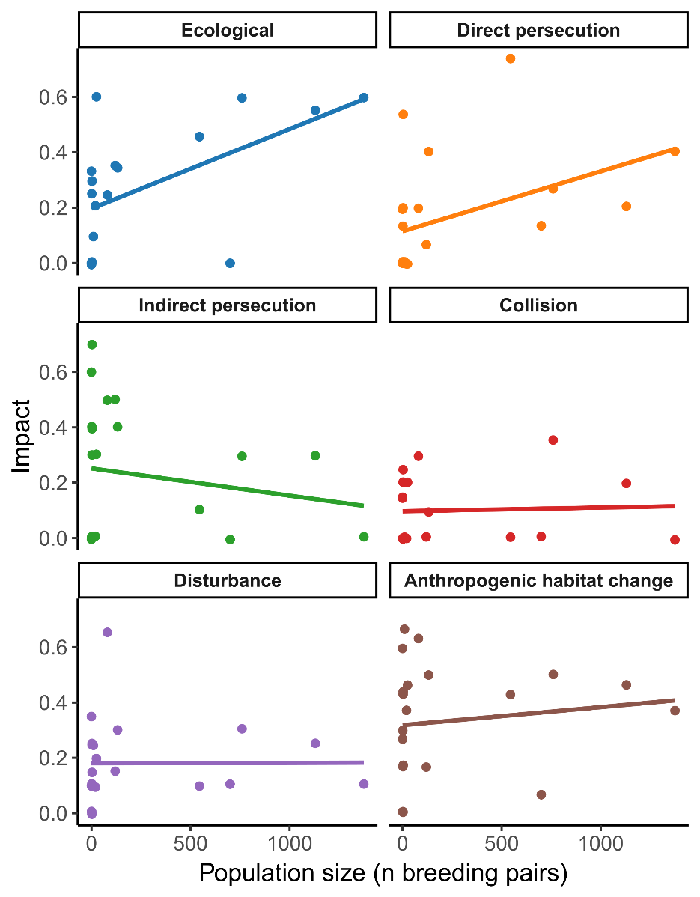
Table S1. Perceived impact of conservation threats to breeding Hen Harrier and Short-eared Owl across Europe, assessed through questionnaires (n = 23 responses from 9 countries for Hen Harrier; n = 12 responses from 6 countries for Short-eared Owl).
Species | Threat category | Threat | Mean impact | SD
Hen Harrier | Ecological | Predation | 2.0 | 1.1
 |  | Extreme weather | 1.9 | 0.9
 |  | Prey availability | 2.8 | 1.5
 |  | Parasites | 0.0 | 0.1
 | Persecution | Shooting | 1.5 | 1.3
 |  | Poisoning | 0.7 | 1.0
 |  | Nest destruction | 1.3 | 1.0
 | Indirect persecution | Secondary poisoning | 0.8 | 1.0
 |  | Accidental nest destruction | 2.4 | 1.9
 | Collision | Wind turbines | 0.9 | 0.9
 |  | Power lines | 0.7 | 0.8
 |  | Cars / trains | 0.6 | 0.7
 |  | Fences | 0.0 | 0.1
 | Disturbance | Forestry | 1.3 | 1.3
 |  | Agriculture | 1.6 | 1.0
 |  | Burning | 0.8 | 1.2
 |  | Recreational activities | 1.0 | 1.0
 | Anthropogenic habitat change | Habitat loss | 2.8 | 2.0
 |  | Afforestation | 1.4 | 1.7
 |  | Agricultural intensification | 3.3 | 1.2
 |  | Grazing regimes | 1.1 | 0.9
 |  | Recreation infrastructures | 0.8 | 0.7
 |  | Developments | 1.2 | 1.1
Short-eared owl | Ecological | Predation | 2.4 | 1.6
 |  | Extreme weather | 2.8 | 1.7
 |  | Prey availability | 4.3 | 1.0
 |  | Parasites | 0.0 | 0.0
 | Persecution | Shooting | 1.8 | 1.4
 |  | Poisoning | 0.0 | 0.1
 |  | Nest destruction | 0.8 | 1.0
 | Indirect persecution | Secondary poisoning | 0.3 | 0.5
 |  | Accidental nest destruction | 2.0 | 1.6
 | Collision | Wind turbines | 0.4 | 0.5
 |  | Power lines | 0.7 | 1.0
 |  | Cars / trains | 1.5 | 1.7
 |  | Fences | 0.2 | 0.5
 | Disturbance | Forestry | 0.3 | 0.8
 |  | Agriculture | 1.5 | 1.4
 |  | Burning | 0.3 | 0.8
 |  | Recreational activities | 1.1 | 0.7
 | Anthropogenic habitat change | Habitat loss | 3.0 | 1.8
 |  | Afforestation | 1.2 | 1.8
 |  | Agricultural intensification | 2.9 | 1.8
 |  | Grazing regimes | 1.7 | 1.1
 |  | Recreation infrastructures | 0.7 | 0.6
 |  | Developments | 0.6 | 0.8

Table S2. Perceived importance of conservation threats to breeding Hen Harrier by country assessed through questionnaires (n = 23 responses from 9 countries). Threats are ordered by perceived importance, mean and standard deviation values are given for countries with multiple responses.
Country | Threat | Threat category | Impact | SD
Belarus | Agricultural intensification | Anthropogenic habitat change | 2 | -
(n = 1) | Shooting | Persecution | 2 | -
 | Agriculture | Disturbance | 1 | -
 | Forestry | Disturbance | 1 | -
Czech Republic | Agricultural intensification | Anthropogenic habitat change | 5 | -
(n = 1) | Habitat loss | Anthropogenic habitat change | 5 | -
 | Accidental nest destruction | Indirect persecution | 4 | -
 | Agriculture | Disturbance | 3 | -
 | Poisoning | Persecution | 3 | -
 | Predation | Ecological | 3 | -
 | Secondary poisoning | Indirect persecution | 3 | -
 | Shooting | Persecution | 3 | -
 | Car / train | Collision | 2 | -
 | Development | Anthropogenic habitat change | 2 | -
 | Forestry | Disturbance | 2 | -
 | Nest destruction | Persecution | 2 | -
 | Power lines | Collision | 2 | -
 | Grazing regimes | Anthropogenic habitat change | 1 | -
Finland | Afforestation | Anthropogenic habitat change | 4 | -
(n = 1) | Habitat loss | Anthropogenic habitat change | 4 | -
 | Agricultural intensification | Anthropogenic habitat change | 3 | -
 | Extreme weather | Ecological | 3 | -
 | Forestry | Disturbance | 3 | -
 | Predation | Ecological | 3 | -
 | Accidental nest destruction | Indirect persecution | 3 | -
 | Nest destruction | Persecution | 2 | -
 | Power lines | Collision | 2 | -
 | Agriculture | Disturbance | 1 | -
 | Car / train | Collision | 1 | -
 | Development | Anthropogenic habitat change | 1 | -
 | Grazing regimes | Anthropogenic habitat change | 1 | -
 | Recreation infrastructures | Anthropogenic habitat change | 1 | -
 | Recreational activities | Disturbance | 1 | -
 | Shooting | Persecution | 1 | -
 | Wind turbines | Collision | 1 | -
France | Agricultural intensification | Anthropogenic habitat change | 5 | -
(n = 1) | Prey availability | Ecological | 5 | -
 | Accidental nest destruction | Indirect persecution | 5 | -
 | Agriculture | Disturbance | 3 | -
 | Extreme weather | Ecological | 1 | -
 | Nest destruction | Persecution | 1 | -
 | Predation | Ecological | 1 | -
Germany | Prey availability | Ecological | 3 | 0
(n = 3) | Habitat loss | Anthropogenic habitat change | 2.3 | 1.6
 | Agricultural intensification | Anthropogenic habitat change | 2 | 0
 | Recreation infrastructures | Anthropogenic habitat change | 1.7 | 1.2
 | Recreational activities | Disturbance | 1.7 | 1.2
 | Predation | Ecological | 1.3 | 1.2
 | Wind turbines | Collision | 1.3 | 1.8
 | Extreme weather | Ecological | 1 | 0
 | Secondary poisoning | Indirect persecution | 1 | 1.4
 | Grazing regimes | Anthropogenic habitat change | 0.3 | 0.4
(Table S2 continued)
Country | Threat | Threat category | Impact | SD
Ireland | Habitat loss | Anthropogenic habitat change | 5 | 0
(n = 2) | Afforestation | Anthropogenic habitat change | 3.5 | 0.5
 | Agricultural intensification | Anthropogenic habitat change | 3 | 0
 | Development | Anthropogenic habitat change | 3 | 1
 | Predation | Ecological | 3 | 0
 | Burning | Disturbance | 2.5 | 0.5
 | Forestry | Disturbance | 2.5 | 0.5
 | Recreational activities | Disturbance | 2.5 | 1.5
 | Extreme weather | Ecological | 2 | 0
 | Prey availability | Ecological | 2 | 0
 | Shooting | Persecution | 2 | 0
 | Accidental nest destruction | Indirect persecution | 2 | 0
 | Wind turbines | Collision | 2 | 0
 | Grazing regimes | Anthropogenic habitat change | 1.5 | 0.5
 | Nest destruction | Persecution | 1.5 | 0.5
 | Secondary poisoning | Indirect persecution | 1.5 | 0.5
 | Agriculture | Disturbance | 1 | 0
 | Poisoning | Persecution | 1 | 1
 | Recreation infrastructures | Anthropogenic habitat change | 1 | 1
 | Car / train | Collision | 0.5 | 0.5
 | Power lines | Collision | 0.5 | 0.5
Netherlands | Prey availability | Ecological | 4 | 0.5
(n = 5) | Agricultural intensification | Anthropogenic habitat change | 3.3 | 2
 | Habitat loss | Anthropogenic habitat change | 2.5 | 2.2
 | Accidental nest destruction | Indirect persecution | 2.5 | 2.2
 | Predation | Ecological | 2.3 | 1.6
 | Agriculture | Disturbance | 2.2 | 1.3
 | Grazing regimes | Anthropogenic habitat change | 1.7 | 1.4
 | Recreational activities | Disturbance | 1.7 | 0.9
 | Development | Anthropogenic habitat change | 1.5 | 1.5
 | Recreation infrastructures | Anthropogenic habitat change | 1.3 | 1.3
 | Car / train | Collision | 1.2 | 0.9
 | Extreme weather | Ecological | 1 | 0.9
 | Nest destruction | Persecution | 0.8 | 1.1
 | Wind turbines | Collision | 0.7 | 0.7
 | Power lines | Collision | 0.5 | 0.5
 | Secondary poisoning | Indirect persecution | 0.5 | 0.7
 | Poisoning | Persecution | 0.3 | 0.4
 | Shooting | Persecution | 0.3 | 0.4
 | Afforestation | Anthropogenic habitat change | 0.2 | 0.3
 | Burning | Disturbance | 0.2 | 0.3
 | Fences | Collision | 0.2 | 0.3
 | Forestry | Disturbance | 0.2 | 0.3

(Table S2 continued)
Country | Threat | Threat category | Impact | SD
Spain | Habitat loss | Anthropogenic habitat change | 5 | 0
(n = 2) | Accidental nest destruction | Indirect persecution | 4.5 | 0.5
 | Agricultural intensification | Anthropogenic habitat change | 4 | 1
 | Afforestation | Anthropogenic habitat change | 3 | 2
 | Burning | Disturbance | 3 | 1
 | Extreme weather | Ecological | 3
 | Forestry | Disturbance | 3 | 2
 | Development | Anthropogenic habitat change | 2.5 | 1.5
 | Grazing regimes | Anthropogenic habitat change | 2.5 | 0.5
 | Wind turbines | Collision | 2.5 | 1.5
 | Agriculture | Disturbance | 2 | 1
 | Recreational activities | Disturbance | 2 | 1
 | Predation | Ecological | 1.5 | 0.5
 | Recreation infrastructures | Anthropogenic habitat change | 1.5 | 0.5
 | Car / train | Collision | 1 | 0
 | Nest destruction | Persecution | 1 | 0
 | Poisoning | Persecution | 1 | 0
 | Power lines | Collision | 1 | 0
 | Prey availability | Ecological | 1 | 0
 | Secondary poisoning | Indirect persecution | 1 | 0
 | Shooting | Persecution | 1 | 0
UK | Shooting | Persecution | 3.8 | 1.7
(n = 6) | Nest destruction | Persecution | 3 | 2.1
 | Predation | Ecological | 3 | 1.2
 | Afforestation | Anthropogenic habitat change | 2.3 | 1.8
 | Extreme weather | Ecological | 2.3 | 0.4
 | Agricultural intensification | Anthropogenic habitat change | 2.2 | 1.7
 | Grazing regimes | Anthropogenic habitat change | 2 | 1.7
 | Prey availability | Ecological | 2 | 0.8
 | Habitat loss | Anthropogenic habitat change | 1.7 | 1.3
 | Burning | Disturbance | 1.3 | 1.1
 | Poisoning | Persecution | 1.3 | 1.3
 | Development | Anthropogenic habitat change | 1.2 | 1.2
 | Recreation infrastructures | Anthropogenic habitat change | 1 | 1.8
 | Agriculture | Disturbance | 0.8 | 1
 | Accidental nest destruction | Indirect persecution | 0.7 | 0.7
 | Recreational activities | Disturbance | 0.5 | 0.5
 | Wind turbines | Collision | 0.5 | 0.7
 | Forestry | Disturbance | 0.3 | 0.7
 | Secondary poisoning | Indirect persecution | 0.3 | 0.7
 | Parasites | Ecological | 0.2 | 0.3

Table S3. Perceived importance of conservation threats to breeding Short-eared Owl by country assessed through questionnaires (n = 12 responses from 6 countries). Threats are ordered by perceived importance, mean and standard deviation values are given for countries with multiple responses.
Country | Threat | Threat category | Impact | SD
Czech Republic | Agricultural intensification | Anthropogenic habitat change | 5 | -
(n = 1) | Habitat loss | Anthropogenic habitat change | 5 | -
 | Accidental nest destruction | Indirect persecution | 4 | -
 | Agriculture | Disturbance | 3 | -
 | Car / train | Collision | 3 | -
 | Predation | Ecological | 3 | -
 | Shooting | Persecution | 3 | -
 | Development | Anthropogenic habitat change | 2 | -
 | Power lines | Collision | 2 | -
 | Recreational activities | Disturbance | 2 | -
 | Grazing regimes | Anthropogenic habitat change | 1 | -
Finland | Agricultural intensification | Anthropogenic habitat change | 4 | -
(n = 1) | Car / train | Collision | 4 | -
 | Habitat loss | Anthropogenic habitat change | 4 | -
 | Predation | Ecological | 4 | -
 | Afforestation | Anthropogenic habitat change | 3 | -
 | Agriculture | Disturbance | 3 | -
 | Extreme weather | Ecological | 3 | -
 | Grazing regimes | Anthropogenic habitat change | 3 | -
 | Prey availability | Ecological | 3 | -
 | Accidental nest destruction | Indirect persecution | 3 | -
 | Forestry | Disturbance | 2 | -
 | Nest destruction | Persecution | 2 | -
 | Power lines | Collision | 2 | -
 | Shooting | Persecution | 2 | -
 | Recreation infrastructures | Anthropogenic habitat change | 1 | -
 | Recreational activities | Disturbance | 1 | -
 | Wind turbines | Collision | 1 | -
Germany | Extreme weather | Ecological | 5 | 0
(n = 3) | Prey availability | Ecological | 5 | 0
 | Habitat loss | Anthropogenic habitat change | 2.3 | 1.6
 | Predation | Ecological | 2.3 | 2.0
 | Accidental nest destruction | Indirect persecution | 2.3 | 1.6
 | Agricultural intensification | Anthropogenic habitat change | 2 | 2.1
 | Grazing regimes | Anthropogenic habitat change | 1.7 | 1.6
 | Fences | Collision | 1.3 | 1.8
 | Recreation infrastructures | Anthropogenic habitat change | 1.3 | 1.2
 | Recreational activities | Disturbance | 1.3 | 1.2
 | Secondary poisoning | Indirect persecution | 1.3 | 1.8
 | Agriculture | Disturbance | 1 | 1.4

(Table S3 continued)
Country | Threat | Threat category | Impact | SD
Netherlands | Agricultural intensification | Anthropogenic habitat change | 4 | 1.2
(n = 4) | Prey availability | Ecological | 4 | 0
 | Habitat loss | Anthropogenic habitat change | 2.5 | 1.8
 | Accidental nest destruction | Indirect persecution | 2.5 | 2.5
 | Grazing regimes | Anthropogenic habitat change | 2.3 | 1
 | Agriculture | Disturbance | 2 | 2.1
 | Recreational activities | Disturbance | 1.5 | 0.8
 | Predation | Ecological | 1.3 | 1.2
 | Extreme weather | Ecological | 1 | 0
 | Car / train | Collision | 0.8 | 1.2
 | Development | Anthropogenic habitat change | 0.8 | 1.2
 | Nest destruction | Persecution | 0.8 | 1.2
 | Recreation infrastructures | Anthropogenic habitat change | 0.8 | 0.8
 | Secondary poisoning | Indirect persecution | 0.5 | 0.8
 | Wind turbines | Collision | 0.5 | 0.8
 | Poisoning | Persecution | 0.3 | 0.4
 | Power lines | Collision | 0.3 | 0.4
 | Shooting | Persecution | 0.3 | 0.4
Spain  (n = 1) | Shooting | Persecution | 2 | -
UK | Prey availability | Ecological | 5 | 0
(n = 2) | Afforestation | Anthropogenic habitat change | 4 | 1
 | Habitat loss | Anthropogenic habitat change | 4 | 1
 | Predation | Ecological | 4 | 1
 | Shooting | Persecution | 3.5 | 0.5
 | Agricultural intensification | Anthropogenic habitat change | 2.5 | 0.5
 | Grazing regimes | Anthropogenic habitat change | 2.5 | 0.5
 | Extreme weather | Ecological | 2 | 2
 | Burning | Disturbance | 2 | 0
 | Nest destruction | Persecution | 2 | 0
 | Car / train | Collision | 1 | 1
 | Development | Anthropogenic habitat change | 1 | 1
 | Recreation infrastructures | Anthropogenic habitat change | 1 | 1
 | Recreational activities | Disturbance | 1 | 1
 | Wind turbines | Collision | 1 | 1

Table S4. Perceived effectiveness of conservation strategies for breeding Hen Harrier and Short-eared Owl across Europe, assessed through questionnaires (n = 23 responses from 9 countries for Hen Harrier; n = 12 responses from 6 countries for Short-eared Owl).
Species | Threat category | Threat | Mean  effectiveness | SD
Hen Harrier | Protection | Protected area | 2.3 | 1.0
 |  | Species-specific protected area (SPA) | 2.3 | 1.4
 |  | Nest protection (from direct or indirect persecution) | 2.9 | 1.9
 | Species management | Supplementary feeding | 2.2 | 1.0
 |  | Brood management | 3.0 | 2.8
 |  | Predator control (nest scale) | 3.4 | 1.7
 |  | Predator control (landscape scale) | 2.8 | 0.8
 | Habitat management | Improvement of nesting habitat | 3.1 | 1.7
 |  | Improvement of foraging habitat | 3.2 | 1.1
 |  | Improvement of linear features | 2.2 | 0.3
 |  | Improvement of grazing regimes | 2.0 | 0.0
 | Policy and legislation | Regulation of afforestation and forestry activities | 2.3 | 1.0
 |  | Regulation of recreation | 2.3 | 1.9
 |  | Rodenticide use regulation | 3.0 | -
Short-eared owl | Protection | Protected area | 2.7 | 1.1
 |  | Species-specific protected area (SPA) | 2.9 | 1.5
 |  | Nest protection (from direct or indirect persecution) | 3.0 | 1.5
 | Species management | Supplementary feeding | - | -
 |  | Brood management | - | -
 |  | Predator control (nest scale) | 4.0 | 1.4
 | Habitat management | Predator control (landscape scale) | 3.5 | 1.7
 |  | Improvement of nesting habitat | 3.7 | 1.5
 |  | Improvement of foraging habitat | 4.2 | 1.2
 |  | Improvement of linear features | 3.0 | -
 |  | Improvement of grazing regimes | 3.3 | 1.1
 | Policy and legislation | Regulation of afforestation and forestry activities | 1.0 | -
 |  | Regulation of recreation | - | -
 |  | Rodenticide use regulation | 4.0 | 1.4

