Supplementary Material

Drivers of population change in common farmland birds in Germany

MALTE BUSCH, JAKOB KATZENBERGER, SVEN TRAUTMANN, BETTINA GERLACH, RAINER DRÖSCHMEISTER and CHRISTOPH SUDFELDT

Contents

Table S1. Details of species selection for analysis.

Table S2. Model-averaged effect estimates for all farmland bird species analysed.
Table S3. Bootstrapped effect estimates for the overall group farmland bird species analysed.
Figure S1. Germany divided into the three regions analysed.

Figure S2. Values of land-use and weather variables 1991-2013 used as predictors in the modelling framework, for the three regions considered.
Figure S3. Relationship between log-transformed trend indices and explanatory variables for all farmland bird species in the analysis with time lag of 0 years.
Figure S4. Relationship between log-transformed trend indices and explanatory variables for all farmland bird species in the analysis with time lag of 1 year.
Table S1. Details of species selection for analysis. Considered were all species using agriculturally characterized breeding and/or feeding habitats according to the German bird trait data base (Wahl et al. 2014). Precluded (and not part of the table below) were species with the breeding status “former breeding bird, now extinct” and “sporadic breeder” as well as species with the frequency class “extremely rare” according to the German Red List (Grüneberg et al. 2015). To the remaining set of species three selection criteria were applied.
 |  | 1. criterion |  | 2. criterion | 3. criterion
 |  | habitat
species (former and current breeding bird species) | scientific name | breeding habitat | feeding habitat during the breeding season | reliable population trends available at regional scale for at least 2 of the 3 classified German regions | most relevant suspected population change determining factors relate to agricultural practices | national farmland indicator species | sub-national indicator species | final species set | comment
Greater Rhea | Rhea americana | arable fields and open land characterized by arable fields | arable fields and open land characterized by arable fields | no | n.a. | no
Greater Canada Goose | Branta canadensis |  | grassland and open land characterized by grassland | no | n.a. | no
Barnacle Goose | Branta leucopsis |  | grassland and open land characterized by grassland | no | n.a. | no
Swan Goose | Anser cygnoides |  | grassland and open land characterized by grassland | no | n.a. | no
Snow Goose | Anser caerulescens |  | grassland and open land characterized by grassland | no | n.a. | no
Bar-headed Goose | Anser indicus |  | grassland and open land characterized by grassland | no | n.a. | no
Greylag Goose | Anser anser |  | grassland and open land characterized by grassland | no | n.a. | no
Egyptian Goose | Alopochen aegyptiaca |  | grassland and open land characterized by grassland | no | n.a. | no
Ruddy Shelduck | Tadorna ferruginea |  | grassland and open land characterized by grassland | no | n.a. | no
Common Quail | Coturnix coturnix | arable fields and open land characterized by arable fields | arable fields and open land characterized by arable fields | no | n.a. | no
Common Pheasant | Phasianus colchicus | farmed open land (indifferent) | farmed open land (indifferent) | yes | no | no |  |  | population status mainly depends on releases of animals by hunters
White Stork | Ciconia ciconia |  | farmed open land (indifferent) | no | n.a. | no
Lesser Spotted Eagle | Aquila pomarina |  | grassland and open land characterized by grassland | no | n.a. | no
Montagu's Harrier | Circus pygargus | arable fields and open land characterized by arable fields | farmed open land (indifferent) | no | n.a. | no
Red Kite | Milvus milvus |  | farmed open land (indifferent) | no | n.a. | yes
Common Linnet | Carduelis cannabina |  | wasteland, ruderal and tall forb communities | yes | yes | no | yes | yes
Common Kestrel | Falco tinnunculus |  | farmed open land (indifferent) | no | n.a. | no
Common Crane | Grus grus |  | grassland and open land characterized by grassland | no | n.a. | no
Great Bustard | Otis tarda | farmed open land (indifferent) | farmed open land (indifferent) | no | n.a. | no
Corncrake | Crex crex |  | farmed open land (indifferent) | no | n.a. | no
Northern Lapwing | Vanellus vanellus | farmed open land (indifferent) | farmed open land (indifferent) | yes | yes | yes |  | yes
Eurasian Curlew | Numenius arquata | grassland and open land characterized by grassland | grassland and open land characterized by grassland | no | n.a. | no
Black-tailed Godwit | Limosa limosa | grassland and open land characterized by grassland | grassland and open land characterized by grassland | yes | yes | yes |  | yes
Common Snipe | Gallinago gallinago | grassland and open land characterized by grassland | grassland and open land characterized by grassland | no | n.a. | no
Ruff | Philomachus pugnax | grassland and open land characterized by grassland | grassland and open land characterized by grassland | no | n.a. | no
Black-headed Gull | Larus ridibundus |  | farmed open land (indifferent) | no | n.a. | no
Mediterranean Gull | Larus melanocephalus |  | farmed open land (indifferent) | no | n.a. | no
Mew Gull | Larus canus |  | grassland and open land characterized by grassland | no | n.a. | no
Gull-billed Tern | Gelochelidon nilotica |  | farmed open land (indifferent) | no | n.a. | no
Stock Dove | Columba oenas |  | farmed open land (indifferent) | yes | no | no |  |  | forest indicator species in several federal states, therefore not considered as farmland bird
European Turtle Dove | Streptopelia turtur |  | farmed open land (indifferent) | yes | yes | no |  | yes
Barn Owl | Tyto alba |  | farmed open land (indifferent) | no | n.a. | no
Little Owl | Athene noctua | grassland and open land characterized by grassland | grassland and open land characterized by grassland | no | n.a. | yes
Long-eared Owl | Asio otus |  | farmed open land (indifferent) | no | n.a. | no
Red-backed Shrike | Lanius collurio | farmed open land (indifferent) | farmed open land (indifferent) | yes | yes | yes |  | yes
Great Grey Shrike | Lanius excubitor | farmed open land (indifferent) | farmed open land (indifferent) | no | n.a. | no
Western Jackdaw | Coloeus monedula |  | farmed open land (indifferent) | yes | no | no |  |  | settlement indicator species at national level, therefore not considered as farmland bird
Rook | Corvus frugilegus |  | farmed open land (indifferent) | no | n.a. | no
Common Whitethroat | Sylvia communis | farmed open land (indifferent) | farmed open land (indifferent) | yes | yes | no | yes | yes
Crested Lark | Galerida cristata | wasteland, ruderal and tall forb communities | wasteland, ruderal and tall forb communities | no | n.a. | no
Eurasian Skylark | Alauda arvensis | farmed open land (indifferent) | farmed open land (indifferent) | yes | yes | yes |  | yes
Common Grasshopper Warbler | Locustella naevia | wasteland, ruderal and tall forb communities | wasteland, ruderal and tall forb communities | yes | yes | no | yes | yes
River Warbler | Locustella fluviatilis | wasteland, ruderal and tall forb communities | wasteland, ruderal and tall forb communities | no | n.a. | no
Marsh Warbler | Acrocephalus palustris | wasteland, ruderal and tall forb communities | wasteland, ruderal and tall forb communities | yes | yes | no | yes | yes
Common Starling | Sturnus vulgaris |  | grassland and open land characterized by grassland | yes | yes | no |  | yes
Mistle Thrush | Turdus viscivorus |  | grassland and open land characterized by grassland | yes | yes | no |  | yes
Common Buzzard | Buteo buteo |  | farmed open land (indifferent) | no | n.a. | no
Fieldfare | Turdus pilaris |  | grassland and open land characterized by grassland | yes | yes | no |  | yes
Whinchat | Saxicola rubetra | grassland and open land characterized by grassland | grassland and open land characterized by grassland | yes | yes | yes |  | yes
Grey Partridge | Perdix perdix | arable fields and open land characterized by arable fields | arable fields and open land characterized by arable fields | no | n.a. | no
Blue-headed Yellow Wagtail | Motacilla flava | farmed open land (indifferent) | farmed open land (indifferent) | yes | yes | no | yes | yes
European Goldfinch | Carduelis carduelis |  | wasteland, ruderal and tall forb communities | yes | yes | no |  | yes
Corn Bunting | Emberiza calandra | farmed open land (indifferent) | wasteland, ruderal and tall forb communities | no | n.a. | yes
Yellowhammer | Emberiza citrinella | farmed open land (indifferent) | farmed open land (indifferent) | yes | yes | yes |  | yes
Cirl Bunting | Emberiza cirlus |  | wasteland, ruderal and tall forb communities | no | n.a. | no
Ortolan Bunting | Emberiza hortulana | arable fields and open land characterized by arable fields | arable fields and open land characterized by arable fields | no | n.a. | no

Table S2. Model-averaged effect estimates for all farmland bird species analysed.
Variable | Estimate | StdError | Pvalue | Species
(Intercept) | 0.222 | 0.038 | <0.001 | Black-tailed Godwit
RegionEast | 0.251 | 0.054 | <0.001 | Black-tailed Godwit
AreaGrassland | -0.042 | 0.029 | 0.163 | Black-tailed Godwit
AreaRapeseed | -0.143 | 0.044 | 0.001 | Black-tailed Godwit
AreaWinterWheat | -0.208 | 0.045 | <0.001 | Black-tailed Godwit
AvgTempApJul | 0.041 | 0.032 | 0.211 | Black-tailed Godwit
ColdSum | -0.028 | 0.028 | 0.328 | Black-tailed Godwit
IndexFallowMaize | 0.060 | 0.040 | 0.147 | Black-tailed Godwit
YieldWinterGrain | -0.035 | 0.031 | 0.265 | Black-tailed Godwit
(Intercept) | 0.002 | 0.068 | 0.978 | Blue-head. Yel. Wagtail
RegionEast | 0.147 | 0.096 | 0.135 | Blue-head. Yel. Wagtail
RegionSouthWest | 0.180 | 0.096 | 0.068 | Blue-head. Yel. Wagtail
AreaWinterWheat | 0.123 | 0.065 | 0.060 | Blue-head. Yel. Wagtail
AvgTempApJul | -0.102 | 0.045 | 0.026 | Blue-head. Yel. Wagtail
ColdSum | 0.082 | 0.042 | 0.054 | Blue-head. Yel. Wagtail
IndexFallowMaize | 0.093 | 0.062 | 0.141 | Blue-head. Yel. Wagtail
SahelRainfall | 0.053 | 0.043 | 0.230 | Blue-head. Yel. Wagtail
(Intercept) | 0.375 | 0.058 | <0.001 | Com. Grasshopper Warbler
RegionEast | -0.108 | 0.072 | 0.142 | Com. Grasshopper Warbler
RegionSouthWest | -0.327 | 0.072 | <0.001 | Com. Grasshopper Warbler
AreaGrassland | -0.041 | 0.035 | 0.254 | Com. Grasshopper Warbler
AreaWinterWheat | -0.174 | 0.050 | 0.001 | Com. Grasshopper Warbler
AvgRainApJul | 0.031 | 0.035 | 0.392 | Com. Grasshopper Warbler
AvgTempApJul | -0.094 | 0.043 | 0.031 | Com. Grasshopper Warbler
IndexFallowMaize | 0.060 | 0.059 | 0.320 | Com. Grasshopper Warbler
YieldWinterGrain | -0.059 | 0.043 | 0.178 | Com. Grasshopper Warbler
(Intercept) | 0.350 | 0.038 | <0.001 | Common Linnet
RegionEast | -0.300 | 0.052 | <0.001 | Common Linnet
RegionSouthWest | 0.286 | 0.052 | <0.001 | Common Linnet
AreaGrassland | 0.117 | 0.026 | <0.001 | Common Linnet
AreaRapeseed | -0.061 | 0.039 | 0.125 | Common Linnet
AreaWinterWheat | -0.181 | 0.038 | <0.001 | Common Linnet
AvgRainApJul | 0.027 | 0.024 | 0.254 | Common Linnet
AvgTempApJul | -0.070 | 0.027 | 0.012 | Common Linnet
ColdSum | -0.043 | 0.023 | 0.069 | Common Linnet
IndexFallowMaize | 0.091 | 0.038 | 0.018 | Common Linnet
YieldWinterGrain | -0.033 | 0.028 | 0.256 | Common Linnet
(Intercept) | 0.385 | 0.035 | <0.001 | Common Starling
RegionEast | -0.199 | 0.050 | <0.001 | Common Starling
RegionSouthWest | -0.247 | 0.050 | <0.001 | Common Starling
AreaGrassland | 0.078 | 0.024 | 0.001 | Common Starling
AreaRapeseed | -0.046 | 0.026 | 0.086 | Common Starling
AvgRainApJul | 0.020 | 0.020 | 0.333 | Common Starling
AvgTempApJul | -0.044 | 0.021 | 0.042 | Common Starling
IndexFallowMaize | 0.134 | 0.027 | <0.001 | Common Starling
(Intercept) | -0.016 | 0.025 | 0.523 | Common Whitethroat
RegionEast | 0.098 | 0.028 | 0.001 | Common Whitethroat
RegionSouthWest | 0.165 | 0.028 | <0.001 | Common Whitethroat
AreaGrassland | -0.158 | 0.015 | <0.001 | Common Whitethroat
AreaRapeseed | -0.047 | 0.020 | 0.022 | Common Whitethroat
AreaWinterWheat | 0.046 | 0.026 | 0.080 | Common Whitethroat
AvgRainApJul | -0.017 | 0.015 | 0.277 | Common Whitethroat
ColdSum | -0.031 | 0.017 | 0.084 | Common Whitethroat
IndexFallowMaize | 0.043 | 0.028 | 0.137 | Common Whitethroat
SahelRainfall | 0.035 | 0.020 | 0.084 | Common Whitethroat
(Intercept) | 0.299 | 0.022 | <0.001 | Eurasian Skylark
RegionEast | -0.204 | 0.030 | <0.001 | Eurasian Skylark
RegionSouthWest | -0.132 | 0.030 | <0.001 | Eurasian Skylark
AreaGrassland | 0.091 | 0.016 | <0.001 | Eurasian Skylark
AreaRapeseed | -0.082 | 0.019 | <0.001 | Eurasian Skylark
AreaWinterWheat | -0.064 | 0.023 | 0.007 | Eurasian Skylark
AvgRainApJul | 0.025 | 0.014 | 0.076 | Eurasian Skylark
AvgTempApJul | 0.019 | 0.017 | 0.268 | Eurasian Skylark
ColdSum | -0.020 | 0.014 | 0.148 | Eurasian Skylark
IndexFallowMaize | 0.045 | 0.023 | 0.055 | Eurasian Skylark
YieldWinterGrain | -0.027 | 0.016 | 0.109 | Eurasian Skylark
(Intercept) | 0.203 | 0.043 | <0.001 | European Goldfinch
RegionEast | 0.086 | 0.061 | 0.163 | European Goldfinch
RegionSouthWest | 0.163 | 0.061 | 0.008 | European Goldfinch
AreaGrassland | -0.041 | 0.029 | 0.162 | European Goldfinch
AreaRapeseed | -0.050 | 0.038 | 0.200 | European Goldfinch
AvgTempApJul | -0.077 | 0.030 | 0.011 | European Goldfinch
IndexFallowMaize | 0.201 | 0.035 | <0.001 | European Goldfinch
(Intercept) | 0.480 | 0.052 | <0.001 | European Turtle Dove
RegionEast | -0.204 | 0.069 | 0.004 | European Turtle Dove
RegionSouthWest | -0.174 | 0.069 | 0.013 | European Turtle Dove
AreaGrassland | 0.154 | 0.035 | <0.001 | European Turtle Dove
AreaRapeseed | -0.085 | 0.049 | 0.091 | European Turtle Dove
AvgTempApJul | -0.088 | 0.039 | 0.029 | European Turtle Dove
ColdSum | -0.079 | 0.034 | 0.022 | European Turtle Dove
IndexFallowMaize | 0.270 | 0.050 | <0.001 | European Turtle Dove
(Intercept) | 0.379 | 0.040 | <0.001 | Fieldfare
RegionEast | -0.323 | 0.047 | <0.001 | Fieldfare
RegionSouthWest | -0.139 | 0.047 | 0.004 | Fieldfare
AreaGrassland | 0.206 | 0.025 | <0.001 | Fieldfare
AreaRapeseed | 0.045 | 0.036 | 0.220 | Fieldfare
AreaWinterWheat | -0.062 | 0.031 | 0.048 | Fieldfare
AvgTempApJul | -0.059 | 0.031 | 0.065 | Fieldfare
ColdSum | -0.037 | 0.028 | 0.195 | Fieldfare
IndexFallowMaize | 0.068 | 0.035 | 0.053 | Fieldfare
(Intercept) | 0.099 | 0.028 | <0.001 | Marsh Warbler
RegionEast | -0.186 | 0.034 | <0.001 | Marsh Warbler
RegionSouthWest | -0.019 | 0.034 | 0.589 | Marsh Warbler
AreaGrassland | 0.117 | 0.017 | <0.001 | Marsh Warbler
AvgTempApJul | -0.019 | 0.020 | 0.365 | Marsh Warbler
IndexFallowMaize | 0.054 | 0.022 | 0.018 | Marsh Warbler
SahelRainfall | 0.017 | 0.020 | 0.419 | Marsh Warbler
YieldWinterGrain | 0.026 | 0.019 | 0.177 | Marsh Warbler
(Intercept) | 0.103 | 0.041 | 0.015 | Mistle Thrush
RegionEast | -0.063 | 0.059 | 0.293 | Mistle Thrush
RegionSouthWest | -0.179 | 0.059 | 0.003 | Mistle Thrush
AreaGrassland | 0.038 | 0.027 | 0.167 | Mistle Thrush
AreaRapeseed | -0.062 | 0.036 | 0.094 | Mistle Thrush
AreaWinterWheat | 0.063 | 0.035 | 0.078 | Mistle Thrush
AvgTempApJul | 0.050 | 0.030 | 0.102 | Mistle Thrush
IndexFallowMaize | -0.055 | 0.039 | 0.166 | Mistle Thrush
YieldWinterGrain | 0.034 | 0.028 | 0.236 | Mistle Thrush
(Intercept) | 0.312 | 0.053 | <0.001 | Northern Lapwing
RegionEast | 0.213 | 0.068 | 0.002 | Northern Lapwing
RegionSouthWest | 0.047 | 0.068 | 0.503 | Northern Lapwing
AreaGrassland | 0.035 | 0.034 | 0.313 | Northern Lapwing
AreaRapeseed | -0.170 | 0.045 | <0.001 | Northern Lapwing
AreaWinterWheat | -0.202 | 0.054 | <0.001 | Northern Lapwing
ColdSum | -0.032 | 0.035 | 0.377 | Northern Lapwing
IndexFallowMaize | 0.119 | 0.055 | 0.033 | Northern Lapwing
YieldWinterGrain | -0.032 | 0.038 | 0.406 | Northern Lapwing
(Intercept) | -0.068 | 0.048 | 0.168 | Red-backed Shrike
RegionEast | 0.082 | 0.067 | 0.232 | Red-backed Shrike
RegionSouthWest | 0.101 | 0.067 | 0.141 | Red-backed Shrike
AvgRainApJul | 0.029 | 0.028 | 0.303 | Red-backed Shrike
IndexFallowMaize | 0.067 | 0.031 | 0.033 | Red-backed Shrike
YieldWinterGrain | 0.067 | 0.033 | 0.046 | Red-backed Shrike
(Intercept) | 0.543 | 0.044 | <0.001 | Whinchat
RegionEast | -0.396 | 0.062 | <0.001 | Whinchat
AreaGrassland | 0.138 | 0.033 | <0.001 | Whinchat
AreaWinterWheat | -0.179 | 0.033 | <0.001 | Whinchat
SahelRainfall | -0.045 | 0.032 | 0.173 | Whinchat
(Intercept) | 0.090 | 0.019 | 0.000 | Yellowhammer
RegionEast | -0.246 | 0.023 | 0.000 | Yellowhammer
RegionSouthWest | 0.014 | 0.023 | 0.557 | Yellowhammer
AreaGrassland | 0.144 | 0.012 | 0.000 | Yellowhammer
AreaWinterWheat | 0.046 | 0.021 | 0.033 | Yellowhammer
AvgRainApJul | 0.022 | 0.012 | 0.067 | Yellowhammer
AvgTempApJul | -0.023 | 0.017 | 0.176 | Yellowhammer
ColdSum | 0.022 | 0.012 | 0.087 | Yellowhammer
IndexFallowMaize | 0.034 | 0.019 | 0.081 | Yellowhammer
YieldWinterGrain | -0.027 | 0.014 | 0.069 | Yellowhammer

Table S3. Bootstrapped effect estimates for the overall group farmland bird species analysed.
Variable | Estimate | StdError
AvgRainApJul | 0.020 | 0.010
AvgTempApJul | -0.039 | 0.017
YieldWinterGrain | -0.010 | 0.016
AreaGrassland | 0.060 | 0.027
AreaRapeseed | -0.070 | 0.021
AreaWinterWheat | -0.072 | 0.038
IndexFallowMaize | 0.086 | 0.022
ColdSum | -0.019 | 0.017
SahelRainfall | 0.015 | 0.024

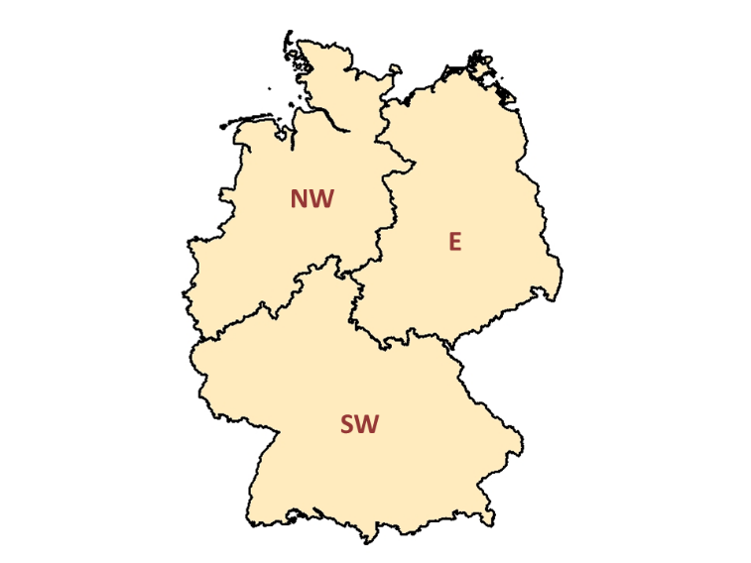
Figure S1. Germany divided into the three regions analysed (NW = northwest Germany, E = East Germany, SW = southwest Germany).

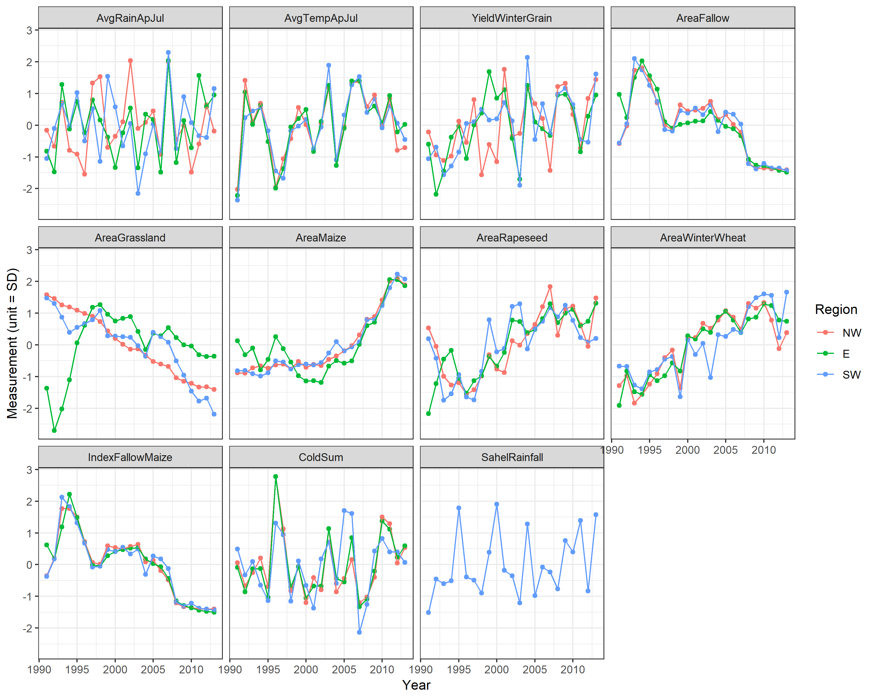
Figure S2. Values of land-use and weather variables 1991-2013 used as predictors in the modelling framework, for the three regions considered. All variables were made comparable by centring and scaling (z-transformation) and thereby converted to units of phenotypic standard deviations (SD) around the mean.

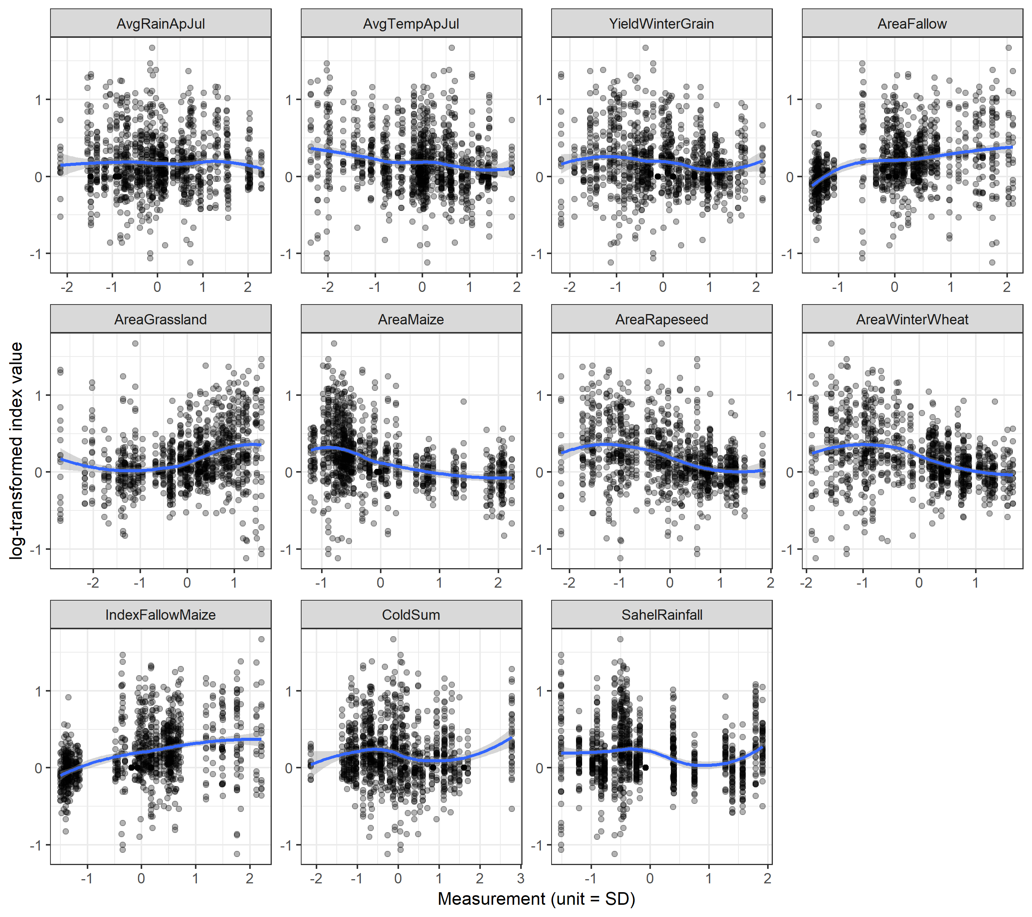
Figure S3. Relationship between log-transformed trend indices and explanatory variables for all farmland bird species in the analysis with time lag of 0 years. The blue line shows a loess smoother.

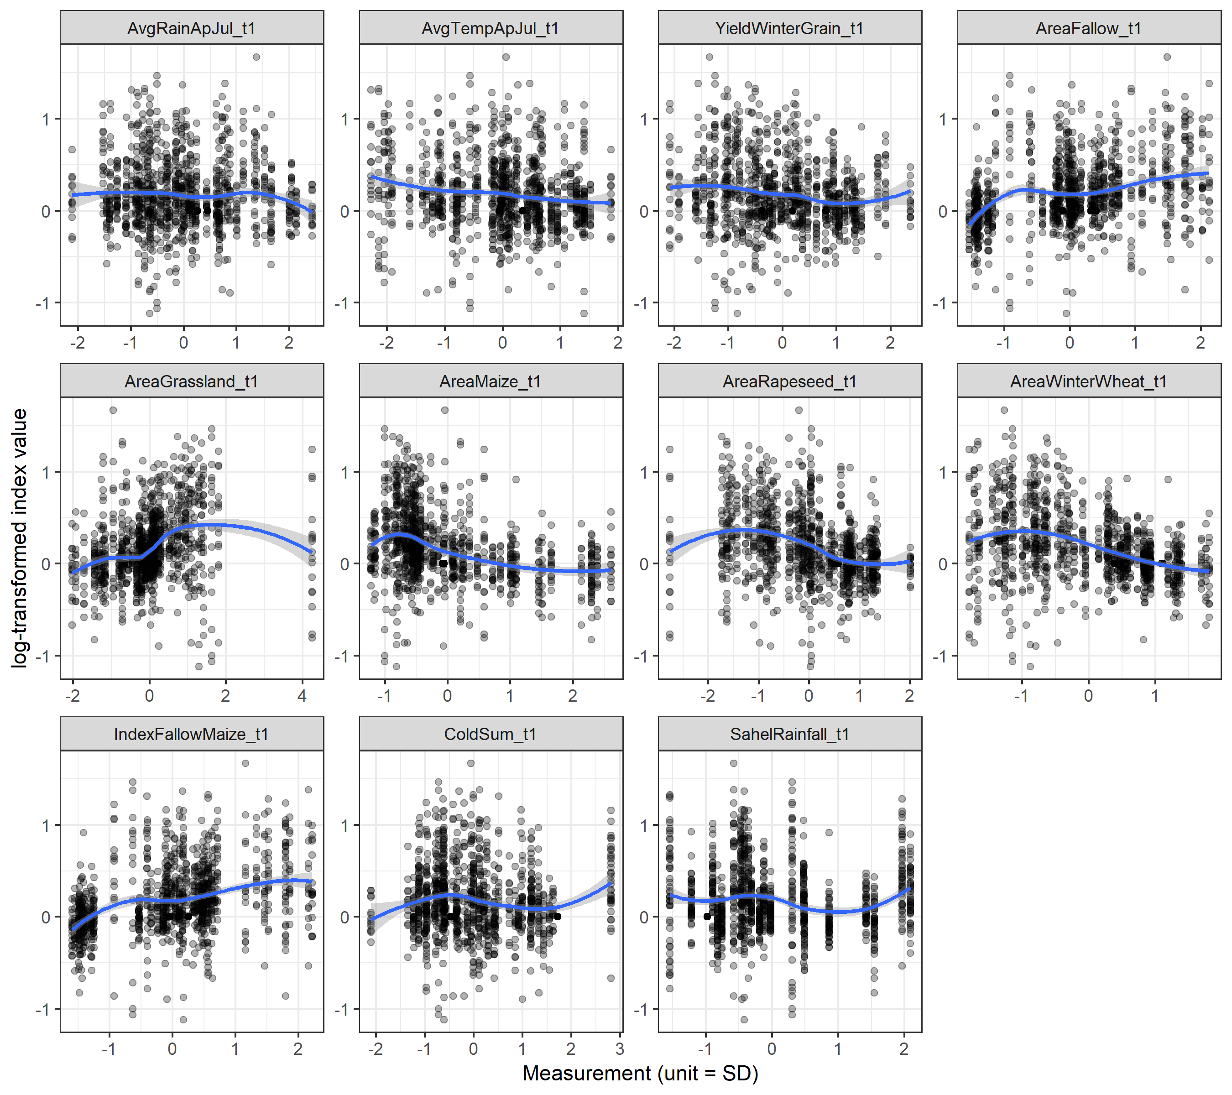
Figure S4. Relationship between log-transformed trend indices and explanatory variables for all farmland bird species in the analysis with time lag of 1 year. The blue line shows a loess smoother.

