Supplementary Material

Assessing the sustainability of harvest of the European Turtle-dove along the European western flyway

Hervé LORMEE, CHRISTOPHE BARBRAUD, WILL PEACH, CARLES CARBONERAS, jEAN DOMINIQUE LEBRETON, lARA mORENO-ZARATE, Leo bacon and Cyril ERAUD

Contents
Appendix S1. Life cycle of the turtle dove.
Appendix S2. The uncertainty of each demographic parameter.

Appendix S1. Life cycle of the turtle dove (left), based on two age classes (1 = 1st year, 2 = adults, F1 = fertility for 1st age class, F2 = fertility for 2nd age class, Sj = 1st year survival, Sa = adult survival) and (right) illustration of the Leslie-Usher matrix implemented, based on females during a post-breeding census and considering a sex ratio in clutches of 0.5.
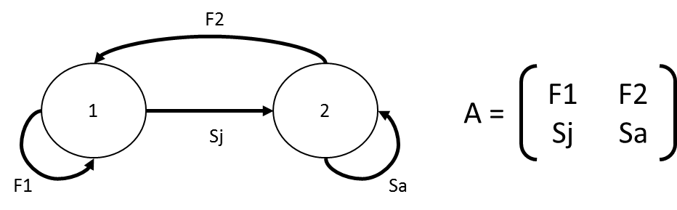

Table showing vital rates used in the two age-class Leslie matrix model to estimate the stable age distribution during the post-breeding period. Values were estimated following 10 000 random sampling within the distribution of each parameter. We integrated vital rates values from sampling specific probability distribution to consider uncertainty of estimates (for ongoing research works) and obtain eigenvalues and eigenvectors distributions. Because data available on 1st year survival rate in turtle dove suffer from large 95% confidence interval, we used as a proxy the more precise juvenile survival rate estimated in the mourning dove (Zenaida macroura), a well-studied dove species breeding and hunted in Northern America, which shows relatively similar vital rates than the turtle dove. The objective of the Leslie matrix modelling is to estimate the actual stable stage distribution of the population. Therefore, we implemented survival estimates considering all mortality causes (contrary to the DIM approach, which has to rely on survival parameters in absence of additive mortality). Median values of growth rate (λ) was 0.88 and median values of stable age distribution were 55.92% juveniles and 44.08% adults.

Vital rates | Notation | Values | type of value used | Probability distribution | References
1st year survival | Sj | [0.270;0.300] | Averaged minimal and maximal values | Uniform | Seamans 2018 (mourning dove)
Adult survival | Sa | 0.525  [0.381;0.665] | Mean ±, 95% confidence interval | Normal | Siriwardena et al. 2000a
Number of fledged chicks per nesting attempt | Nchicks | [0.82;0.86] | Averaged minimal and maximal | Uniform | ONCFS – 2019 (unpublished data)
Number of nesting attempts per season | Nattempts | m=3.150, σ = 0.370 | Mean and standard deviation | Normal | ONCFS – 2019 (unpublished data)
Productivity (number of fledged chick/pairs) | f | Nchicks×Nattempt
Fertility 1 | F1 | Sj×f×0.5×0.9
Fertility 2 | F2 | Sa×f×0.5

Appendix S2. The uncertainty of each demographic parameter.

The uncertainty of each demographic parameter (So, a, n, q, N) was modelled using a probability distribution corresponding to our current knowledge on the parameters. For So, we used a beta distribution to ensure the values were bounded between 0 and 1. Uncertainty estimates for survival probability of wild turtle dove populations were taken from Eraud et al. 2009 (average apparent adult survival rate in western France for the period 1998-2004: 0.51 ± 0.15 (SE)) with a variance of 0.0225, which are the most recent estimates available. Thus, So was modelled as ~beta(5.88,3.56) and ~beta(4.26,0.84) for low (0.623) and high (0.839) values of So respectively. The parameter values for these beta distributions beta (a,b) were obtained by resolving the mean and variance formulas for a beta distribution ($mean=\frac{a}{a+b}, variance=\frac{ab}{{\left(a+b\right)}^{2}(a+b+1)}$). For age at first breeding, we used for a uniform distribution (unif(1,1.2)) corresponding to the mean age at first breeding of 1.1 year and a range of age at first breeding from 1 to 2 years. For n, the coefficient of variation was only available for France. It was estimated for the 2013 annual hunting season at 0.26 based on a national survey conducted with hunters, thus corresponding to within year variation (Aubry et al. 2016). We therefore assumed a similar coefficient of variation for other countries and used a uniform distribution unif(1 143 612,3 018 000) corresponding to the hunting bag including the Italian component of the western European flyway. The upper and lower values of the uniform distribution were obtained by resolving the mean and variance formulas for a uniform distribution$(mean=\frac{1}{2}(a+b), variance=\frac{1}{12}{\left(b-a\right)}^{2})$. For q, the stable age distribution, we used a uniform distribution unif(0.391,0.491) corresponding to the estimates obtained from the matrix population model. The upper and lower values of the uniform distribution were obtained as for n. Finally, for N we used a uniform distribution unif(4 361 990,6 919 096) corresponding to the population size (adults and juveniles) including the Italian component of the Western European Flyway. Uncertainty distributions for each parameter were obtained using 1 000 000 iterations where independent values for each parameter were drawn randomly from their respective distributions.
The proportional contribution of the variance of each entry parameter θ(S, a, n, q, N) to the variance of the estimated parameters E(λ_{max}, P, SI) were estimated using the delta method (Seber 1982) as:
$C\left(θ/E\right)=\frac{V(θ)}{V(E)}{\left(\frac{∂E}{∂θ}\right)}^{2}$(5)
where V is the variance of each parameter. Partial derivatives were calculated from equations (1), (2), and (3).

