Supplementary Material

Physiological stress and behavioural responses of European Rollers and Eurasian Scops Owls to human disturbance differ in farming habitats in the south of Spain

MÓNICA EXPÓSITO-GRANADOS, DESEADA PAREJO, OLIVIER CHASTEL and JESÚS M. AVILÉS

Contents
Appendix S1. Prey availability
Table S1. Correlation matrix of variables used in the PCA.
Figure S1. Roller and Scops owl nest distribution across scores of PC1 and PC2.
Figure S2. Roller and Scops owl nest distribution across scores of PC1 and PC3.
References
Appendix S1. Prey availability
Prey availability was measured around all nests during the second fortnight of 2014, when roller and scops owl chicks were already born. For that purpose, we did linear transects of 50 m within an area with 100 m radius around each nest. During the sampling one researcher was walking slowly and recording all the prey spotted. Most detected prey by this method were orthopterans and hence we decided to focus on their abundance as an indicator of prey availability. Moreover, orthopterans are main prey of the two study species (Latková et al. 2012, Parejo et al. 2013). All measurements were done during the early morning or late afternoon.
We performed a Generalized Lineal Model (GENMOD procedure in SAS, Poisson distribution, link=log) to analyse whether orthopteran abundance varied in response to PCA components. We found that prey abundance was related to PC1 (χ₁² = 5.23, P = 0.002, Estimate = 0.10 ± 0.04, N= 21 nests) and PC2 (χ₁² = 107.37, P < 0.001, Estimate = 0.69 ± 0.07, N = 21 nests) so that prey were more abundant in areas with high farming activities and far from human infrastructures (i.e. PC1) and in areas with high scrublands cover (i.e. PC2).

Table S1. Correlation matrix of variables used in the PCA. Significant correlations between variables are shown in bold (p> 0.05).

 | Distance to road | Distance to highway | Distance to building | Urban surface | Bare surface | Riparian surface | Surface of herb crop | Surface of tree crop | Surface of pine plantation | Surface of scrublands | Altitude
Distance to road | 1.00 | 0.37 | 0.41 | -0.24 | -0.27 | -0.04 | 0.12 | -0.21 | -0.04 | 0.31 | -0.16
Distance to highway | 0.37 | 1.00 | 0.37 | -0.15 | -0.39 | -0.10 | 0.44 | -0.47 | -0.15 | 0.16 | 0.12
Distance to building | 0.41 | 0.37 | 1.00 | -0.32 | -0.04 | -0.10 | 0.11 | -0.22 | 0.02 | 0.22 | 0.15
Urban surface | -0.24 | -0.15 | -0.32 | 1.00 | 0.13 | 0.02 | -0.27 | 0.01 | 0.14 | -0.05 | -0.04
Bare surface | -0.27 | -0.39 | -0.04 | 0.13 | 1.00 | 0.04 | -0.33 | 0.27 | 0.08 | -0.11 | -0.03
Riparian surface | -0.04 | -0.10 | -0.10 | 0.02 | 0.04 | 1.00 | -0.05 | 0.07 | -0.17 | 0.19 | 0.10
Surface of herb crop | 0.12 | 0.44 | 0.11 | -0.27 | -0.33 | -0.05 | 1.00 | -0.58 | -0.60 | -0.23 | 0.09
Surface of tree crop | -0.21 | -0.47 | -0.22 | 0.01 | 0.27 | 0.07 | -0.58 | 1.00 | -0.15 | -0.05 | -0.18
Surface of pine plantation | -0.04 | -0.15 | 0.02 | 0.14 | 0.08 | -0.17 | -0.60 | -0.15 | 1.00 | -0.14 | 0.03
Surface of scrublands | 0.31 | 0.16 | 0.22 | -0.05 | -0.11 | 0.19 | -0.23 | -0.05 | -0.14 | 1.00 | 0.04
Altitude | -0.16 | 0.12 | 0.15 | -0.04 | -0.03 | 0.10 | 0.09 | -0.18 | 0.03 | 0.04 | 1.00

Figure S1. Roller and Scops owl nest distribution across scores of PC1 and PC2. Values in parentheses represent the explained variance for each PC component.
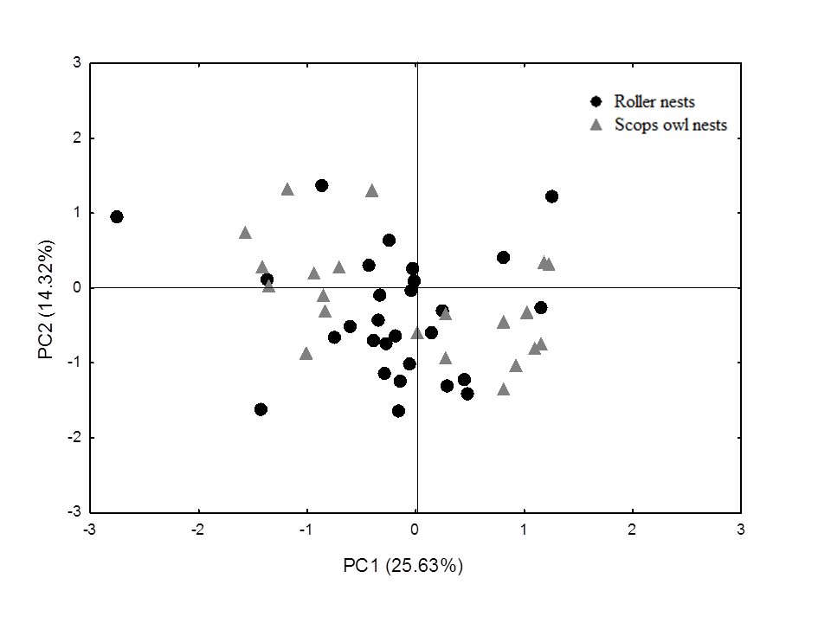

Figure S2. Roller and Scops owl nest distribution across scores of PC1 and PC3. Values in parentheses represent the explained variance for each PC component.

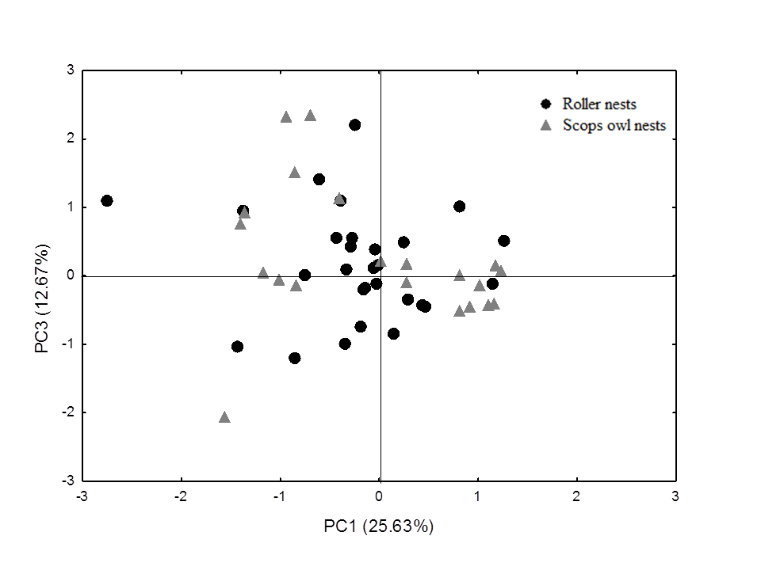

References
Latkovà, H., Sàndor, A.K. and Krištìn, A. (2012) Diet composition of the scops owl (Otus scops) in central Romania. Slovak Raptor J. 6:17–26.
Parejo D., Avilés J. M., Pena A., Sánchez L., Ruano F., Zamora-Muñoz C. and Martin-Vivaldi M. (2013) Armed Rollers: Does nestling's vomit function as a defence against predators? PlosONE 8: e68862

