Supplementary Material

Long-term declines in common breeding seabirds in Japan

MASAYUKI SENZAKI, AKIRA TERUI, NAOKI TOMITA, FUMIO SATO, YOSHIHIRO FUKUDA, YOSHIHIRO KATAOKA and YUTAKA WATANUKI

Contents
Figure S1. Raw counts of 10 focal species on each focal colony.
Table S1. Estimates of process error terms of the Bayesian state-space model.

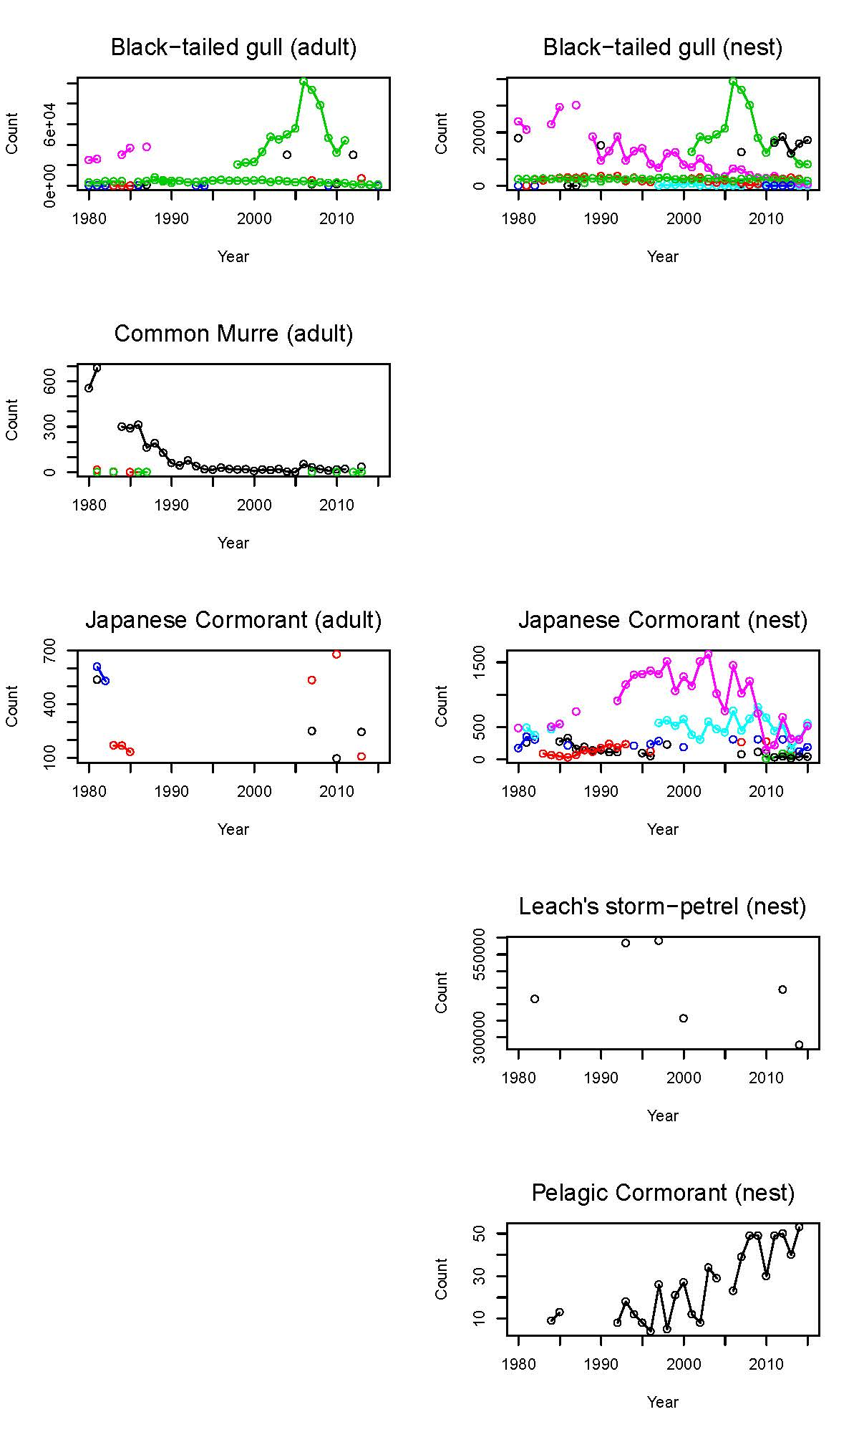

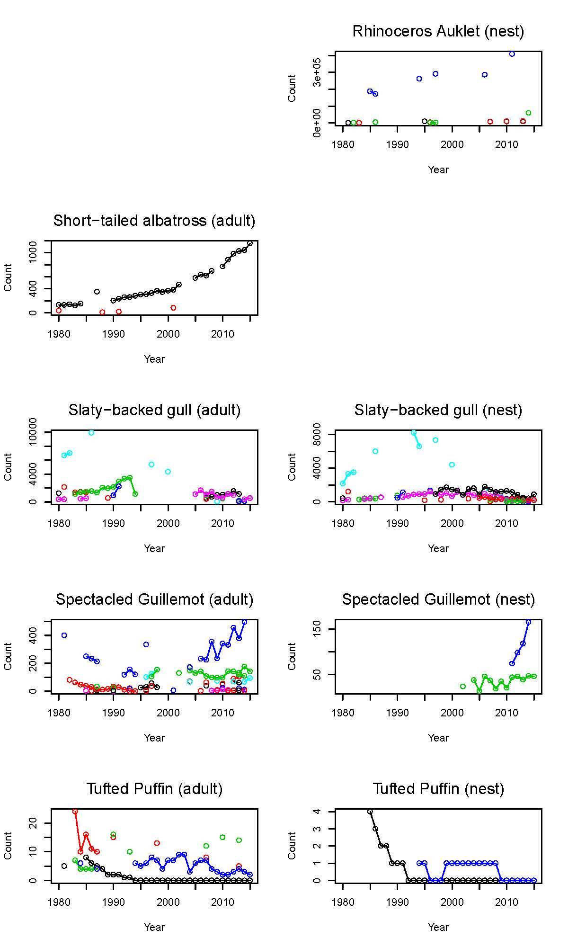
Figure S1. Raw counts of 10 focal species on each focal colony. Different colors indicate different colonies. The blanks indicate absence of the respective data (e.g. the nest counts in Common Murre).
Table S1. Estimates of process error terms of the Bayesian state-space model.

 |  | Estimate
 | Species | Median | 2.50% | 97.50%
Temporal variation in population growth rate, σ_{temp,j} | Black-tailed Gull | 0.21 | 0.12 | 0.37
 | Common Murre | 0.38 | 0.16 | 0.72
 | Japanese Cormorant | 0.10 | 0.01 | 0.24
 | Leach's Storm-petrel | 0.19 | 0.02 | 0.85
 | Pelagic Cormorant | 0.14 | 0.01 | 0.44
 | Rhinoceros Auklet | 0.25 | 0.01 | 0.79
 | Short-tailed Albatross | 0.10 | 0.00 | 0.37
 | Slaty-backed Gull | 0.23 | 0.13 | 0.42
 | Spectacled Guillemot | 0.24 | 0.04 | 0.45
 | Tufted Puffin | 0.17 | 0.01 | 0.47
Conversion coefficient, log B |  | 1.02 | 0.55 | 1.58
Observation error for nest count, σ_{nest} |  | 0.77 | 0.71 | 0.83
Observation error for adult count, σ_{adult} |  | 0.89 | 0.82 | 0.99
Among-species variation in conversion coefficient, σ_{b} |  | 0.34 | 0.02 | 1.16
Among-species variation in mean population growth rate, σ_{r} |  | 0.05 | 0.01 | 0.11
Among-colony variation in nest count, σ_{β} |  | 2.03 | 1.66 | 2.61

