Supplementary Material

Influence of historical and contemporary habitat changes on the population genetics of the endemic South African parrot Poicephalus robustus

WILLEM G. COETZER, COLLEEN T. DOWNS, MIKE R. PERRIN and SANDI WILLOWS-MUNRO
Contents

Figure S1. The STUCTURE analysis for the two main Eastern Cape (South) sample groups (Alice and King William’s Town).
Figure S2. The genetic structure analysis performed with TESS using the historical dataset.
Figure S3. The genetic structure analysis performed with TESS using the contemporary dataset.
Figure S4. Principle coordinates analysis (PCoA) of pairwise historical dataset F_{ST} values obtained from GenAlEx.
Figure S5. Principle coordinates analysis (PCoA) of pairwise contemporary dataset F_{ST} values obtained from GenAlEx.
Table S1. Sample information for all Poicephalus robustus specimens used in the current study.
Table S2. Prior settings used for the MSVAR analyses (init_v_file) in the current study.
Table S3. Per locus statistics performed in this study; over all samples, contemporary samples only and historic samples only.
Table S4. Mantel tests conducted using all samples, contemporary samples only and historic samples only. Three pairwise distance matrices were compared: genetic difference, geographic distance and difference in age of sample.
Table S5. Migration rate estimates (m) for Poicephalus robustus, obtained from BayesAss using the contemporary and historic datasets. The 95% confidence interval is provided in parentheses.

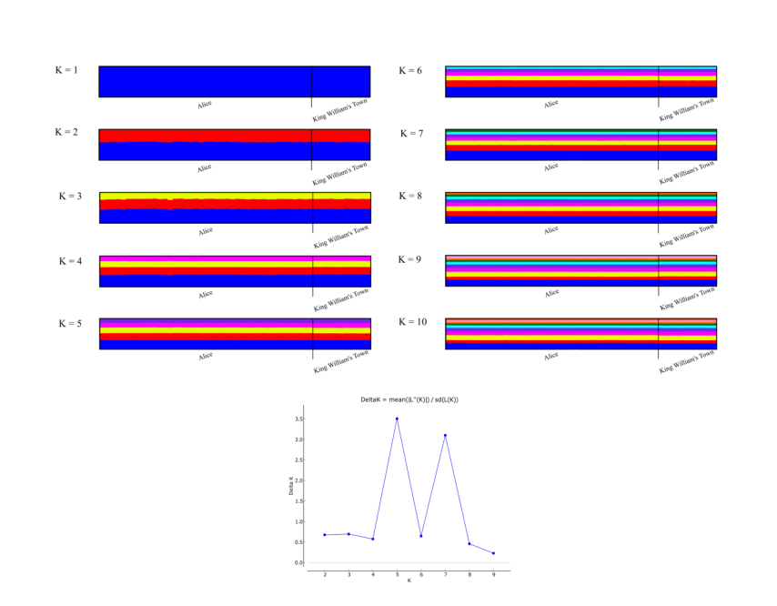

Figure S1. The STUCTURE analysis for the two main Eastern Cape (South) sample groups (Alice and King William’s Town) to assess the occurrence of possible genetic substructure within these groups. Although the deltaK values indicate that the most probable K is equal to 5 or 7, we do not observe any signs of substructuring at these values.

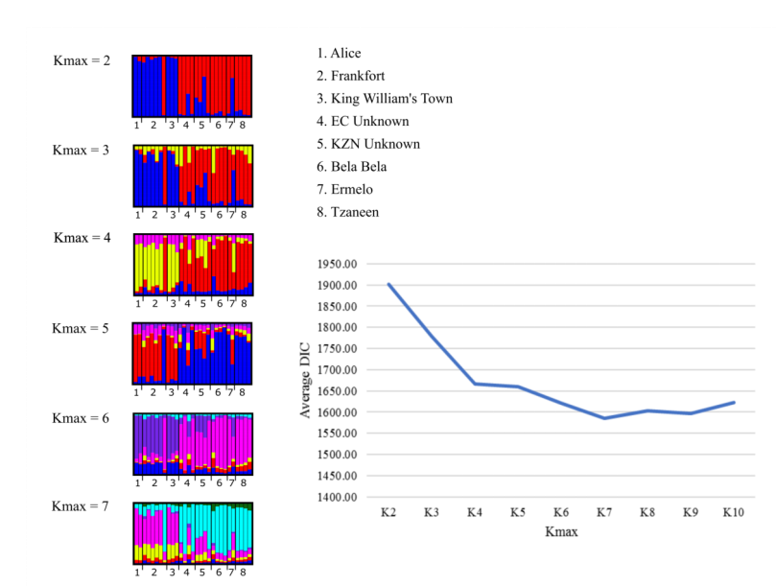
Figure S2. The genetic structure analysis performed with TESS using the historical dataset. Genetic structuring indicates two main genetic clusters with the southern populations separate from the remaining localities. Each vertical line in the represents an individual and is coloured according to every individual’s estimated membership coefficient values.

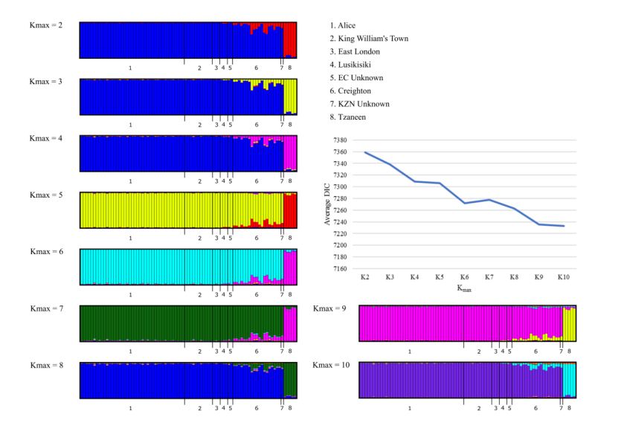
Figure S3. The genetic structure analysis performed with TESS using the contemporary dataset. Genetic structuring indicates two main genetic clusters with the northern group separate from the remaining localities. Some admixture is apparent for the central group. Each vertical line in the represents an individual and is colored according to every individual’s estimated membership coefficient values.

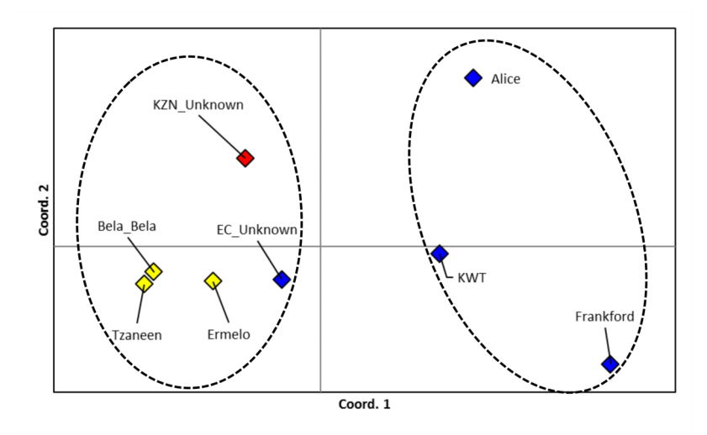
Figure S4. Principle coordinates analysis (PCoA) of pairwise historical dataset F_{ST} values obtained from GenAlEx. The diamond colors indicate the different sampling regions: blue – South, red – Central, yellow – North. The dashed ellipses resemble the genetic clusters observed for the historical STRUCTURE and TESS results.

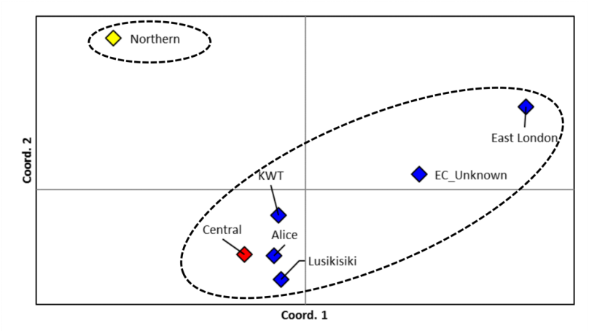
Figure S5. Principle coordinates analysis (PCoA) of pairwise contemporary dataset F_{ST} values obtained from GenAlEx. The diamond colours indicate the different sampling regions: blue – South, red – Central, yellow – North. The dashed ellipses resemble the genetic clusters observed for the contemporary TESS results.

