Supplementary Material

Survival and extinction of breeding landbirds on San Cristóbal, a highly degraded island in the Galápagos

MICHAEL DVORAK, BIRGIT FESSL, ERWIN NEMETH, DAVID ANCHUNDIA, JAVIER COTÍN, CHRISTIAN H. SCHULZE, WASHINGTON TAPIA and BEATE WENDELIN

Contents

Table S1. Results of interviews conducted in September 2016 and January 2018 in San Cristóbal.

Figure S1. Approximate position of the Least Vermilion Flycatcher sightings reported by interviewees with the corresponding year.

Table S1. Results of interviews conducted in September 2016 and January 2018 in San Cristóbal. Activity of the interviewee, approximate year of observation, site of observation and additional comments are given. The data are shown in chronological order starting with most recent sightings.
Interviewee | Approximate date of sighting | Place | Comment
Farmer 1 | January 2018 | Transition zone below the area "Socavon" /farm “Cafetal” | Has never seen the bird before in the farm area
Technicians INIAP | September 2016 | "Socavon" INIAP farm | Three technicians observed one bird on a fence
Retired farmer 1 | About two years ago  (2014) | On the ravine that split “El Chino” and “Cerro Verde” | There were many previously; but he seemed confused with years
Retired farmer 2 | About five years ago  (2011) | "El Progreso“ | There were many previously; but he seemed confused with years
Retired farmer 3 | About five years ago (2011) | "Soledad“ | Seemed confused with years
Park warden 1 reported sightings of a farmer | 2008 | "Las Goteras“ farm | Park warden reported this sighting. Farmer could not be contacted
Park warden 2 | 2008 or 2009 | Natural tortoise breeding area close to Punta Pitt.  0 42.974 S - 89 18.444 W | Some park wardens have doubts about this sighting as this park warden works on boats and rarely hikes inland
Park warden 3 | About eight years ago  (2008) | "El Suspiro“ - National Park border | In 1977 there were plenty, but they started to decline in the 80s and became rare in the 90s; last sightings in 2008.
Farmer 2 | About six to eight years ago, not sure of dates | Cannot remember where, but in the highlands | Not sure about dates
3rd person about farmer 3 | About eight years ago (2008) | "El Progreso“ cemetery | Farmer could not be contacted
Naturalist guide 1 | 2006 | "Las Goteras" | Seemed confused with years
3rd person about farmer 4 | 2006 | Highland zone – does not remember location; reported to have seen a female | Farmer could not be contacted
Park warden 4 | About ten years ago  (2006) | "Las Goteras“, National Park Area | In 1997 there were 4-5 individuals in this sector; interviewee lived there
Farmer 5 | About ten years ago  (2006) | "Montones"; direction to the coast, dry zone | Few in 1991, rare in 2001, the last he saw was in a very dry area
Retiree 1 | About ten years ago (2006) | “Soledad“ | Decline noted 40 years ago
Park warden 5 | 2001 | "Cerro Verde” - farm 0 53.235 S - 89 26.318 W | Has seen few in his life
Resident "Cerro Verde" 1 | About 15 years ago (2001) | “Cerro Verde” – road | Was common 30 years ago
Farmer 6; he was park warden till 2007 | 15 to 20 years ago  (1996-2001) | “San Joaquin”, “Cerro Soledad”, “El suspiro” | Not sure about dates
Resident "Cerro Verde" 2 | 1998 | “Cerro Verde” area
Retired farmer 4 | 1996 | “Cerro Mundo”, “Soledad”, “Las Negritas” | Before there were many, also in the village
Park warden 6 | 1995 | “El Chino” - farm; there was a pair present | Rare
Park warden 7 | 1992 | “Ballena”, “Las Negritas”, “Tres Palos”, “Leon” | Works in different sectors of San Cristóbal, but has not seen the bird since 1992
Naturalist guide 2 | 1986 | “Cerro Gato” | Moved to San Cristóbal in the 80s and has seen only one bird
Retiree 2 and 3 | About 30 years ago  (1986) | “Negrita”, “El suspiro”, “Cerro Verde” | Has the impression that Galapagos flycatchers and yellow warblers are declining
Retired farmer 5 | Before the big El Niňo in 1982-83 | Widespread | Sharp decline after the El Niňo 1982-83
Retired farmer 6 | About 40 years ago (1976) | “Soledad”, “Ochoa” - dry and coastal zone | Was in this area often until the year 2000 and has not seen this bird there since 1976
Manager of “Jatun Sacha”, Cerro Verde area | Never seen
A young person, age ca. 18-years-old | Never seen |  | “This bird does not exist in San Cristóbal anymore”
Two high-school  teachers, age ca 50-years-old | Never seen |  | Never heard of this bird
Three local taxi drivers, age 20-40 | Never seen |  | Never heard about this bird
Two local ABG technician of the biosecurity agency (ABG; age 25-35 | Never seen |  | Never heard about this bird
Three young people, age 15-25 | Never seen |  | Never heard about this bird
15 high school students, age 14-15 | Never seen |  | Never heard about this bird
.

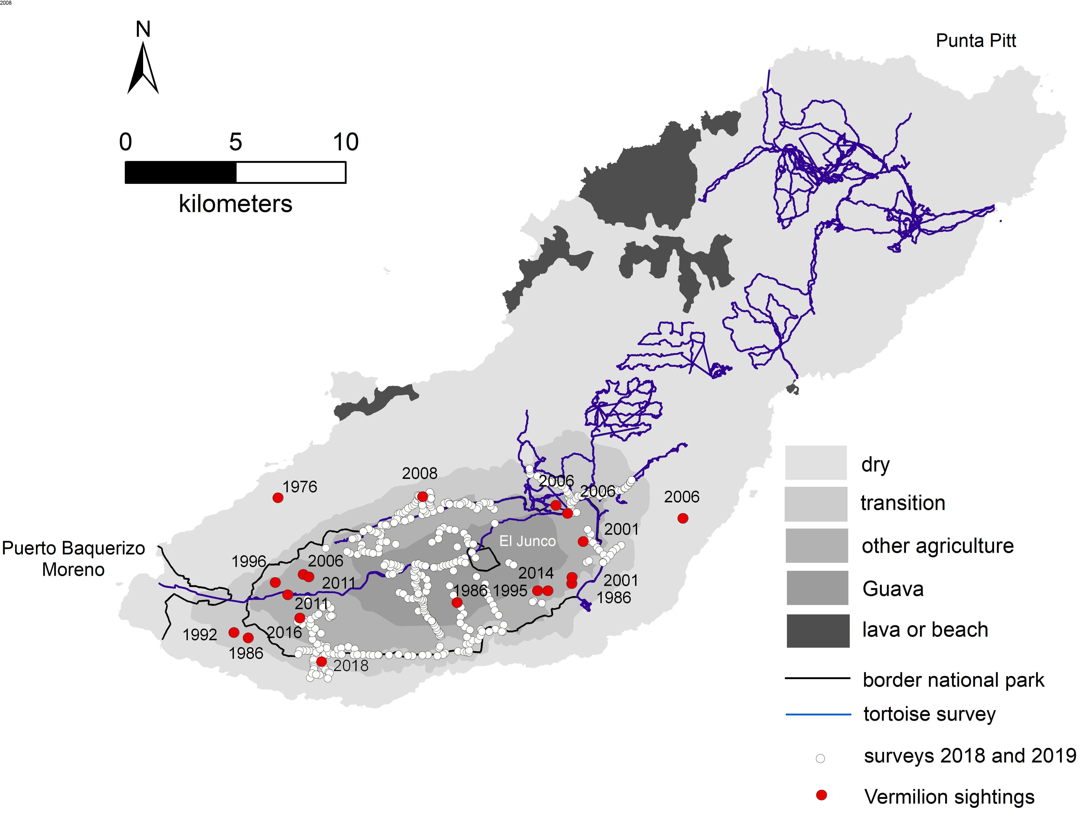

Figure S1. Approximate position of the Least Vermilion Flycatcher sightings reported by interviewees with the corresponding year; only reliable sightings are plotted to the map. In blue, the tracks of the giant tortoise survey team from November 2016, with zero observations of Vermilion Flycatchers. Points in white are where playback was broadcast during January 2018 and 2019. Compare with regular point counts from 2015 and 2017.

