Supplementary Material

An assessment of the Tagula Honeyeater Microptilotis vicina, a Data Deficient bird species in a Melanesian endemic hotspot

WILLIAM GOULDING, PATRICK MOSS and CLIVE MCALPINE

Contents

Figure S1. A graph showing the time of day when the location data were collected for individual honeyeaters.

Figure S2. Variograms of the Tagula Honeyeater movement data.

Figure S3. The dimensions of bird home range estimates using the R package CTMM (Calabrese and Fleming 2016).

Table S1. Results of two sample t-tests comparing morphometrics of male Tagula Honeyeaters M. vicina from Junet Island.

Figure S1. A graph showing the time of day when the location data were collected for individual honeyeaters. At the time of data collection sunrise was at 05h30 and sunset was at 18h10. Data were numerically spread on the y-axis in the order of collection (for each individual) to aid in presentation.
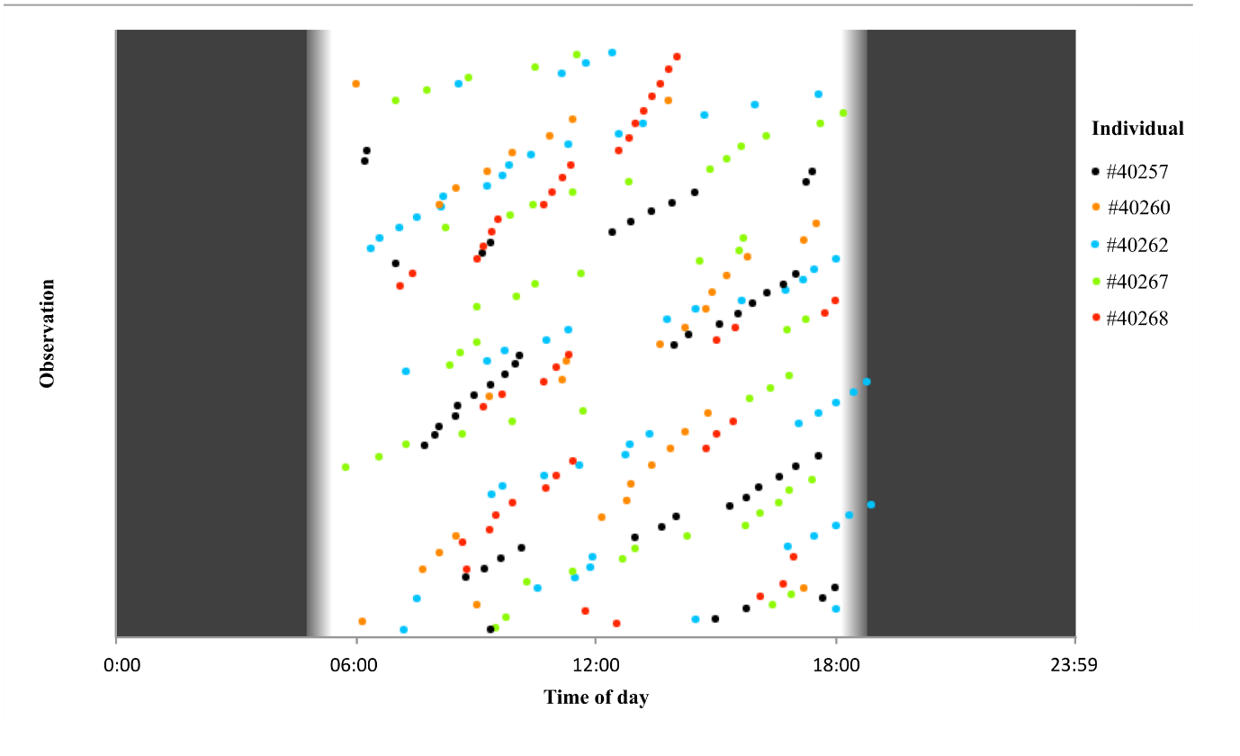

Figure S2. Variograms of the Tagula Honeyeater movement data. The fit of the chosen home range estimation models are shown in green. Short time lags are shown on the left and medium to long time lags on the right. Poor model selection fit (IID) at the short time lags was evident from individual #40267. Model OU was subsequently selected for this individual.
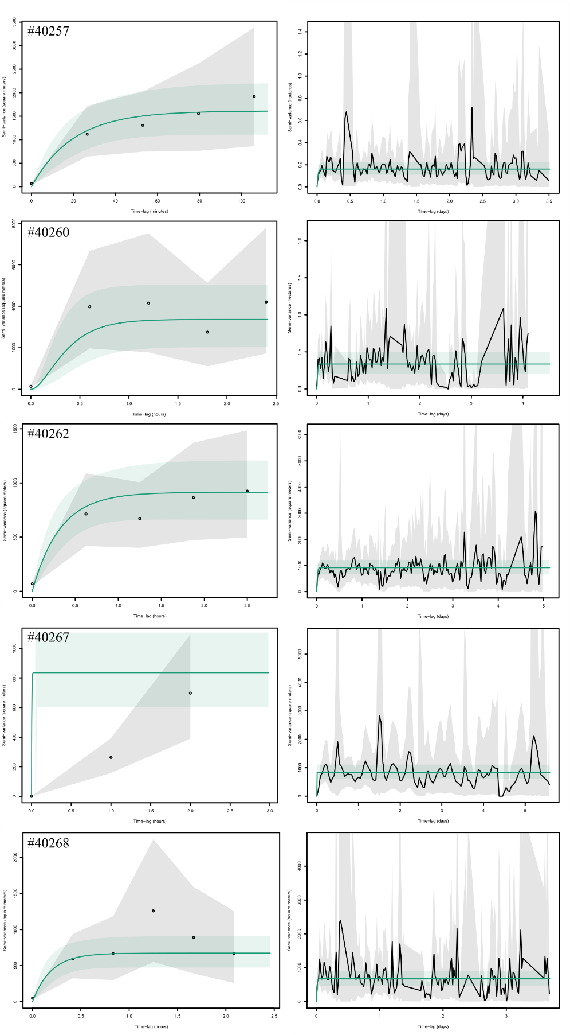
Figure S3. The dimensions of bird home range estimates using the R package CTMM (Calabrese and Fleming 2016). The 95% home range estimate (black contour) with 95% confidence intervals are shown (grey contours). Blue shading indicates the predicted density function. The 95% home range area estimates (ha) follow below each panel with low, medium and high confidence intervals (CI). Home range estimates were derived using: a) Male #40257 using AKDE with model OU; b) Female #40260 using AKDE with model OUF; c) Suspected female #40262 using an AKDE with model OU; d) Male #40267 using an AKDE with model OU; and e) Female #40268 using an AKDE with model OU.
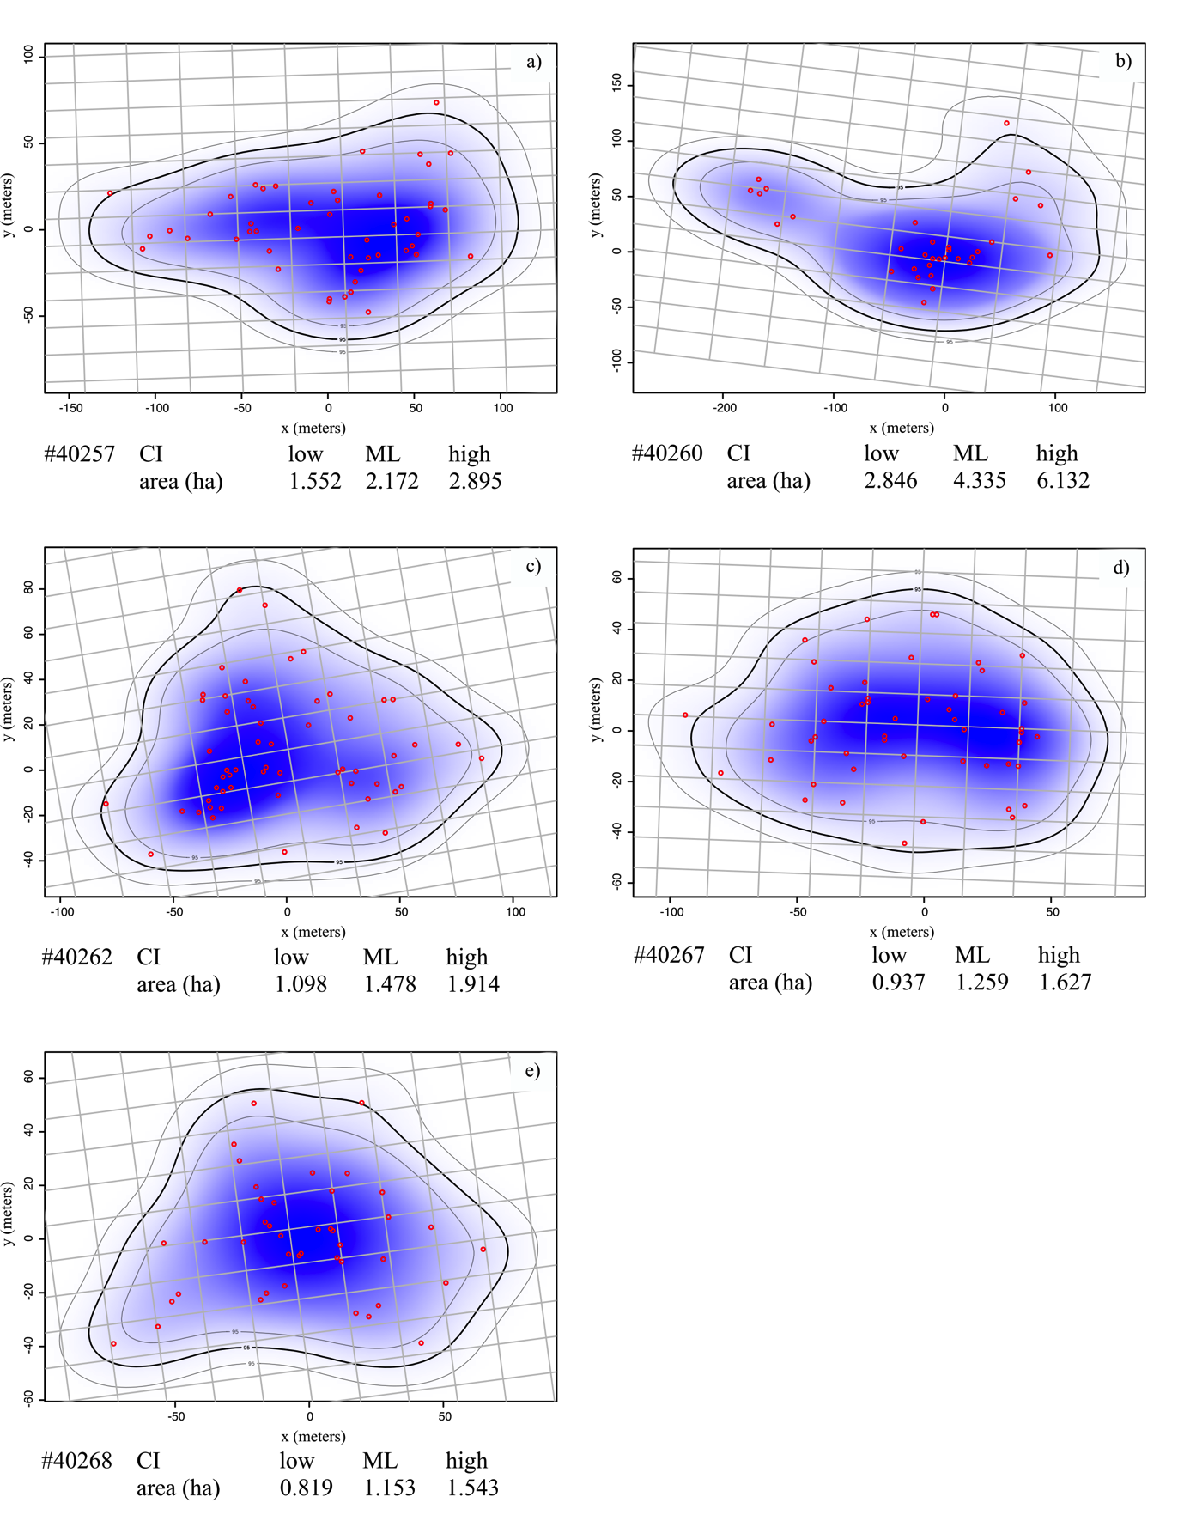
Table S1. Results of two sample t-tests comparing morphometrics of male Tagula Honeyeaters M. vicina from Junet Island (n = 10) and Sudest Island (n = 12). Significance is set at P = 0.05.

Measure | t-value | df | p
Weight | 0.916 | 18.46 | 0.37
Head + bill | 1.207 | 19.44 | 0.24
Wing chord | 0.080 | 18.23 | 0.94
Tarsus | 1.148 | 16.03 | 0.27
Tail | 0.304 | 13.85 | 0.77
Bill to skull | 1.540 | 19.95 | 0.14
Bill width | 0.893 | 17.08 | 0.38
Bill depth | 1.888 | 19.98 | 0.07

