Supplementary Material

Modeling the distribution of Nonggang Babbler Stachyris nonggangensis, a threatened bird of limestone karst forests of the Sino-Vietnam border, and implications for its conservation

DEMENG JIANG, EBEN GOODALE, GANG YANG, LIJIANG YU, AIWU JIANG, and XU LUO

Contents

Chinese abstract

Supplemental Results for Modeling Effort with 41 Occurrence Points

Figure S1. A demonstration of the necessity of eliminating forest with < 40% cover.

Figure S2. The model result for the extent of suitable habitat of NB, when using 41 occurrence datapoints, in contrast to the 33 used in the models in the main text.

Chinese abstract

详细的地理分布信息是物种保护的基础。弄岗穗鹛是一种新近发现的珍稀鸟种，仅分布于中越边境的石灰岩地区。由于弄岗穗鹛分布狭窄，已经被IUCN列为易危种。本研究使用了33个分布点数据和9个环境变量预测了弄岗穗鹛的适宜地分布。模型结果表明其最适宜，次适宜及低适宜的栖息地面积分别为541 km²，3218 km² 及 722 km²。其中有越南境内占25.8 %，其余则分布于广西西南部（特别是龙州县北部和大新县的南部）。然而，仅12.4 %生境面积有弄岗穗鹛实际分布， 且自然保护区以外的适宜栖息地退化或破碎化较为严重。包括在野外核查时新发现的分布点，弄岗穗鹛整个分布点被隔离在4个区域之内。因此，我们建议将弄岗穗鹛定为濒危物种，并列入中国及越南动物红皮书。
关键词：鸟类保护，中国鸟类，石灰岩特有种，弄岗穗鹛，最大熵

Supplemental Results for Modeling Effort with 41 Occurrence Points

The entire suitable habitat estimated by this modeling for NB was 4934 km² in extent, the majority of which was in southwest of Guangxi Zhuang Autonomous Region, China (74.7%), with the rest in northeast Vietnam (Figure S2). The highly suitable habitat for NB (dark green in Figure S2) was 561 km², with 14.5% in Vietnam. Habitat with the intermediate level of suitability (light green in Figure S2) was in total area 2477 km², 26.5% of which was in Vietnam. Habitat with a low level of suitability (grey in Figure S2) covered 1896 km², with 26.9% of the habitat located in Vietnam. If one goes with these model results, 11.2% of the suitable habitat is known to be occupied. Further, 27.6% of the suitable habitat is in a protected reserve. In conclusion, these results are quite close to the modeling with 33 occurrence points, and the modeling seems robust to the small sample size.

Figure S1. A demonstration of the necessity of eliminating forest with < 40% cover. The limestone karst region consists of small karst mountains through which narrow ribbon-like protrusions of valleys run. The models have trouble recognizing these protrusions (“Before”, top right panel), due to the low resolution. However, after elimination of forest with less than 40% cover, the model is able to restrict the suitable area more efficiently to the karsts themselves and not the valleys (“After”, bottom right panel).

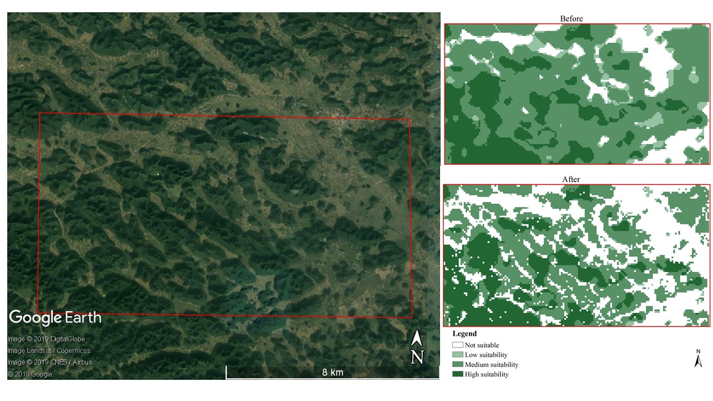

Figure S2. The model result for the extent of suitable habitat of NB, when using 41 occurrence datapoints, in contrast to the 33 used in the models in the main text. Details similar to Figure 1 of the main text.