Supplementary Material

Use of winter habitat at an early age: spatial ecology and association with human activities of juvenile Olrog’s Gull Larus atlanticus

MARÍA TERESA RAVASI, JUAN PABLO SECO PON, JESICA PAZ, MARCO FAVERO and SOFÍA COPELLO
Contents
Table S1. Summary of tracking juveniles Olrog´s Gull.
Figure S1. Sampling areas for Neohelice granulata and Cyrtograpsus angulatus.

Table S1: Summary of tracking juveniles Olrog´s Gull.

Year | Plastic band number | Sex | Number of locations | Number of resampled locations
2013 | 002 | ND | 1 | -
 | 003 | Male | 43 | 141
 | 004 | Male | 22 | 151
 | 005 | Male | 12 | 74
 | 006 | Female | 0 | -
 | 007 | Female | 91 | 388
 | 008 | Female | 81 | 272
 | 009 | Female | 49 | 219
2014 | 011 | Female | 53 | 121
 | 012 | Male | 247 | 100
 | 013 | Male | 104 | 208
 | 014 | Female | 162 | 2414
 | 015 | Female | 20 | 143
 | 016 | Female | 18 | 33
 | 017 | Female | 67 | 602
 | 020 | Male | 0 | -
 | 021 | Male | 3 | -
 | 022 | Male | 0 | -
 | 024 | Male | 20 | 98
 | 025 | Male | 21 | 58
 | 026 | Female | 64 | 159
 | 037 | Male | 10 | 54

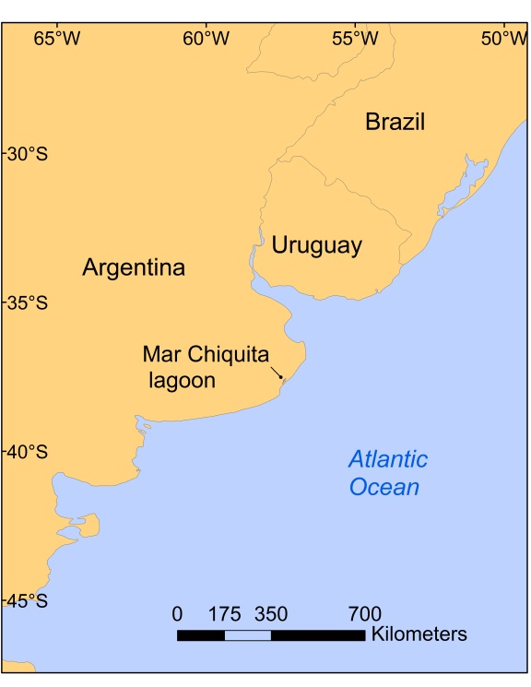
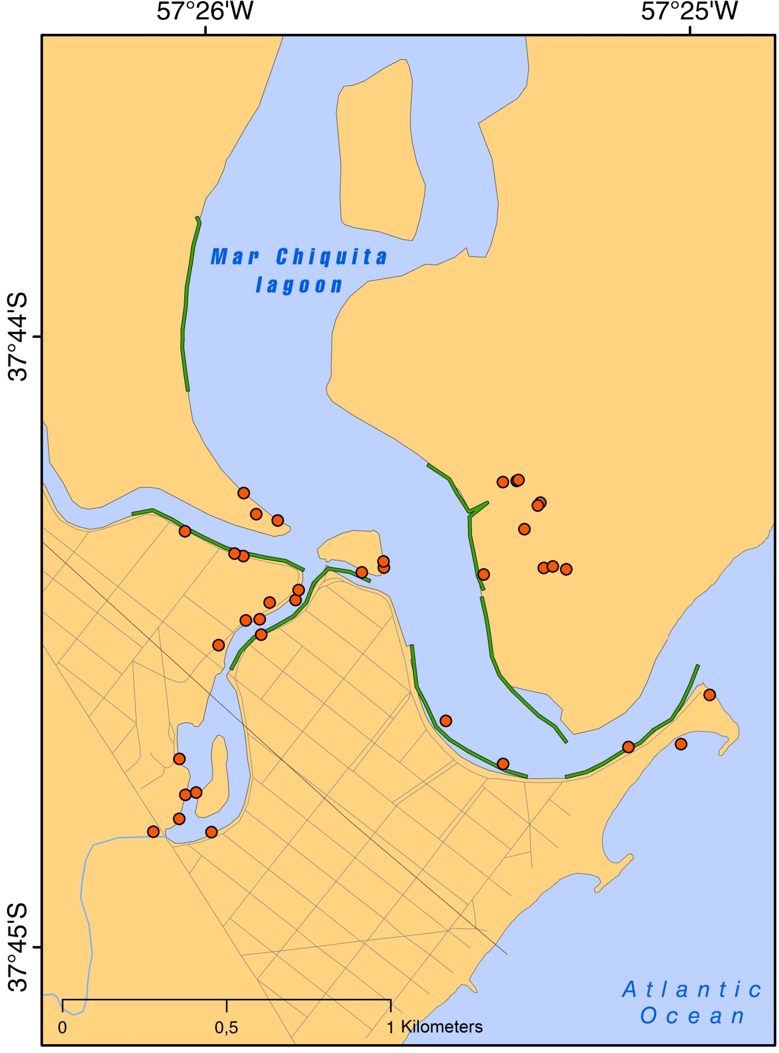
Figure S1. Sampling areas for Neohelice granulata (red dots) and Cyrtograpsus angulatus (green lines). Inset: location of the study area.

