# Supplementary Material

Vultures attacking livestock: a problem of vulture behavioural change or farmers’ perception?

OLIVIER DURIEZ, SANDRINE DESCAVES, REGIS GALLAIS, RAPHAËL NEOUZE, JULIE FLUHR and FREDERIC DECANTE

**Contents**

## Appendix S1. Map of the study area

## Appendix S2. Information letter

## Appendix S3. Mass of carrion available

## Appendix S4. Documents available to farmers

## Appendix S5. Species composition and age of livestock

## Appendix S1: Map of the study area

Map of the study area, showing the centre of vulture colonies (red star indicating the reintroduction aviaries), the network of c.100 supplementary feeding stations (SFS) available in 2014 (black squares), the area of carcasses collection in farms by vulture rangers, and the contours of the protected areas (Cevennes National Park and Natural Regional Parks).

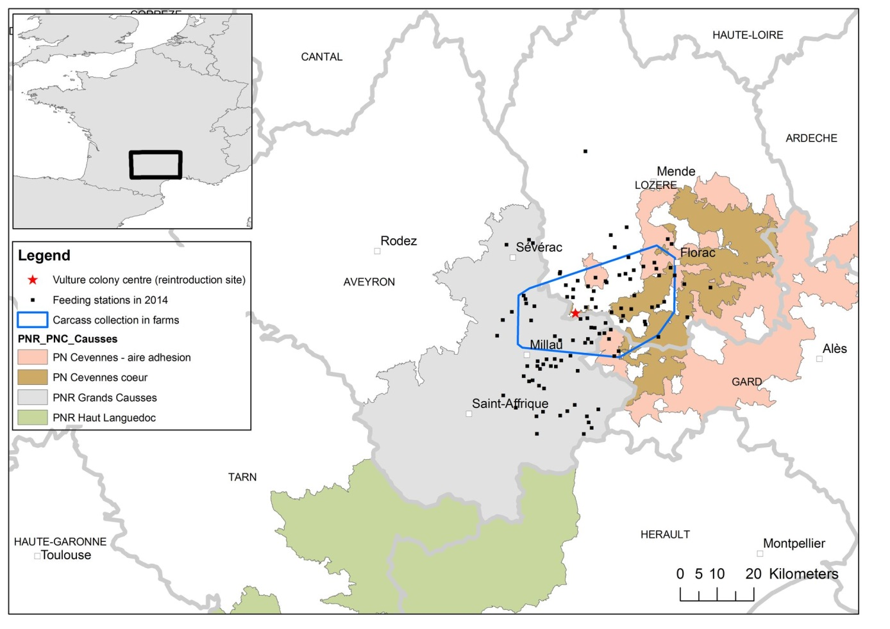

## Appendix S2: Information letter

Information letter sent in June 2011 to all farmers in the Parc National des Cevennes and Parc Naturel des Grands Causses about the procedure to follow when they suspect an interaction with vultures.

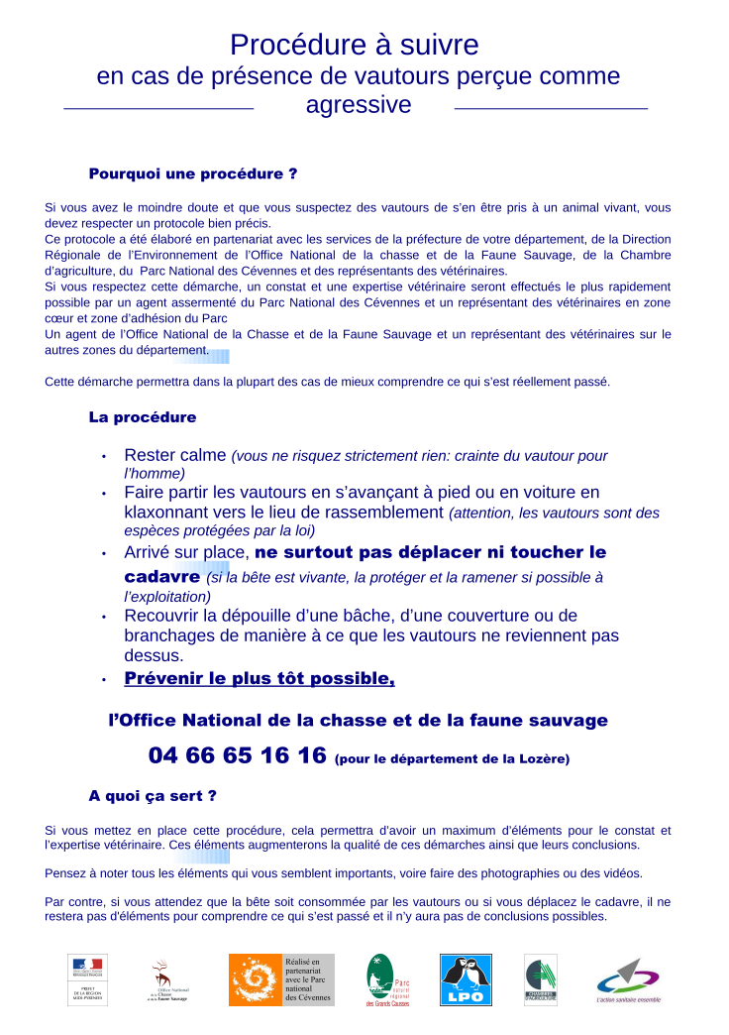

Partial translation:

**Procedure to follow in case of presence of vultures perceived as aggressive**

Why a procedure?

If you have a doubt and if you suspect vultures to have attacked a live animal, you should follow a precise protocol. This protocol has been developed in collaboration with the services of the prefecture, the national hunting and wildlife services, the agricultural services, the Cevennes National Park and veterinarians. If you respect this procedure, a report and a veterinarian assessment will be conducted by a park ranger, or wildlife officer and a veterinarian. This procedure will allow in most cases to understand what really happened.

The protocol

* Stay calm (you risk nothing, as vultures are afraid of humans)
* Make vultures go away by approaching them on foot or by car by honking towards vultures (beware that vultures are protected species by law)
* Once on site, do not move or touch the carcass (if the animal is alive, protect it and bring it back to the farm)
* Cover the carcass with a blanket, a sheet or branches to prevent vultures coming back.
* Call the Hunting and Wildlife Service (Office national de la Chasse et de la Faune Sauvage) as soon as possible

To what purpose?

If you follow this procedure, it will allow collection of a maximum of elements for the report and the vet assessment. These elements will increase the quality of the procedure and their conclusion.

Think about recording or noting all elements that seem important for you, including photographs and videos.

Conversely, if you wait that the animal is consumed by vultures, or if you move the carcass, no elements will be left to understand what happened and there will be no conclusion possible

## Appendix S3: Mass of carrion available

Annual mass of carrion deposited at feeding stations in the Grands Causses (Lozère and Aveyron) between 2010 and 2014 (data from 2007–2009 are not available; data from Vulture-Livestock interaction committee, Prefecture de Lozère, March 2018).



## Appendix S4: Documents available to farmers

Sample of document distributed to farmers who want to install a supplementary feeding station by park rangers and administrative authorities. More documents can be found at http://rapaces.lpo.fr/grands-causses/ressources-et-liens

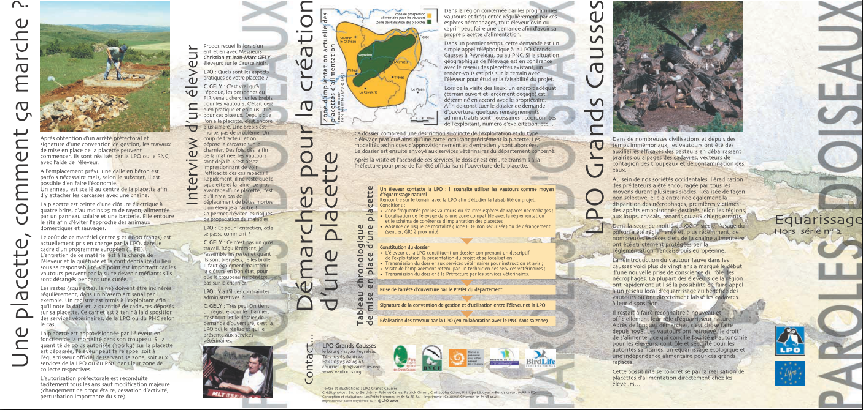

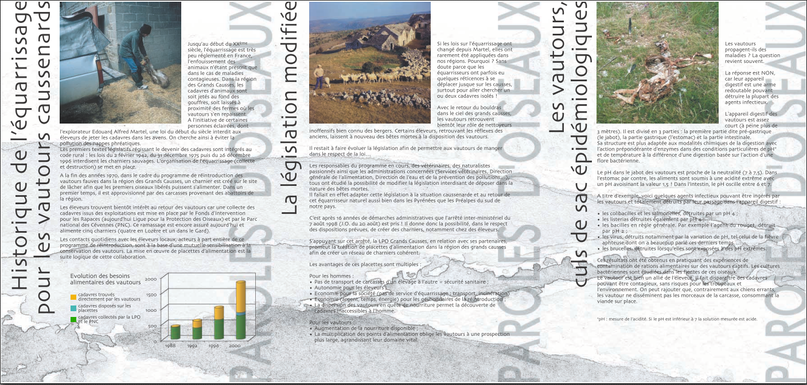

## Appendix S5: Species composition and age of livestock

Species composition and age of livestock (ovine, bovine, equine) concerned by vulture interactions (*n* = 156 reports).

