Supplementary Material

Preliminary survival and movement data for a declining population of Flesh-footed Shearwater Ardenna carneipes in Western Australia provides insights into marine threats

JENNIFER L. LAVERS, SIMEON LISOVSKI and ALEXANDER L. BOND

Contents
Figure S1. Map of Shelter (Muttonbird) Island in Torbay, Western Australia.

Table S1. Models to estimate apparent annual survival (ϕ) and encounter probability (p) of Flesh-footed Shearwaters ranked by quasi-Akaike Information Criteria adjusted for small sample size (QAIC_{c}).

Table S2. Published estimates of apparent annual adult survival (ϕ) from Flesh-footed Shearwaters, and other shearwater species.

References

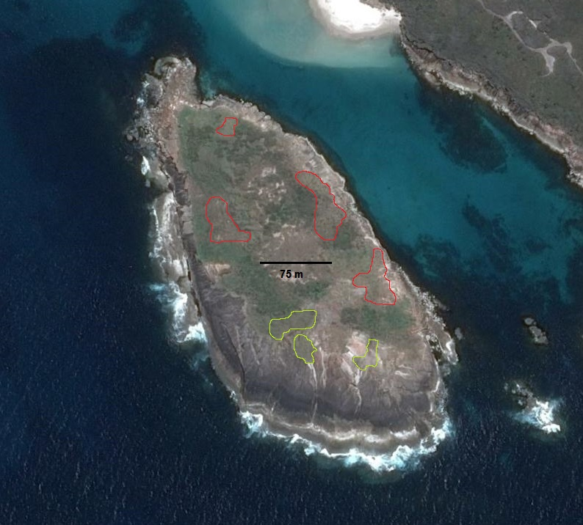
Figure S1. Map of Shelter (Muttonbird) Island in Torbay, Western Australia. The approximate boundaries of the three Flesh-footed Shearwater sub-colonies monitored during 2011-2015 (using capture-mark-recapture) are shown in yellow. Additional sub-colonies (no monitoring) are shown in red.

Table S1. Models to estimate apparent annual survival (ϕ) and encounter probability (p) of Flesh-footed Shearwaters ranked by quasi-Akaike Information Criteria adjusted for small sample size (QAIC_{c}). K: number of parameters, ΔQAIC_{c}: difference in QAICc from the top-ranked model; w_{i}: Akaike weight. Models include time-varying (t) and constant (.) parameters.
Model | K | QAIC_{c} | ΔQAIC_{c} | w_{i} | Likelihood | Deviance
ϕ(t) p(.) | 6 | 223.76 | 0.00 | 0.46 | 1.00 | 19.314
ϕ(.) p(t) | 6 | 224.92 | 1.16 | 0.26 | 0.56 | 18.286
ϕ(.) p(.) | 3 | 225.17 | 1.40 | 0.23 | 0.50 | 24.969
ϕ(t) p(t) | 9 | 228.15 | 4.39 | 0.05 | 0.11 | 17.032

Table S2. Published estimates of apparent annual adult survival (ϕ) from Flesh-footed Shearwaters, and other shearwater species.
Species | Location | ϕ ± $\hat{\text{SE}}$ | Reference
Flesh-footed Shearwater A. c. carneipes | Western Australia | 0.634 ± 0.130 to 0.835 ± 0.164 | This study
Flesh-footed Shearwater A. c. hullianus | New Zealand | 0.756 ± 0.027 to 0.940 ± 0.087 | Waugh and Taylor (2012); Barbraud et al. (2014)
Short-tailed Shearwater Ardenna tenuirostris | Tasmania | 0.878 ± 0.021 | Bradley et al. (1989)
Sooty Shearwater Ardenna griseus | New Zealand | 0.917 to 0.966 | Clucas et al. (2008)
Balearic Shearwater Puffinus mauritanicus | Balearic Islands | 0.780 ± 0.020 | Oro et al. (2004)
Manx Shearwater Puffinus puffinus | Wales | 0.861 ± 0.103 | Brown et al. (2004)
Hutton's Shearwater Puffinus huttoni | New Zealand | 0.931 ± 0.013 | Cuthbert and Davis (2002)
Christmas Shearwater Puffinus nativitatis | Hawaii | 0.864 ± 0.034 | VanderWerf et al. (2015)
Cory’s Shearwater Calonectris diomedea | Italy | 0.85 ± 0.02 to 0.92 ± 0.02 | Boano et al. (2010)
Cory’s Shearwater Calonectris diomedea | Selvagem Grande | 0.914 ± 0.022 | Ramos et al. (2012)

References
Barbraud, C., Booth, A., Taylor, G. A. and Waugh, S. M. (2014) Survivorship in Flesh-footed Shearwater Puffinus carneipes at two sites in northen New Zealand. Mar. Ornithol. 42: 91-97.
Boano, G., Brichetti, P. and Foschi, U. F. (2010) ‘La Niña’-driven Atlantic storms affect winter survival of Mediterranean Cory's Shearwaters. Ital. J. Zool. 77: 460-468.
Bradley, J. S., Wooller, R. D., Skira, I. J. and Serventy, D. L. (1989) Age-dependent survival of breeding Short-tailed Shearwaters Puffinus tenuirostris. J. Anim. Ecol. 58: 175-188.
Brown, J. G., Boyle, D., Duffield, S., Dunstan, A., Easton, J. and Smith, S. (2004) Seabird monitoring on Skomer Island in 1999-2002. Aberdeen.
Clucas, R. J., Fletcher, D. J. and Moller, H. (2008) Estimates of adult survival rate for three colonies of Sooty Shearwater (Puffinus griseus) in New Zealand. Emu 108: 237-250.
Cuthbert, R. and Davis, L. S. (2002) Adult survival and productivity of Hutton's Shearwaters. Ibis 144: 423-432.
Oro, D., Agular, J. S., Iguala, J. M. and Louzao, M. (2004) Modelling demography and extinction risk in the endangered Balearic Shearwater. Biol. Cons. 116: 93-102.
Ramos, R., Granadeiro, J. P., Nevoux, M., Mougin, J. L., Dias, M. P. and Catry, P. (2012) Combined spatio-temporal impacts of climate and longline fisheries on the survival of a trans-equatorial marine migrant. PLoS One 7: e40822.
VanderWerf, E. A., Smith, D. G., Vanderlip, C., Marie, A., Saunter, M., Parrish, J. and Worcester, N. (2015) Status and demographic rates of the Christmas Shearwater Puffinus nativitatis on Kure Atoll. Mar. Ornithol. 43: 199-205.
Waugh, S. M. and Taylor, G. (2012) Annual Report on Project POP2011-02 Flesh-footed Shearwaters - population study trial and at-sea distribution. Wellington:Te Papa Museum.

