Supplementary Material

Habitat selection of an endangered European farmland bird, the Ortolan Bunting Emberiza hortulana, in two contrasting landscapes: implications for management

MARTIN ŠÁLEK, VÍT ZEMAN and RADOVAN VÁCLAV

Contents
Appendix S1. Classification of terrain ruggedness at the territory scale.
Appendix S2. Median habitat attributes of occupied and unoccupied habitat patches by Ortolan bunting Emberiza hortulana in (A, B) the farmland and (C, D) the post-mining landscapes at the (A, C) territory and the (B, D) foraging spatial scales.
Appendix S3. Typical habitat of Ortolan Bunting Emberiza hortulana in post-mining landscape.

Appendix S1.

Table S1. Classification of terrain ruggedness at the territory scale (100m radius) based on mean slope and its variability.
 | Slope
Slope category | Mean | Range | SD
1 | 8.60 | 29.76 | 6.78
2 | 8.06 | 28.84 | 6.29
3 | 5.44 | 24.69 | 4.34
4 | 3.42 | 14.41 | 1.92
5 | 0.93 | 2.47 | 0.39
6 | 7.06 | 62.07 | 11.28

Figure S1. Frequency histogram of slope ranges (in degrees) within six slope categories describing the level of terrain ruggedness in terms of mean slope and its variability.

Appendix S2.
Figure S2. Median habitat attributes of occupied and unoccupied habitat patches by Ortolan Bunting Emberiza hortulana in (A, B) the farmland and (C, D) the post-mining landscapes at the (A, C) territory and the (B, D) foraging spatial scales. The value 0 and 1 on X-axis mean unoccupied and occupied habitat patches, respectively. The horizontal thick line is the median, the box shows the 25–75% quartile range, and the error bars are 1.5 times the inter-quartile range. Only graphs for habitat attributes with sufficient variability, i.e. for those enabling calculations of the quartile boxes, are shown.

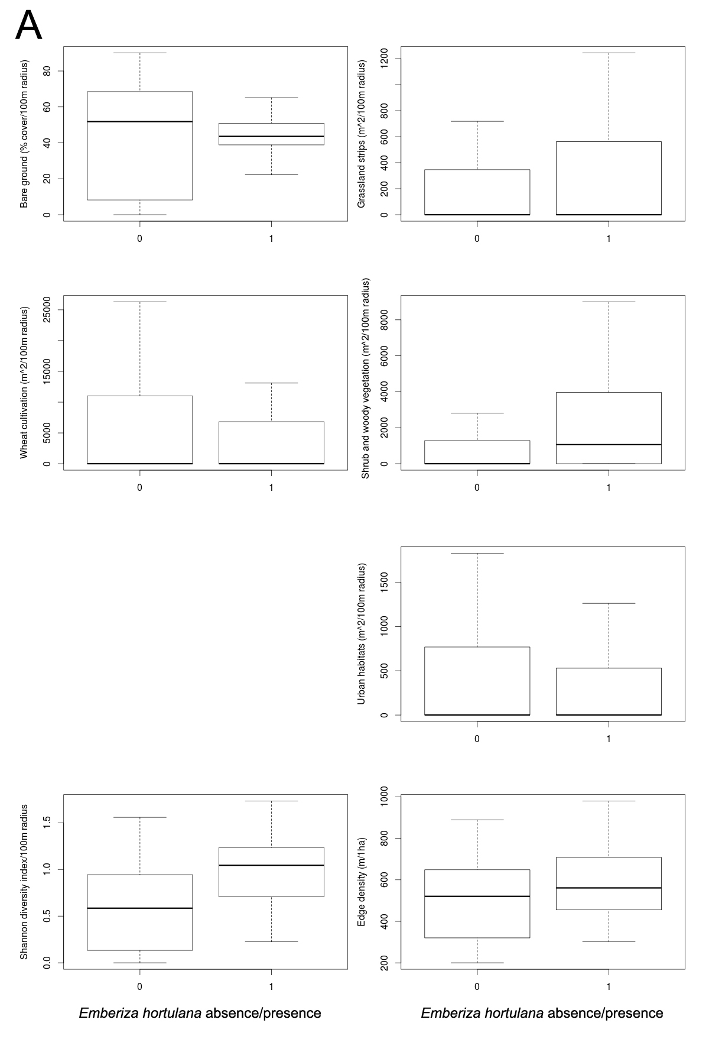
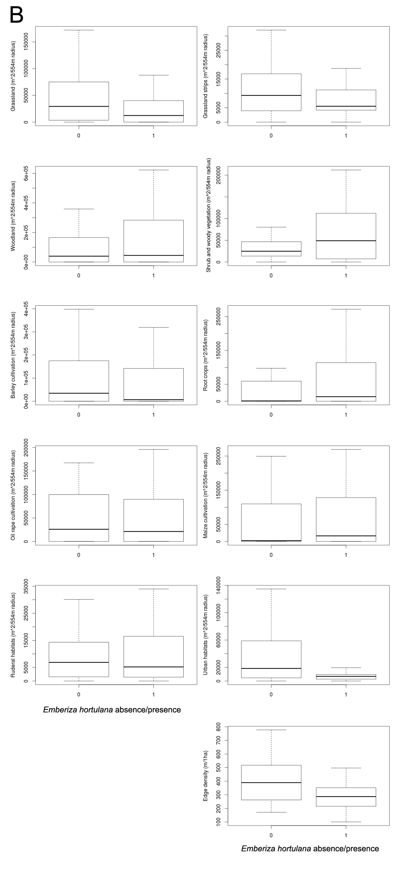
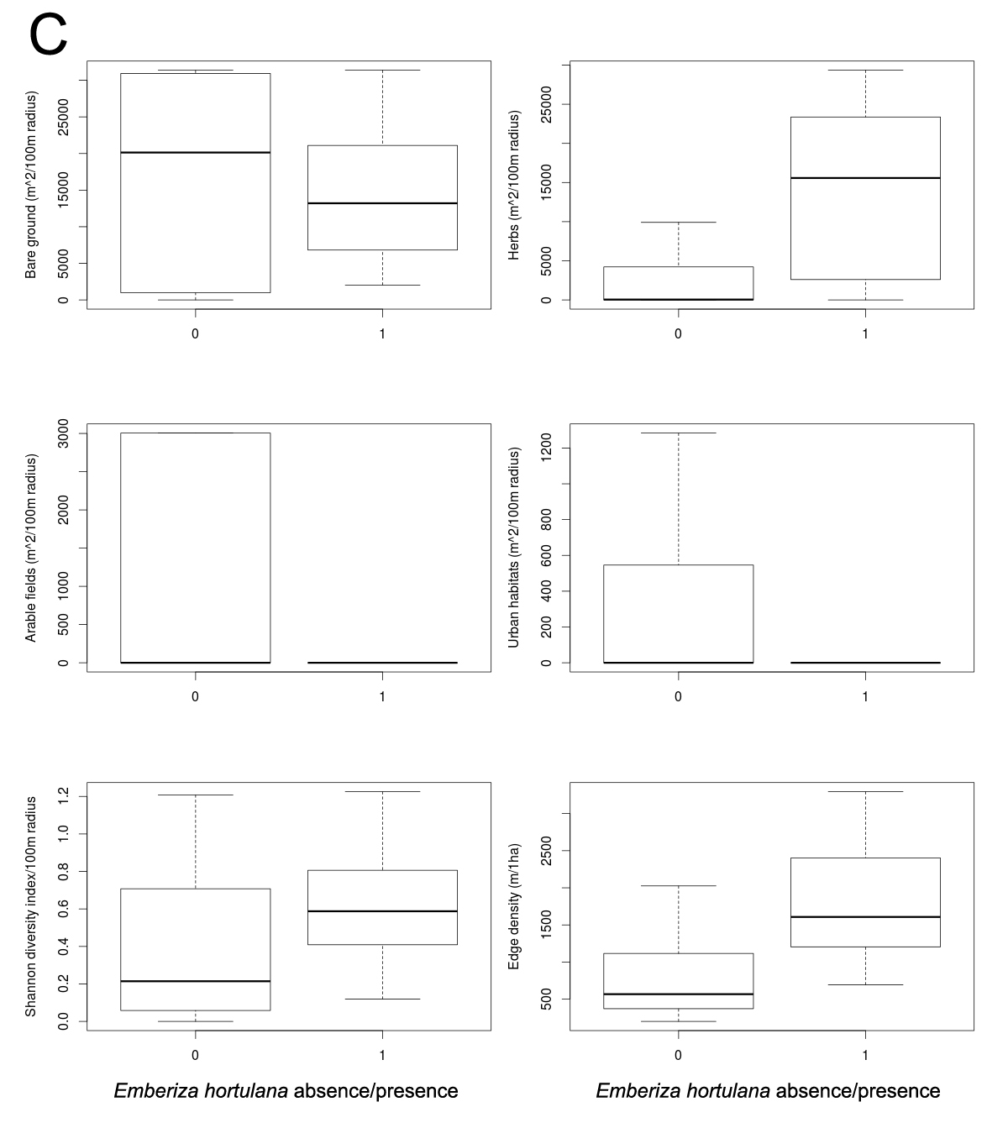
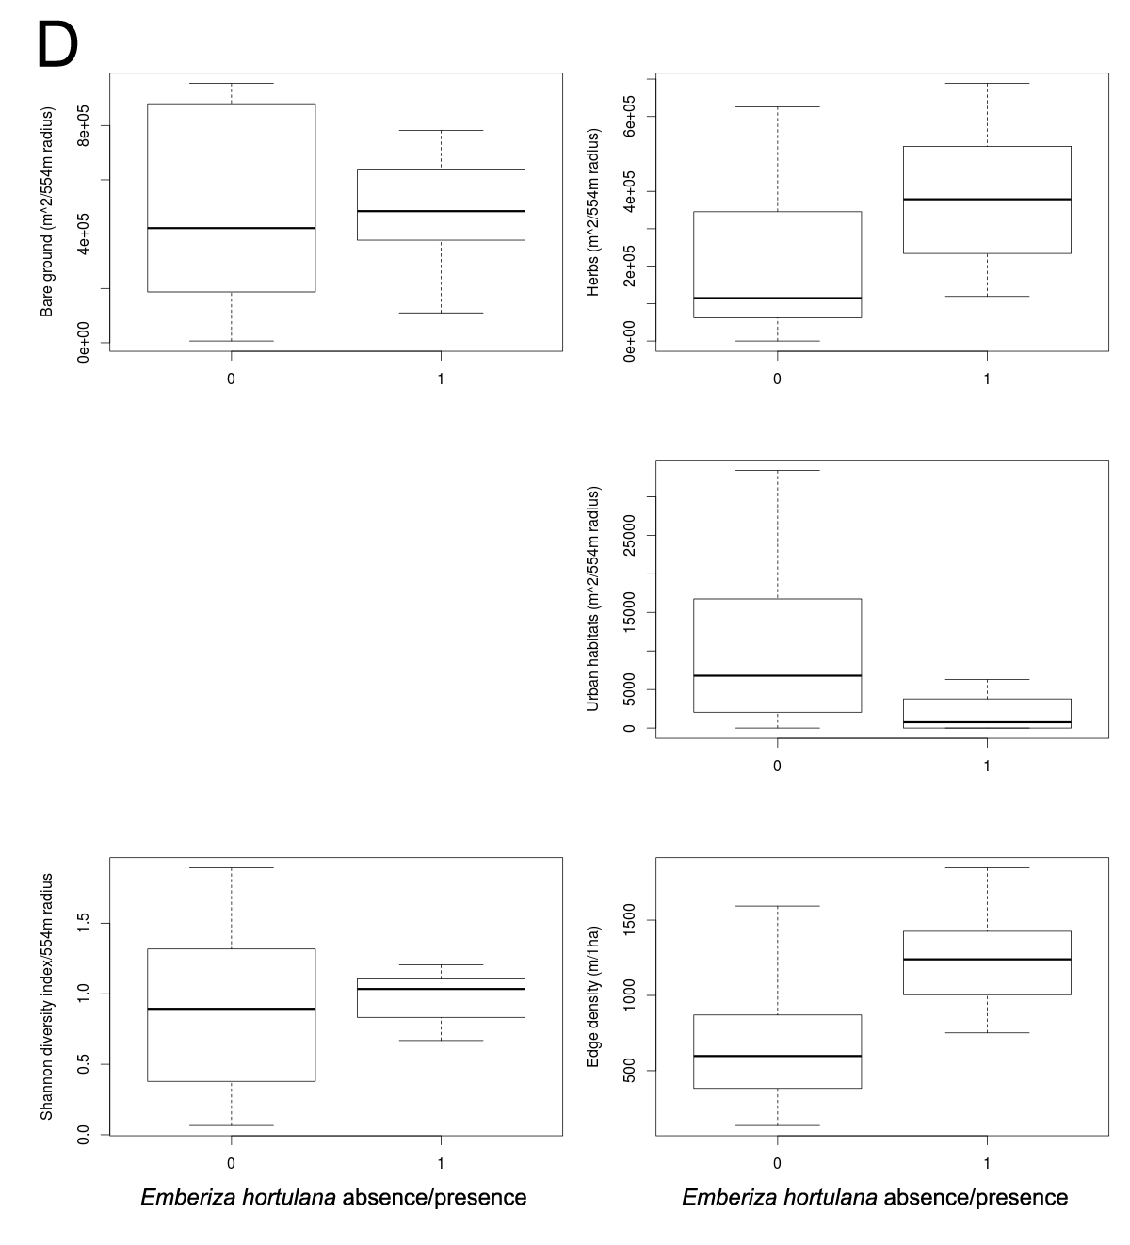

Appendix S3.
Typical habitat of Ortolan Bunting Emberiza hortulana in post-mining landscape created by the deposition of upper layers during surface mining. The characteristic feature of occupied habitat patches is a higher cover of herbs, greater terrain ruggedness, and a larger proportion of bare ground (Photo: Václav Beran).

