Supplementary Material

Hottentot Buttonquail Turnix hottentottus: Endangered or just overlooked?
ALAN T. K. LEE, BRIAN REEVES and DALE. R. WRIGHT

Contents
Table S1. Intact and transformed broad landcover classes derived from 2014 South African National Landcover Layer (GTI South Africa 2015).

Figure S1a. MaxEnt logistic output showing minimum prediction from 100 replicates.

Figure S1b. MaxEnt logistic output showing median prediction from 100 replicates.

Figure S1c. MaxEnt logistic output showing maximum prediction from 100 replicates.

Figure S2. Results of MaxEnt jackknife test of variable importance, averaged over 100 replicate runs. Top picture shows gain from training data while the bottom picture shows gain from test data.

Figure S3. Response curves showing how the logistic prediction changes as each of the variables are adjusted while keeping the remaining variables at the mean sample value.

Table S1. Intact and transformed broad landcover classes derived from 2014 South African National Landcover Layer (GTI South Africa, 2015).
Broad landcover class | Parent class | Class Number | Class name
Intact | Water | 1 | Permanent water
 |  | 2 | Seasonal water
 | Wetland | 3 | Wetland
 | Forest | 4 | Indigenous forest
 |  | 5 | Dense bush, thicket and tall dense shrubs
 | Woodland / open bush | 6 | Woodland and open bushland
 | Grassland | 7 | Grassland
 | Low shrubland | 8 | Low shrubland: fynbos
 |  | 9 | Low shrubland: other
Transformed | Cultivated | 10 – 12 | Commercial annuals (rainfed)
 |  | 13 – 15 | Commercial pivot
 |  | 16 – 22 | Commercial permanent (orchards / vines)
 |  | 23 – 24 | Subsistence
 |  | 25 | Sugarcane pivot
 |  | 26 – 31 | Sugarcane non-pivot
 | Forest plantation | 32 | Forest plantations: mature trees
 |  | 33 | Forest plantations: young trees
 |  | 34 | Forest plantations: temporary clearfelled stands
 | Mine | 35 | Mine: bare
 |  | 36 | Mine: semi-bare
 |  | 37 | Mine water seasonal
 |  | 38 | Mine water permanent
 |  | 39 | Mine buildings
 | Bare | 40 | Erosion dongas and gullies
 |  | 41 | Bare: non-vegetated
 | Built-up | 42 | Commercial
 |  | 43 | Industrial
 |  | 44 – 47 | Informal
 |  | 48 – 51 | Residential
 |  | 52 | School and sports grounds
 |  | 53 – 56 | Smallholding
 |  | 57 – 60 | Sports and golf
 |  | 61 – 64 | Township
 |  | 65 – 68 | Village
 |  | 69 – 72 | Built-up

Figure S1a. MaxEnt logistic output showing minimum prediction from 100 replicates.

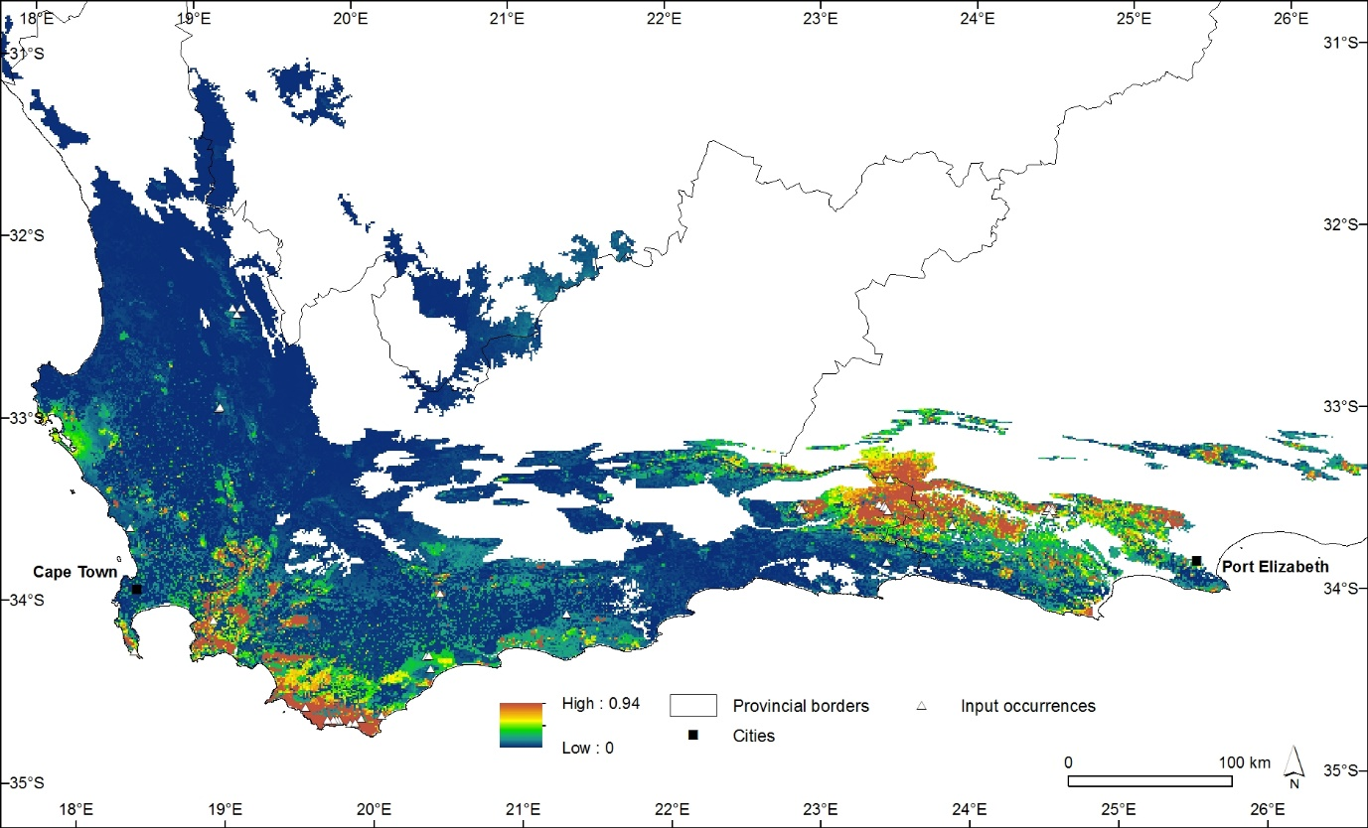

Figure S1b. MaxEnt logistic output showing median prediction from 100 replicates.

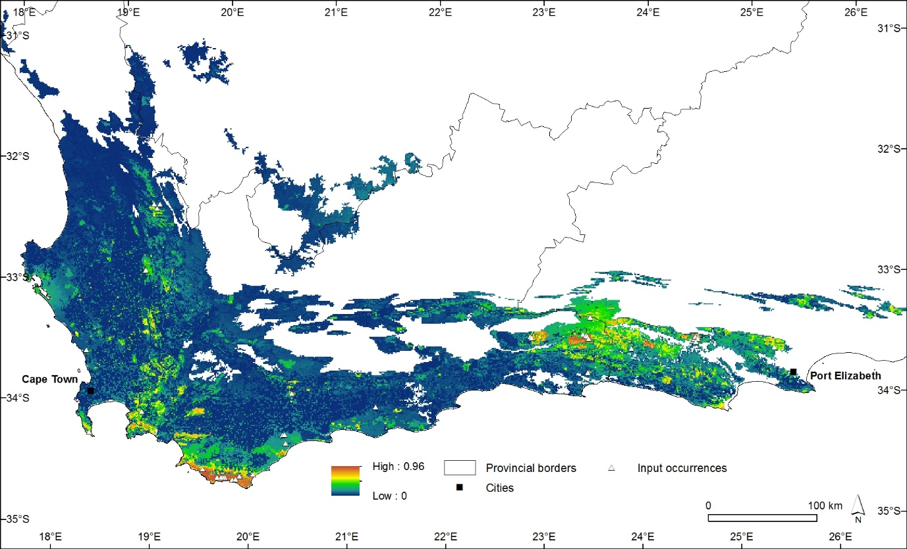

Figure S1c. MaxEnt logistic output showing maximum prediction from 100 replicates.

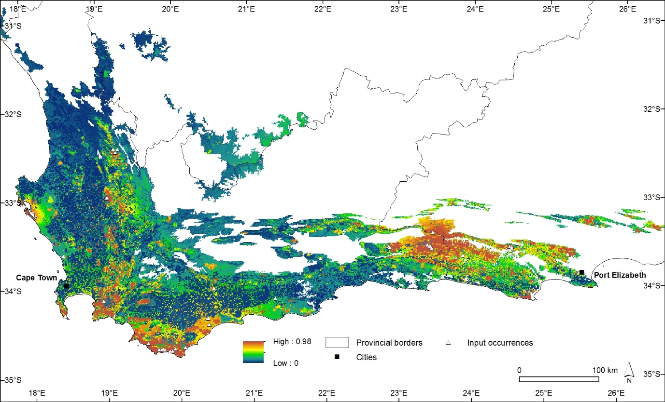

Figure S2. Results of MaxEnt jackknife test of variable importance, averaged over 100 replicate runs. Top picture shows gain from training data while the bottom picture shows gain from test data.

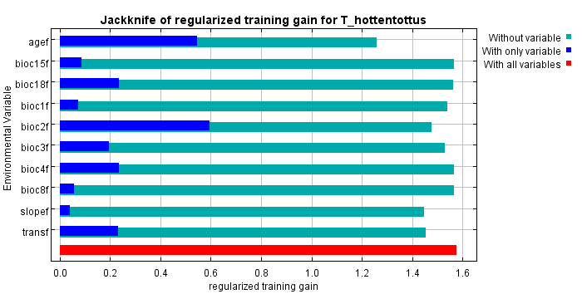
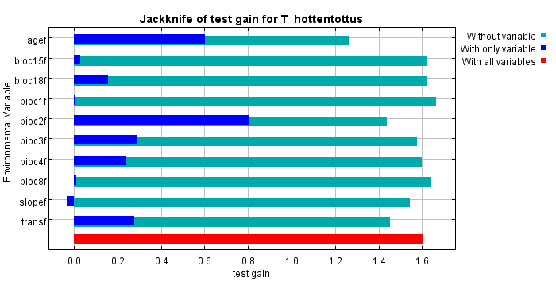

Figure S3. Response curves showing how the logistic prediction changes as each of the variables are adjusted while keeping the remaining variables at the mean sample value.
