Supplementary Material

The relationship between seasonal water level fluctuation and habitat availability for wintering waterbirds at Shengjin Lake, China

CHUNLIN LI, YANG YANG, ZHEN WANG, LING YANG, DONGMEI ZHANG and LIZHI ZHOU

Contents

Figure S1. Land-cover maps of Shengjin Lake at different water levels.

Table S1. Cloud-free Landsat images with the resolution of 30 m used in the study and the corresponding water levels.

Table S2. Inventory of wintering waterbirds in the three simultaneous surveys carried out in 2 March 2014, 2 November 2014 and 12 January 2015 at Shengjin Lake.

Figure S1. Figure S1. Land-cover maps of Shengjin Lake at different water levels.
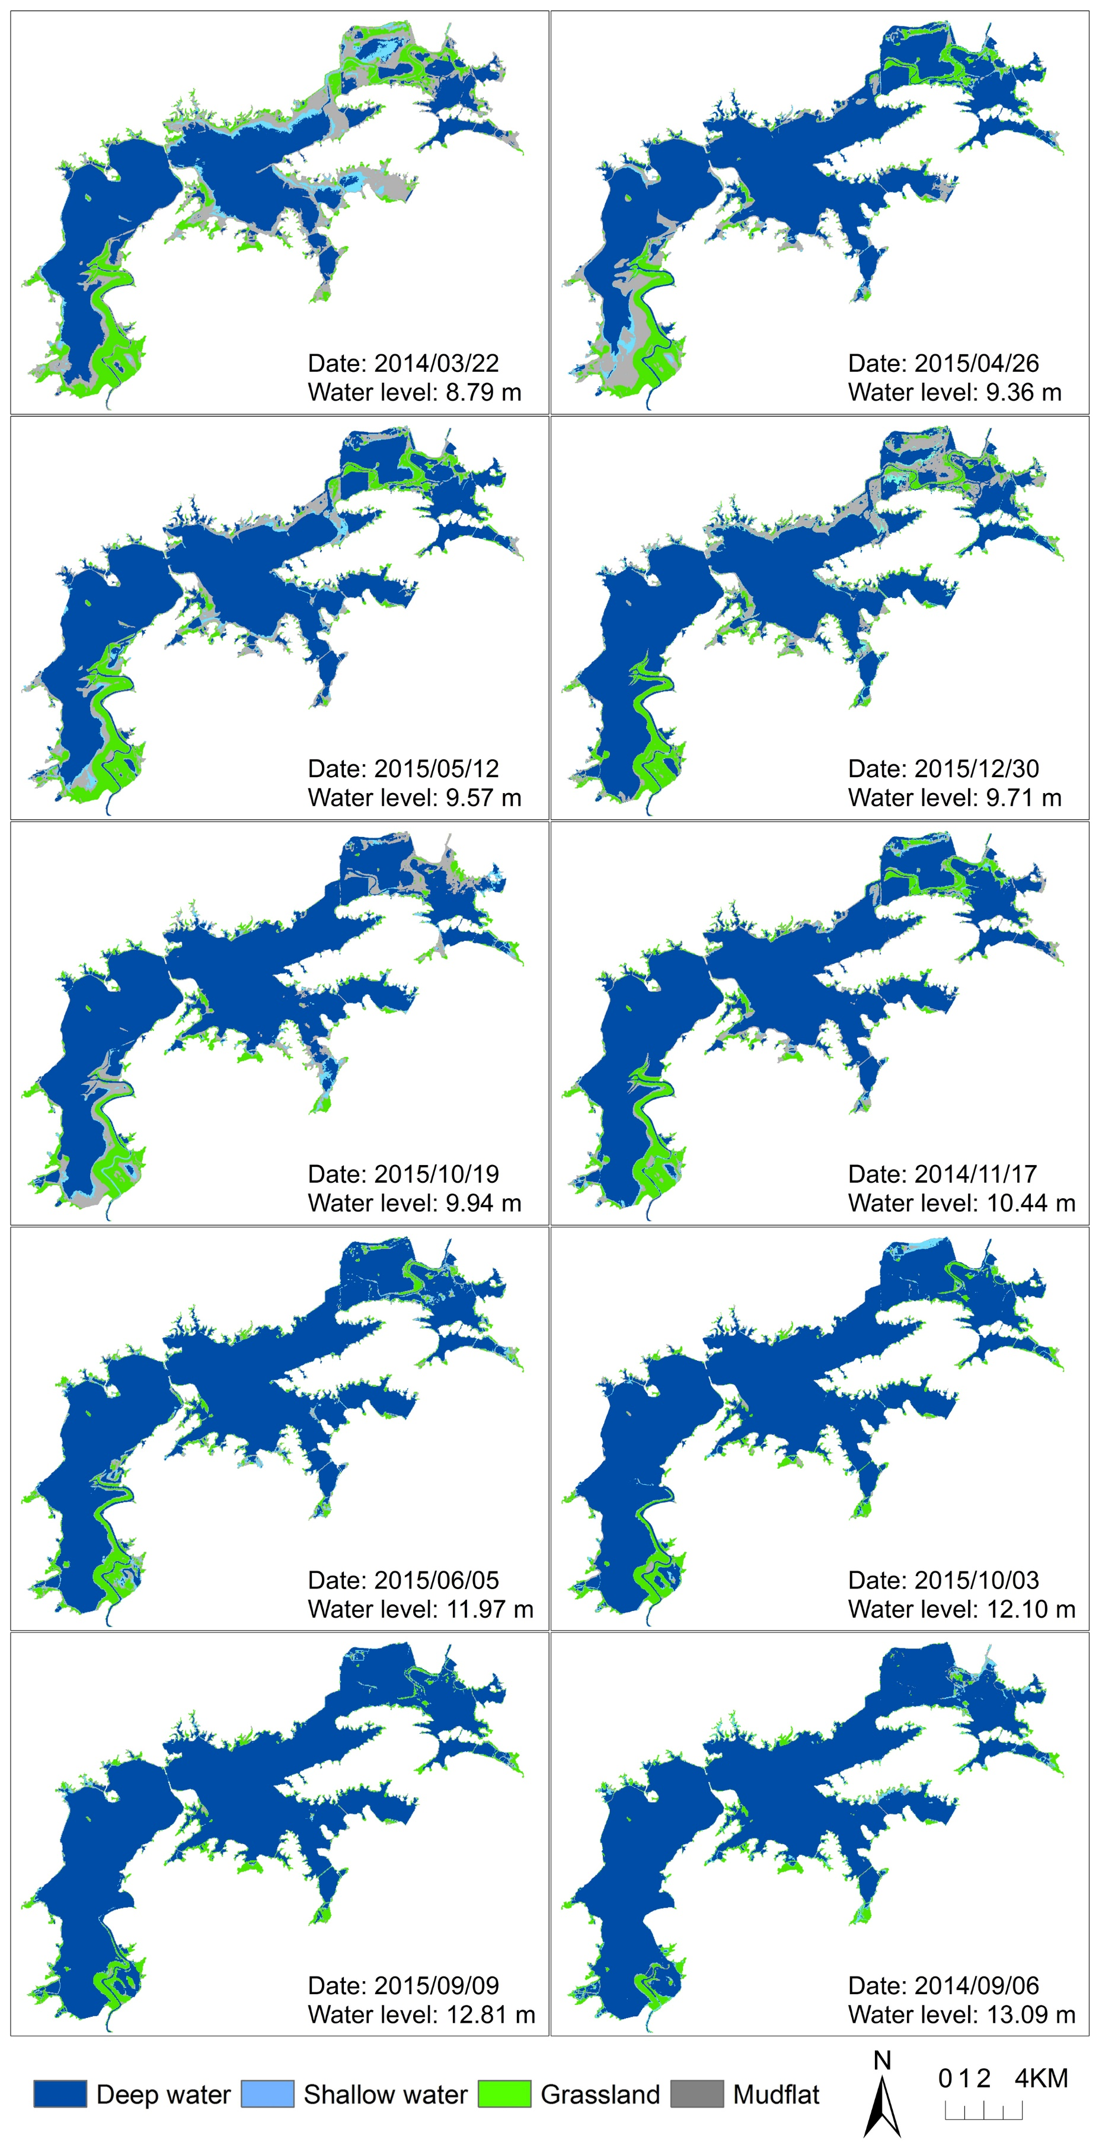
Table S1. Cloud-free Landsat images with the resolution of 30 m used in the study and the corresponding water levels measured inside the Huangpen Sluice Gate at Shengjin Lake. No.1-16 were used for land-cover classification while No.17 for defining the analysis area.
No. | Image date | Water level (m) | Satellite
1 | 13 February 2015 | 8.21 | landsat8
2 | 22 March 2014 | 8.79 | landsat7
3 | 25 March 2015 | 9.19 | landsat7
4 | 26 April 2015 | 9.36 | landsat7
5 | 12 May 2015 | 9.57 | landsat7
6 | 30 December 2015 | 9.71 | landsat8
7 | 19 October 2015 | 9.94 | landsat7
8 | 1 May 2014 | 10.09 | landsat8
9 | 17 November 2014 | 10.44 | landsat7
10 | 11 October 2015 | 11.06 | landsat8
11 | 5 June 2015 | 11.97 | landsat8
12 | 3 October 2015 | 12.1 | landsat7
13 | 8 October 2014 | 12.27 | landsat8
14 | 9 September 2015 | 12.81 | landsat8
15 | 6 September 2014 | 13.09 | landsat8
16 | 31 July 2015 | 13.52 | landsat7
17 | 18 August 2010 | 14.56 | landsat7

Table S2. Inventory of wintering waterbirds in the three simultaneous surveys carried out in 2 March 2014, 2 November 2014 and 12 January 2015 at Shengjin Lake.
Common name | Scientific name | Family | Order | Threatened status in IUCN Red List | Bird group¹ | Dominant habitat² | Abundance
 |  |  |  |  |  |  | 2 March 2014 | 2 November 2014 | 12 January 2015
Great Crested Grebe | Podiceps cristatus | Podicipedidae | PODICIPEDIFORMES | LC | DF | DW | 32 | 63 | 217
Little Grebe | Tachybaptus ruficollis | Podicipedidae | PODICIPEDIFORMES | LC | DF | DW | 61 | 179 | 143
Dalmatian Pelican | Pelecanus crispus | Pelecanidae | PELECANIFORMES | VU | DF | DW | 0 | 0 | 1
Great Cormorant | Phalacrocorax carbo | Phalacrocoracidae | PELECANIFORMES | LC | DF | DW | 657 | 2106 | 2376
Little Egret | Egretta garzetta | Ardeidae | PELECANIFORMES | LC | LW | SW | 34 | 131 | 65
Intermediate Egret | Ardea intermedia | Ardeidae | PELECANIFORMES | LC | LW | SW | 2 | 228 | 207
Great White Egret | Ardea alba | Ardeidae | PELECANIFORMES | LC | LW | SW | 54 | 79 | 218
Grey Heron | Ardea cinerea | Ardeidae | PELECANIFORMES | LC | LW | SW | 225 | 346 | 993
Black-crowned Night Heron | Nycticorax nycticorax | Ardeidae | PELECANIFORMES | LC | LW | SW | 0 | 1 | 0
Oriental Stork | Ciconia boyciana | Ciconiidae | PELECANIFORMES | EN | LW | SW | 0 | 23 | 75
Eurasian Spoonbill | Platalea leucorodia | Threskiornithidae | PELECANIFORMES | LC | LW | SW | 276 | 434 | 390
Tundra Swan | Cygnus columbianus | Anatidae | ANSERIFORMES | LC | GS | DW | 218 | 57 | 50
Lesser White-fronted Goose | Anser erythropus | Anatidae | ANSERIFORMES | VU | GS | GL | 301 | 150 | 1478
Greater White-fronted Goose | Anser albifrons | Anatidae | ANSERIFORMES | LC | GS | GL | 6011 | 491 | 5829
Bean Goose | Anser fabalis | Anatidae | ANSERIFORMES | LC | GS | GL | 21250 | 17050 | 18575
Swan Goose | Anser cygnoid | Anatidae | ANSERIFORMES | VU | GS | GL | 15 | 15 | 42
Greylag Goose | Anser anser | Anatidae | ANSERIFORMES | LC | GS | GL | 1 | 0 | 10
Chinese Spot-billed Duck | Anas zonorhyncha | Anatidae | ANSERIFORMES | LC | DF | DW | 121 | 85 | 1113
Common Teal | Anas crecca | Anatidae | ANSERIFORMES | LC | DF | DW | 312 | 0 | 291
Mallard | Anas platyrhynchos | Anatidae | ANSERIFORMES | LC | DF | DW | 18 | 4 | 639
Northern Pintail | Anas acuta | Anatidae | ANSERIFORMES | LC | DF | DW | 0 | 20 | 225
Garganey | Spatula querquedula | Anatidae | ANSERIFORMES | LC | DF | DW | 0 | 0 | 69
Eurasian Wigeon | Mareca penelope | Anatidae | ANSERIFORMES | LC | DF | DW | 0 | 0 | 87
Gadwall | Mareca strepera | Anatidae | ANSERIFORMES | LC | DF | DW | 0 | 0 | 86
Falcated Duck | Mareca falcata | Anatidae | ANSERIFORMES | NT | DF | DW | 9 | 30 | 1750
Northern Shoveler | Spatula clypeata | Anatidae | ANSERIFORMES | LC | DF | DW | 0 | 0 | 22
Smew | Mergellus albellus | Anatidae | ANSERIFORMES | LC | DF | DW | 1 | 0 | 0
Ruddy Shelduck | Tadorna ferruginea | Anatidae | ANSERIFORMES | LC | DF | DW | 3 | 9 | 6
Common Shelduck | Tadorna tadorna | Anatidae | ANSERIFORMES | LC | DF | DW | 0 | 0 | 15
Tufted Duck | Aythya fuligula | Anatidae | ANSERIFORMES | LC | DF | DW | 0 | 0 | 154
Hooded Crane | Grus monacha | Gruidae | GRUIFORMES | VU | LW | MF | 248 | 26 | 87
White-naped Crane | Antigone vipio | Gruidae | GRUIFORMES | VU | LW | SW | 0 | 0 | 2
Common Moorhen | Gallinula chloropus | Rallidae | GRUIFORMES | LC | DF | DW | 1 | 5 | 0
Brown Crake | Zapornia akool | Rallidae | GRUIFORMES | LC | SB | SW | 2 | 0 | 0
Pied Avocet | Recurvirostra avosetta | Recurvirostridae | CHARADRIIFORMES | LC | SB | SW | 17 | 0 | 0
Northern Lapwing | Vanellus vanellus | Charadriidae | CHARADRIIFORMES | LC | SB | MF | 746 | 98 | 704
Grey-headed Lapwing | Vanellus cinereus | Charadriidae | CHARADRIIFORMES | LC | SB | MF | 45 | 0 | 0
Little Ringed Plover | Charadrius dubius | Charadriidae | CHARADRIIFORMES | LC | SB | MF | 0 | 2 | 0
Long-billed Plover | Charadrius placidus | Charadriidae | CHARADRIIFORMES | LC | SB | SW | 2 | 0 | 0
Common Redshank | Tringa totanus | Scolopacidae | CHARADRIIFORMES | LC | SB | SW | 0 | 0 | 36
Spotted Redshank | Tringa erythropus | Scolopacidae | CHARADRIIFORMES | LC | SB | SW | 16 | 27 | 47
Green Sandpiper | Tringa ochropus | Scolopacidae | CHARADRIIFORMES | LC | SB | SW | 10 | 11 | 98
Wood Sandpiper | Tringa glareola | Scolopacidae | CHARADRIIFORMES | LC | SB | SW | 0 | 1 | 48
Common Greenshank | Tringa nebularia | Scolopacidae | CHARADRIIFORMES | LC | SB | SW | 17 | 3 | 73
Marsh Sandpiper | Tringa stagnatilis | Scolopacidae | CHARADRIIFORMES | LC | SB | SW | 0 | 6 | 0
Eurasian Curlew | Numenius arquata | Scolopacidae | CHARADRIIFORMES | NT | SB | SW | 0 | 0 | 184
Dunlin | Calidris alpina | Scolopacidae | CHARADRIIFORMES | LC | SB | SW | 0 | 0 | 24
Black-tailed Godwit | Limosa limosa | Scolopacidae | CHARADRIIFORMES | NT | SB | SW | 0 | 0 | 8
Common Sandpiper | Actitis hypoleucos | Scolopacidae | CHARADRIIFORMES | LC | SB | SW | 0 | 0 | 6
Common Snipe | Gallinago gallinago | Scolopacidae | CHARADRIIFORMES | LC | SB | SW | 5 | 3 | 0
Black-headed Gull | Larus ridibundus | Laridae | CHARADRIIFORMES | LC | DF | DW | 350 | 152 | 2108
European Herring Gull | Larus argentatus | Laridae | CHARADRIIFORMES | LC | DF | DW | 6 | 10 | 13
¹GS: geese, SB: shorebirds, LW: larger waders, DF: deep-water feeders.
²DW: deep water, SW: shallow water, MF: mudflat, GL: grassland.

