Supplementary Material

Traditional ecological knowledge of the Critically Endangered Tooth-billed Pigeon Didunculus strigirostris endemic to Samoa
GIANLUCA SERRA, GREG SHERLEY, S. AFELE FAILAGI, S. TALIE FOLIGA, MOEUMU UILI, FIALELEI ENOKA and TEPA SUAESI

Contents
Annex S1. Questionnaire for village native experts rare biodiversity survey

Annex S2. Forest surveys led by selected reliable hunters within 4 kbas

Annex S1. Questionnaire for village native experts rare biodiversity survey

# | Question | Goal/approach | Data
1 | Visual Test (VT) #1a and 1b  (3 very different birds) | A preliminary visual test designed to understand the level of naturalistic knowledge and ability in bird species discrimination: this test is easy (3 very different and common birds are shown). This first question is like a preliminary filter aimed at not wasting additional time with individuals who are bluffing about their knowledge due to various possible reasons. | VT 1a:  - Kingfisher/tiotala  - Samoan Fruit-dove/manutagi  - Samoan Starling/Fuia  VT 1b:  - Fantail/Seu  - Mao/ Ma’o ma’o  - White-throated Pigeon/Fiaui
2 | Audio Test (AT) #1a and 1b  (3 very different birds) | Recorded calls of three very different birds, to test naturalistic knowledge.  If visual and audio tests #1 go bad (i.e. all three birds wrongly identified) perform a short version of questionnaire: only ask questions 3 , 8, 9, 10, 11, and then finish. | AT 1a:  - Many-coloured Dove/Manuma/Manulua  - Polynesian Triller/Miti vao  - Pacific Robin/Kolei  AT 1b:  - Polynesian Starling/Fuia  - Samoan Whistler/Vasa vasa  - Kingfisher/Tiotala
3 | How often has he/she visited the forest during the past  - 60 years  - 20 years  - 10 years  - 5 years | To understand the degree of familiarity and association of the interviewee with the forest in question. It is a kind of double check / cross check with the previous question. If an interviewee responds well to previous questions, it is expected he will also respond this second question that he/she has spent good part of his/her life in the forest | 60 years:  20 years:  10 years  5 years:
4 | What does he/she reckon his/her forest is SPECIAL for in terms of wildlife or plants?  What is UNIQUE/RARE and not found elsewhere in Samoa? | Key question of the whole questionnaire. Important: to NOT provide hints of what we are looking for specifically at this stage. ALL INPUTS about rare fauna and flora, especially in terms of anatomical and behavioural descriptions, should come from the interviewee. No influences at all from the interviewer.  Give the interviewee some time to focus and think. No rush.  Note: it is NOT about what is common! We would like to know what is RARE!  Then once he/she has finished, assist him/her by focusing on the taxa we are more interested in, see next set of questions following audio test.
5 | In relation with question #3, does the forest host anything special in relation to bats?  If he/she describes only fruit bats, then ask: “are there bats smaller than the fruitbats/pe’a?”  If they say no, then ask if they have ever seen the small bat by showing the two photographs. | If yes, describe the type of bats that are unique to your forest.
6 | Anything special in relation to butterflies?  If reply is positive, then ask description of:  - size  - body colour  - wing shape and colour.  Try to ask if he/she has ever seen a large dark butterfly with tails? If yes ask description.  After he/she finished, ask her if she has ever seen the swallowtail indicating it in the plates. | Once he/she replies show him/her the plates of butterflies and see if she can show any interesting butterfly.  Important to underline difference with the Blue Moon (confusion species).
7 | Anything SPECIAL or RARE about birds? | If reply is positive, then ask description of:  - size  - body colour  - bill shape and colour  - what food  - what habitat  - where seen last time, in what context, where usually  - what behaviour  - what breeding season.  Note (important): avoid asking and mentioning/guessing any name of species we think the interviewee is talking about at this stage. Just focus on getting as much information as possible from him/her in terms of anatomical, ecological and behavioural description. All inputs should come from the interviewee, no suggestions/indications/influences should come from the interviewer.
8 | Anything SPECIAL or RARE about pigeons and doves? | If reply is positive, then ask description of:  - size  - body colour  - bill shape and colour  - what food  - what habitat  - where seen last time, in what context, where usually  - what behaviour  - what breeding season.  Audio test about pigeons here: Manutagi, Lupe, White-throated, Manumea.  Once he/she finishes, show him/her the plates with all pigeons (without showing the names!) and ask which pigeons and doves live in the forest. Pass through each plate one by one.  If until now Manumea or Manuma is not mentioned, then ask the following: “Have you ever heard about a bird called “Manumea/Manuma”?”  This question should be asked ONLY at this point, as a last option. And if the answer is positive evidence should be asked.  If something similar to Manumea is described, ask what trends of abundance he/she has noticed during the past 20, 10, 5 years?
9 | Visual Test #2a, 2b and 2c  (3 birds similar, belonging to same family) |  | VT #2a  - Purple Swamphen/Manuali  - Samoan Moorhen/Puna’e  - Banded Rail/Ve’a  VT #2b  - P. Imperial Pigeon/Lupe  - Samoan Fruit-dove/Manutagi  - White-throated Pigeon/ Fiaui  VT #2c  - Many-coloured Dove/Manuma  - Rock Pigeon/Lupe palagi  - Friendly Ground Dove/ Tu’aimeo
10 | Audio Test #2a and 2b  (3 birds similar, belonging to same family) |  | AT #2a  - White-throated Pigeon/Fiaui  - Tooth-billed Pigeon/Manumea  - P. Imperial Pigeaon/Lupe  - Manumea/Manumea  AT #2b  - Polynesian Triller/Miti vao  - Wattled Honeyeater/Iao  - Cardinal/Sega
11 | Anything SPECIAL or RARE about rails family? | If reply is positive, then ask description of:  - size  - body colour  - bill shape and colour  - what food  - what habitat  - where seen last time, in what context, where usually  - what behaviour  - what breeding season.  Once he/she finishes, show him/her the plates with all rails and ask which one live in the forest. Pass through each plate one by one.  If no interesting answer, than zoom in on the Puna’e and see if he/she knows it.
12 | Anything special or rare about medicinal plants?
13 | Anything special or rare about forest trees? | If a special tree is mentioned by interviewee, these questions should be asked:  - Shape and colour of leaves  - Branches and bark  - Stems  - Fruits and flowers (shape and colours)  - Habitat they grow.  Once he/she finishes: “Is Maota occurring in the forest, is it abundant or scarce? Which season does it fruit?”
14 | Anything special or rare about fruits or roots?
15 | How often do you eat wild meat or wild plants in a week or a month?
16 | How many hunters are in the village?
17 | How often do they go hunting?
18 | Wild meat or plants are consumed only in the village or sold in markets outside village?  What is the pigeon meat used for?  What is the bat meat used for?
19 | Any species you avoid hunting?
20 | Is there a hunting season? Is there a season when pigeons are not hunted?
21 | Have you or your group ever shot a Manumea/Manuma?

NOTES

- In order to get unbiased and reliable information, the approach of the questionnaire is that the interviewer does not have to give ANY clue whatsoever of what information he/she is aiming to obtain from the interviewee, e.g. if the interviewee knows that interviewer is looking for Manumea, he/she may pretend to know it and/or could give biased information with the aim/hope to get benefits from the project.

- Questionnaire is to be run in the local language by MNRE trained staff with good naturalistic knowledge.

- We are NOT much interested to know the name of the animal and plant in question (local names are confusing most of times) BUT we are very interested to get a detailed description of the animal (anatomy or behavior) or plant.

- A psychological approach on part of the interviewer is desirable and advised: it is important to note down how much confident was the interviewee while replying to the questions and how much keen to share data.

Annex S2. Forest surveys led by selected reliable hunters within 4 kbas

UAFATO-TIAVEA COASTAL FOREST

Uafato, 16 and 17 March 2016

On 16 June 2016 we were led by hunter Tuaoi of Uafato village within the coastal forest slopes to the east of the village up to the Vaoto headland. The forest looked quite pristine (primary/secondary forest). In regards to bird calls Tuaoi looked quite confident, including identifying Lupe versus Manumea. In two occasions we heard a coo call from the canopy of fruiting Maota trees, and Tuaoi identified it as Lupe (versus Fialelei Enoka who identified one of them as Manunmea). An automatic sound recorder was deployed following the indication of Tuaoi (see Table 3 for details) and left in place for 7 days continuously (from sunrise to sunset). A series of coo calls recorded and detected using program Song Scope was identified by Sabine Baumann and Ulf Beichle as Manumea.

On 17 June 2016 we were led by hunter Lohia of Uafato within the highly steep forest slopes to the west of the village almost up to the ridge that overlooks it and where a scenic and high waterfall is located. The forest looked more disturbed then the one seen the previous day, with several logged large trees laying on the ground. In regards to bird calls Lohia looked quite confident but he admitted not to be able to identify Lupe versus Manumea. An automatic sound recorder was deployed following the indications of Lohia (see Table 3 for details) and left in place for 15 days from sunrise to sunset. Two series of coo calls recorded and detected using program Song Scope were identified by Sabine Baumann and Ulf Beichle as Manumea.

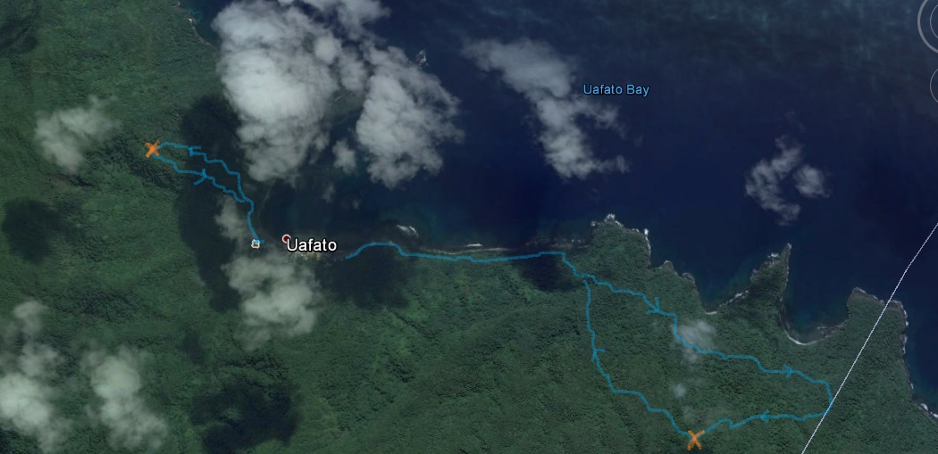
Figure 3. Two surveys within Uafato forest (UTCF KBA), refer to Fig. 1 for geographic reference; North direction is up. Blue loop to the east: survey track led by selected reliable hunter Tuaoi on 16 March 2016, ca. 7 km, one full day hiking. Blue loop to the west: survey track led by Lohia on 17 March 2016, ca. 2.5 km, one full day hiking. The two orange crosses indicate the locations where the automatic sound recorders were deployed.

Tiavea, 30 August 2015 and 18 March 2016

On 30 August 2015, as a preliminary test to present study, G. Serra requested hunter Tes to lead him within the forest east of Tiavea village. The hunter was later assessed, through the standard questionnaire approach, to not be very reliable in terms of TEK about native biodiversity. The forest around Tiavea appeared much more disturbed and open than the around Uafato village. The number of cartridges found on the ground were quite impressive suggesting a high hunting pressure. The same was not observed during the two days spent in the Uafato forest.

On 18 March 2016 local expert Lau from Tiavea - ranked as not very reliable according to the standard questionnaire approach - led us on a morning survey within the northern coastal forest of Tiavea to visit some caves where he claimed to have seen Pacific Sheath-tailed Bats some years earlier. No trace of bats was found and the caves seemed too shallow for hosting bats.

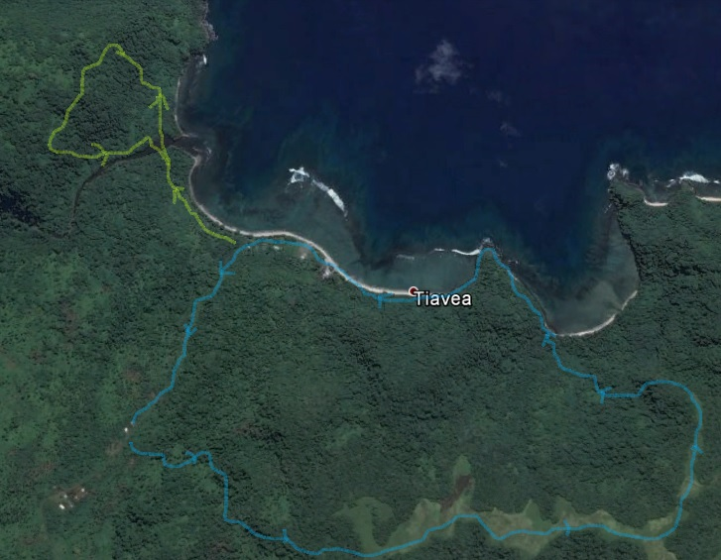
Figure 4. Two surveys within Tiavea forest (UTCF KBA), refer to Fig. 1 for geographic reference, North direction is up. Yellow loop to the west: survey track led by local expert Lau on 18 March 2016, 2.5 km, 2-3 hours hiking. Blue loop to the east: survey track led by local expert Tes on 30 August 2015, ca. 5.5 km, half day hiking.

APIA CATCHEMENTS

Magiagi, 29 June 2016

On 29 June 2016 we were led by reliable hunter from Magiagi known as Pepe across the forest of Maualuga and Mauga on the flat ridges of the upper AC (ca. 520 m altitude). The forest was of a quite good quality dotted by massive trees of Tava (Rhus taitensis), Aoa (Ficus obliqua) and Ma’ali (Canarium samoense /vitiense). We found ripe fruits of several trees on the ground, including a couple of impressive patches of Maota (Dysoxylum maota) fruits. Differently from the forests visited at other KBAs, the forest of Magiagi is invaded by Tamaligi (Albizia sp.) and by the African Giant Snail (Achatina fulica). Pepe, very knowledgeable about forest trees and medicinal plants, showed us the location where he shot Manumea 20 years ago while perched on a tree of Luaufuauli. According to Pepe Manumea still occurs in this area and it has been spotted several times in recent times.

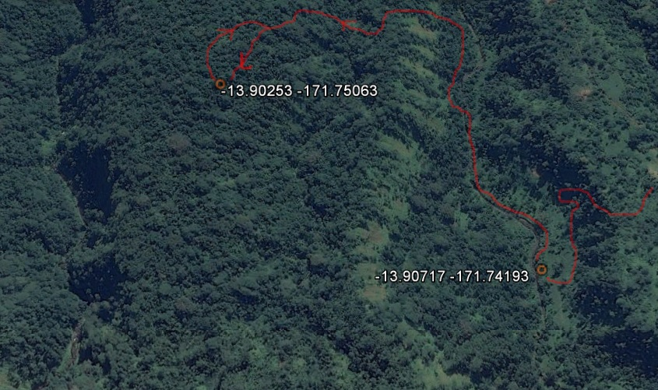
Figure 5a. Survey within Maualuga and Mauga forests (AC KBA) in the vicinity of Magiagi village, refer to Fig. 1 for geographic reference, North direction is up. Dark red line: one-day survey led by selected reliable hunter Pepe on day 29 June 2016, ca. 9 hours of hiking.

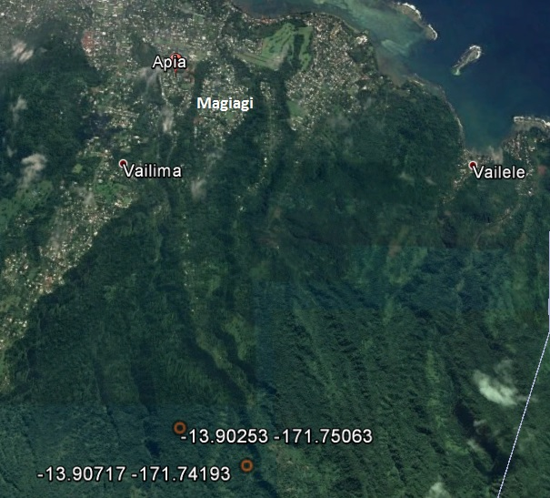
Figure 5b. General view of the Maualuga and Mauga forests and their spatial relation to the adjacent suburbs of Apia including Magiagi village; North direction is up. Two red circles: the locations of the two GPS points shown in Fig. 5a, as a reference.

Malololelei-Lanoto’o, 2014-2016

Due to being adjacent to the capital of Samoa, Apia, the forests of Malololelei and of Lake Lanoto’o were surveyed by several of the authors of present study, without the guidance of local experts, through innumerable informal excursions during period 2014-2016, for a total of at least 150 hours in the field, for an estimated 57 independent occasions. Endangered and endemic Giant Honeyeater/Ma’o ma’o (Gymnomyza samoensis) is a breeding resident of Malololelei forest. Possible coo calls of Manumea have been heard within the forest of Malololelei several times during June 2015 - January 2016. Two people living in the area and claiming to have seen Manumea were interviewed opportunistically using a standard approach in 2015 and 2016. One of these interviews led G. Serra to make a definite visual observation of Manumea on 29 February 2016 (see indication of location in the image below). An automatic sound recorder was deployed within Malololelei forest during the first half of March 2016 at a location whose details are reported in Table 3 (see indication of location in the image below). A series of coo calls recorded through this recorder were identified as Manumea by Sabine Baumann and Ulf Beichle.

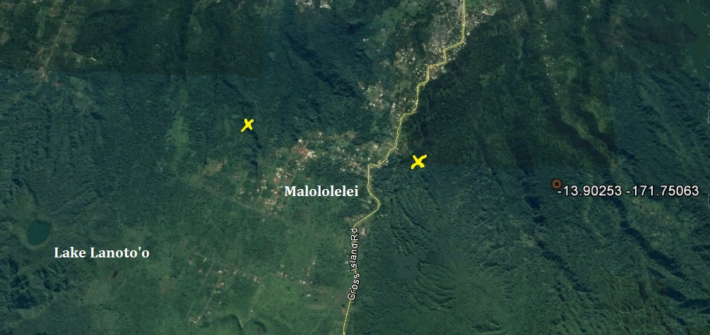
Figure 6. Malololelei-Lanoto’o forest (AC KBA), refer to Fig. 1 for geographic reference, North direction is up. Yellow cross to the left: location where the automatic sound recorder was deployed within Malololelei forest. Yellow cross to the right: location of the definite observation of Manumea by G. Serra on 29 February 2016. Red circle to the right: one of the two GPS points taken during the survey in Magiagi forest (refer to Fig 5b).

CENTRAL SAVAII RAINFOREST

Aopo, 11-12 May 2016

On 11 May 2016 we were led by selected reliable hunter Malauita Onolua of Aopo village within the forest slopes of Mount Ma’atalafi (500-1500 m asl). We hiked ca. 1.5 hours through disturbed forest at the beginning of the survey while the rest of the day was spent surveying a quite pristine medium and high slope cloud rain forest. In regards to bird calls Onolua looked quite confident, including identifying Lupe versus Manumea. Endangered Ma’o ma’o was heard several times calling from the forests on the plateau. While descending through the same route on the second day we heard two series of coo calls at different locations within the upper slope forest that were confidently identified on the spot by Onolua as Manumea.

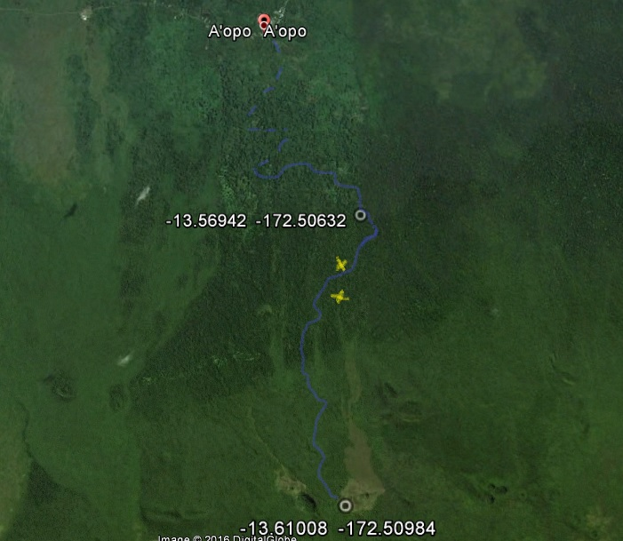
Figure 7. Survey within Aopo forest (CSR KBA), refer to Fig. 2 for geographic reference, North direction is up. Two-day hike led by selected reliable hunter Malaita Onolua on days 11-12 May 2016. Disconnected blue line: ca. 2.5 km of forest road covered by 4x4 vehicle. Continuous blue line: trail hiked through the medium and upper slope forest and then through the top plateau. White circle at the bottom of the image: the location of the camp site of Mt Mata’alafi (ca. 1600 m asl). White circle in the middle of the image: the point where open disturbed forest gave way to good-quality secondary and primary forests (ca. 1 hour and a half hiking from the vehicle parking location). In total 7-8 hours were hiked on the first day. The same amount of time took to hike back the next day using the same route. Yellow crosses: the locations where the two automatic sound recorders were deployed.

Taga 8-10 June 2016

On 8 June 2016 we were led by selected reliable hunter Lupe Toilolo across an open and highly disturbed lowland forest mixed to plantations few km NE from the village of Taga. We observed a mix of plantations and cleared areas invaded by Merremia. In some places we noticed surviving patches of large Maota trees fruiting. According to Lupe Toilolo Manumea occurs in this area and “there is no need to go in the upper forest to find it”. At the beginning of the hike, in the early morning, we heard a series of coo calls coming from a patch of trees covered in Merremia that was positively identified on the spot by Lupe Toilolo as Manumea. In the early afternoon, we heard again a series of coo calls at the same location.

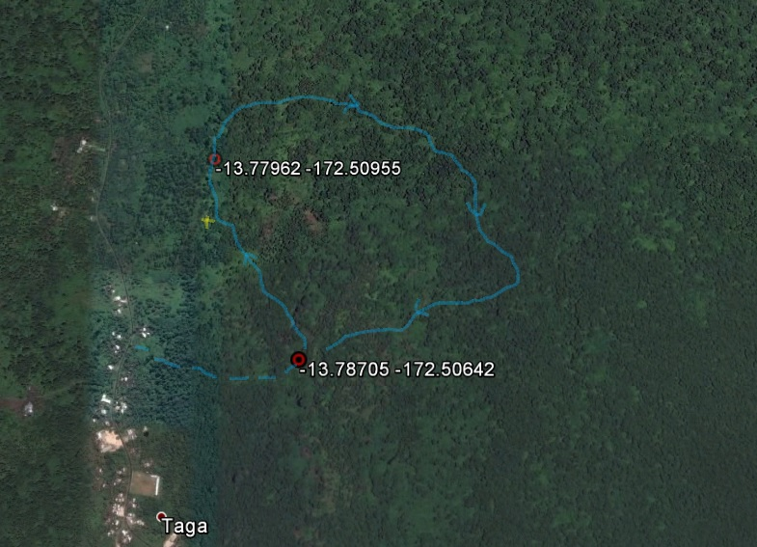
Figure 8. Survey within open highly disturbed forest in the outskirts of the village of Taga (CSR KBA), refer to Fig. 2 for geographic reference, North direction is up. One-day hike led by selected reliable hunter Lupe Toilolo on day 8 June 2016. Disconnected blue line: the stretch of dirt track driven by 4x4 vehicle. Continuous blue line: track hiked within the course of 3-4 hours. Yellow cross: the location where an automatic sound recorder was deployed (i.e. this is the location where coo calls identified by Lupe Toilolo as Manumea were heard twice that same day).

On 9-10 June 2016 we were led by selected reliable hunter Lupe Asimani of Taga village within the slopes of Punaoa community cloud forest reserve. The hike to the camp site (500-550 m asl) took about 3-4 hours, two of them through a thick primary cloud forest. In regards to bird calls Lupe Asimani looked quite confident, including identifying Lupe versus Manumea. Both during first day and second day he identified a number of series of coo calls of both Manumea and Lupe on the spot.

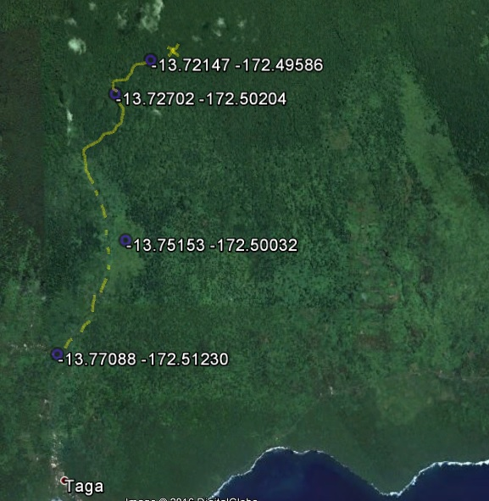
Figure 9. Two-day survey within the Punaoa community cloud forest reserve, Taga forest (CSR KBA), refer to Fig. 2 for geographic reference, North direction is up. The survey was led by selected reliable hunter Lupe Asimani on days 9-10 June 2016. Disconnected yellow line: the stretch of dirt road driven by 4x4 vehicle. Continuous yellow line: the track hiked across the forest over 3-4 hours. Purple circle at the bottom of the image: the start of the 4x4 vehicle run. Purple circle at the top of the image: the location where camp was set up to overnight. The same amount of time took to hike back to the car the next day using the same route. Yellow cross at the top of the image: the location where an automatic sound recorder was deployed following the recommendation of Lupe Asimani.

FALEALUPO PENINSULA

Falealupo 21 June 2016

On 21 June 2016 we were led by selected reliable hunter Afalese to visit three forest sites in the surroundings of Falealupo village. First site is known as Kapau: it is an unprotected forest area, where we found several Ifilele trees (Intsia bijuga) fallen down. Several fruiting trees were found. Second area visited was Vautele Reserve, not far from the touristic Canopy Walkaway. This area had been badly hit by cyclone Ofa in the early 1990s and the dead trunks of large trees were bearing testimony of this catastrophic event. Mostly small trees were seen in this quite disturbed forest, with several Ifilele trees laying on the ground. Several Toi tree (Alphitonia zizyphoides) were found fruiting. A third site, known as Vaiala, also quite close to the Canopy Walkaway, was visited at last. Several fruiting Lopa trees (Adenanthera pavonina) were noted, together with Maota, Ma’ali, Alaa (Planchonella linggesis) and Mosooi (Canaga odorata). Manumea had been seen by Afalese at this site about 20 years ago. Only Lupe calls were identified on the spot by Afalese on that day. Falealupo forest appeared as the driest among the ones surveyed in this study.

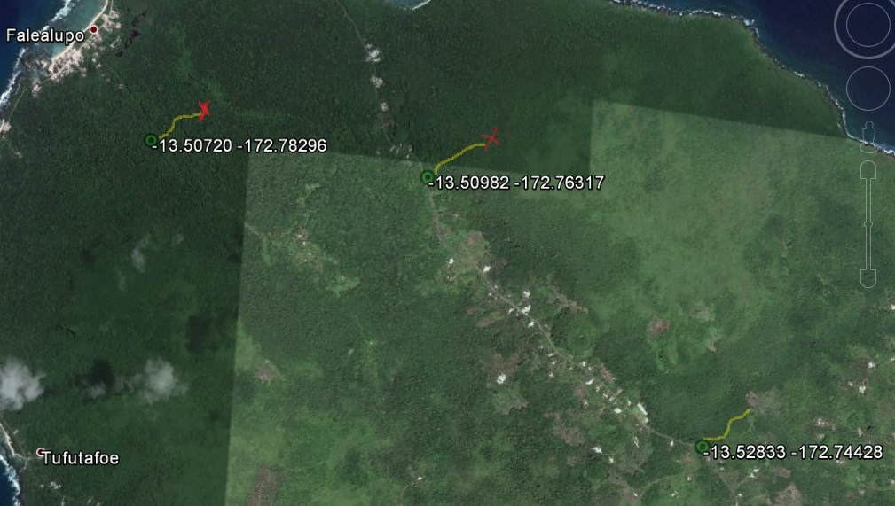
Figure 10. Short surveys within Falealupo forest (FP KBA), refer to Fig. 2 for geographic reference, North direction is up. Three short hikes led by selected reliable hunter Afaese on day 21 June 2016. First green circle from the left: the start of the hike across Kapau forest while the yellow line is the actual track followed. Second green circle from the left: the start of the hike across Vautele reserve. Green circle to the right: the start of the hike across Vaiala forest. Each hike took about 2 hours of slow easy hiking. Two red crosses: the locations where automatic sound recorders were deployed following recommendations by Afaese.

