Supplementary Material

Drivers of bird diversity in an understudied African centre of endemism: The Angolan Central Escarpment Forest

AIMY CÁCERES, MARTIM MELO, JOS BARLOW, RICARDO FAUSTINO DE LIMA and MICHAEL S. L. MILLS

Contents
Figure S1. Pair plots and correlation coefficients for explanatory variables.
Figure S2. Map of residuals from generalized linear models of (A) Species Richness, presence of (B) Red-crested Turaco, (C) Gabela Akalat and (D) Gabela Bushshrike.
Table S1. Environmental variables obtained through vegetation surveys (ground variables) and remote sensing.
Table S2. Results of Pearson-based Mantel test with 1000 permutations.
Table S3. Set of models generated for species richness.
Table S4. Complete set of models generated for Red-crested Turaco presence.
Table S5. Complete set of models generated for Gabela Akalat presence.
Table S6. Complete set of models generated for Gabela Bushshrike presence.

Figure S1. Pair plots and correlation coefficients for explanatory variables, elev – elevation, cc – canopy cover, ch – canopy height, shrub – shrub cover, ld – liana density, c – carbon, xfor – forest cover percent, LSWI – land surface water index, EVI – enhanced vegetation index, BR – blue-red ratio index (n= 132 sample points).

Figure S2. Map of residuals from generalized linear models of (A) Species Richness, presence of (B) Red-crested Turaco, (C) Gabela Akalat and (D) Gabela Bushshrike. Black dots represent the sample points (N=201) and their size is proportional to the absolute value of residuals. No pattern is observed with the residuals so there is no influence of spatial location on model residuals.
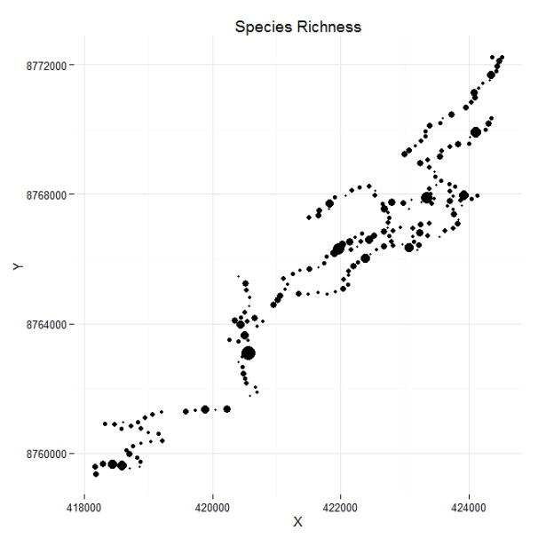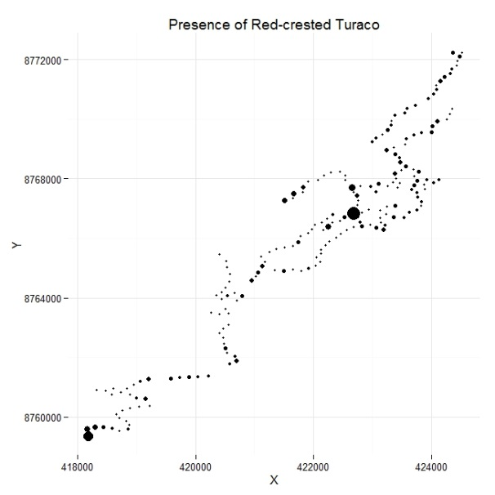
(C)
(B)
(A)
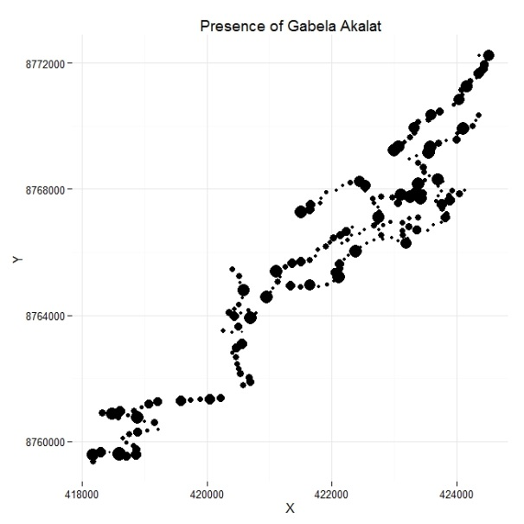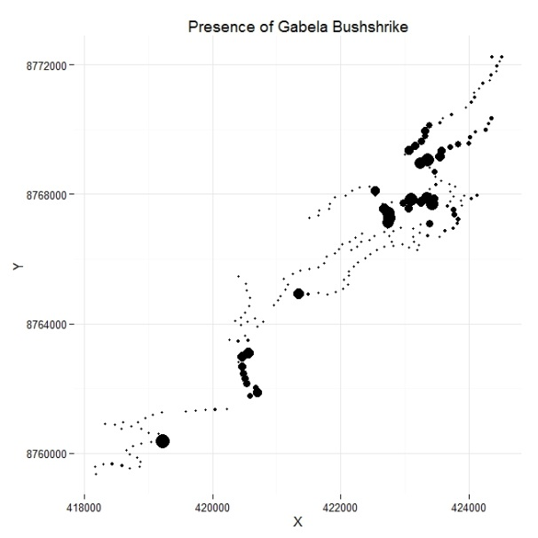
(D)

Table S1. Environmental variables obtained through vegetation surveys (ground variables) and remote sensing.
Variables | Description | Unit | Group
Elevation (elev) | Elevation at each sample point | Meters | Ground
Canopy Cover (cc) | Percent of canopy cover | % | Ground
Canopy Height (ch) | Maximum visible height of the canopy | meters | Ground
Shrub cover (shrub) | Percent of vegetation cover at shrub level (0.15 – 1.5) | % | Ground
Liana density (ld) | Number of lianas in a 10 m transect | #lianas/meter | Ground
Above-ground carbon (c) | Carbon per area estimated from above-ground biomass (AGB) | Mg/ha | Ground
Land Surface Water Index (LSWI) | Proportion between Near Infrared (NIR) and Short Wave Infrared (SWIR) bands and represents the amount of moisture present in the leaves and soil | --- | Remote sensing
Blue- Red Ratio Index (BR) | Normalized difference between Blue and Red bands and represents the shadow produced by the canopy | --- | Remote sensing
Enhanced Vegetation Index (EVI) | Optimizes vegetation signal in high biomass areas and reduces atmosphere influences | --- | Remote sensing
Forest Cover (xfor) | Percent of the forest mask in a 50 m circular plot around each sample point | % | Remote sensing

Table S2. Results of Pearson-based Mantel test with 1000 permutations. Only the presence of Red-crested Turaco was significant (p-value < 0.05) presenting some spatial autocorrelation.
 | Values
Species Richness | r = -0.05, P = 0.951
Red-crested Turaco | r = 0.04, P = 0.032
Gabela Akalat | r = 0.007, P = 0.147
Gabela Bushshrike | r = -0.02, P = 0.703

Table S3. Set of models generated for species richness. Here are listed all possible variables in the models, followed by degrees of freedom (df), model log-likelihood (logLik), Akaike´s Information Criterion with small sample size correction (AICc), AIC differences (ΔAICc), Akaike weights (ω) and adjusted coefficient of determination (adjR²). c – carbon, cc – canopy cover, elev – elevation, ld – liana density, shrub – shrub cover.
 | (Intercept) | c | cc | elev | ld | shrub | df | logLik | AICc | ΔAICc | ω | adjR²
11 | -6.05E-17 | NA | 0.278872 | NA | 0.223486 | NA | 4 | -268.41 | 545.02 | 0 | 3.65E-01 | 0.159
15 | 1.82E-17 | NA | 0.288224 | 4.41E-02 | 0.213701 | NA | 5 | -268.20 | 546.70 | 1.68 | 1.57E-01 | 0.161
27 | -3.26E-17 | NA | 0.288467 | NA | 0.23137 | -0.0310208 | 5 | -268.32 | 546.94 | 1.92 | 1.40E-01 | 0.160
12 | -5.96E-17 | 0.0243281 | 0.269525 | NA | 0.22443 | NA | 5 | -268.35 | 547.01 | 1.98 | 1.35E-01 | 0.160
16 | -1.17E-17 | 0.0251605 | 0.278651 | 4.45E-02 | 0.214581 | NA | 6 | -268.13 | 548.70 | 3.68 | 5.80E-02 | 0.162
31 | 1.09E-17 | NA | 0.293887 | 3.95E-02 | 0.22017 | -0.0214498 | 6 | -268.16 | 548.74 | 3.72 | 5.68E-02 | 0.161
28 | -3.17E-17 | 0.0253971 | 0.278987 | NA | 0.232584 | -0.0319177 | 6 | -268.25 | 548.94 | 3.91 | 5.16E-02 | 0.160
32 | -1.92E-17 | 0.0258184 | 0.284286 | 3.97E-02 | 0.221328 | -0.0222967 | 7 | -268.09 | 550.76 | 5.73 | 2.08E-02 | 0.162
3 | -3.06E-17 | NA | 0.318272 | NA | NA | NA | 3 | -273.97 | 554.07 | 9.04 | 3.97E-03 | 0.108
7 | 6.79E-17 | NA | 0.334109 | 9.15E-02 | NA | NA | 4 | -273.06 | 554.32 | 9.30 | 3.48E-03 | 0.116
19 | -2.68E-17 | NA | 0.306187 | NA | NA | 0.03412842 | 4 | -273.86 | 555.92 | 10.90 | 1.57E-03 | 0.109
23 | 8.14E-17 | NA | 0.317608 | 9.88E-02 | NA | 0.05019416 | 5 | -272.82 | 555.94 | 10.92 | 1.55E-03 | 0.119
4 | -3.00E-17 | 0.0144865 | 0.312806 | NA | NA | NA | 4 | -273.95 | 556.11 | 11.09 | 1.43E-03 | 0.108
8 | 6.91E-17 | 0.017098 | 0.327731 | 9.19E-02 | NA | NA | 5 | -273.03 | 556.37 | 11.35 | 1.25E-03 | 0.117
20 | -5.77E-17 | 0.0137324 | 0.301111 | NA | NA | 0.03382825 | 5 | -273.84 | 557.99 | 12.97 | 5.58E-04 | 0.109
24 | 8.24E-17 | 0.0161929 | 0.311665 | 9.92E-02 | NA | 0.04989933 | 6 | -272.79 | 558.02 | 12.99 | 5.50E-04 | 0.119
10 | -1.35E-17 | 0.1247417 | NA | NA | 0.269043 | NA | 4 | -275.24 | 558.68 | 13.66 | 3.94E-04 | 0.096
9 | -1.62E-17 | NA | NA | NA | 0.272651 | NA | 3 | -276.94 | 560.01 | 14.98 | 2.03E-04 | 0.079
26 | -4.06E-17 | 0.118156 | NA | NA | 0.255109 | 0.04575508 | 5 | -275.04 | 560.38 | 15.36 | 1.69E-04 | 0.097
14 | -5.04E-17 | 0.1242563 | NA | -5.10E-03 | 0.27 | NA | 5 | -275.24 | 560.78 | 15.76 | 1.38E-04 | 0.096
25 | -1.01E-17 | NA | NA | NA | 0.252728 | 0.06453756 | 4 | -276.53 | 561.27 | 16.25 | 1.08E-04 | 0.083
13 | -3.50E-17 | NA | NA | -1.73E-02 | 0.275851 | NA | 4 | -276.91 | 562.03 | 17.00 | 7.41E-05 | 0.079
30 | -1.28E-18 | 0.1185526 | NA | 7.22E-03 | 0.253142 | 0.04777122 | 6 | -275.03 | 562.49 | 17.47 | 5.86E-05 | 0.098
29 | -4.13E-17 | NA | NA | 8.31E-05 | 0.252705 | 0.06456148 | 5 | -276.53 | 563.37 | 18.35 | 3.78E-05 | 0.083
18 | -1.45E-18 | 0.1133933 | NA | NA | NA | 0.12523491 | 4 | -281.35 | 570.89 | 25.87 | 8.79E-07 | 0.035
17 | -2.27E-18 | NA | NA | NA | NA | 0.14255481 | 3 | -282.64 | 571.41 | 26.38 | 6.81E-07 | 0.022
22 | 4.74E-17 | 0.117747 | NA | 7.25E-02 | NA | 0.13933008 | 5 | -280.82 | 571.95 | 26.93 | 5.18E-07 | 0.040
2 | -1.28E-17 | 0.1325219 | NA | NA | NA | NA | 3 | -282.92 | 571.97 | 26.95 | 5.13E-07 | 0.019
21 | 6.99E-17 | NA | NA | 6.53E-02 | NA | 0.15584955 | 4 | -282.22 | 572.65 | 27.63 | 3.66E-07 | 0.026
1 | -1.57E-17 | NA | NA | NA | NA | NA | 2 | -284.71 | 573.47 | 28.45 | 2.42E-07 | 0.000
6 | 3.71E-17 | 0.136637 | NA | 4.59E-02 | NA | NA | 4 | -282.71 | 573.63 | 28.60 | 2.24E-07 | 0.021
5 | 2.08E-17 | NA | NA | 3.36E-02 | NA | NA | 3 | -284.59 | 575.31 | 30.28 | 9.68E-08 | 0.001

Table S4. Complete set of models generated for Red-crested Turaco presence. Here are listed all possible variables in the models, followed by degrees of freedom (df), model log-likelihood (logLik), Akaike´s Information Criterion with small sample size correction (AICc), AIC differences (ΔAICc), Akaike weights (ω) and adjusted coefficient of determination (adjR2). c – carbon, cc – canopy cover, elev – elevation, ld – liana density, shrub – shrub cover and slope.
 | (Intercept) | c | cc | elev | ld | shrub | df | logLik | AICc | ΔAICc | ω | adjR²
14 | 0.8060029 | -0.28415 | NA | -0.5277 | 0.45433 | NA | 4 | -117.87 | 243.94 | 0.00 | 0.2989 | 0.115
13 | 0.7896822 | NA | NA | -0.4884 | 0.426913 | NA | 3 | -119.61 | 245.34 | 1.41 | 0.1479 | 0.093
16 | 0.8091374 | -0.33095 | 0.130981 | -0.50834 | 0.425815 | NA | 5 | -117.60 | 245.51 | 1.58 | 0.1358 | 0.118
30 | 0.8059233 | -0.28182 | NA | -0.53181 | 0.460689 | -0.01731 | 5 | -117.86 | 246.03 | 2.09 | 0.1049 | 0.115
29 | 0.7903613 | NA | NA | -0.50531 | 0.452329 | -0.06451 | 4 | -119.54 | 247.28 | 3.35 | 0.0561 | 0.094
15 | 0.7897053 | NA | -0.00798 | -0.49004 | 0.429013 | NA | 4 | -119.61 | 247.42 | 3.49 | 0.0523 | 0.093
32 | 0.8096766 | -0.3302 | 0.150118 | -0.52022 | 0.444314 | -0.06041 | 6 | -117.55 | 247.53 | 3.59 | 0.0496 | 0.119
6 | 0.775076 | -0.25686 | NA | -0.44407 | NA | NA | 3 | -121.22 | 248.55 | 4.62 | 0.0297 | 0.072
8 | 0.7831896 | -0.3373 | 0.222742 | -0.42048 | NA | NA | 4 | -120.42 | 249.03 | 5.10 | 0.0234 | 0.082
31 | 0.7903913 | NA | 0.012466 | -0.5038 | 0.450655 | -0.06844 | 5 | -119.54 | 249.38 | 5.44 | 0.0197 | 0.094
5 | 0.7628697 | NA | NA | -0.4139 | NA | NA | 2 | -122.67 | 249.40 | 5.46 | 0.0195 | 0.052
22 | 0.7786386 | -0.27643 | NA | -0.42253 | NA | 0.133605 | 4 | -120.88 | 249.97 | 6.04 | 0.0146 | 0.076
24 | 0.7837762 | -0.33769 | 0.196869 | -0.41133 | NA | 0.070745 | 5 | -120.33 | 250.97 | 7.03 | 0.0089 | 0.083
21 | 0.7644519 | NA | NA | -0.39786 | NA | 0.087576 | 3 | -122.52 | 251.16 | 7.22 | 0.0081 | 0.054
7 | 0.7643647 | NA | 0.083932 | -0.40104 | NA | NA | 3 | -122.53 | 251.19 | 7.25 | 0.0080 | 0.054
23 | 0.7650971 | NA | 0.060941 | -0.39232 | NA | 0.066439 | 4 | -122.45 | 253.11 | 9.18 | 0.0030 | 0.055
10 | 0.7657008 | -0.21697 | NA | NA | 0.333743 | NA | 3 | -123.58 | 253.29 | 9.35 | 0.0028 | 0.040
9 | 0.7583267 | NA | NA | NA | 0.320847 | NA | 2 | -124.67 | 253.39 | 9.46 | 0.0026 | 0.025
12 | 0.7712924 | -0.3006 | 0.222852 | NA | 0.291848 | NA | 4 | -122.74 | 253.67 | 9.74 | 0.0023 | 0.051
4 | 0.7552993 | -0.30865 | 0.276285 | NA | NA | NA | 3 | -124.18 | 254.49 | 10.55 | 0.0015 | 0.032
26 | 0.7681303 | -0.23736 | NA | NA | 0.29385 | 0.126452 | 4 | -123.28 | 254.77 | 10.83 | 0.0013 | 0.044
1 | 0.7382676 | NA | NA | NA | NA | NA | 1 | -126.51 | 255.04 | 11.10 | 0.0012 | 0.000
11 | 0.7591609 | NA | 0.096838 | NA | 0.299787 | NA | 3 | -124.47 | 255.07 | 11.13 | 0.0011 | 0.028
2 | 0.7445415 | -0.20491 | NA | NA | NA | NA | 2 | -125.53 | 255.12 | 11.18 | 0.0011 | 0.014
25 | 0.7588277 | NA | NA | NA | 0.293473 | 0.081135 | 3 | -124.54 | 255.19 | 11.26 | 0.0011 | 0.027
18 | 0.7523067 | -0.23906 | NA | NA | NA | 0.208455 | 3 | -124.64 | 255.41 | 11.47 | 0.0010 | 0.026
28 | 0.7715715 | -0.30253 | 0.201082 | NA | 0.274664 | 0.065443 | 5 | -122.66 | 255.63 | 11.69 | 0.0009 | 0.052
20 | 0.7576382 | -0.31121 | 0.226602 | NA | NA | 0.134417 | 4 | -123.85 | 255.90 | 11.97 | 0.0008 | 0.036
17 | 0.743033 | NA | NA | NA | NA | 0.1645 | 2 | -125.92 | 255.91 | 11.97 | 0.0008 | 0.008
3 | 0.7422525 | NA | 0.149045 | NA | NA | NA | 2 | -126.03 | 256.13 | 12.19 | 0.0007 | 0.007
27 | 0.7592288 | NA | 0.079075 | NA | 0.285306 | 0.053459 | 4 | -124.42 | 257.05 | 13.11 | 0.0004 | 0.029
19 | 0.7445153 | NA | 0.103022 | NA | NA | 0.126524 | 3 | -125.73 | 257.58 | 13.64 | 0.0003 | 0.011
Table S5. Complete set of models generated for Gabela Akalat presence. Here are listed all possible variables in the models, followed by degrees of freedom (df), model log-likelihood (logLik), Akaike´s Information Criterion with small sample size correction (AICc), AIC differences (ΔAICc), Akaike weights (ω) and adjusted coefficient of determination (adjR2). c – carbon, cc – canopy cover, elev – elevation, ld – liana density, shrub – shrub cover and slope.

 | (Intercept) | c | cc | elev | ld | shrub | df | logLik | AICc | ΔAICc | ω | adjR²
3 | -0.172006 | NA | 0.287602 | NA | NA | NA | 2 | -136.58 | 277.22 | 0.0000 | 0.1459 | 0.0266
7 | -0.173917 | NA | 0.318783 | 0.1703981 | NA | NA | 3 | -135.89 | 277.91 | 0.6899 | 0.1033 | 0.0356
4 | -0.172524 | -0.1601 | 0.349397 | NA | NA | NA | 3 | -136.05 | 278.23 | 1.0118 | 0.0880 | 0.0335
19 | -0.172913 | NA | 0.334877 | NA | NA | -0.12944199 | 3 | -136.23 | 278.59 | 1.3711 | 0.0735 | 0.0311
8 | -0.17463 | -0.157 | 0.37895 | 0.1676578 | NA | NA | 4 | -135.39 | 278.99 | 1.7734 | 0.0601 | 0.0420
1 | -0.169559 | NA | NA | NA | NA | NA | 1 | -138.60 | 279.23 | 2.0077 | 0.0535 | 0.0000
11 | -0.171935 | NA | 0.290764 | NA | -0.0178112 | NA | 3 | -136.57 | 279.26 | 2.0462 | 0.0524 | 0.0267
23 | -0.174597 | NA | 0.354432 | 0.1558818 | NA | -0.10488782 | 4 | -135.67 | 279.55 | 2.3341 | 0.0454 | 0.0384
20 | -0.173091 | -0.1579 | 0.395052 | NA | NA | -0.12647107 | 4 | -135.73 | 279.65 | 2.4365 | 0.0431 | 0.0377
15 | -0.173803 | NA | 0.331443 | 0.1834227 | -0.0584975 | NA | 4 | -135.82 | 279.84 | 2.6191 | 0.0394 | 0.0365
12 | -0.172442 | -0.1612 | 0.354188 | NA | -0.0243464 | NA | 4 | -136.04 | 280.28 | 3.0662 | 0.0315 | 0.0337
5 | -0.169964 | NA | NA | 0.1125428 | NA | NA | 2 | -138.29 | 280.64 | 3.4192 | 0.0264 | 0.0042
27 | -0.172974 | NA | 0.333724 | NA | 0.01537885 | -0.13380611 | 4 | -136.23 | 280.66 | 3.4431 | 0.0261 | 0.0312
24 | -0.175024 | -0.155 | 0.412801 | 0.153154 | NA | -0.10173349 | 5 | -135.19 | 280.68 | 3.4659 | 0.0258 | 0.0446
16 | -0.174551 | -0.1597 | 0.393959 | 0.1818903 | -0.0644161 | NA | 5 | -135.30 | 280.91 | 3.6926 | 0.0230 | 0.0432
9 | -0.1696 | NA | NA | NA | 0.03298837 | NA | 2 | -138.58 | 281.21 | 3.9941 | 0.0198 | 0.0004
2 | -0.16959 | -0.0256 | NA | NA | NA | NA | 2 | -138.59 | 281.23 | 4.0159 | 0.0196 | 0.0002
17 | -0.169562 | NA | NA | NA | NA | -0.00715844 | 2 | -138.60 | 281.26 | 4.0457 | 0.0193 | 0.0000
31 | -0.174518 | NA | 0.357713 | 0.1641465 | -0.0309308 | -0.09477234 | 5 | -135.65 | 281.62 | 4.3993 | 0.0162 | 0.0386
28 | -0.173116 | -0.1575 | 0.394313 | NA | 0.00772156 | -0.12866272 | 5 | -135.72 | 281.76 | 4.5376 | 0.0151 | 0.0377
21 | -0.169973 | NA | NA | 0.1158896 | NA | 0.01647524 | 3 | -138.28 | 282.69 | 5.4676 | 0.0095 | 0.0043
6 | -0.169976 | -0.0156 | NA | 0.1111498 | NA | NA | 3 | -138.28 | 282.69 | 5.4685 | 0.0095 | 0.0043
13 | -0.169978 | NA | NA | 0.110199 | 0.01272871 | NA | 3 | -138.28 | 282.69 | 5.4726 | 0.0095 | 0.0042
32 | -0.174969 | -0.1568 | 0.417573 | 0.1633874 | -0.0383237 | -0.08916282 | 6 | -135.16 | 282.75 | 5.5327 | 0.0092 | 0.0450
10 | -0.169632 | -0.0266 | NA | NA | 0.03375971 | NA | 3 | -138.56 | 283.24 | 6.0204 | 0.0072 | 0.0006
25 | -0.169614 | NA | NA | NA | 0.03891877 | -0.01921298 | 3 | -138.57 | 283.26 | 6.0387 | 0.0071 | 0.0005
18 | -0.16959 | -0.0251 | NA | NA | NA | -0.00333739 | 3 | -138.59 | 283.29 | 6.0766 | 0.0070 | 0.0002
22 | -0.169988 | -0.0182 | NA | 0.1147863 | NA | 0.01902689 | 4 | -138.27 | 284.75 | 7.5339 | 0.0034 | 0.0044
14 | -0.169992 | -0.0163 | NA | 0.1086087 | 0.01350137 | NA | 4 | -138.28 | 284.76 | 7.5420 | 0.0034 | 0.0043
29 | -0.16998 | NA | NA | 0.1138647 | 0.00785067 | 0.01362709 | 4 | -138.28 | 284.77 | 7.5472 | 0.0034 | 0.0043
26 | -0.169642 | -0.0244 | NA | NA | 0.03843925 | -0.01535624 | 4 | -138.55 | 285.31 | 8.0923 | 0.0026 | 0.0007
30 | -0.169995 | -0.0182 | NA | 0.1127779 | 0.00779286 | 0.01619608 | 5 | -138.27 | 286.85 | 9.6350 | 0.0012 | 0.0044

Table S6. Complete set of models generated for Gabela Bushshrike presence. Here are listed all possible variables in the models, followed by degrees of freedom (df), model log-likelihood (logLik), Akaike´s Information Criterion with small sample size correction (AICc), AIC differences (ΔAICc), Akaike weights (ω) and adjusted coefficient of determination (adjR2). c – carbon, cc – canopy cover, elev – elevation, ld – liana density, shrub – shrub cover and slope.

 | (Intercept) | c | cc | elev | ld | shrub | df | logLik | AICc | ΔAICc | ω | adjR²
15 | -1.398236 | NA | 0.301902 | 0.4113347 | -0.3309844 | NA | 4 | -99.10 | 206.40 | 0.0000 | 0.0964 | 0.0598
5 | -1.357536 | NA | NA | 0.3049394 | NA | NA | 2 | -101.34 | 206.74 | 0.3374 | 0.0815 | 0.0259
13 | -1.373097 | NA | NA | 0.3415879 | -0.2557456 | NA | 3 | -100.44 | 207.01 | 0.6071 | 0.0712 | 0.0396
16 | -1.413335 | -0.2544 | 0.39607 | 0.4108218 | -0.3404305 | NA | 5 | -98.35 | 207.01 | 0.6086 | 0.0711 | 0.0709
7 | -1.373926 | NA | 0.23694 | 0.351059 | NA | NA | 3 | -100.48 | 207.09 | 0.6864 | 0.0684 | 0.0390
8 | -1.387632 | -0.2412 | 0.321901 | 0.3491518 | NA | NA | 4 | -99.81 | 207.82 | 1.4187 | 0.0474 | 0.0491
23 | -1.388341 | NA | 0.320165 | 0.3256553 | NA | -0.2321732 | 4 | -99.85 | 207.90 | 1.5008 | 0.0455 | 0.0485
31 | -1.40452 | NA | 0.347771 | 0.387927 | -0.2921182 | -0.142274 | 5 | -98.88 | 208.07 | 1.6623 | 0.0420 | 0.0630
1 | -1.331235 | NA | NA | NA | NA | NA | 1 | -103.03 | 208.07 | 1.6691 | 0.0419 | 0.0000
6 | -1.361132 | -0.1116 | NA | 0.2960127 | NA | NA | 3 | -101.17 | 208.46 | 2.0542 | 0.0345 | 0.0286
21 | -1.360766 | NA | NA | 0.2856214 | NA | -0.1043661 | 3 | -101.18 | 208.47 | 2.0710 | 0.0342 | 0.0284
24 | -1.400485 | -0.2334 | 0.396045 | 0.324697 | NA | -0.2224435 | 5 | -99.22 | 208.75 | 2.3470 | 0.0298 | 0.0579
32 | -1.417767 | -0.2467 | 0.431857 | 0.3896167 | -0.3043064 | -0.1259983 | 6 | -98.18 | 208.79 | 2.3871 | 0.0292 | 0.0734
14 | -1.375457 | -0.0952 | NA | 0.3325843 | -0.2489949 | NA | 4 | -100.32 | 208.84 | 2.4364 | 0.0285 | 0.0415
29 | -1.373174 | NA | NA | 0.3375884 | -0.2495146 | -0.016142 | 4 | -100.44 | 209.09 | 2.6824 | 0.0252 | 0.0396
9 | -1.341427 | NA | NA | NA | -0.1891151 | NA | 2 | -102.52 | 209.10 | 2.6965 | 0.0250 | 0.0078
3 | -1.338524 | NA | 0.158829 | NA | NA | NA | 2 | -102.60 | 209.26 | 2.8539 | 0.0231 | 0.0066
17 | -1.338804 | NA | NA | NA | NA | -0.1619511 | 2 | -102.60 | 209.26 | 2.8551 | 0.0231 | 0.0066
19 | -1.357747 | NA | 0.263556 | NA | NA | -0.2753955 | 3 | -101.63 | 209.39 | 2.9823 | 0.0217 | 0.0215
2 | -1.336622 | -0.1371 | NA | NA | NA | NA | 2 | -102.75 | 209.56 | 3.1563 | 0.0199 | 0.0043
11 | -1.352373 | NA | 0.193833 | NA | -0.2295315 | NA | 3 | -101.89 | 209.91 | 3.5025 | 0.0167 | 0.0175
4 | -1.351528 | -0.2368 | 0.24193 | NA | NA | NA | 3 | -101.90 | 209.92 | 3.5192 | 0.0166 | 0.0174
20 | -1.368577 | -0.2277 | 0.336807 | NA | NA | -0.2656065 | 4 | -100.99 | 210.19 | 3.7891 | 0.0145 | 0.0312
22 | -1.363501 | -0.0984 | NA | 0.2802926 | NA | -0.0906465 | 4 | -101.05 | 210.30 | 3.8916 | 0.0138 | 0.0304
12 | -1.366488 | -0.2464 | 0.283608 | NA | -0.2398944 | NA | 4 | -101.13 | 210.47 | 4.0672 | 0.0126 | 0.0291
10 | -1.346017 | -0.1292 | NA | NA | -0.1834383 | NA | 3 | -102.27 | 210.66 | 4.2600 | 0.0115 | 0.0117
27 | -1.365408 | NA | 0.275379 | NA | -0.1751394 | -0.2288855 | 4 | -101.26 | 210.72 | 4.3152 | 0.0111 | 0.0272
25 | -1.344612 | NA | NA | NA | -0.1497134 | -0.1165171 | 3 | -102.32 | 210.75 | 4.3498 | 0.0110 | 0.0110
30 | -1.375458 | -0.0949 | NA | 0.3320384 | -0.2481048 | -0.0023212 | 5 | -100.32 | 210.94 | 4.5399 | 0.0100 | 0.0415
18 | -1.342391 | -0.1138 | NA | NA | NA | -0.144346 | 3 | -102.42 | 210.95 | 4.5483 | 0.0099 | 0.0095
28 | -1.376881 | -0.2351 | 0.353297 | NA | -0.1863945 | -0.214554 | 5 | -100.57 | 211.46 | 5.0525 | 0.0077 | 0.0376
26 | -1.348002 | -0.1137 | NA | NA | -0.1500997 | -0.0979178 | 4 | -102.13 | 212.46 | 6.0604 | 0.0047 | 0.0138

