Supplementary Material

Habitat selection, home range and population size of Baillon’s Crake Zapornia pusilla in the Senegal Delta, north-west Senegal

NINA SEIFERT, COSIMA TEGETMEYER and ANGELA SCHMITZ ORNÉS

Contents

Appendix S1. Summary of models for a) predicting presence probability and b) density of Baillon’s Crakes.

Appendix S2. Fixed kernel 95% home ranges of six Baillon’s Crakes radio-tracked at study site Grand Lac.

Appendix S3. Fixed kernel 95% home ranges of ten Baillon’s Crakes radio-tracked at study site Tiguet.

Appendix S1. Summary of models for a) predicting presence probability and b) density of Baillon’s Crakes. We present intermediate steps in backward model selection based on Akaike’s information criterion corrected for small sample sizes (AICc).

- Binomial model:

Global model:
P_A~TYPHA.sc+ELEO.sc+SCL.sc+ORYZA.sc+SPORO.sc+WOOD.sc+EdgeTYPH.sc+EdgeSCL.sc+EdgeELE.sc+EdgeORY.sc+(1|Site)

 | TYPHA | ELEO | SCM | SCL | ORYZA | SPORO | WOOD | EdgeTYPH | EdgeSCL | EdgeELE | EdgeORY |  | (1|Site) | df | AICc
mod1.4 | x | x |  | x | x | x | x | x | x | x | x |  | x | 12 | 153.243
mod2.4 | x | x | x | x |  |  | x | x | x | x | x |  | x | 11 | 150.711
mod3.7 | x | x | x | x |  |  | x | x |  | x | x |  | x | 10 | 149.003
mod4.5 | x | x | x | x |  |  |  | x |  | x | x |  | x | 9 | 147.623
mod5.3 | x | x |  | x |  |  |  | x |  | x | x |  | x | 8 | 147.222
mod6.5 | x | x |  | x |  |  |  | x |  |  | x |  | x | 7 | 145.053
mod7.2 | x |  |  | x |  |  |  | x |  |  | x |  | x | 6 | 143.848

- Poisson model

Global model:
Captures~TYPHA.sc+ELEO.sc+SCM.sc+SCL.sc+ORYZA.sc+SPORO.sc+WOOD.sc+EdgeTYPH.sc+EdgeSCL.sc+EdgeELE.sc+EdgeORY.sc+
EdgeWood.sc+(1|Site)

 | TYPHA | ELEO | SCM | SCL | ORYZA | SPORO | WOOD | EdgeTYPH | EdgeSCL | EdgeELE | EdgeORY | EdgeWood | (1|Site) | df | AICc
mod 1.4 | x | x | x |  | x | x | x | x | x | x | x | x | x | 13 | 181.156
mod 2.8 | x | x | x |  | x | x | x | x |  | x | x | x | x | 12 | 176.110
mod3.4 | x | x | x |  |  | x | x | x |  | x | x | x | x | 11 | 173.714
mod4.9 | x | x | x |  |  | x | x | x |  | x | x |  | x | 10 | 172.015
mod5.4 | x | x | x |  |  |  | x | x |  | x | x |  | x | 9 | 171.889
mod6.5 | x | x | x |  |  |  | x |  |  | x | x |  | x | 8 | 171.391
mod7.4 | x | x | x |  |  |  |  |  |  | x | x |  | x | 7 | 170.033

Appendix S2. Fixed kernel 95% home ranges of six Baillon’s Crakes radio-tracked at study site Grand Lac. Home range of individual 150063 consists of two separated polygons (dashed line). Vegetation map based on aerial photos taken from December 2009–February 2010.

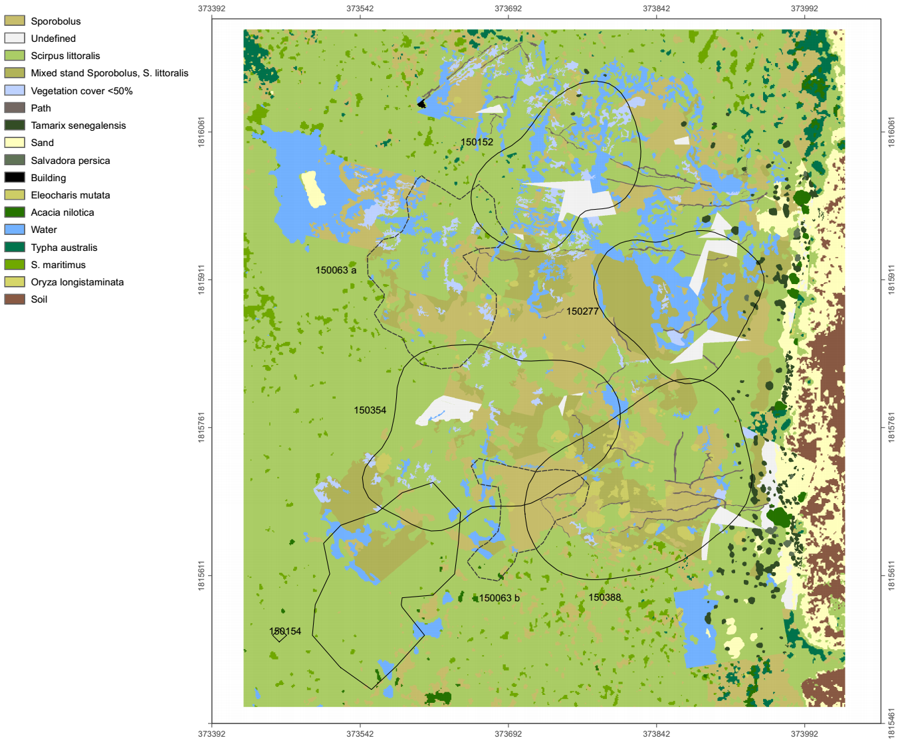

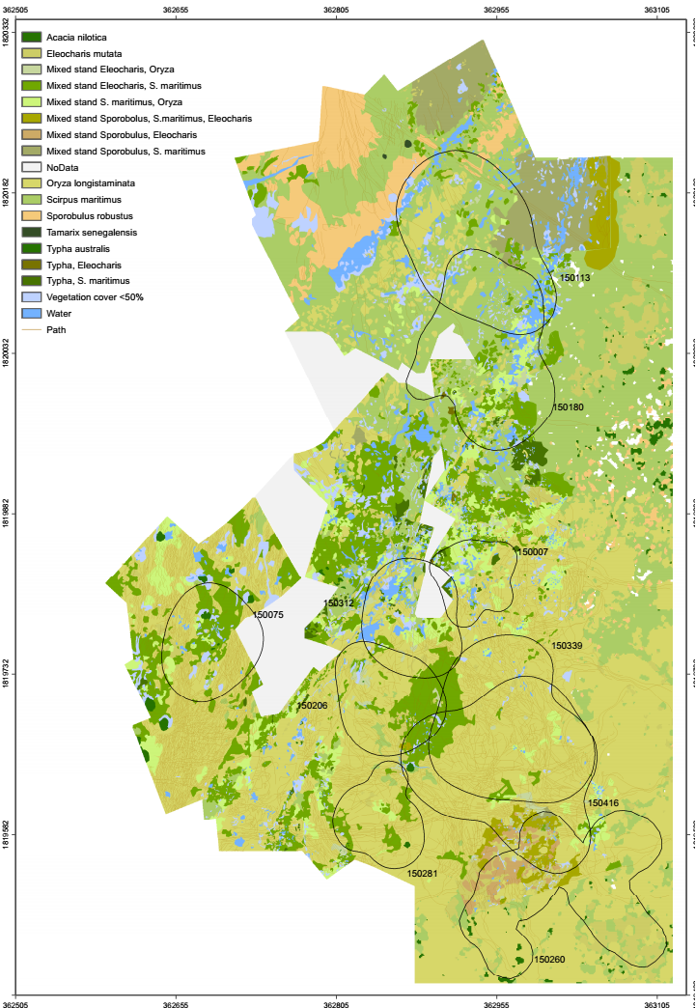
Appendix S3. Fixed kernel 95% home ranges of ten Baillon’s Crakes radio-tracked at study site Tiguet. Vegetation map based on aerial photos taken from December 2009–February 2010.

