Supplementary Material
Avian population trends in Scalesia forest on Floreana Island (2004-2013): Acoustical surveys cannot detect hybrids of Darwin’s Tree Finches Camarhynchus spp.
KATHARINA J. PETERS and SONIA KLEINDORFER

Contents
Extended methods
Extended results
Table S1
Table S2.
Table S3.
Table S4.
Figure S1.
Figure S2.
Figure S3.
Figure S4.

Appendix S1. Extended methods
Sample collection for genetic analyses
We captured and measured a total of 368 adult tree finches using 6 x 12m mist-nets between 06h00 and 11h00 from February to April 2004, 2005, 2006, 2008, 2010, 2012, 2013 and 2014. At the time of capture, we measured birds, collected a blood sample for subsequent genetic analysis, and banded each bird with a numbered aluminium band and a distinct combination of coloured plastic bands. We measured the following morphological variables to the nearest 0.1 mm using a caliper: beak length head, beak length, beak length naris, beak depth, beak width and tarsus length. Wing length was measured to the nearest mm using a wing ruler. Measurements were taken by S.K., J.O’C. and K.J.P. (all banders were annually calibrated against S.K. to maintain consistency across years). The blood samples (10μl) were immediately transferred to Whatman Classic FTA® paper for DNA preservation (2004, N = 4; 2005, N = 87; 2006, N = 11; 2008, N = 4; 2010; N = 89; 2012, N = 32; 2013, N = 82; 2014, N = 59). For this study, we only analyse data from adult birds to minimize genetic relatedness between individuals within years.
DNA extraction, genotyping and locus characteristics
We extracted the DNA samples from Whatman Classic FTA® paper using a modification (200 μl volumes used for all washes) of method #4 from Smith and Burgoyne (2004). Each individual was genotyped at 11 microsatellite loci designed for Geospiza fuliginosa: Gf1, Gf3, Gf4, Gf5, Gf6, Gf7, Gf9, Gf11, Gf12, Gf13, Gf15 (Petren, 1998). We performed PCR amplification following the exact method described in Galligan et al. (2012). Due to lack of sufficient amplification across individuals, we excluded the microsatellite loci Gf9 and Gf15 from further analysis. We also excluded eleven individuals that failed to amplify at more than three loci. We subsequently analysed a total of 357 individuals at nine microsatellite loci. Genotypes were analysed on an ABI 3770 (Applied Biosystems) automated sequencer and scored using Genemapper® Software 4.0 (Applied Biosystems) with manual editing. All samples were scored by KJP under the supervision of SAM.
Exploratory analysis
We assigned individuals to one of two putative populations based on morphology and in accordance with results of O’Connor (O'Connor, 2012). In putative population 1 (C. parvulus phenotype) we included all individuals with beak length naris < 8.2, and in putative population 2 (C. pauper phenotype) all individuals with beak length naris ≥ 8.2. Putative populations were used for exploratory analysis using GenAlEx 6.5 (Peakall & Smouse, 2006; 2012)and Bayesian clustering analyses using the LOCPRIOR model in STRUCTURE 2.3.4(Pritchard et al., 2000; Hubisz et al., 2009). We then performed tests of Hardy-Weinberg Equilibrium (HWE) per locus and putative population using GenePop 4.2 with Bonferroni correction (Rice, 1989). We tested for linkage disequilibrium at each locus using GenePop 4.2 and evaluated significance (P = 0.01) after Bonferroni correction. Data were checked for neutrality by estimating the mean F_{ST} and calculating the confidence intervals using LOSITAN (Antao et al., 2008).
COLONY analysis
Because the inclusion of directly related individuals can hamper genetic analyses, we used the software COLONY 2.0 (Jones & Wang, 2010) to identify putative close relatives; parents, offspring, and full siblings. COLONY can reconstruct sib-ship and paternity while accommodating for class I errors (allelic dropouts) and class II errors (typing errors which could stem from contaminated DNA, allele identification error, false alleles, mutations) and can result in incorrect relationship inference if not accounted for. We used all nine loci for COLONY analysis with locus-specific error rates, which ranged from 1 – 9% across loci. We only detected class II errors in our dataset. Error rates were determined by repeated genotyping of 116 individuals. Based on COLONY results, we restructured our original data into three new datasets, aiming to minimize the amount of closely related individuals and retaining only the parents (dataset 1), one offspring of each family (dataset 2) the other offspring of each family (dataset 3). Comparing results of HWE tests and F_{ST} estimates between datasets 1-3 and our initial dataset containing all individuals showed very little difference, suggesting that inclusion of putatively closely related individuals had a negligible effect on results. We therefore decided to proceed with the analysis using the initial dataset containing all samples.
Structure analysis
Population structure was assessed using a Bayesian model-based clustering method in the program STRUCTURE 2.3.4 (Pritchard et al., 2000). We ran an initial 10 Markov chain Monte Carlo (MCMC) iterations for K = 1 - 4 with burn-in of 100,000, chain length 500,000 and allele frequency priors set according to our data: mean F_{ST} = 0.03, SD = 0.03, λ = 1. The results for both the standard admixture and the LOCPRIOR model were identical with respect to optimal K. We expected weak genetic structure because of the generally close genetic relatedness of Darwin’s finch species, therefore we proceeded with the LOCPRIOR model. LOCPRIOR uses information such as ecotype or sampling location to support clustering if correlated with genetic structure (Hubisz et al., 2009); in our case we used morphology-based putative population assignments (see above). We then ran another 20 iterations for K = 2, using optimized priors derived from previous runs: initial alpha = 2.35, mean F_{ST} = 0.07, standard deviation = 0.029, λ = 1, burn-in = 100,000, chain length 100,000. We averaged multiple runs for each K using the program CLUMPP (Jakobsson & Rosenberg, 2007) and examined most likely K using Structure Harvester (Earl, 2012). We evaluated the number of clusters detected using both the mean log likelihood method following Pritchard et al. (2000) and the delta K method following Evanno et al. (2005). We then assigned each genotype to a genetic group using the individual membership coefficient (q_{i}). Following simulation results (see below and results) we used an inclusive threshold of q_{i} > 0.80 to the morphologically smaller cluster (C. parvulus) to assign individuals to three genetic groups: the C. parvulus group, hereafter referred to as C. parvulus (q_{i} ≥ 0.80), the C. pauper group, hereafter referred to as C. pauper (q_{i} ≤ 0.20) and the admixed group (0.20 < q_{i} < 0.80). We identified private (group specific) alleles and calculated their percentage within each group using GenAlEx 6.5 (Peakall & Smouse, 2006; 2012).
Assessing accuracy of threshold values
In order to select the most suitable threshold value for q_{i}, we assessed the accuracy of three potential threshold values using simulations based on real genotypes. Simulations were done using the software HYBRIDLAB 1.0 (Nielsen et al., 2006), which randomly draws alleles based on their estimated frequency distributions from each of the two user specified populations and creates F1 hybrids, assuming linkage equilibrium among loci, marker neutrality and random mating.
The highest assignment probability for the C. parvulus cluster was 0.88, so, assuming there were ‘pure’ parental individuals in the population, we tested three threshold values below this, 0.75, 0.80, and 0.85. Using each of these values, we assigned our data to C. parvulus cluster and C. pauper cluster while omitting hybrid individuals, resulting in three datasets containing only ‘pure’ individuals. In order to avoid pseudo replication, we generated nine times as many genotypes of the C. pauper cluster and the C. parvulus cluster as were in each respective dataset. Simulated and original individuals were then merged and randomly split into ten separate datasets per tested threshold value, containing the same number of C. pauper and C. parvulus individuals as the original data. Using these ‘parental’ datasets, we simulated hybrid genotypes and added them to the dataset of their ‘parents’, resulting in 30 datasets (three threshold values, ten datasets per value) consisting of a mix of original and simulated C. pauper and C. parvulus individuals, and their simulated hybrids. We ran these datasets in STRUCTURE for K = 2, using the LOCPRIOR model and the same running conditions, method and replicates as for the original samples. The proportion of incorrect cluster assignments was used to evaluate the threshold values (see Table B).
Morphological analysis
We compared the following morphological traits of male and female tree finches across genetic groups: beak-head, beak, beak-naris, beak-depth, beak-width, tarsus length and wing length. Male and female morphology was analysed separately due to known sexual dimorphism (Lack, 1983). Using IBM® SPSS® Statistics 22, we examined data for normality and homogeneity of variances and used ANOVA with Tukey HSD post hoc test for female tarsus length. All other morphological variables violated assumptions of normality and were therefore analysed using Kruskal-Wallis test with pairwise comparisons performed using Dunn’s (Dunn, 1964) procedure with Bonferroni correction for multiple comparisons as post-hoc test. We used factor reduction via principal component analysis (PCA) to condense the morphological measurements into a reduced set of variables; PCA_beak (beak-head, beak, beak-naris, beak-depth) and PCA_body (wing length and tarsus length). The derived PCA factor scores for PCA_beak had high factor loadings for beak length head (male: 0.95, female: 0.96), beak length (male: 0.92, female: 0.96), beak length naris (male: 0.94, female: 0.95) and beak depth (male: 0.91, female: 0.92), and explained 87% (male) and 90% (female) of the variance. PCA factor scores for PCA_body had high factor loadings for wing length (male: 0.91, female: 0.89) and tarsus length (male: 0.91, female: 0.89) and explained 84% (male) and 76% (female) of the variance.
We then explored the relationship between beak morphology (PCA_beak_male and PCA_beak_female) and body size (PCA_body_male and PCA_body_female) and individual probability of genetic membership (q_{i}) using bivariate correlation analysis. Tree finches can be sexed visually when males are > 1 year old due to a gradual change in male plumage coloration, but females and yearling males look alike (Kleindorfer, 2007), although males can often be determined due to their protruding cloaca and breeding females by their swollen ventral brood patch (Kleindorfer, pers. obs.). To reduce potential error, we conducted avian molecular sexing using modified standard methods (see below) for 58 out of 116 birds for which gender could not be confidently identified via their plumage coloration. For the remaining 58 individuals we relied on visual sex determination.
Genetic sexing
We performed genetic sexing using the primers P8 (5'-CTC- CCAAGGATGAGRAAYTG-3') and P2 (5'-TCTGCATC- GCTAAATCCTTT-3') (Griffiths et al., 1998), following standard methods outlined in (Griffiths et al., 1998) with modifications to the protocol as follows. We carried out PCR amplification in a total volume of 24μl with PCR reagents in following final concentrations: 1XμM MRT buffer, 0.2μM of each primer, 0.5 units Immolase and between 10-100ng DNA. PCR conditions were an initial denaturing step at 94°C for 10 min, followed by 35 cycles of 94°C for 45 s, 48°C for 45 s and 72°C for 45 s. The program was completed with a final run of 72°C for 5 min and 25°C for 2 min.
Extended results
Microsatellite characteristics and genetic structure
In total, four loci (Gf1, Gf3, Gf4, Gf11) showed significant departure from HWE, but only one (Gf11) departed from HWE in both putative populations. Given that we expected our dataset to include hybrids, we anticipated that this might influence HWE dynamics, and we proceeded with data analysis using all nine loci, as all loci have been used successfully for Darwin’s finches in previous studies (Petren, 1998; Petren et al., 1999; Kleindorfer et al., 2014). All loci were unlinked and confirmed to be neutral. The number of alleles per locus across all individuals ranged from 3 - 19 (mean 9.2 ± 1.3 SE), expected heterozygosity ranged from 0.06 - 0.89 (mean 0.54 ± 0.07 SE) (Table S1). Missing data were 6 - 21% across loci. Estimates of the logarithm of probability averaged over 10 MCMC replicates for K = 1 - 4 were maximal for K = 2 using both the mean log likelihood method (Pritchard et al., 2000) and delta K method (Evanno et al., 2005) for the standard admixture model (F_{ST} between clusters = 0.082) and the LOCPRIOR model (F_{ST} between clusters = 0.084) in STRUCTURE (Figures S1 & S2). Following morphological analysis (see below), the two clusters are hereafter referred to as the ‘C. parvulus cluster’ and the ‘C. pauper cluster’. See Figure S3 for individual proportions of membership (q_{i}) for LOCPRIOR model.
Private alleles can be used as a tool to identify the direction of genetic introgression between two species (e.g. Gottelli et al., 1994; Beaumont et al., 2001). The C. parvulus cluster had more private alleles, (31, 32.3 % of all alleles were private), higher heterozygosity (Ho = 0.52) and higher mean allelic richness (AR = 8.87) than the C. pauper cluster (5 private alleles (7.1%), Ho = 0.46, AR = 7.57). Using an inclusive threshold of q_{i} > 0.80, the LOCPRIOR analysis correctly recognized 91.3% of simulated individuals (compared to 83.4 % for 0.75 and 76.8% for 0.85, Table S2) and was therefore selected as the most suitable threshold for our dataset. Mean q_{i} was 0.83 ± 0.003 for C. parvulus group (N = 62), 0.92 ± 0.004 for C. pauper group (N = 85), and 0.66 ± 0.009 for the admixed group (N = 210). This difference in mean q_{i} suggests asymmetrical gene flow between groups, with introgression into the C. pauper group being less frequent as membership coefficients are higher and individuals are less mixed.

Morphological differentiation among parental and hybrid birds
Birds of the C. pauper group were significantly larger than C. parvulus and birds of the admixed group for all morphological variables (Tukey HSD/pairwise comparison test all P < 0.001), while C. parvulus and birds of the admixed group did not differ from each other (Tukey HSD/pairwise comparisons all P > 0.05), Table S3. For both sexes, beak size and body size were both strongly negatively correlated with membership coefficient (q_{i}); birds with higher q_{i} were smaller and vice versa (PCA_beak_male: ρ = -0.816, P < 0.001, N = 247; PCA_body_male: ρ = -0.743, P < 0.001, N = 232; PCA_beak_female: ρ = -0.874, P < 0.001, N = 107; PCA_body_female: ρ = -0.807, P < 0.001, N = 94).

Table S1. Allelic variation for two putative populations at 9 microsatellite loci across 8 sampling periods over 10 years (2004, 2005, 2006, 2008, 2010, 2012, 2013, 2014). Loci that depart significantly from Hardy-Weinberg equilibrium are indicated in bold. N = sample size; NA = number of alleles; HO = expected heterozygosity, HE = observed heterozygosity; (GenAlEx 6.5; GenePop 4.2).
Putative population | Locus | N | Na | Ho | He
Population 1 | Gf1 | 226 | 19 | 0.84 | 0.89
 | Gf3 | 230 | 12 | 0.59 | 0.66
 | Gf4 | 248 | 4 | 0.11 | 0.16
 | Gf5 | 237 | 6 | 0.56 | 0.62
 | Gf6 | 250 | 5 | 0.11 | 0.13
 | Gf7 | 223 | 7 | 0.47 | 0.45
 | Gf11 | 230 | 12 | 0.50 | 0.57
 | Gf12 | 242 | 15 | 0.83 | 0.85
 | Gf13 | 239 | 17 | 0.69 | 0.75
Population 2 | Gf1 | 98 | 13 | 0.76 | 0.87
 | G3 | 96 | 10 | 0.54 | 0.72
 | Gf4 | 101 | 3 | 0.08 | 0.09
 | Gf5 | 94 | 4 | 0.76 | 0.75
 | Gf6 | 101 | 4 | 0.06 | 0.06
 | Gf7 | 90 | 6 | 0.29 | 0.25
 | Gf11 | 80 | 8 | 0.41 | 0.53
 | Gf12 | 98 | 11 | 0.76 | 0.81
 | Gf13 | 95 | 10 | 0.45 | 0.53

Table S2. Assessing the accuracy of three different threshold values of individual proportion of membership (q_{i}). Error rates for genetic cluster assignment using 10 simulated datasets for each of the three different q_{i} threshold values, data are shown as % error (SE). Error rates are calculated as the percentage of mismatches when assigning the simulated individuals to a genetic cluster based on the averaged probabilities derived from 10 runs in STRUCTURE (version 2.3.4) per dataset using the LOCPRIOR model. Based on these results, the inclusive threshold value of q_{i} > 0.8 was chosen for the real data.
 |  | Inclusive threshold for q_{i}
 |  | 0.75 | 0.80 | 0.85
% Overall |  | 16.6 (1.6) | 8.7 (1.8) | 23.2 (5.3)
% Per cluster | C. parvulus cluster | 38.4 (3.0) | 17.4 (3.6) | 63.6 (13.6)
 | Hybrid | 10.6 (1.3) | 7.9 (1.4) | 3.4 (1.5)
 | C. pauper cluster | 0.7 (0.3) | 0.8 (0.5) | 2.4 (0.9)

Table S3. Inflection points (distance) of point-count survey data determined individually for different years and species following Reynolds et al (1980). Only birds recorded within the distance of the inflection points were included in calculations of relative abundance and estimated population size.
Species | 2004 | 2008 | 2013
Small Tree Finch Camarhynchus parvulus & hybrid group¹ | 70 | 50 | 50
Medium Tree Finch C. pauper | 70 | 50 | 40
Small Ground Finch Geospiza fuliginosa | 60 | 50 | 40
Medium Ground Finch G. fortis | 60 | 50 | 40
Yellow warbler Dendroica petechia | 30 | 20 | 30
Galápagos flycatcher Myiarchus magnirostris | Not detected | 20 | 10
Smooth-billed ani Crotophaga ani | 10 | 20 | 40
Dark-billed cuckoo Coccyzus melacoryphus | Not detected | 50 | 70

Table S4. Male (a) and female (b) morphology of different genetic groups of Darwin’s tree finches. Camarhynchus pauper was significantly larger than C. parvulus and the admixed group in all variables (pairwise comparisons all P < 0.001), C. parvulus and the admixed group did not differ morphologically.

(a) Male | C. parvulus (Small Tree Finch) |  | Admixed group |  | C. pauper (Medium Tree Finch) |  | Test statistics
Measurements (mm) | N | Mean ± SE (CI 95%) | N | Mean ± SE (CI 95%) | N | Mean ± SE (CI 95%) | P | df | Kruskal-Wallis test
Beak-head | 42 | 26.4 ± 0.1 (26.2 - 26.5) | 140 | 26.7 ± 0.1 (26.5 - 26.8) | 65 | 29.3 ± 0.1 (29.1 - 29.6) | <0.001 | 2 | 1117.996 (2)
Beak | 42 | 13.2 ± 0.1 (13.0 - 13.4) | 141 | 13.4 ± 0.1 (13.3 - 13.6) | 65 | 15.2 ± 0.1 (14.9 - 15.4) | <0.001 | 2 | 99.474 (2)
Beak-naris | 42 | 7.4 ± 0.1 (7.3 - 7.5) | 141 | 7.5 ± 0.04 (7.5 - 7.6) | 65 | 8.7 ± 0.1 (8.6 - 8.9) | <0.001 | 2 | 116.612 (2)
Beak-depth | 42 | 7.4 ± 0.05 (7.3 - 7.5) | 141 | 7.4 ± 0.04 (7.4 - 7.5) | 65 | 8.4 ± 0.1 (8.3 - 8.6) | <0.001 | 2 | 99.543 (2)
Beak-width | 42 | 6.5 ± 0.06 (6.3 – 6.6) | 141 | 6.5 ± 0.04 (6.5 - 6.6) | 65 | 7.2 ± 0.0 (7.1 - 7.3) | <0.001 | 2 | 82.165 (2)
Tarsus length | 42 | 20.5 ± 0.1 (20.3 - 20.7) | 141 | 20.5 ± 0.1 (20.3 - 20.7) | 64 | 22.2 ± 0.1 (22.0 - 22.4) | <0.001 | 2 | 93.753 (2)
Wing length | 39 | 63.1 ± 0.3 (62.5 - 63.8) | 133 | 63.8 ± 0.2 (63.3 - 64.2) | 60 | 68.5 ± 0.4 (67.9 - 69.1) | <0.001 | 2 | 89.349 (2)

(b) Female | C. parvulus (Small Tree Finch) |  | Admixed group |  | C. pauper (Medium Tree Finch) |  | Test statistic (df)
Measurements (mm) | N | Mean ± SE (CI 95%) | N | Mean ± SE (CI 95%) | N | Mean ± SE (CI 95%) | P | df | Kruskal-Wallis test, ANOVA*
Beak-head | 19 | 25.7 ± 0.1 (25.4 - 25.9) | 68 | 26.5 ± 0.2 (26.2 - 26.9) | 20 | 29.3 ± 0.2 (29 - 29.7) | <0.001 | 2 | 42.807
Beak-length | 19 | 12.8 ± 0.1 (12.5 - 13.1) | 68 | 13.2 ± 0.1 (13 - 13.4) | 20 | 15.4 ± 0.2 (15 - 15.7) | <0.001 | 2 | 43.511
Beak-naris | 19 | 7.2 ± 0.1 (7 - 7.3) | 68 | 7.4 ± 0.1 (7.2 - 7.5) | 20 | 8.9 ± 0.1 (8.7 - 9.1) | <0.001 | 2 | 44.594
Beak-depth | 19 | 7 ± 0.04 (6.9 - 7.1) | 68 | 7.3 ± 0.1 (7.2 - 7.4) | 20 | 8.2 ± 0.1 (8 - 8.4) | <0.001 | 2 | 40.282
Beak-width | 19 | 6.1 ± 0.1 (6 - 6.2) | 68 | 6.4 ± 0.1 (6.2 - 6.5) | 20 | 6.9 ± 0.1 (6.7 - 7) | <0.001 | 2 | 29.471
Tarsus length | 19 | 19.6 ± 0.2 (19.2 - 19.9) | 68 | 20 ± 0.1 (19.8 - 20.3) | 20 | 21.4 ± 0.2 (21.1 - 21.7) | <0.001 | 2, 106 | 20.097*
Wing length | 18 | 61.1 ± 0.3 (60.5 - 61.7) | 58 | 62.4 ± 0.4 (61.6 - 63.1) | 18 | 67.4 ± 0.5 (66.3 - 68.6) | <0.001 | 2 | 33.478

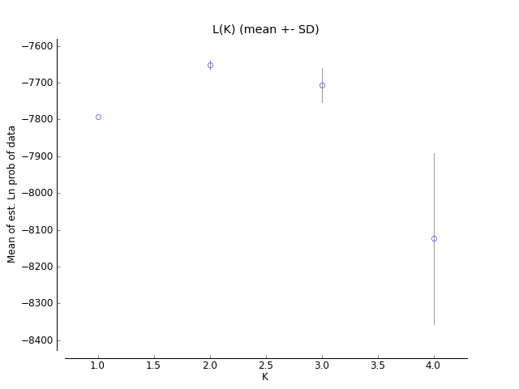
Figure S1. Mean logarithm of probability of the data for K = 1–4, estimated using the LOCPRIOR model in STRUCTURE.

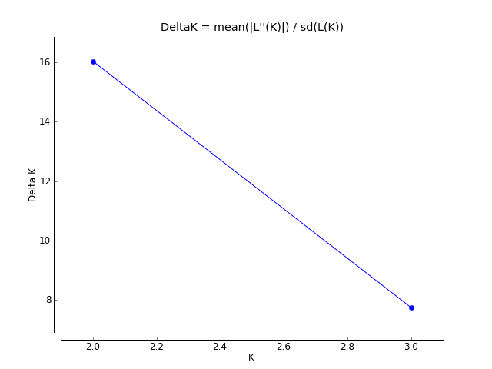
Figure S2. Delta K for K = 1–4, calculated by transforming logarithm of probability of the data estimated using the LOCPRIOR model in STRUCTURE.

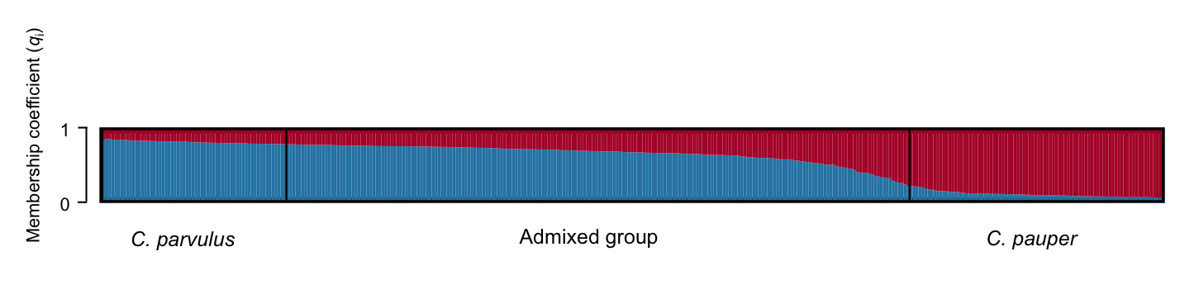
Figure S3. Probabilistic assignment to the genetic clusters using individual membership coefficient (q_{i}) inferred by the Bayesian analysis performed in STRUCTURE with K = 2 clusters for Tree Finches on Floreana Island. Each vertical bar represents one individual; membership to Camarhynchus pauper cluster (medium tree finch) is shown in red, and membership to C. parvulus cluster (small tree finch) in blue. Birds were sorted into three genetic groups using an inclusive threshold of q_{i} > 0.80 (C. parvulus) and q_{i} < 0.20 (C. pauper) to the C. parvulus cluster. Individuals with 0.20 < q_{i} < 0.80 were assigned to the admixed group. Black bars show the border between groups.

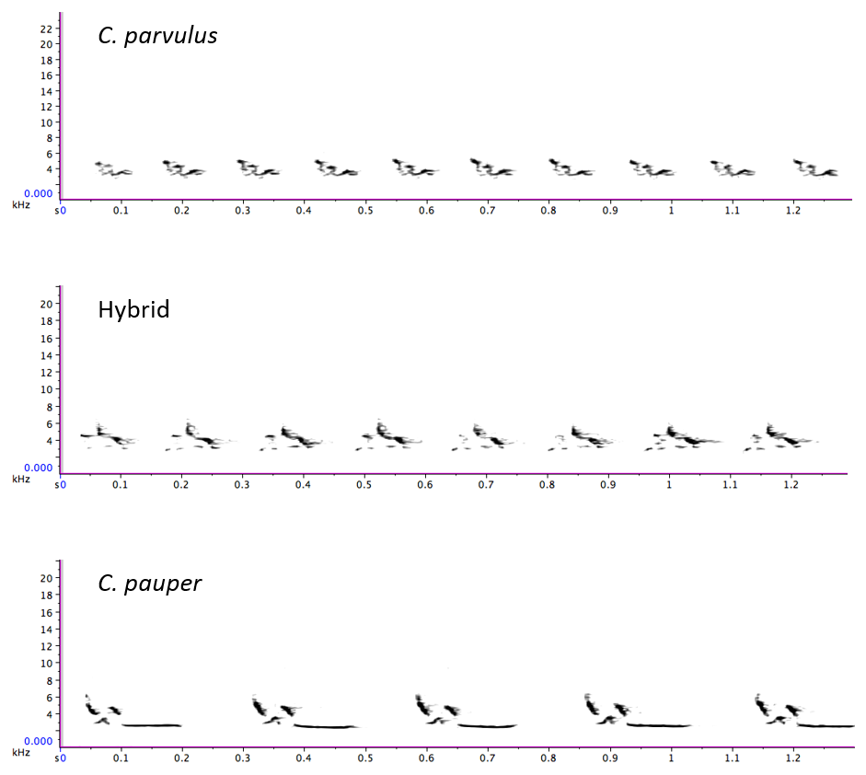

Figure S4. Spectrograms of one full-length song for each genetic group (C. parvulus, Hybrid, and C. pauper).
References

Antao, T., Lopes, A., Lopes, R., Beja-Pereira, A. & Luikart, G. 2008. LOSITAN: A workbench to detect molecular adaptation based on a Fst-outlier method. BMC Bioinformatics 9: 323.
Beaumont, M., Barratt, E., Gottelli, D., Kitchener, A., Daniels, M., Pritchard, J. & Bruford, M.W. 2001. Genetic diversity and introgression in the Scottish wildcat. Molecular ecology 10: 319-336.
Dunn, O.J. 1964. Multiple comparisons using rank sums. Technometrics 6: 241-252.
Earl, D.A. 2012. STRUCTURE HARVESTER: a website and program for visualizing STRUCTURE output and implementing the Evanno method. Conservation genetics resources 4: 359-361.
Evanno, G., Regnaut, S. & Goudet, J. 2005. Detecting the number of clusters of individuals using the software STRUCTURE: a simulation study. Molecular Ecology 14: 2611-2620.
Galligan, T.H., Donnellan, S.C., Sulloway, F.J., Fitch, A.J., Bertozzi, T. & Kleindorfer, S. 2012. Panmixia supports divergence with gene flow in Darwin's small ground finch, Geospiza fuliginosa, on Santa Cruz, Galápagos Islands. Molecular Ecology 21: 2106-2115.
Gottelli, D., Sillero‐Zubiri, C., Applebaum, G.D., Roy, M.S., Girman, D.J., Garcia‐Moreno, J., Ostrander, E.A. & Wayne, R.K. 1994. Molecular genetics of the most endangered canid: the Ethiopian wolf Canis simensis. Molecular Ecology 3: 301-312.
Griffiths, R., Double, M.C., Orr, K. & Dawson, R. 1998. A DNA test to sex most birds. Molecular Ecology 7: 1071-1075.
Hubisz, M.J., Falush, D., Stephens, M. & Pritchard, J.K. 2009. Inferring weak population structure with the assistance of sample group information. Molecular Ecology Resources 9: 1322-1332.
Jakobsson, M. & Rosenberg, N.A. 2007. CLUMPP: a cluster matching and permutation program for dealing with label switching and multimodality in analysis of population structure. Bioinformatics 23: 1801-1806.
Jones, O.R. & Wang, J. 2010. COLONY: a program for parentage and sibship inference from multilocus genotype data. Molecular Ecology Resources 10: 551-555.
Kleindorfer, S. 2007. Nesting success in Darwin's small tree finch, Camarhynchus parvulus: evidence of female preference for older males and more concealed nests. Animal Behaviour 74: 795-804.
Kleindorfer, S., O'Connor, J.A., Dudaniec, R.Y., Myers, S.A., Robertson, J. & Sulloway, F.J. 2014. Species collapse via hybridization in Darwin's tree finches. American Naturalist 183: 325-341.
Lack, D.L. 1983. Darwin's Finches. Cambridge University Press, Cambridge, NY.
Nielsen, E.E., Bach, L.A. & Kotlicki, P. 2006. Hybridlab (version 1.0): a program for generating simulated hybrids from population samples. Molecular Ecology Notes 6: 971-973.
O'Connor, J. 2012. Conservation issues for Darwin's finches in the Galápagos Islands: invasive species and loss of genetic diversity. School of Biological Sciences, The Flinders University of South Australia. Adelaide, South Australia. PhD.
Peakall, R. & Smouse, P.E. 2006. GenAlEx 6: genetic analysis in Excel. Population genetic software for teaching and research. Molecular Ecology Notes 6: 288-295.
Peakall, R. & Smouse, P.E. 2012. GenAlEx 6.5: genetic analysis in Excel. Population genetic software for teaching and research—an update. Bioinformatics 28: 2537-2539.
Petren, K. 1998. Microsatellite primers from Geospitza fortis and cross-species amplification in Darwin's finches. Molecular Ecology 7: 1771-1788.
Petren, K., Grant, B.R. & Grant, P.R. 1999. A phylogeny of Darwin's finches based on microsatellite DNA length variation. Proceedings of the Royal Society of London Series B-Biological Sciences 266: 321-329.
Pritchard, J.K., Stephens, M. & Donnelly, P. 2000. Inference of population structure using multilocus genotype data. Genetics 155: 945-959.
Rice, W.R. 1989. Analyzing tables of statistical tests. Evolution 43: 223-225.
Smith, L. & Burgoyne, L.A. 2004. Collecting, archiving and processing DNA from wildlife samples using FTA® databasing paper. BMC ecology 4: 4.

