Supplementary Material
Large changes in the avifauna in an extant hotspot of farmland biodiversity in the Alps

PIUS KORNER, ROMAN GRAF and LUKAS JENNI

Contents
Species developments: comparison with other monitoring programs in the area
Table S1. As Table 1 in the article, but with the comparisons of trends from other sources in the last four columns (instead of ecological categorisations as in the article). Species in black boxes showed a significant change according to our change estimate (column “change”).
Appendix S1. Estimates with 95% Bayesian credible intervals (in brackets) of the effects in a path analysis of five landscape parameters on the vegetation change (column “Vegetation change”), their direct, indirect, and total effect on the bird change and the effect of the vegetation change on the bird change between the first census in 1987/88 and the second census in 2009/10.

Species developments: comparison with other monitoring programs in the area
The bird population trends used in Korner et al. “Large changes in the avifauna in an extant hotspot of farmland biodiversity in the Alps” are based on two census periods, each containing only two years (1987/88 and 2009/10) and with many plots observed only during one of the two years. This has raised concerns regarding the reliability of the population trends, given the known annual variations of bird populations. Note that the issue only pertains to (annual) influences affecting the entire population of the area, eg specific weather situations, but not to within-plot annual variations (these are no problem for the conclusions as we have observed multiple plots).
To help assessing the reliability of our trends we can compare them with the trends in a small number of plots in the Engadin that are observed each year (“constant observation plots”) and with the trends from Common Breeding Bird Monitoring squares in the region. The constant observation plots are 50–200ha large (triangles in Figure S1) and there are mainly three plots suitable for a comparison (orange, blue and black triangle). Common Breeding Bird Monitoring squares are 100ha in size and are distributed over the entire canton of Graubünden (red and mango dots in Figure S1).
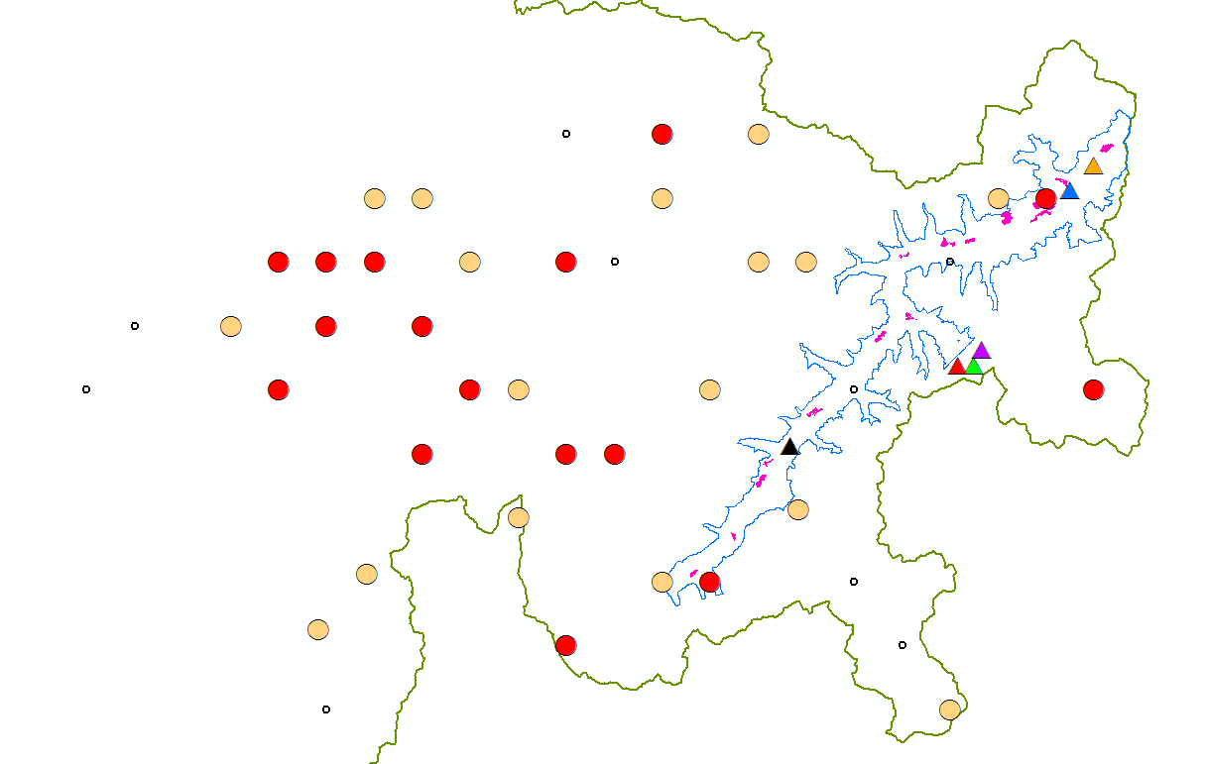
Figure S1. Canton of Graubünden (eastern Switzerland) with the Engadin (blue line = contour line at 2,150m a.s.l. in the Engadin; the Engadin is 80km long). The pink areas in the Engadin are the study plots used in Korner et al. “Large changes in the avifauna in an extant hotspot of farmland biodiversity in the Alps”. The triangles mark the positions of the constant observation plots and the dots mark the squares from the Swiss Common Breeding Bird Monitoring: red dots are best suited for a comparison with the developments in the Engadin study plots (they contain a considerable portion of agricultural land below the tree line), mango dots are partially suited (most are agricultural areas above the tree line), and small circles are squares that are not suitable for a comparison (settlement areas, high alpine scree areas or forested).

The constant observation plots in the Engadin cover almost the same time period as the period used in our analyses, but there are only six plots of which three are essentially too high (above the tree line) for most comparisons (purple, green and red triangles in Figure S1).
The development in the constant observation plots mostly mirror the development we observed in our 58 study plots (Figure S2). In the skylark, note that the only constant observation plot that shows a non-negative development is the green plot, which is a plot at 2,450m a.s.l., ie above the tree line where the situation is different from the area we discuss in the article (ie agricultural land below the tree line).
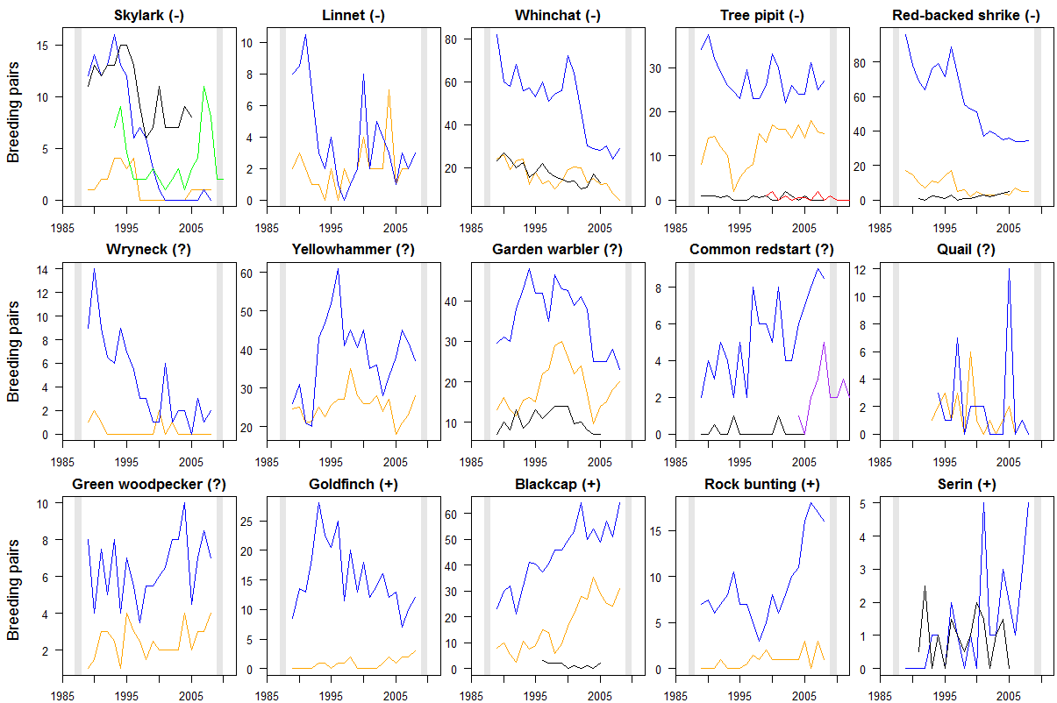
Figure S2. Development of the breeding bird population in six constant observation plots (annual counts) in the Engadin (species-plot combinations that were always zero are excluded). The same line colour corresponds to the same plot for all panels and also identifies the precise position of the plot in Figure S1. The two vertical grey bars show the census periods for our analysis in the article, covering 58 plots. The sign given with the species name indicates the trend we observed in these 58 plots (exact values in Table S1).

There are many plots from the Common Breeding Bird Monitoring Scheme available for comparison, however, this program only started in 1999, ie about half-ways between our two study periods (Figure S3). We distinguish between plots that appear especially suitable for a comparison, ie plots with at least about 25% agricultural areas below the tree line. Note that all these plots are squares that are a mixture of agricultural and other habitat, unlike our study plots that essentially contained only agricultural landscapes.
The trends from the Common Breeding Bird Monitoring are mostly similar to the trends we observed, but the change is often less marked compared to our study, especially for the species showing a decline. This may be due to the shorter time span available from the Common Breeding Bird Monitoring. Or, it may be due to the habitat difference, since the squares from the Common Breeding Bird Monitoring contain a variety of habitats, while our plots were agricultural land only, where the changes in land use have been strongest and, hence, the effect on the bird community may be expected to be greater than in other habitats (eg semi-open forest, sometimes with scree areas, etc, which might still be well suited for species such as the tree pipit and linnet.)

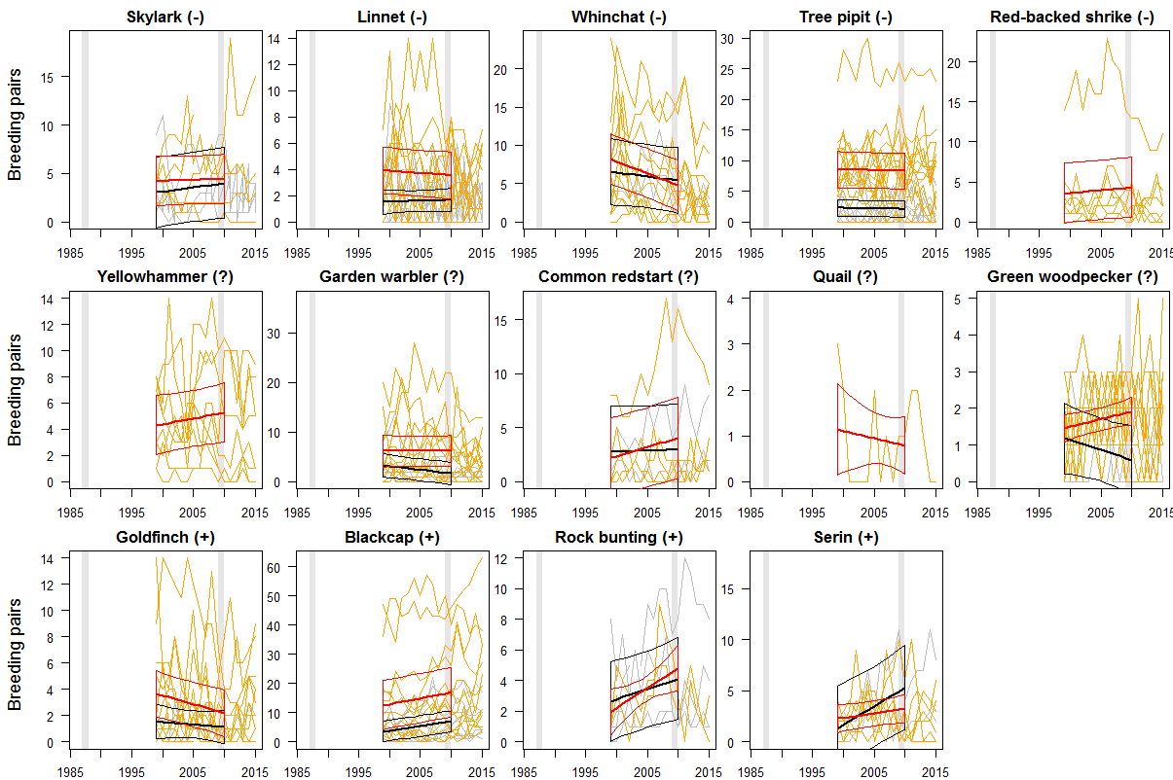
Figure S3. Developments in Common Breeding Bird Monitoring squares in the region (see Figure S1). Orange lines and the red regression line (together with a 95% Bayesian credible interval) correspond to squares which are best suited for a comparison, grey lines and the black regression line correspond to squares which are partially suited. Regressions are only calculated with the data up to the year 2010. The two vertical grey bars show the census periods for our analysis in the article, covering 58 plots. The sign given with the species name indicates the trend we observed in these 58 plots (exact values in Table S1).

In Table S1 we summarize the findings from these comparisons together with the corresponding values already presented in Table 1 in the article: our observed changes and the national (CH) and European (EBCC) trends. We conclude that for most species the trend we observed is well justified. Uncertainties mainly pertain to species for which we also found non-significant changes (which may be due to more or less constant population sizes or due to large uncertainties).

Table S1. As Table 1 in the article, but with the comparisons of trends from other sources in the last four columns (instead of ecological categorizations as in the article). Species in black boxes showed a significant change according to our change estimate (column “change”). Red indicates a decrease, green an increase (significant or not).
Species |  | Density ^{b} |  | Change ^{c}  [95 % credible interval] |  | Const. obs. plots ¹ | Comm. Breed. Bird ² | Trend CH ^{g} | Trend EBCC ^{h}
 |  | 1987/88 | 2009/10
Eurasian skylark | Alauda arvensis | 0.86 | 0.38 | 44 % | [31 %; 63 %] | - | 0 | 66 % | 77 %
Whinchat | Saxicola rubetra | 2.54 | 1.48 | 58 % | [50 %; 68 %] | - - | - - | 54 % | 81 %
Linnet | Carduelis cannabina | 0.46 | 0.27 | 58 % | [34 %, 101 %] | 0 | 0 | 72 % | 34 %
Tree pipit | Anthus trivialis | 1.76 | 1.07 | 61 % | [50 %; 74 %] | 0 | 0 | 32 % | 52 %
Red-backed shrike | Lanius collurio | 0.95 | 0.64 | 67 % | [49 %; 92 %] | - | 0 | 91 % | 109 %
Wryneck | Jynx torquilla | 0.33 | 0.33 | 99 % | [41 %, 245 %] | - | no data | 83 % | 36 %
Yellowhammer | Emberiza citrinella | 0.94 | 1.07 | 113 % | [83 %; 154 %] | 0 | 0(+) | 141 % | 77 %
Common redstart | Phoenicurus phoenicurus | 0.32 | 0.43 | (133 %) from 9 to 12 pairs |  | + + | + | 41 % | 130 %
Garden warbler | Sylvia borin | 0.44 | 0.60 | 138 % | [90 %; 212 %] | 0 | 0 | 90 % | 80 %
Common quail | Coturnix coturnix | 0.33 | 0.58 | (163 %) from 4 to 6-7 pairs |  | 0 (-) | 0(-) | 131 % | no data
Green woodpecker | Picus viridis | 0.21 | 0.35 | 167 % | [90 %, 309 %] | + | + | 194 % | 195 %
European goldfinch | Carduelis carduelis | 0.21 | 0.56 | 264 % | [135 %; 506 %] | 0 (+) | - | 53 % | 129 %
Eurasian blackcap | Sylvia atricapilla | 0.16 | 0.94 | 572 % | [260 %; 1228 %] | + + | + | 130 % | 176 %
Rock bunting | Emberiza cia | 0.08 | 0.76 | (1000 %) from 1 to 10 pairs |  | + | + | 174 % | (+) ^{i)}
European serin | Serinus serinus | 0.00 | 0.59 | (inf) from 0 to 9 pairs |  | + | + | 117 % | 53 %
¹ Compare with Figure S2. The development according to the constant observation plots suggests a clear increase: ++, an increase: +, no large change or strong fluctuations: 0 (sometimes with a putative trend direction), a decrease: -, or a very strong decrease: - -.
² Compare with Figure S3. Same interpretation of the symbols as in the previous column, but the signs are based on the credible interval of the linear model slope.
Relevant comments from Table 1 in the article:
^{b)} Breeding pairs per 10ha, including only study plots with at least one breeding pair during either census.
^{c)} Poisson mixed model (log-link) with the number of breeding pairs per plot and year as the outcome variable, and the census as the fixed factor; plot, groups of plots (= adjacent plots) and year were random factors, the log of the plot area was used as an offset. Thereby, we estimate the change between the two census periods accounting, as much as possible, for the variability of the counts within a census period. No model for rare species, where the raw percentage change is given in parentheses and used for species ordering, only.
^{g)} Trend in Switzerland. Data are from the common bird monitoring scheme of the Swiss Ornithological Institute. Change calculated for predicted values for 1987 and 2009 from a linear regression through the available index points from 1990–2009 (ie 3-year extrapolation to 1987).
^{h)} Trend in Europe according to www.ebcc.info (accessed 24/272015); change of fitted values for 1987 and 2009 of a linear regression through the index points 1987–2009.
^{i)} Data available only since 1998; 1998–2009: trend slightly positive

Appendix S1. Estimates with 95% Bayesian credible intervals (in brackets) of the effects in a path analysis of five landscape parameters on the vegetation change (column “Vegetation change”), their direct, indirect, and total effect on the bird change and the effect of the vegetation change on the bird change between the first census in 1987/88 and the second census in 2009/10. Effects with credible intervals not spanning across 0 are in boldface (these are depicted in Figure 5). Vegetation change: Bray-Curtis dissimilarity of the proportion of six vegetation aggregations (see Figure 1). Bird change: Bray-Curtis dissimilarity of the breeding bird density of 15 bird species of the open and semi-open agricultural landscape (see Table 1). Observed values of vegetation and bird change are depicted in Figure 4 (scaled vegetation change values given on the upper x-axis), helping to interpret the values of the parameter estimates. n = 58 study plots
Effect | Unit or level | Vegetation change | Bird change
 |  |  | Direct effect | Indirect effect | Total effect
Intercept |  | -0.61 [-1.21; 0.01] | 0.42 [0.28; 0.55] | -0.05 [-0.13; 0.00] | 0.36 [0.22; 0.50]
Vegetation change | B-C dissim. (scaled) |  | 0.09 [0.03; 0.15]
Elevation | m a.s.l. (scaled) | -0.50 [-2.49; 1.51] | -0.25 [-0.68; 0.17] | -0.04 [-0.25; 0.15] | -0.29 [-0.75; 0.17]
Slope | degree (scaled) | -0.20 [-0.50; 0.11] | -0.05 [-0.12; 0.01] | -0.02 [-0.05; 0.01] | -0.07 [-0.14; 0.00]
Impediments ^{a)} | few | 0.66 [-0.12; 1.40] | 0.05 [-0.11; 0.22] | 0.05 [-0.01; 0.15] | 0.11 [-0.06; 0.29]
Impediments ^{a)} | much | 0.57 [-0.18; 1.32] | 0.05 [-0.11; 0.21] | 0.05 [-0.01; 0.14] | 0.10 [-0.08; 0.27]
Distance to farm | m (scaled) | -0.11 [-0.37; 0.16] | 0.02 [-0.03; 0.08] | -0.01 [-0.04; 0.01] | 0.01 [-0.05; 0.07]
Agric. improvem. proj. ^{b)} | before 1st census | -0.18 [-0.66; 0.32] | 0.08 [-0.02; 0.19] | -0.01 [-0.07; 0.03] | 0.07 [-0.04; 0.18]
Agric. improvem. proj. ^{b)} | between censuses | 1.47 [0.71; 2.24] | -0.11 [-0.29; 0.08] | 0.13 [0.03; 0.26] | 0.02 [-0.15; 0.21]
^{a)} Impediments to cultivation. Baseline level = none.
^{b)} Agricultural improvement project. Baseline level = none.

