Supplementary Material

A multi-scale analysis of habitat selection in peripheral populations of the endangered Dupont’s Lark Chersophilus duponti

CRISTIAN PÉREZ-GRANADOS, GERMÁN M. LÓPEZ-IBORRA and JAVIER SEOANE

Contents
Figure S1: Dupont’s Lark Chersophilus duponti distribution in Spain

Table S1. Loading factors of the PCA performed with lithological and vegetation cover variables measured at the microhabitat scale

Table S2. The number of times that each variable was considered within the total number of candidate models (Nº ∆AICc < 2) used for model averaging

Figure S1: Dupont’s Lark Chersophilus duponti distribution in Spain. Red circle shows location of the study area in the Iberian Peninsula. Most of the populations located south of the study area were inhabited by less than 10 males. Source: Suárez (2010).

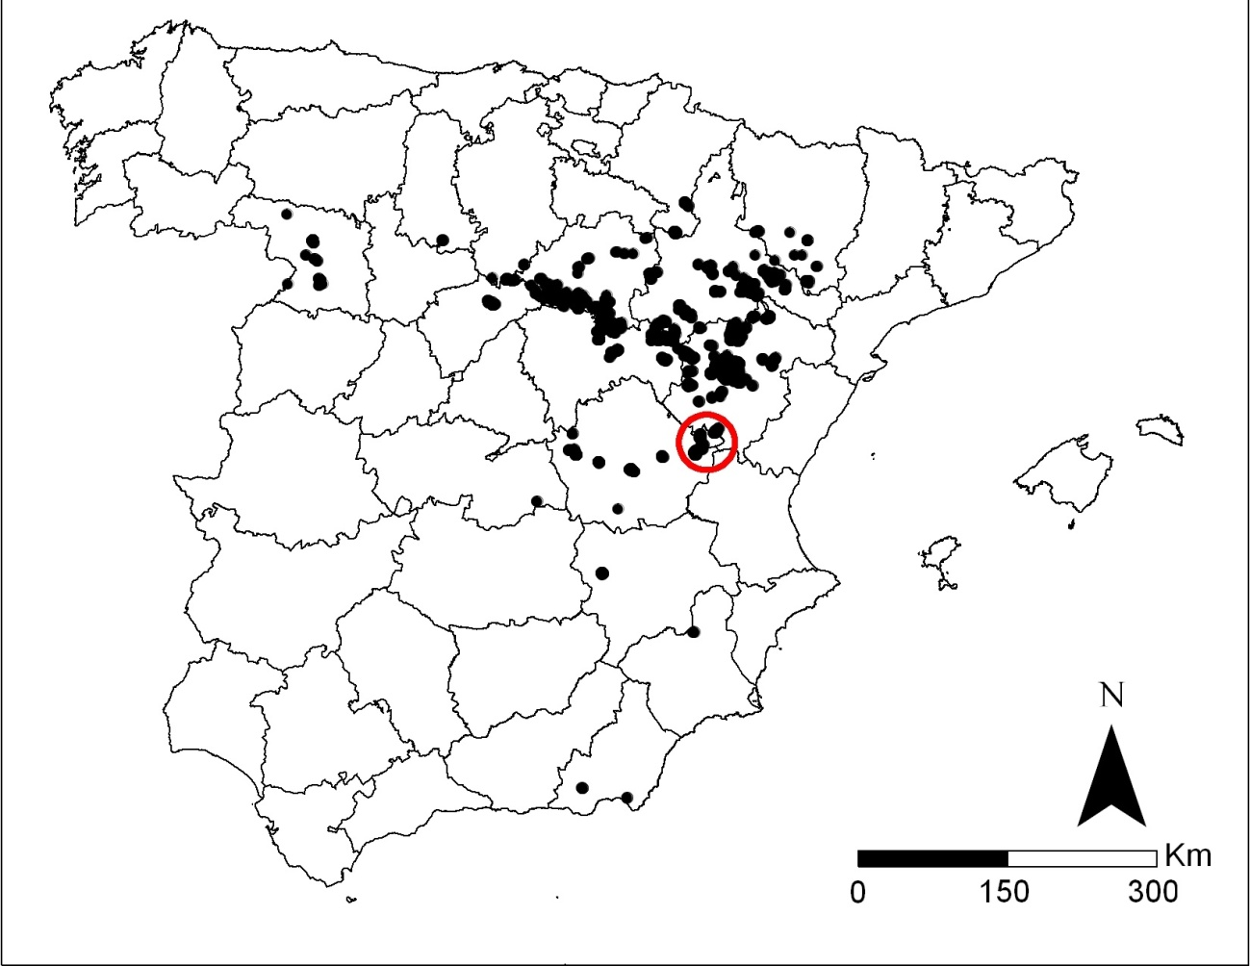

Table S1: Loading factors of the PCA performed with lithological and vegetation cover variables measured at the microhabitat scale. * < 0.05; ** < 0.01; *** < 0.005.
 | PCA
 | PCA I | PCA II | PCA III | PCA IV
Bare rock % | -0.0121 | 0.2673*** | 0.1763** | -0.8450***
Pebble % | 0.2822*** | 0.4605*** | 0.3008*** | 0.2695***
Bare soil % | -0.1216 | 0.2321*** | 0.5658*** | 0.3242***
Herb. < 20 cm % | 0.6515*** | -0.0540 | 0.1421* | -0.3972***
Herb. 20-40 cm % | 0.3416*** | -0.8388*** | -0.1057 | 0.0845
Herb. > 40 cm % | 0.1053 | -0.8460*** | 0.0836 | 0.1824***
Rosemary < 20 cm % | -0.8719*** | 0.2071*** | 0.2187*** | 0.0505
Rosemary 20-40 cm % | -0.9093*** | 0.2204*** | 0.1995*** | 0.0108
Rosemary > 40 cm % | -0.8787*** | 0.1812*** | 0.1257* | -0.0015
Broom < 20 cm % | 0.5812*** | 0.2581*** | -0.2985*** | 0.2440***
Broom 20-40 cm % | 0.5185*** | 0.0861 | -0.7018*** | 0.2224***
Broom > 40 cm % | 0.2163*** | -0.0736 | -0.8000*** | 0.1822***
Thyme < 20 cm % | 0.5735*** | 0.3690*** | 0.3403*** | 0.3602***
Thyme 20-40 cm % | 0.7796*** | 0.1019 | -0.1938*** | 0.2598***
Thyme > 40 cm % | 0.2417*** | 0.0653 | -0.4545*** | 0.0214***
Variance explained (%) | 31.0 | 14.1 | 14.4 | 9.6

Table S2: The number of times that each variable was considered within the total number of candidate models (Nº ∆AICc < 2) used for model averaging. Rosemary was not used in Pinar habitat modelling since this shrub was lacking this area.
 | Hontanar | Losar 1 | Pinar 1
Spatial term | 18 | 8 | 27
Slope | 19 | 0 | 13
Crops | 18 | 0 | 2
Bare ground | 3 | 2 | 10
Herbaceous | 13 | 8 | 2
Rosemary | 4 | 4 | -
Broom | 6 | 3 | 14
Thyme | 4 | 3 | 7
Pines | 6 | 8 | 12
Junipers | 17 | 8 | 2
Nº ∆AICc < 2 | 19 | 8 | 27

