Supplementary Material

Characteristics of home range areas used by Saker Falcons (Falco cherrug) wintering on the Qinghai-Tibetan Plateau

ANDREW DIXON, XINHAI LI, MD. LUTFOR RAHMAN, NYAMBAYAR BATBAYAR and XIANGJIANG ZHAN

Contents

Appendix S1. Status (estimated breeding pairs) and distribution (by country) of Saker Falcons, as used in the IUCN/BirdLife International Global Red List assessment in 2012

Appendix S2. Details of platform transmitter terminals (PPTs) used in this study.

Appendix S3. Mean and median distance from a reference GPS point of satellite location data.

Appendix S4. Land cover types identified on the Qinghai-Tibetan Plateau.

Figure S1. Location points for surveys of Plateau Pikas and pika holes along a road and track route in Qinghai Province.

Figure S2a-d. Winter home range descriptions for two Saker Falcons deployed with PTTs providing both Argos and GPS location data.
Appendix S1. Status (estimated breeding pairs) and distribution (by country) of Saker Falcons, as used in the IUCN/BirdLife International Global Red List assessment in 2012.

Country | Year | Min | Max | Med
Afghanistan | 2010 | 10 | 100 | 55
Austria | 2010 | 15 | 25 | 20
Bulgaria | 2010 | 0 | 10 | 5
China | 2010 | 1000 | 5000 | 3000
Croatia | 2010 | 5 | 10 | 8
Czech Republic | 2010 | 10 | 15 | 13
Georgia | 2010 | 3 | 5 | 4
Germany | 2010 | 0 | 1 | 1
Hungary | 2010 | 176 | 190 | 183
Iraq | 2010 | 0 | 50 | 25
Iran | 2010 | 10 | 100 | 55
Kazakhstan | 2011 | 800 | 1450 | 1125
Kyrgyzstan | 2010 | 50 | 50 | 50
Macedonia | 2010 | 0 | 3 | 2
Moldova | 2010 | 8 | 15 | 12
Mongolia | 2010 | 2000 | 5000 | 3500
Pakistan | 2010 | 0 | 50 | 25
Poland | 2010 | 0 | 2 | 1
Romania | 2010 | 2 | 12 | 7
Russia | 2010 | 1854 | 2542 | 2198
Serbia | 2010 | 52 | 64 | 58
Slovakia | 2010 | 23 | 25 | 24
Tajikistan | 2010 | 10 | 100 | 55
Turkey | 2010 | 5 | 70 | 38
Turkmenistan | 2010 | 100 | 150 | 125
Ukraine | 2010 | 270 | 345 | 308
Uzbekistan | 2010 | 10 | 15 | 13
Totals |  | 6413 | 15399 | 10910

Appendix S2. Details of platform transmitter terminals (PPTs) used in this study, showing PTT identification number, age (Ad. = adult; Juv. = juvenile) and sex (F = female) of the Saker Falcon, country of deployment, weight and power source, manufacturer (Microwave Telemetry, Inc., Columbia, MD, USA and North Star Science and Technology, LLC, King George, VA, USA), type of location data provided, number of Argos and GPS locations used to plot home ranges in winter tracking period (LC 3, 2, 1 and A), start and end date of winter tracking period.

PTT # | Age/Sex | Country | PTT type | Manufacturer | Location data | N. locations |  | Period
 |  |  |  |  |  | Argos | GPS | Start | End
3839 | Ad./F | Russia | 30g battery | Microwave | Argos | 5 | NA | 25 Jan 1998 | 23 Feb 1998
29040 | Ad./F | Mongolia | 35g solar | Microwave | Argos | 51 | NA | 25 Sep 2000 | 03 Mar 2001
35989 | Ad./F | Mongolia | 35g solar | Microwave | Argos | 29 | NA | 17 Oct 2002 | 11 Feb 2003
56581 | Juv./F | Mongolia | 16g solar | North Star | Argos | 45 | NA | 24 Oct 2006 | 02 Apr 2007
90890 | Ad./F | Mongolia | 30g solar | Microwave | Argos & GPS | NA | 283 | 27 Nov 2009 | 27 Feb 2010
90893 | Ad./F | Mongolia | 30g solar | Microwave | Argos & GPS | NA | 413 | 17 Oct 2009 | 20 Feb 2010
93546 | Ad./F | Mongolia | 30g solar | Microwave | Argos & GPS | NA | 123 | 13 Oct 2010 | 23 Feb 2011
93548 | Juv./F | Mongolia | 30g solar | Microwave | Argos & GPS | NA | 124 | 15 Oct 2009 | 18 Nov 2009

Appendix S3. Mean and median distance from a reference GPS point of satellite location data of varying quality i.e., GPS location signals and Argos signals of location classes (LC) 3, 2, 1, 0, A and B. All signals were received within 4 hours of the GPS reference location; mean interval (h) between signals of each type is shown

Signal Type/LC | N | Mean ± SE (km) | Median: Range (km) | Interval ± SE (h)
GPS | 592 | 1.7 ± 0.1 | 0.6: 0.0 - 20.3 | 2.4 ± 0.0
3 | 8 | 0.4 ± 0.8 | 0.2: 0.1 - 1.5 | 1.9 ± 0.7
2 | 11 | 1.2 ± 0.3 | 0.8: 0.0 - 3.3 | 2.2 ± 0.4
1 | 12 | 2.2 ± 1.0 | 1.0: 0.3 - 12.8 | 1.6 ± 0.4
0 | 7 | 11.7 ± 3.3 | 7.7: 2.9 - 27.8 | 1.4 ± 0.4
A | 16 | 5.0 ± 3.0 | 1.0: 0.1 - 49.3 | 1.6 ± 0.2
B | 48 | 31.5 ± 7.3 | 11.2: 0.5 - 216.2 | 1.7 ± 0.2

.

Appendix S4. Land cover types identified on the Qinghai-Tibetan Plateau.

Code | Land cover types
11 | cropland irrigated
12 | cropland non-irrigated
21 | forest canopy >30%
22 | shrub
23 | forest canopy 10-30%
31 | grassland cover >50%
32 | grassland cover 20-50%
33 | grassland cover 5-20%
42 | Lake
44 | glacier/permanent snow
46 | flooded
61 | desert
62 | Gobi
63 | salt flat
64 | marsh
65 | Bare
66 | bare rock
67 | other non-vegetated

Figure S1. Location points for surveys of Plateau Pikas and pika holes along a road and track route in Qinghai Province.

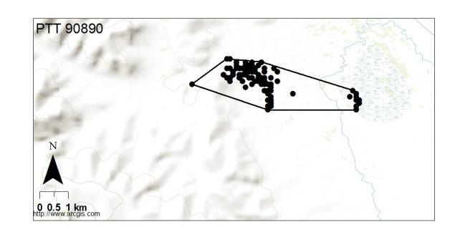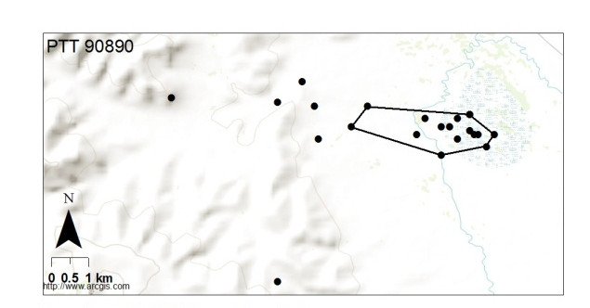
a b
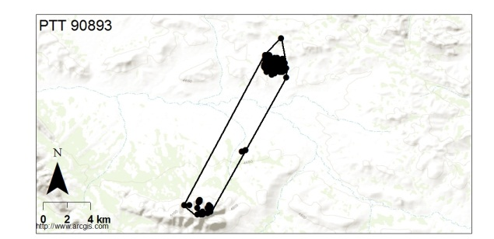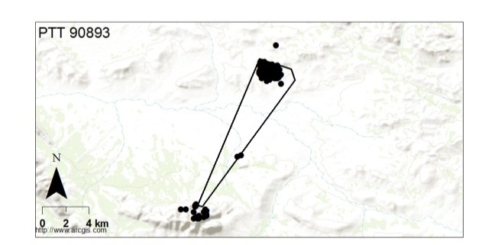
c d
Figure S2a-d. Winter home range descriptions for two Saker Falcons deployed with PTTs providing both Argos and GPS location data. a: 95% MCP of GPS locations and b: 70% MCP of Argos location for PTT# 90890. c: 95% MCP of GPS locations and d: 70% MCP of Argos location for PTT# 90893.

