**Supplementary Material**

Distribution and habitat associations of the critically endangered bird species of São Tomé Island (Gulf of Guinea)

RICARDO F. DE LIMA, HUGO SAMPAIO, JONATHON C. DUNN, GABRIEL CABINDA, RICARDO FONSECA, GABRIEL OQUIONGO, JOEL OQUIONGO, SEDNEY SAMBA, ARISTIDES SANTANA, ESTEVÃO SOARES, LEONEL VIEGAS, ALICE WARD-FRANCIS, LUÍS T. COSTA, JORGE M. PALMEIRIM and GRAEME M. BUCHANAN

**Contents**

Figure S1. The categorical distribution model for the São Tomé Dwarf Olive Ibis (a,e,i), Fiscal (b,f,j) and Grosbeak (c,g,k), as predicted by logistic MaxEnt modelling.

Figure S2. Key locations in the study area.

Figure S3. Results of the automated model selection based on second-order Akaike Information Criterion for the São Tomé (a) ibis, (b) fiscal and (c) grosbeak.

Table S1. Predictor variables used to build the SDMs in MaxEnt.

Table S2. Presence data used to build the SDMs in MaxEnt.

Table S3. Summary of MaxEnt model outputs. The grey shading indicates the best models based on AICc and AUC.

Table S4. Predictor variables used in each final SDMs.

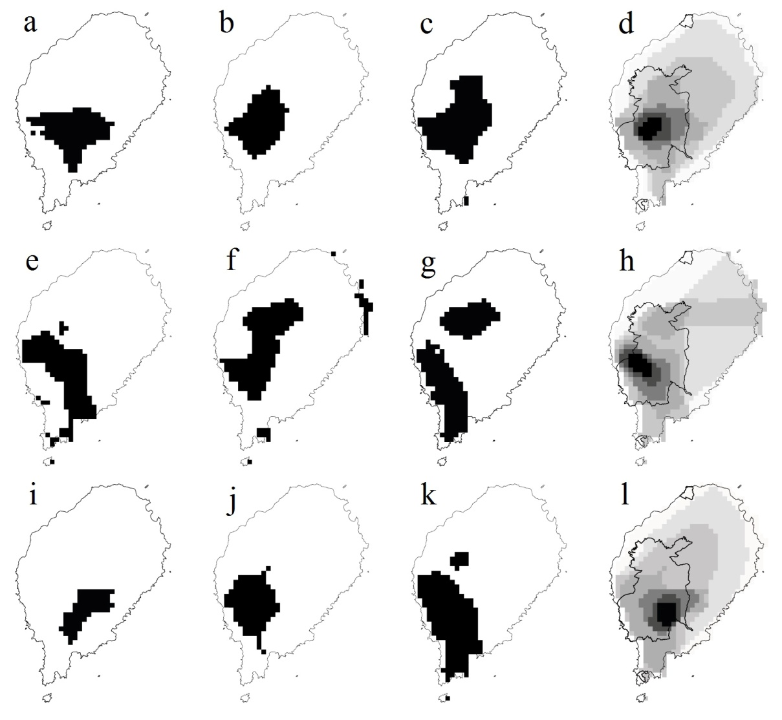

Figure S1. The categorical distribution model for the São Tomé Dwarf Olive Ibis (a,e,i), Fiscal (b,f,j) and Grosbeak (c,g,k), as predicted by logistic MaxEnt modelling. Quadrats in black are suitable, while those unsuitable are blank. Annual (a,b,c), *gravana* (e,f,g) and *gravanito* (i,j,k) distributions are shown, as well as the corresponding zonation based on categorical SDM (d,h,l). In the zonation panels, the darkest colours indicate the most important conservation areas (0-19% = almost white, 20-49% = very light grey, 50-74% = light grey, 75-89% = intermediate grey, 90-94% = dark grey, 95-97% = very dark grey and 98-100% = black) and the additional black lines shows the boundaries of the São Tomé Obô Natural Park.



Figure S2. Key locations in the study area. The dark green line shows the boundaries of the São Tomé Obô Natural Park and the light green those of its buffer zone. The 100 m contour lines are shown in grey and island outline in black.

(a)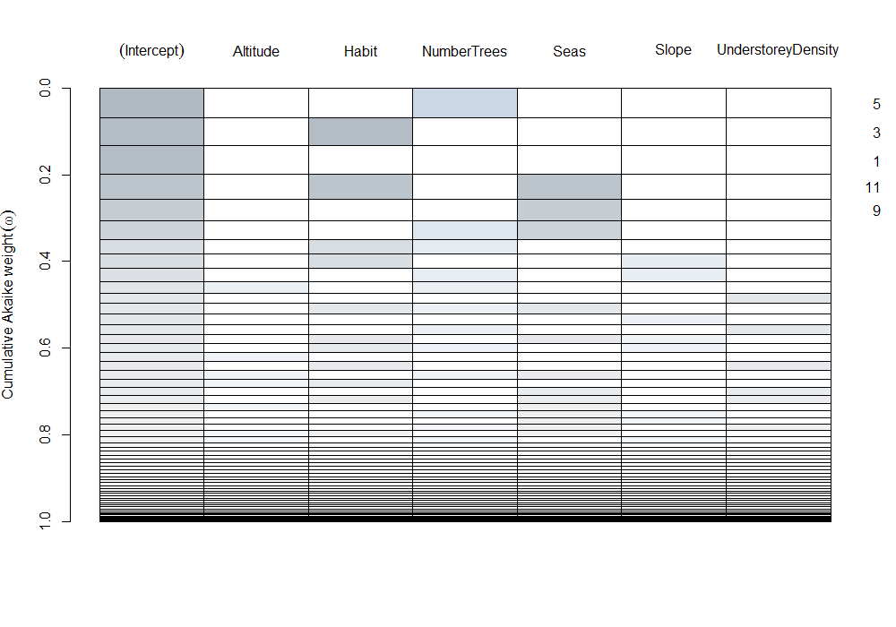

(b)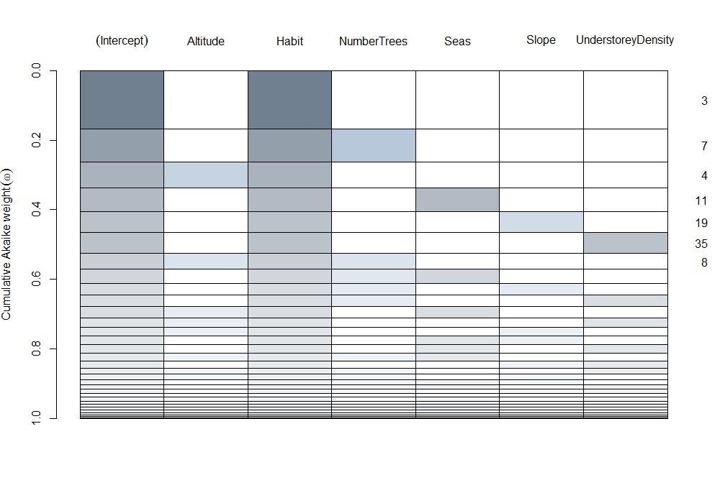

(c)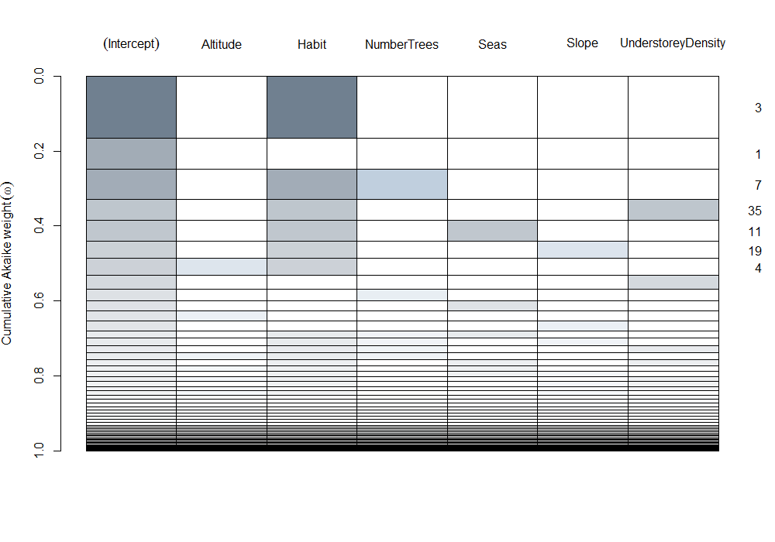

Figure S3. Results of the automated model selection based on second-order Akaike Information Criterion for the São Tomé (a) ibis, (b) fiscal and (c) grosbeak. Each line corresponds to a possible model, ranked by the cumulative Akaike weight, and each column to an environmental variable (altitude, habitat type, number of trees, season, slope and understorey density). The colouring of a cell indicates if a variable is present in a model. The taller the cell, the larger the cumulative Akaike weight for the corresponding model.

Table S1. Predictor variables used to build the SDMs in MaxEnt.

| **Name of raster** | **Description** |
| --- | --- |
| Bio 1 | Annual mean temperature |
| Bio 2 | Mean diurnal range |
| Bio 3 | Isothermality |
| Bio 4 | Temperature seasonality |
| Bio 5 | Maximum temperature warmest month |
| Bio 6 | Minimum temperature coldest month |
| Bio 7 | Temperature annual range |
| Bio 8 | Mean temperature wettest quarter |
| Bio 9 | Mean temperature driest quarter |
| Bio 10 | Mean temperature warmest quarter |
| Bio 11 | Mean temperature coldest quarter |
| Bio 12 | Annual precipitation |
| Bio 13 | Precipitation wettest month |
| Bio 14 | Precipitation driest month |
| Bio 15 | Precipitation seasonality |
| Bio 16 | Precipitation wettest quarter |
| Bio 17 | Precipitation driest quarter |
| Bio 18 | Precipitation warmest quarter |
| Bio 19 | Precipitation coldest quarter |
| NDVI January | NDVI of named month |
| NDVI February | NDVI of named month |
| NDVI March | NDVI of named month |
| NDVI April | NDVI of named month |
| NDVI May | NDVI of named month |
| NDVI June | NDVI of named month |
| NDVI July | NDVI of named month |
| NDVI August | NDVI of named month |
| NDVI September | NDVI of named month |
| NDVI October | NDVI of named month |
| NDVI November | NDVI of named month |
| NDVI December | NDVI of named month |
| Elevation |  |
| Slope |  |

* Yearly set ‘A’ of uncorrelated predictor variables: isothermality, temperature seasonality, temperature annual range, precipitation in the driest quarter and January NDVI.
* *Gravana* set of ‘A’ uncorrelated predictors were the same but January NDVI was substituted for July NDVI.
* *Gravanito* set of ‘A’ uncorrelated predictors were the same as the yearly set.
* For the *gravana* set of maximal predictors, only June NDVI, July NDVI and August NDVI were retained.
* For the *gravanito* set of maximal predictors, only January NDVI and February NDVI were retained.

Table S2. Presence data used to build the SDMs in MaxEnt.

|  |  |  |  |  |
| --- | --- | --- | --- | --- |
| **Species** | **Season** | **Total number of records** | **Number of unique training records** | **Number of test records** |
| Ibis | Annual | 363 | 42 | 82 |
| Ibis | *Gravana* | 60 | 17 | 19 |
| Ibis | *Gravanito* | 77 | 18 | 9 |
| Fiscal | Annual | 269 | 39 | 126 |
| Fiscal | *Gravana* | 73 | 12 | 49 |
| Fiscal | *Gravanito* | 89 | 18 | 30 |
| Grosbeak | Annual | 74 | 24 | 33 |
| Grosbeak | *Gravana* | 13 | 12 | 0 |
| Grosbeak | *Gravanito* | 33 | 10 | 13 |

Table S3. Summary of MaxEnt model outputs. The grey shading indicates the best models based on AICc and AUC.

|  |  |  |  |  |  |  |  |
| --- | --- | --- | --- | --- | --- | --- | --- |
| **Species** | **Period** | **Number of unique training points** | **Regularization parameters** | **Predictors** | **AICc** | **AUC test**  **(± SD)** | **Smooth curves** |
| Ibis | Annual | 42 | 2 | All significant | 1115.5 | 0.901 (0.043) | Yes |
| Ibis | Annual | 42 | 1 | A | 1178.3 | 0.868 (0.049) | Yes |
| Fiscal | Annual | 39 | 1 | All significant | 1050.0 | 0.908 (0.029) | Yes |
| Fiscal | Annual | 39 | 0.5 | A | 1114.4 | 0.880 (0.039) | Yes |
| Grosbeak | Annual | 24 | 3.5 | All significant | 323.2 | 0.845 (0.068) | Yes |
| Grosbeak | Annual | 24 | 4 | A | 352.3 | 0.764 (0.063) | Yes |
| Ibis | *Gravana* | 17 | 1 | All significant | 315.4 | 0.859 (0.070) | Yes |
| Ibis | *Gravana* | 17 | 1 | A | 345.8 | 0.852 (0.083) | Yes |
| Fiscal | *Gravana* | 12 | 0.5 | All significant | 259.8 | 0.818 (0.039) | Yes |
| Fiscal | *Gravana* | 12 | 1 | A | 230.1 | 0.835 (0.120) | Yes |
| Grosbeak | *Gravana* | 12 | 1 | All significant | 157.2 | 0.878 (0.088) | Yes |
| Grosbeak | *Gravana* | 12 | 1 | A | 167.0 | 0.841 (0.095) | Yes |
| Ibis | *Gravanito* | 18 | 1 | All significant | 396.5 | 0.945 (0.068) | Yes |
| Ibis | *Gravanito* | 18 | 0.5 | A | 409.6 | 0.940 (0.055) | Yes |
| Fiscal | *Gravanito* | 18 | 1 | All significant | 480.4 | 0.912 (0.064) | Yes |
| Fiscal | *Gravanito* | 18 | 1 | A | 501.4 | 0.908 (0.055) | Yes |
| Grosbeak | *Gravanito* | 10 | 0.5 | All significant | 152.0 | 0.801 (0.104) | Yes |
| Grosbeak | *Gravanito* | 10 | 0.5 | A | 173.2 | 0.787 (0.110) | Yes |

Table S4. Predictor variables used in each final SDMs.

| **Species** | **Season** | **Significant variables** |
| --- | --- | --- |
| Ibis | Annual | Temperature annual range, Annual precipitation, Precipitation driest month, Precipitation seasonality, Precipitation wettest quarter, Precipitation warmest quarter, June NDVI, November NDVI, elevation |
| Ibis | *Gravana* | Annual precipitation, Precipitation wettest month, Precipitation wettest quarter, Precipitation warmest quarter |
| Ibis | *Gravanito* | Precipitation wettest month, Precipitation driest month, Precipitation seasonality, Precipitation wettest quarter, Temperature annual range, January NDVI, elevation |
| Fiscal | Annual | Mean diurnal range, Precipitation wettest month, Precipitation wettest quarter, Precipitation warmest quarter, January NDVI, June NDVI, elevation, slope |
| Fiscal | *Gravana* | Precipitation wettest month, June NDVI |
| Fiscal | *Gravanito* | Mean diurnal range, Annual precipitation, Precipitation wettest month, Precipitation warmest quarter, January NDVI, slope |
| Grosbeak | Annual | Precipitation wettest month, Precipitation wettest quarter, Precipitation warmest quarter, June NDVI, November NDVI, December NDVI, elevation |
| Grosbeak | *Gravana* | Temperature annual range, Precipitation wettest month |
| Grosbeak | *Gravanito* | Annual precipitation, Precipitation warmest quarter |