Supplementary Material

The winter distribution of the Spoon-billed Sandpiper Calidris pygmaeus
CHRISTOPH ZÖCKLER, ALISON E. BERESFORD, GILLIAN BUNTING, SAYAM U. CHOWDHURY, NIGEL A. CLARK, VIVIAN WING KAN FU, TONY HTIN HLA¶, VLADIMIR V. MOROZOV, EVGENY E. SYROECHKOVSKIY, MINORU KASHIWAGI, ELENA G. LAPPO, MENGXIU TONG, TRAI LE LONG, YAT-TUNG YU, FALK HUETTMANN, HERRICK K. AKASOFU, HIROSHI TOMIDA and GRAEME M. BUCHANAN

Contents

Figure S1. Marginal response curves for relationship between likelihood of Spoon-billed Sandpiper occurrence and variable.
Figure S2. A spatially referenced (Lat, long, WGS84) .tif file for opening in a GIS with the predicted distribution of the Spoon-billed Sandpiper.

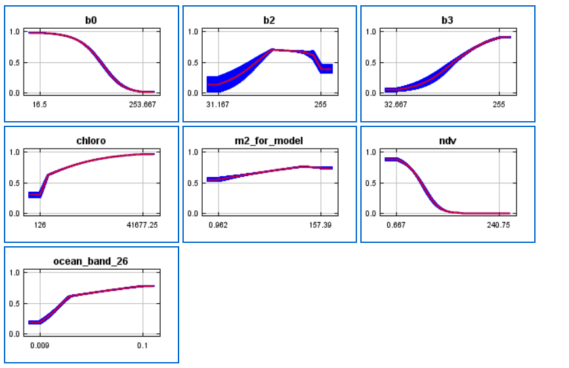
Figure S1. Marginal response curves for relationship between likelihood of Spoon-billed Sandpiper occurrence and variable. B0 is radiance in band 0 of VGT, B2 is reflectance in band 2, B3 band 3 radiance, chloro is chlorophyll from Modis, m2_for_model is tide height, NDV is NDVI from VGT and ocean_band_26 is distance from coast. Red lines are mean relationship over 10 cross validation runs (blue is SD)

Figure S2. A spatially referenced (Lat, long, WGS84) .tif file for opening in a GIS with the predicted distribution of the Spoon-billed Sandpiper on which Figure 2 is based. A ‘1’ indicates locations predicted to be suitable for Spoon-billed Sandpipers.

