Supplementary Material

Migratory behaviour of bird species occurring in critical numbers at Besh Barmag bottleneck in Azerbaijan

MICHAEL HEISS

Contents
Appendix S1. Phenology of migrating species meeting the 1% criterion of the world or flyway population in at least one observation season.

Appendix S2. Flight heights of bird species migrating through the coastal plain in autumn 2011 meeting the 1% criterion of either the world or flyway population.

Appendix S3. Flight heights of bird species migrating through the coastal plain in spring 2012.

Appendix S4. Flight heights of bird species migrating above the Caspian Sea in autumn 2011.

Appendix S5. Flight heights of migrating bird species above the Caspian Sea in spring 2012.

Appendix S6. Migratory distance to the shoreline of bird species exceeding the 1% criterion of world or flyway population in autumn 2011.

Appendix S7. Migratory distance to the shoreline of bird species exceeding the 1% criterion of world or flyway population in spring 2012.

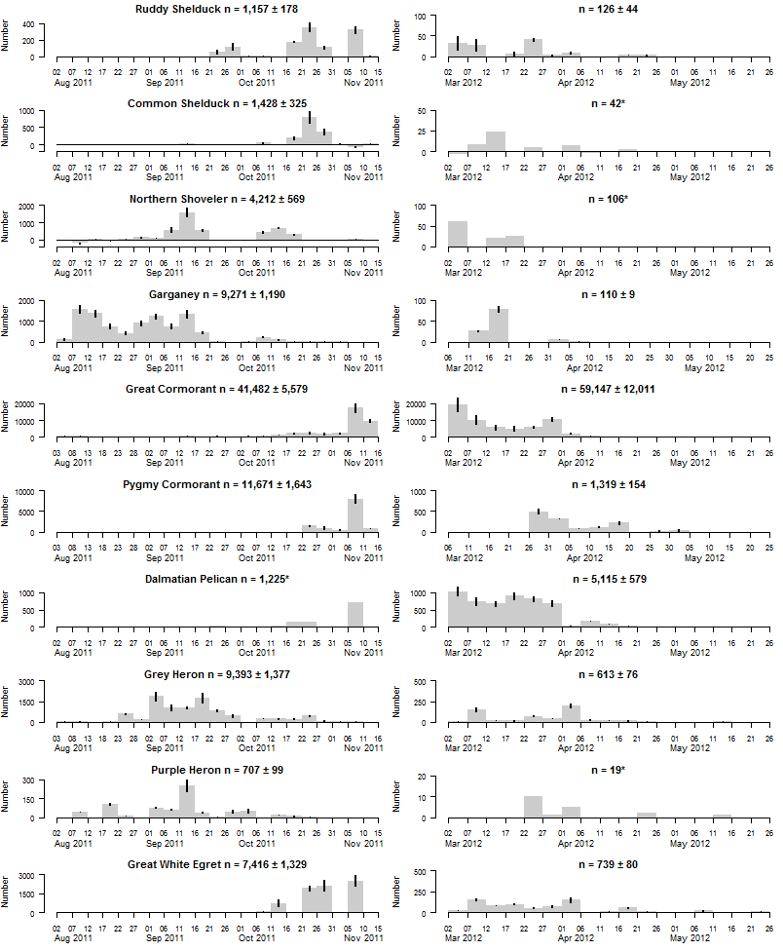
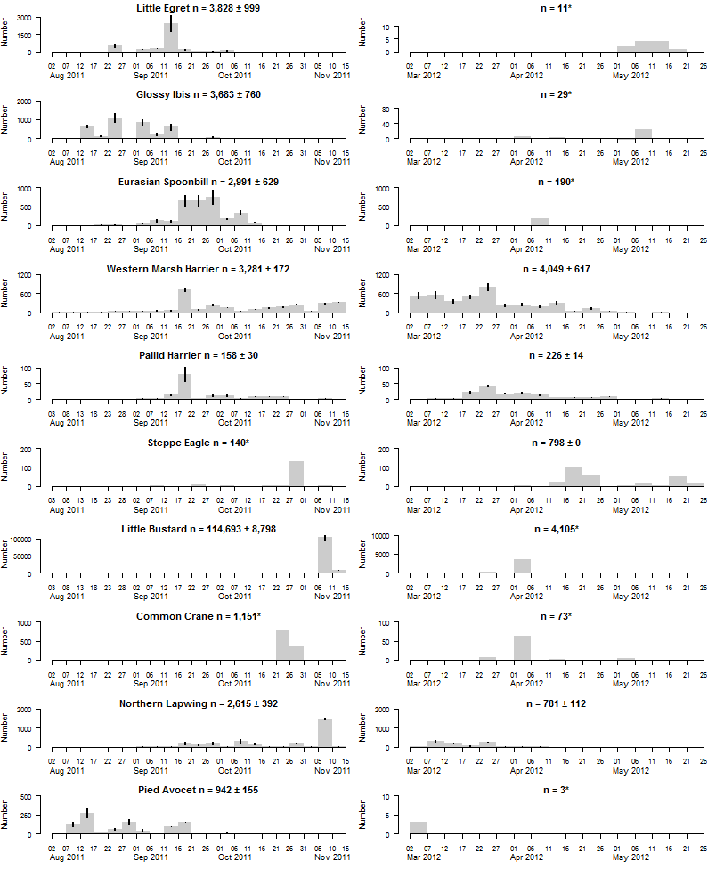
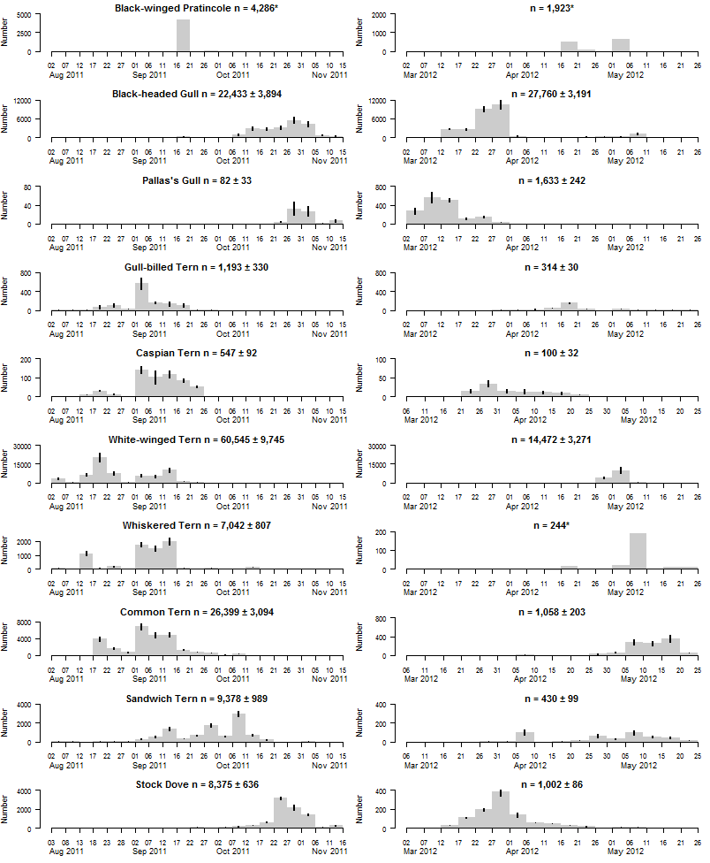
Aug Sep Oct Nov 2011 Mar Apr May 2012
Appendix S1. Phenology of migrating species meeting the 1% criterion of the world or flyway population in at least one observation season. Shown is the calculated estimate per pentade and standard deviation derived from the estimation method by Heiss (2013).
*For some species no phenology could be calculated, the data set being inadequate to calculate estimates (see Heiss 2013).

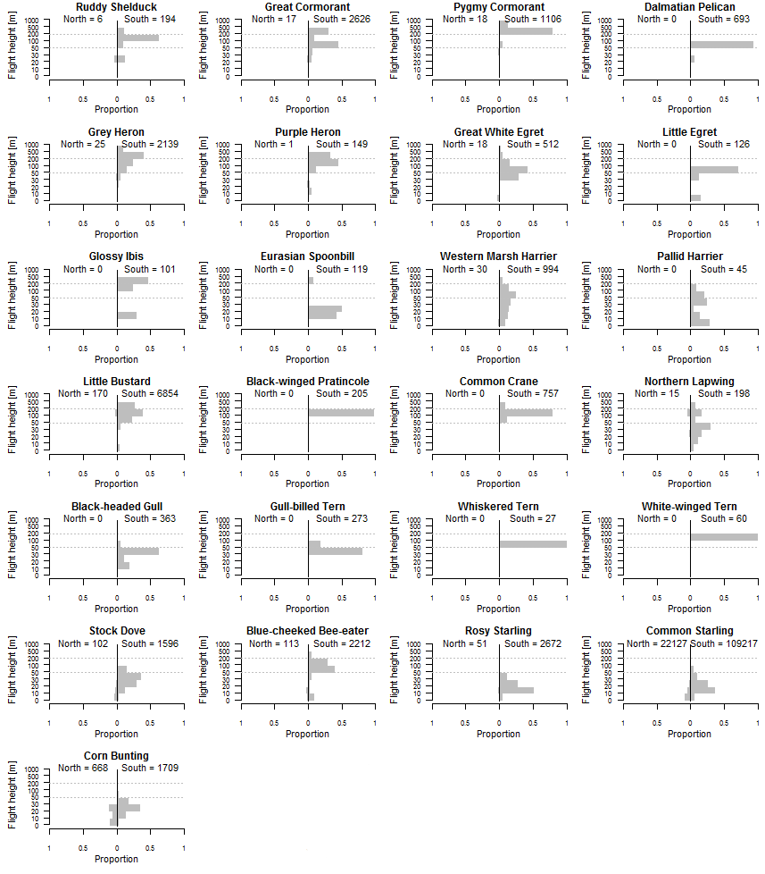
Appendix S2. Flight heights of bird species migrating through the coastal plain in autumn 2011 meeting the 1% criterion of either the world or flyway population. Dotted lines show the anticipated collision risk (0–50 m agl = immediate risk, 51–200 m agl = possible future risk, > 200 m agl = no immediate or possible future risk).

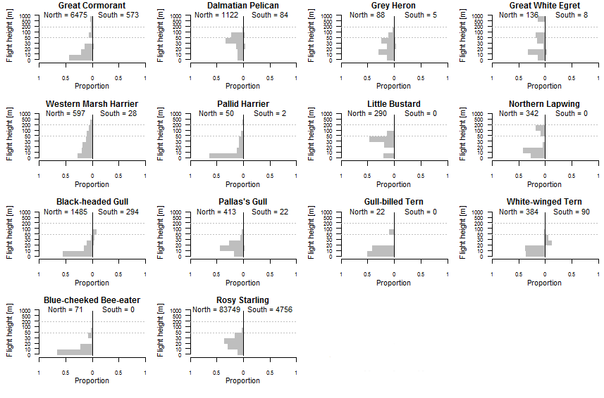
Appendix S3. Flight heights of bird species migrating through the coastal plain in spring 2012. Dotted lines show the anticipated collision risk (0–50 m agl = immediate risk, 51–200 m agl = possible future risk, > 200 m agl = no immediate or possible future risk).

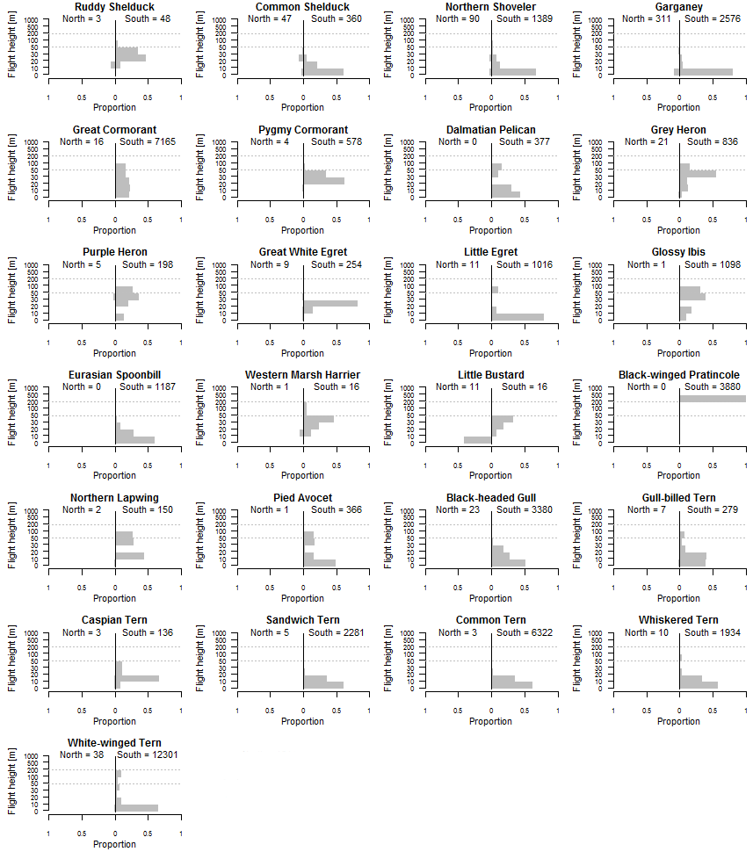
Appendix S4. Flight heights of bird species migrating above the Caspian Sea in autumn 2011. Dotted lines show the anticipated collision risk (0–50 m asl = immediate risk, 51–200 m asl= possible future risk, > 200 m asl = no immediate or possible future risk).

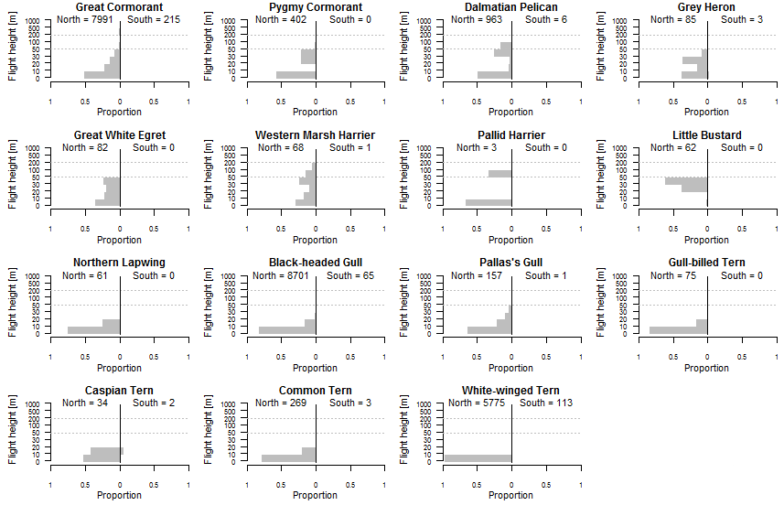
Appendix S5. Flight heights of migrating bird species above the Caspian Sea in spring 2012. Dotted lines show the anticipated collision risk (0–50 m asl = immediate risk, 51–200 m asl = possible future risk, > 200 m asl = no immediate or possible future risk).

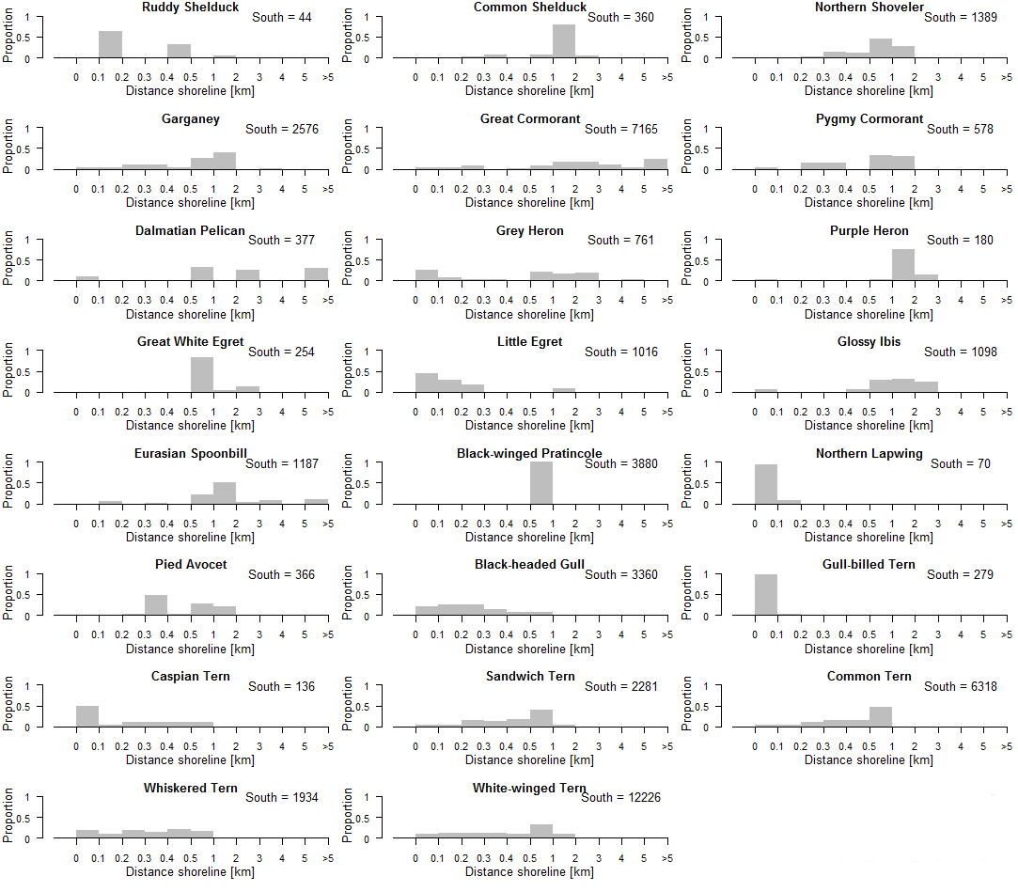

Appendix S6. Migratory distance to the shoreline of bird species exceeding the 1% criterion of world or flyway population in autumn 2011.

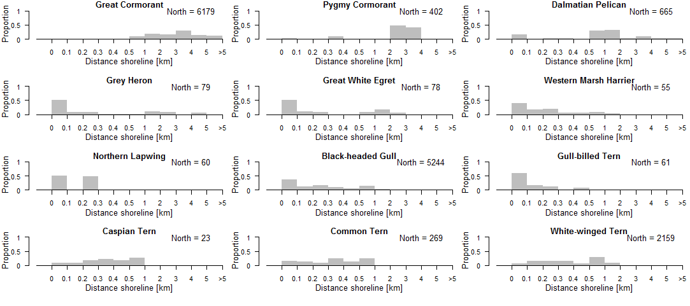
Appendix S7. Migratory distance to the shoreline of bird species exceeding the 1% criterion of world or flyway population in spring 2012.

