Supplementary Material
Evaluating abundance and trends in a Hawaiian avian community using state-space analysis
RICHARD J. CAMP, KEVIN W. BRINCK, P. MARCOS GORRESEN and EBEN H. PAXTON

Contents
Table S1. Sampling effort at Hakalau in open and closed forest strata by year.

Table S2. The best-fit detection-function model of each species used to calculate population abundances at Hakalau Forest NWR.

Figure S1. Species-specific detection function (line), and distance data (histogram) pooled across all surveys from 1987 to 2012.

Table S3. Model parameters and model-selection results for forest birds at Hakalau Forest NWR.

Table S4. Annual counts, and abundance and 95% CI estimates for forest birds at Hakalau in open and closed forest strata.

Figure S2. Trend with 95% Confidence band around a log-linear fit, and credible band around a state-space fit for forest birds at Hakalau Forest National Wildlife Refuge, Hawai‘i.

Table S5. Geometric mean, minimum and maximum population size changes (lambda) from one year to the next for both the uncorrected counts and detection-corrected abundance (Distance) estimates derived from variance non-partitioned log-linear regression and their corresponding state-space corrected population estimates.

Table S1. Sampling effort at Hakalau in open and closed forest strata by year. Effort is the number of samples conducted at the forest bird survey stations. Missing year in the series indicated with a NA.
Year | Open | Closed
1987 | 205 | NA
1988 | 213 | NA
1989 | 198 | NA
1990 | 203 | NA
1991 | 197 | NA
1992 | 197 | NA
1993 | 194 | NA
1994 | 194 | NA
1995 | 195 | NA
1996 | 198 | NA
1997 | 193 | NA
1998 | 197 | NA
1999 | 195 | 113
2000 | 198 | 108
2001 | 196 | 93
2002 | 195 | 94
2003 | 200 | 95
2004 | 198 | 95
2005 | 168 | 63
2006 | 164 | 61
2007 | 169 | 74
2008 | 158 | 85
2009 | NA | NA
2010 | 140 | 59
2011 | 142 | 62
2012 | 162 | 63

Table S2. The best-fit detection-function model of each species used to calculate population abundances at Hakalau Forest NWR. Detection function and data histogram figures for the best-fit model, and AICc statistics for the full set of detection-function models are provided in Appendix 2. Models included half-normal (HN) and hazard-rate (HR) key detection functions and with cosine (COS), and Hermite polynomial (Hpoly) series expansions. The numbers in parenthesis indicate the series expansion order adjustments. Covariates included detection type (Detect, pooled auditory and visually confirmed auditory detections [14Detect], and pooled visual and visually confirmed auditory detections [24Detect]). Data were truncated at a distance where detection probability was < 10%. This procedure facilitates modeling by deleting outliers and reducing the number of parameters needed to modify the detection function.
Species | Model | Series expansion | Covariate | Truncation (m)
Hawai‘i ‘Elepaio | HR | Key | Detect | 54.1
‘Ōma‘o | HR | Key | 24Detect | 73.7
Hawai‘i ‘Amakihi | HN | Cos(2,3) | 14Detect | 57.0
‘Akiapōlā‘au | HN | Key | 24Detect | 78.0
Hawai‘i Creeper | HN | Key | 24Detect | 58.0
Hawai‘i ‘Ākepa | HR | Key | 24Detect | 58.0
‘I‘iwi | HN | Hpoly(4,6) | 14Detect | 49.8
‘Apapane | HR | Key | Detect | 58.3
Red-billed Leiothrix | HN | Cos(2,3) | 24Detect | 68.0
Japanese White-eye | HN | Key | 24Detect | 45.8

Figure S1. Species-specific detection function (line), and distance data (histogram) pooled across all surveys from 1987 to 2012.

Table S3. Model parameters and model-selection results for forest birds at Hakalau Forest NWR. Within each species analysis, models were sorted by differences in second-order Akaike’s information criterion corrected for small sample size (∆AICc) between each candidate model and the model with the lowest AICc value. Models examined included half-normal (HN) and hazard-rate (HR) key detection functions and with cosine (COS), Hermite polynomial (Hpoly), and simple polynomial (Spoly) series expansions. Covariates were incorporated with the most parsimonious model to improve model precision. Covariates included the categorical variables cloud cover (Cloud), amount of rain (Rain), Beaufort wind scale (Wind), Beaufort gust scale (Gust), detection type (Detect, pooled auditory and visually confirmed auditory detections [14Detect], and pooled visual and visually confirmed auditory detections [24Detect]), vegetation (Veg), observer (OBS), and survey year [Year(f)]. Continuous covariates included the variables elevation, (Elev), time of day (Time), and survey year [Year(c)]. The number of estimated parameters (# Params), and negative log-likelihood (-LogL) are presented. The Akaike model weight (w) is the likelihood that each model is the best of the 19 models evaluated for each species.
Species
Model | Series expansion | Covariate | # Params | -LogL | AICc | ∆AICc | w
Hawai‘i ‘Elepaio
HR | Key | Detect | 4 | 23763.18 | 47534.38 | 0.00 | 1.00000
HR | Key | 24Detect | 3 | 23791.94 | 47589.89 | 55.51 | 0.00000
HR | Key | 14Detect | 3 | 24117.28 | 48240.56 | 706.18 | 0.00000
HR | Key | Observer | 34 | 24774.08 | 49616.53 | 2082.15 | 0.00000
HR | Cos |  | 3 | 24826.95 | 49659.91 | 2125.53 | 0.00000
HN | Cos |  | 2 | 24830.50 | 49665.00 | 2130.62 | 0.00000
HN | Key |  | 1 | 24840.46 | 49682.92 | 2148.54 | 0.00000
HR | Key |  | 2 | 24869.95 | 49743.89 | 2209.51 | 0.00000
HR | Key | Time | 3 | 24873.36 | 49752.72 | 2218.34 | 0.00000
HR | Key | Elev | 3 | 24873.37 | 49752.75 | 2218.37 | 0.00000
HR | Key | Veg | 4 | 24873.20 | 49754.40 | 2220.02 | 0.00000
HR | Key | Rain | 6 | 24873.08 | 49758.18 | 2223.80 | 0.00000
HR | Key | Gust | 6 | 24873.30 | 49758.61 | 2224.23 | 0.00000
HR | Key | Wind | 6 | 24873.51 | 49759.03 | 2224.65 | 0.00000
HR | Key | Year(f) | 26 | 24855.12 | 49762.46 | 2228.08 | 0.00000
HR | Key | Cloud | 13 | 24872.66 | 49771.39 | 2237.01 | 0.00000
HN | Hpoly¹
HR | Spoly²
HR | Key | Year(c) ²
‘Ōma‘o
HR | Key | 24Detect | 2 | 53841.70 | 107687.40 | 0.00 | 0.70057
HR | Key | Detect | 3 | 53841.55 | 107689.10 | 1.70 | 0.29943
HR | Key | 14Detect | 2 | 54337.00 | 108678.00 | 990.60 | 0.00000
HR | Key | Observer | 51 | 54367.45 | 108837.30 | 1149.90 | 0.00000
HR | Key |  | 2 | 54539.50 | 109083.00 | 1395.60 | 0.00000
HR | Key | Year(f) | 25 | 54521.06 | 109092.20 | 1404.80 | 0.00000
HR | Key | Veg | 3 | 54641.43 | 109288.90 | 1601.50 | 0.00000
HR | Key | Wind | 5 | 54641.44 | 109292.90 | 1605.50 | 0.00000
HR | Key | Elev | 2 | 54647.39 | 109298.80 | 1611.40 | 0.00000
HR | Key | Gust | 5 | 54656.30 | 109322.60 | 1635.20 | 0.00000
HR | Key | Rain | 5 | 54658.23 | 109326.50 | 1639.10 | 0.00000
HR | Key | Cloud | 12 | 54657.12 | 109338.30 | 1650.90 | 0.00000
HR | Key | Time | 2 | 54676.24 | 109356.50 | 1669.10 | 0.00000
HN | Key |  | 1 | 54682.33 | 109366.70 | 1679.30 | 0.00000
HN | Cos²
HN | Hpoly²
HR | Cos²
HR | Spoly²
HR | Key | Year(c)²
Hawai‘i ‘Amakihi
HN | Cos(2,3) | 14Detect | 4 | 98201.18 | 196410.40 | 0.00 | 1.00000
HN | Cos(2,3) | Year(f) | 27 | 99232.88 | 198519.80 | 2109.40 | 0.00000
HN | Cos(2,3) | Veg | 5 | 99427.15 | 198864.30 | 2453.90 | 0.00000
HN | Cos(2,3) | Cloud | 14 | 99438.72 | 198905.50 | 2495.10 | 0.00000
HN | Cos(2,3) | Wind | 7 | 99459.38 | 198932.80 | 2522.40 | 0.00000
HN | Cos(2,3) | Rain | 7 | 99473.70 | 198961.40 | 2551.00 | 0.00000
HN | Cos(2,3) | Elev | 4 | 99505.69 | 199019.40 | 2609.00 | 0.00000
HN | Cos(2,3) | Gust | 7 | 99528.20 | 199070.40 | 2660.00 | 0.00000
HN | Cos(2,3) | Time | 4 | 99537.14 | 199082.30 | 2671.90 | 0.00000
HN | Cos |  | 3 | 99541.65 | 199089.30 | 2678.90 | 0.00000
HR | Spoly |  | 4 | 99547.11 | 199102.20 | 2691.80 | 0.00000
HR | Cos |  | 4 | 99548.44 | 199104.90 | 2694.50 | 0.00000
HN | Key |  | 1 | 99581.30 | 199164.60 | 2754.20 | 0.00000
HR | Key |  | 2 | 99626.63 | 199257.30 | 2846.90 | 0.00000
HN | Hpoly³
HN | Cos(2,3) | Detect³
HN | Cos(2,3) | 24Detect³
HN | Cos(2,3) | Observer²
HN | Cos(2,3) | Year(c) ²
‘Akiapōlā‘au
HN | Key | Detect ⁴ | 3 | 2712.75 | 5431.53 | 0.00 | 0.81382
HN | Key | 24Detect | 2 | 2715.23 | 5434.48 | 2.95 | 0.18618
HN | Key | 14Detect | 2 | 2755.55 | 5515.12 | 83.59 | 0.00000
HN | Key | Observer | 3 | 2775.87 | 5557.78 | 126.25 | 0.00000
HN | Key | Rain | 4 | 2781.53 | 5571.13 | 139.60 | 0.00000
HN | Hpoly |  | 3 | 2786.12 | 5578.28 | 146.75 | 0.00000
HN | Key | Year(c) | 2 | 2787.42 | 5578.86 | 147.33 | 0.00000
HN | Key |  | 1 | 2789.04 | 5580.09 | 148.56 | 0.00000
HR | Cos |  | 3 | 2787.14 | 5580.32 | 148.79 | 0.00000
HN | Key | Veg | 3 | 2787.28 | 5580.60 | 149.07 | 0.00000
HN | Key | Cloud | 2 | 2788.36 | 5580.73 | 149.20 | 0.00000
HN | Key | Elev | 2 | 2788.85 | 5581.71 | 150.18 | 0.00000
HN | Key | Time | 2 | 2788.94 | 5581.89 | 150.36 | 0.00000
HR | Key |  | 2 | 2789.07 | 5582.17 | 150.64 | 0.00000
HN | Key | Wind | 4 | 2788.36 | 5584.79 | 153.26 | 0.00000
HN | Key | Gust | 5 | 2787.53 | 5585.16 | 153.63 | 0.00000
HN | Cos¹
HR | Spoly¹
HN | Key | Year(f) ²
Hawai‘i Creeper
HN | Key | Detect ⁴ | 3 | 14661.44 | 29328.88 | 0.00 | 0.73007
HN | Key | 24Detect | 2 | 14663.43 | 29330.87 | 1.99 | 0.26993
HN | Key | 14Detect | 2 | 15053.98 | 30111.96 | 783.08 | 0.00000
HN | Key | Year(f) | 25 | 15207.10 | 30464.55 | 1135.67 | 0.00000
HN | Key | Observer | 19 | 15214.30 | 30466.80 | 1137.92 | 0.00000
HN | Key | Wind | 5 | 15243.25 | 30496.53 | 1167.65 | 0.00000
HN | Key | Cloud | 12 | 15243.20 | 30510.48 | 1181.60 | 0.00000
HR | Cos |  | 4 | 15252.83 | 30513.66 | 1184.78 | 0.00000
HN | Key | Rain | 5 | 15253.91 | 30517.83 | 1188.95 | 0.00000
HN | Key | Gust | 5 | 15256.78 | 30523.58 | 1194.70 | 0.00000
HN | Key | Time | 2 | 15261.96 | 30527.93 | 1199.05 | 0.00000
HN | Key |  | 1 | 15264.33 | 30530.67 | 1201.79 | 0.00000
HN | Key | Elev | 2 | 15263.42 | 30530.85 | 1201.97 | 0.00000
HN | Key | Veg | 3 | 15263.05 | 30532.11 | 1203.23 | 0.00000
HR | Key |  | 2 | 15290.75 | 30585.50 | 1256.62 | 0.00000
HN | Cos¹
HN | Hpoly¹
HR | Spoly²
HN | Key | Year(c) ²
Hawai‘i ‘Ākepa
HR | Key | Detect ⁴ | 4 | 15116.71 | 30241.44 | 0.00 | 0.99964
HR | Key | 24Detect | 3 | 15125.64 | 30257.29 | 15.85 | 0.00036
HR | Key | 14Detect | 3 | 15377.12 | 30760.26 | 518.82 | 0.00000
HR | Key | Observer | 21 | 15483.11 | 31008.45 | 767.01 | 0.00000
HR | Key | Year(f) | 26 | 15483.43 | 31019.22 | 777.78 | 0.00000
HR | Key | Wind | 6 | 15548.75 | 31109.53 | 868.09 | 0.00000
HR | Key | Year(c) | 3 | 15553.70 | 31113.40 | 871.96 | 0.00000
HR | Cos |  | 4 | 15553.35 | 31114.70 | 873.26 | 0.00000
HR | Spoly |  | 3 | 15555.78 | 31117.57 | 876.13 | 0.00000
HN | Cos |  | 2 | 15556.79 | 31119.58 | 878.14 | 0.00000
HR | Key | Veg | 4 | 15558.00 | 31124.01 | 882.57 | 0.00000
HR | Key | Gust | 6 | 15556.55 | 31125.12 | 883.68 | 0.00000
HR | Key | Rain | 6 | 15557.82 | 31127.67 | 886.23 | 0.00000
HR | Key | Elev | 3 | 15560.86 | 31127.73 | 886.29 | 0.00000
HR | Key | Cloud | 13 | 15551.27 | 31128.64 | 887.20 | 0.00000
HR | Key |  | 2 | 15564.38 | 31132.77 | 891.33 | 0.00000
HR | Key | Time | 3 | 15563.54 | 31133.09 | 891.65 | 0.00000
HN | Key |  | 1 | 15594.65 | 31191.30 | 949.86 | 0.00000
HN | Hpoly²
‘I‘iwi
HN | Hpoly(4,6) | 14Detect | 4 | 143991.80 | 287991.60 | 0.00 | 1.00000
HN | Hpoly(4,6) | Observer | 60 | 144181.40 | 288483.00 | 491.40 | 0.00000
HN | Hpoly(4,6) | Year(f) | 27 | 144507.80 | 289069.70 | 1078.10 | 0.00000
HN | Hpoly(4,6) | Cloud | 14 | 144762.50 | 289553.00 | 1561.40 | 0.00000
HN | Hpoly(4,6) | Wind | 7 | 144788.60 | 289591.10 | 1599.50 | 0.00000
HN | Hpoly(4,6) | Rain | 7 | 144788.60 | 289591.20 | 1599.60 | 0.00000
HN | Hpoly(4,6) | Veg | 5 | 144864.10 | 289738.20 | 1746.60 | 0.00000
HN | Hpoly(4,6) | Gust | 7 | 144903.10 | 289820.20 | 1828.60 | 0.00000
HN | Hpoly |  | 3 | 144941.50 | 289889.00 | 1897.40 | 0.00000
HR | Cos |  | 4 | 145027.00 | 290062.00 | 2070.40 | 0.00000
HN | Cos |  | 2 | 145037.10 | 290078.20 | 2086.60 | 0.00000
HN | Key |  | 1 | 145038.20 | 290078.40 | 2086.80 | 0.00000
HR | Spoly |  | 4 | 145058.80 | 290125.70 | 2134.10 | 0.00000
HR | Key |  | 2 | 145175.80 | 290355.50 | 2363.90 | 0.00000
HN | Hpoly(4,6) | Detect³
HN | Hpoly(4,6) | 24Detect³
HN | Hpoly(4,6) | Elev²
HN | Hpoly(4,6) | Time²
HN | Hpoly(4,6) | Year(c) ²
‘Apapane
HR | Key | Detect | 4 | 129316.80 | 258641.70 | 0.00 | 1.00000
HR | Key | 24Detect | 3 | 129333.40 | 258672.80 | 31.10 | 0.00000
HR | Key | 14Detect | 3 | 130425.80 | 260857.60 | 2215.90 | 0.00000
HR | Key | Year(f) | 26 | 131042.60 | 262137.20 | 3495.50 | 0.00000
HR | Key | Observer | 55 | 131021.70 | 262153.70 | 3512.00 | 0.00000
HR | Key | Cloud | 13 | 131566.00 | 263158.00 | 4516.30 | 0.00000
HR | Key | Wind | 6 | 131592.50 | 263197.10 | 4555.40 | 0.00000
HR | Key | Rain | 6 | 131653.40 | 263318.70 | 4677.00 | 0.00000
HN | Cos |  | 2 | 131666.80 | 263337.70 | 4696.00 | 0.00000
HR | Cos |  | 4 | 131667.60 | 263343.30 | 4701.60 | 0.00000
HR | Spoly |  | 4 | 131669.60 | 263347.20 | 4705.50 | 0.00000
HR | Key | Gust | 6 | 131724.90 | 263461.90 | 4820.20 | 0.00000
HR | Key | Time | 3 | 131742.00 | 263489.90 | 4848.20 | 0.00000
HR | Key |  | 2 | 131744.90 | 263493.80 | 4852.10 | 0.00000
HR | Key | Elev | 3 | 131748.80 | 263503.60 | 4861.90 | 0.00000
HN | Key |  | 1 | 131758.40 | 263518.80 | 4877.10 | 0.00000
HR | Key | Veg | 4 | 131826.10 | 263660.20 | 5018.50 | 0.00000
HN | Hpoly²
HR | Key | Year(c) ²
Red-billed Leiothrix
HN | Cos(2,3) | 24Detect | 4 | 43894.54 | 87797.09 | 0.00 | 0.61301
HN | Cos(2,3) | Detect | 5 | 43894.00 | 87798.01 | 0.92 | 0.38699
HN | Cos(2,3) | 14Detect | 4 | 44930.36 | 89868.72 | 2071.63 | 0.00000
HN | Cos(2,3) | Observer | 46 | 44938.88 | 89970.16 | 2173.07 | 0.00000
HN | Cos(2,3) | Year(f) | 27 | 45184.84 | 90423.83 | 2626.74 | 0.00000
HN | Cos(2,3) | Rain | 7 | 45240.30 | 90494.62 | 2697.53 | 0.00000
HN | Cos(2,3) | Cloud | 14 | 45241.76 | 90511.55 | 2714.46 | 0.00000
HN | Cos(2,3) | Wind | 7 | 45254.41 | 90522.82 | 2725.73 | 0.00000
HN | Cos(2,3) | Gust | 7 | 45272.39 | 90558.79 | 2761.70 | 0.00000
HN | Cos(2,3) | Veg | 5 | 45275.68 | 90561.38 | 2764.29 | 0.00000
HN | Cos(2,3) | Time | 4 | 45278.57 | 90565.14 | 2768.05 | 0.00000
HN | Cos(2,3) | Elev | 4 | 45281.77 | 90571.53 | 2774.44 | 0.00000
HR | Cos |  | 4 | 45283.43 | 90574.86 | 2777.77 | 0.00000
HN | Cos |  | 3 | 45284.58 | 90575.16 | 2778.07 | 0.00000
HN | Key |  | 1 | 45309.38 | 90620.77 | 2823.68 | 0.00000
HN | Hpoly |  | 1 | 45309.38 | 90620.77 | 2823.68 | 0.00000
HR | Key |  | 2 | 45367.73 | 90739.47 | 2942.38 | 0.00000
HR | Spoly²
HN | Cos(2,3) | Year(c) ²
Japanese White-eye
HN | Key | 24Detect | 3 | 27831.74 | 55669.48 | 0.00 | 1.00000
HN | Key | Detect | 4 | 27885.10 | 55778.20 | 108.72 | 0.00000
HN | Key | Observer | 32 | 28146.27 | 56356.81 | 687.33 | 0.00000
HN | Key | Year(f) | 26 | 28288.71 | 56629.61 | 960.13 | 0.00000
HR | Spoly |  | 3 | 28352.16 | 56710.32 | 1040.84 | 0.00000
HR | Key |  | 2 | 28373.99 | 56751.98 | 1082.50 | 0.00000
HN | Key | Veg | 4 | 28381.24 | 56770.48 | 1101.00 | 0.00000
HN | Key | 14Detect | 3 | 28384.76 | 56775.52 | 1106.04 | 0.00000
HN | Key | Time | 3 | 28384.79 | 56775.59 | 1106.11 | 0.00000
HN | Key | Wind | 6 | 28381.80 | 56775.61 | 1106.13 | 0.00000
HN | Key | Elev | 3 | 28384.60 | 56775.81 | 1106.33 | 0.00000
HN | Key | Gust | 6 | 28382.99 | 56778.00 | 1108.52 | 0.00000
HN | Key | Rain | 6 | 28384.65 | 56781.31 | 1111.83 | 0.00000
HN | Key | Cloud | 13 | 28382.73 | 56791.52 | 1122.04 | 0.00000
HN | Key |  | 1 | 28395.13 | 56792.27 | 1122.79 | 0.00000
HN | Cos²
HN | Hpoly²
HR | Cos²
HN | Key | Year(c) ²
¹ Key model selected.
² Parameters highly correlated.
³ Failed to converge.
⁴ Parsimonious model with 24Detect used because of bootstrap errors.

Table S4. Annual counts, and abundance and 95% CI estimates for forest birds at Hakalau in open and closed forest strata. Missing year in the series indicated with a NA.
Species |  |  | 95% Credible |  |  | 95% Confidence |  |  | 95% Credible
Year | Count | State-space | lower | upper | DISTANCE | lower | upper | State-space | lower | upper
Hawai‘i ‘Elepaio
Open forest
1987 | 849 | 978 | 794 | 1,194 | 10,521 | 8,116 | 12,548 | 11,440 | 9,634 | 13,547
1988 | 1,516 | 1,029 | 832 | 1,381 | 14,767 | 11,794 | 17,332 | 11,912 | 10,097 | 14,717
1989 | 884 | 952 | 808 | 1,118 | 11,195 | 8,713 | 13,427 | 11,361 | 9,927 | 13,111
1990 | 961 | 921 | 773 | 1,069 | 11,436 | 8,918 | 13,658 | 11,044 | 9,521 | 12,606
1991 | 624 | 863 | 648 | 1,023 | 7,451 | 5,681 | 9,050 | 10,393 | 7,851 | 12,198
1992 | 761 | 877 | 713 | 1,020 | 10,492 | 8,135 | 12,747 | 10,853 | 9,133 | 12,357
1993 | 1,005 | 914 | 780 | 1,075 | 11,658 | 9,078 | 14,068 | 11,264 | 9,876 | 12,780
1994 | 1,021 | 925 | 791 | 1,119 | 12,044 | 9,299 | 14,332 | 11,536 | 10,150 | 13,364
1995 | 1,067 | 921 | 791 | 1,124 | 12,904 | 10,106 | 15,265 | 11,738 | 10,256 | 13,795
1996 | 965 | 886 | 758 | 1,033 | 13,162 | 10,249 | 15,867 | 11,626 | 10,212 | 13,560
1997 | 668 | 829 | 662 | 954 | 9,313 | 7,331 | 11,302 | 10,984 | 9,183 | 12,516
1998 | 731 | 822 | 675 | 947 | 9,960 | 7,574 | 12,166 | 10,987 | 9,233 | 12,562
1999 | 810 | 829 | 695 | 953 | 11,291 | 8,897 | 13,495 | 11,270 | 9,787 | 12,803
2000 | 758 | 826 | 700 | 947 | 10,968 | 8,612 | 12,831 | 11,448 | 9,994 | 13,123
2001 | 954 | 851 | 734 | 1,006 | 13,679 | 10,637 | 16,327 | 11,925 | 10,433 | 14,152
2002 | 800 | 836 | 723 | 971 | 11,291 | 8,530 | 13,754 | 11,741 | 10,360 | 13,526
2003 | 900 | 842 | 730 | 996 | 13,031 | 10,195 | 15,405 | 11,971 | 10,514 | 14,033
2004 | 859 | 833 | 719 | 976 | 12,406 | 9,739 | 14,669 | 11,876 | 10,441 | 13,775
2005 | 821 | 826 | 716 | 978 | 11,412 | 8,707 | 14,061 | 11,734 | 10,329 | 13,533
2006 | 976 | 830 | 712 | 1,012 | 13,790 | 10,398 | 17,045 | 11,896 | 10,326 | 14,201
2007 | 834 | 797 | 684 | 938 | 12,319 | 9,694 | 14,543 | 11,490 | 10,016 | 13,325
2008 | 646 | 757 | 616 | 902 | 9,290 | 7,000 | 11,413 | 10,824 | 9,029 | 12,449
2009 | NA | 749 | 588 | 908 | NA | NA | NA | 10,701 | 8,164 | 12,465
2010 | 657 | 741 | 607 | 885 | 9,307 | 6,828 | 11,719 | 10,600 | 8,787 | 12,345
2011 | 796 | 753 | 629 | 908 | 11,497 | 8,731 | 14,095 | 10,857 | 9,241 | 12,549
2012 | 741 | 745 | 608 | 915 | 10,262 | 7,653 | 12,792 | 10,736 | 8,903 | 12,670
Closed forest
1999 | 1,168 | 1,125 | 889 | 1,370 | 9,500 | 7,192 | 11,496 | 9,219 | 7,294 | 11,426
2000 | 935 | 1,009 | 846 | 1,238 | 7,968 | 6,138 | 9,736 | 8,660 | 7,056 | 10,625
2001 | 935 | 1,000 | 853 | 1,196 | 8,204 | 6,210 | 9,992 | 8,702 | 7,255 | 10,493
2002 | 1,277 | 1,127 | 911 | 1,358 | 11,043 | 8,471 | 13,129 | 9,338 | 7,605 | 11,474
2003 | 1,032 | 1,018 | 863 | 1,187 | 8,405 | 6,341 | 10,344 | 8,471 | 7,140 | 10,122
2004 | 768 | 895 | 736 | 1,086 | 6,444 | 4,486 | 8,337 | 7,747 | 6,201 | 9,507
2005 | 1,063 | 1,001 | 834 | 1,171 | 8,731 | 6,291 | 11,091 | 8,289 | 6,882 | 9,881
2006 | 1,049 | 997 | 829 | 1,178 | 8,872 | 6,223 | 11,124 | 8,310 | 6,861 | 10,120
2007 | 1,000 | 950 | 792 | 1,115 | 8,752 | 6,604 | 10,553 | 8,078 | 6,665 | 9,707
2008 | 753 | 829 | 690 | 1,003 | 6,367 | 4,584 | 8,181 | 7,214 | 5,831 | 8,700
2009 | NA | 806 | 599 | 1,024 | NA | NA | NA | 7,139 | 5,205 | 8,968
2010 | 746 | 800 | 670 | 971 | 6,316 | 4,504 | 8,009 | 6,967 | 5,634 | 8,465
2011 | 855 | 842 | 695 | 991 | 7,584 | 5,311 | 9,843 | 7,316 | 5,994 | 8,902
2012 | 889 | 856 | 676 | 1,038 | 7,886 | 5,671 | 9,745 | 7,460 | 5,835 | 9,369
‘Ōma‘o
Open forest
1987 | 2,668 | 2,693 | 2,148 | 3,305 | 9,538 | 8,541 | 10,648 | 9,002 | 7,338 | 11,128
1988 | 3,418 | 2,792 | 2,155 | 3,467 | 9,570 | 8,316 | 10,696 | 8,965 | 7,499 | 10,782
1989 | 2,500 | 2,497 | 2,092 | 2,940 | 9,901 | 8,752 | 11,166 | 8,836 | 7,520 | 10,565
1990 | 2,468 | 2,309 | 1,981 | 2,690 | 8,891 | 7,814 | 10,044 | 8,377 | 7,173 | 9,658
1991 | 1,528 | 1,982 | 1,540 | 2,443 | 5,266 | 4,395 | 6,126 | 7,667 | 5,729 | 9,165
1992 | 1,843 | 2,007 | 1,649 | 2,393 | 8,398 | 7,483 | 9,439 | 8,029 | 6,709 | 9,342
1993 | 2,093 | 2,102 | 1,780 | 2,437 | 7,405 | 6,486 | 8,349 | 8,094 | 6,843 | 9,309
1994 | 2,335 | 2,170 | 1,849 | 2,552 | 8,876 | 7,974 | 9,840 | 8,369 | 7,152 | 9,606
1995 | 2,133 | 2,117 | 1,807 | 2,479 | 7,873 | 6,877 | 8,983 | 8,362 | 7,087 | 9,590
1996 | 2,000 | 2,057 | 1,746 | 2,384 | 8,356 | 7,496 | 9,271 | 8,521 | 7,303 | 9,807
1997 | 1,969 | 2,028 | 1,725 | 2,346 | 8,976 | 7,969 | 9,961 | 8,744 | 7,500 | 10,139
1998 | 2,076 | 2,040 | 1,738 | 2,345 | 8,530 | 7,665 | 9,427 | 8,792 | 7,552 | 10,103
1999 | 1,908 | 1,988 | 1,682 | 2,306 | 9,016 | 8,041 | 9,943 | 8,978 | 7,737 | 10,352
2000 | 1,949 | 1,996 | 1,702 | 2,311 | 8,958 | 8,099 | 9,815 | 9,113 | 7,868 | 10,590
2001 | 2,061 | 2,018 | 1,724 | 2,329 | 9,950 | 8,998 | 10,913 | 9,370 | 8,100 | 11,028
2002 | 1,979 | 1,993 | 1,697 | 2,307 | 9,575 | 8,482 | 10,568 | 9,375 | 8,113 | 10,905
2003 | 1,715 | 1,955 | 1,638 | 2,271 | 7,883 | 6,951 | 8,804 | 9,294 | 7,828 | 10,865
2004 | 2,449 | 2,137 | 1,810 | 2,545 | 11,892 | 10,898 | 12,909 | 9,895 | 8,470 | 11,838
2005 | 1,881 | 2,054 | 1,746 | 2,394 | 8,830 | 7,820 | 9,927 | 9,728 | 8,351 | 11,446
2006 | 2,622 | 2,194 | 1,813 | 2,687 | 12,270 | 10,994 | 13,608 | 10,133 | 8,667 | 12,261
2007 | 1,947 | 2,020 | 1,723 | 2,348 | 10,035 | 8,929 | 11,057 | 9,802 | 8,377 | 11,475
2008 | 1,823 | 1,938 | 1,626 | 2,294 | 8,502 | 7,444 | 9,611 | 9,418 | 7,842 | 11,036
2009 | NA | 1,918 | 1,492 | 2,358 | NA | NA | NA | 9,404 | 7,433 | 11,294
2010 | 1,707 | 1,889 | 1,555 | 2,258 | 8,298 | 7,158 | 9,523 | 9,325 | 7,690 | 11,076
2011 | 1,908 | 1,987 | 1,667 | 2,355 | 8,510 | 7,401 | 9,678 | 9,571 | 7,961 | 11,333
2012 | 2,556 | 2,189 | 1,710 | 2,747 | 12,358 | 10,967 | 13,713 | 10,312 | 8,333 | 12,796
Closed forest
1999 | 2,646 | 2,413 | 1,694 | 3,084 | 7,232 | 6,401 | 8,032 | 6,569 | 4,744 | 8,482
2000 | 2,046 | 2,101 | 1,656 | 2,645 | 5,718 | 5,058 | 6,445 | 5,853 | 4,679 | 7,410
2001 | 1,849 | 1,954 | 1,569 | 2,457 | 5,352 | 4,678 | 6,008 | 5,541 | 4,491 | 6,813
2002 | 1,936 | 1,934 | 1,557 | 2,367 | 5,491 | 4,810 | 6,229 | 5,465 | 4,346 | 6,617
2003 | 1,611 | 1,801 | 1,442 | 2,264 | 4,398 | 3,654 | 5,156 | 5,009 | 3,918 | 6,299
2004 | 2,063 | 1,958 | 1,581 | 2,368 | 5,595 | 4,860 | 6,329 | 5,417 | 4,364 | 6,536
2005 | 1,857 | 1,887 | 1,531 | 2,316 | 5,267 | 4,406 | 6,137 | 5,375 | 4,372 | 6,512
2006 | 1,902 | 1,885 | 1,519 | 2,294 | 5,490 | 4,715 | 6,280 | 5,435 | 4,430 | 6,632
2007 | 1,973 | 1,873 | 1,488 | 2,289 | 6,061 | 5,288 | 6,863 | 5,544 | 4,368 | 6,775
2008 | 1,624 | 1,693 | 1,333 | 2,108 | 4,807 | 4,056 | 5,562 | 5,021 | 4,007 | 6,248
2009 | NA | 1,555 | 947 | 2,224 | NA | NA | NA | 4,634 | 3,119 | 6,242
2010 | 1,085 | 1,428 | 1,036 | 2,035 | 3,281 | 2,520 | 4,054 | 4,322 | 3,081 | 5,953
2011 | 2,016 | 1,850 | 1,405 | 2,293 | 5,599 | 4,636 | 6,609 | 5,336 | 4,150 | 6,709
2012 | 2,270 | 2,024 | 1,381 | 2,642 | 6,973 | 5,799 | 8,149 | 6,084 | 4,250 | 8,040
Hawai‘i ‘Amakihi
Open forest
1987 | 3,576 | 3,786 | 3,094 | 4,533 | 24,717 | 22,176 | 27,302 | 26,952 | 21,368 | 33,442
1988 | 3,484 | 3,841 | 3,192 | 4,535 | 23,789 | 20,991 | 26,659 | 27,585 | 21,984 | 33,553
1989 | 3,788 | 4,018 | 3,432 | 4,637 | 29,177 | 26,285 | 32,170 | 29,916 | 25,179 | 34,947
1990 | 4,773 | 4,306 | 3,717 | 5,033 | 36,057 | 32,765 | 39,798 | 32,675 | 27,694 | 38,934
1991 | 4,761 | 4,427 | 3,797 | 5,217 | 35,511 | 32,310 | 38,975 | 33,851 | 28,797 | 40,184
1992 | 4,467 | 4,450 | 3,837 | 5,217 | 37,737 | 34,513 | 41,461 | 34,926 | 29,545 | 42,050
1993 | 5,381 | 4,542 | 3,861 | 5,445 | 41,393 | 37,676 | 45,330 | 35,378 | 29,992 | 42,955
1994 | 3,964 | 4,302 | 3,713 | 4,990 | 28,288 | 25,335 | 30,979 | 32,802 | 27,339 | 38,243
1995 | 3,774 | 4,250 | 3,672 | 4,892 | 28,772 | 25,837 | 31,904 | 33,125 | 27,801 | 38,642
1996 | 5,818 | 4,490 | 3,822 | 5,429 | 48,571 | 43,785 | 53,901 | 36,996 | 30,820 | 47,355
1997 | 3,876 | 4,204 | 3,618 | 4,848 | 33,249 | 30,045 | 36,793 | 34,784 | 30,033 | 40,974
1998 | 4,320 | 4,143 | 3,593 | 4,723 | 36,358 | 32,864 | 40,398 | 34,448 | 29,665 | 40,293
1999 | 3,856 | 3,984 | 3,385 | 4,559 | 31,739 | 27,700 | 35,966 | 32,908 | 28,006 | 37,903
2000 | 3,061 | 3,824 | 3,100 | 4,448 | 26,521 | 24,048 | 29,139 | 31,798 | 25,883 | 37,075
2001 | 4,184 | 4,022 | 3,474 | 4,578 | 35,872 | 33,055 | 39,214 | 33,903 | 29,129 | 39,218
2002 | 4,369 | 4,107 | 3,560 | 4,685 | 36,506 | 32,909 | 39,613 | 34,518 | 29,639 | 40,080
2003 | 3,845 | 4,052 | 3,476 | 4,646 | 32,743 | 28,991 | 36,597 | 33,985 | 29,125 | 39,244
2004 | 3,828 | 4,087 | 3,521 | 4,662 | 32,454 | 29,112 | 35,868 | 34,206 | 29,266 | 39,665
2005 | 5,143 | 4,266 | 3,682 | 5,049 | 42,058 | 37,919 | 46,305 | 35,679 | 30,389 | 42,476
2006 | 3,854 | 4,074 | 3,494 | 4,684 | 31,484 | 28,461 | 34,543 | 33,448 | 28,308 | 38,704
2007 | 3,379 | 3,961 | 3,311 | 4,611 | 27,596 | 24,626 | 30,560 | 32,302 | 26,151 | 38,145
2008 | 3,968 | 4,084 | 3,450 | 4,730 | 31,959 | 28,140 | 35,953 | 33,430 | 27,802 | 39,291
2009 | NA | 4,228 | 3,486 | 4,987 | NA | NA | NA | 34,625 | 27,745 | 42,123
2010 | 4,207 | 4,356 | 3,714 | 5,082 | 34,189 | 30,860 | 37,818 | 35,673 | 30,139 | 41,954
2011 | 5,134 | 4,590 | 3,843 | 5,443 | 42,351 | 38,206 | 46,564 | 37,938 | 31,421 | 45,225
2012 | 4,704 | 4,612 | 3,810 | 5,583 | 37,393 | 33,254 | 41,721 | 37,759 | 31,178 | 45,911
Closed forest
1999 | 2,611 | 2,265 | 1,628 | 3,031 | 12,637 | 11,039 | 14,300 | 11,204 | 8,257 | 14,832
2000 | 1,620 | 2,003 | 1,501 | 2,593 | 8,222 | 6,805 | 9,711 | 10,030 | 7,697 | 13,292
2001 | 2,151 | 2,108 | 1,660 | 2,637 | 11,056 | 9,413 | 12,767 | 10,630 | 8,341 | 13,401
2002 | 2,468 | 2,163 | 1,696 | 2,748 | 12,540 | 10,956 | 14,148 | 10,894 | 8,651 | 13,876
2003 | 1,674 | 1,963 | 1,523 | 2,439 | 8,582 | 7,010 | 10,164 | 9,881 | 7,737 | 12,356
2004 | 1,968 | 2,029 | 1,614 | 2,517 | 10,003 | 8,427 | 11,719 | 10,097 | 8,143 | 12,463
2005 | 2,508 | 2,146 | 1,690 | 2,723 | 11,869 | 9,598 | 14,088 | 10,390 | 8,281 | 13,028
2006 | 1,967 | 2,001 | 1,608 | 2,451 | 8,768 | 7,333 | 10,271 | 9,539 | 7,513 | 11,670
2007 | 1,959 | 1,922 | 1,535 | 2,366 | 9,614 | 8,089 | 11,236 | 9,389 | 7,358 | 11,542
2008 | 1,365 | 1,759 | 1,257 | 2,275 | 7,026 | 5,582 | 8,646 | 8,723 | 6,439 | 11,239
2009 | NA | 1,860 | 1,240 | 2,468 | NA | NA | NA | 9,213 | 6,309 | 12,249
2010 | 1,746 | 1,909 | 1,477 | 2,435 | 8,801 | 7,060 | 10,523 | 9,623 | 7,483 | 12,281
2011 | 2,371 | 2,103 | 1,581 | 2,680 | 12,144 | 10,076 | 14,377 | 10,739 | 8,051 | 13,828
2012 | 2,238 | 2,115 | 1,547 | 2,816 | 11,622 | 9,468 | 13,831 | 10,932 | 7,895 | 14,519
‘Akiapōlā‘au
Open forest
1987 | 98 | 78 | 53 | 123 | 515 | 229 | 896 | 353 | 214 | 572
1988 | 113 | 76 | 54 | 111 | 443 | 232 | 716 | 337 | 223 | 492
1989 | 45 | 71 | 50 | 96 | 168 | 29 | 349 | 310 | 207 | 437
1990 | 69 | 70 | 50 | 94 | 328 | 157 | 557 | 315 | 218 | 435
1991 | 61 | 69 | 49 | 92 | 310 | 133 | 554 | 315 | 219 | 431
1992 | 51 | 69 | 47 | 90 | 254 | 91 | 456 | 313 | 212 | 423
1993 | 52 | 70 | 51 | 91 | 200 | 80 | 373 | 317 | 215 | 424
1994 | 119 | 75 | 57 | 104 | 487 | 221 | 820 | 343 | 249 | 475
1995 | 51 | 75 | 56 | 100 | 228 | 59 | 467 | 348 | 256 | 469
1996 | 177 | 80 | 60 | 127 | 869 | 524 | 1,283 | 388 | 274 | 608
1997 | 83 | 76 | 59 | 106 | 403 | 141 | 754 | 373 | 272 | 527
1998 | 76 | 73 | 55 | 98 | 366 | 178 | 618 | 361 | 265 | 494
1999 | 46 | 70 | 49 | 89 | 256 | 84 | 481 | 351 | 246 | 471
2000 | 66 | 71 | 50 | 91 | 365 | 162 | 614 | 357 | 256 | 476
2001 | 66 | 70 | 50 | 89 | 368 | 146 | 661 | 361 | 262 | 481
2002 | 51 | 70 | 49 | 89 | 256 | 87 | 461 | 359 | 246 | 479
2003 | 100 | 73 | 54 | 95 | 555 | 298 | 884 | 378 | 272 | 515
2004 | 51 | 71 | 50 | 92 | 280 | 131 | 466 | 369 | 261 | 494
2005 | 77 | 73 | 53 | 95 | 331 | 112 | 631 | 375 | 267 | 498
2006 | 55 | 74 | 52 | 97 | 305 | 106 | 534 | 385 | 274 | 516
2007 | 95 | 78 | 57 | 105 | 493 | 225 | 813 | 411 | 298 | 577
2008 | 101 | 80 | 57 | 111 | 562 | 233 | 1,010 | 427 | 304 | 617
2009 | NA | 79 | 54 | 112 | NA | NA | NA | 426 | 286 | 624
2010 | 64 | 78 | 54 | 107 | 357 | 126 | 638 | 423 | 290 | 599
2011 | 113 | 79 | 54 | 111 | 626 | 295 | 1,051 | 437 | 294 | 637
2012 | 56 | 76 | 47 | 110 | 308 | 130 | 535 | 422 | 265 | 627
Closed forest
1999 | 230 | 160 | 42 | 422 | 757 | 423 | 1,160 | 546 | 145 | 1,466
2000 | 46 | 108 | 36 | 254 | 152 | 28 | 354 | 333 | 106 | 841
2001 | 140 | 115 | 43 | 262 | 389 | 133 | 786 | 360 | 126 | 838
2002 | 149 | 105 | 43 | 230 | 490 | 251 | 793 | 343 | 129 | 767
2003 | 42 | 77 | 30 | 155 | 104 | 0 | 238 | 225 | 77 | 503
2004 | 95 | 77 | 30 | 165 | 312 | 132 | 543 | 249 | 91 | 541
2005 | 48 | 64 | 24 | 131 | 157 | 0 | 362 | 199 | 74 | 438
2006 | 66 | 58 | 22 | 121 | 162 | 0 | 348 | 172 | 62 | 356
2007 | 14 | 46 | 13 | 97 | 44 | 0 | 168 | 135 | 37 | 311
2008 | 94 | 59 | 22 | 131 | 310 | 45 | 640 | 199 | 69 | 465
2009 | NA | 58 | 16 | 155 | NA | NA | NA | 222 | 46 | 871
2010 | 34 | 51 | 18 | 116 | 111 | 0 | 289 | 164 | 59 | 379
2011 | 113 | 60 | 19 | 155 | 371 | 103 | 726 | 218 | 61 | 533
2012 | 32 | 47 | 14 | 121 | 104 | 0 | 274 | 153 | 41 | 417
Hawai‘i Creeper
Open forest
1987 | 439 | 420 | 298 | 562 | 4,001 | 2,671 | 5,525 | 3,970 | 2,764 | 5,455
1988 | 404 | 420 | 312 | 543 | 3,391 | 2,121 | 4,755 | 4,024 | 2,860 | 5,305
1989 | 298 | 422 | 321 | 535 | 2,968 | 1,969 | 4,315 | 4,133 | 3,032 | 5,388
1990 | 616 | 443 | 346 | 559 | 6,755 | 4,868 | 8,794 | 4,433 | 3,370 | 5,899
1991 | 401 | 445 | 350 | 553 | 4,350 | 3,006 | 5,609 | 4,485 | 3,455 | 5,760
1992 | 487 | 452 | 355 | 563 | 5,780 | 4,215 | 7,490 | 4,583 | 3,513 | 5,831
1993 | 309 | 452 | 350 | 557 | 2,777 | 1,775 | 3,981 | 4,527 | 3,286 | 5,673
1994 | 582 | 474 | 377 | 589 | 5,427 | 4,163 | 6,841 | 4,750 | 3,622 | 5,977
1995 | 338 | 481 | 383 | 595 | 2,825 | 1,699 | 4,303 | 4,850 | 3,586 | 6,095
1996 | 838 | 515 | 415 | 675 | 8,842 | 6,677 | 11,342 | 5,312 | 4,156 | 7,085
1997 | 606 | 515 | 411 | 654 | 6,914 | 5,109 | 8,840 | 5,432 | 4,270 | 7,079
1998 | 381 | 506 | 396 | 624 | 4,164 | 2,852 | 5,649 | 5,422 | 4,195 | 6,902
1999 | 456 | 518 | 408 | 645 | 4,897 | 3,474 | 6,332 | 5,589 | 4,283 | 7,076
2000 | 505 | 536 | 430 | 669 | 5,812 | 4,187 | 7,701 | 5,843 | 4,570 | 7,553
2001 | 643 | 560 | 453 | 721 | 7,121 | 5,408 | 9,075 | 6,151 | 4,820 | 8,127
2002 | 969 | 580 | 464 | 770 | 10,736 | 8,338 | 13,345 | 6,405 | 4,986 | 8,914
2003 | 430 | 560 | 445 | 699 | 4,775 | 3,336 | 6,333 | 6,227 | 4,868 | 8,062
2004 | 646 | 564 | 450 | 708 | 7,420 | 5,578 | 9,499 | 6,355 | 4,997 | 8,237
2005 | 464 | 560 | 440 | 688 | 5,174 | 3,582 | 6,711 | 6,331 | 4,814 | 8,097
2006 | 549 | 566 | 442 | 707 | 6,495 | 4,870 | 8,406 | 6,492 | 5,010 | 8,360
2007 | 609 | 575 | 444 | 721 | 7,172 | 5,550 | 8,991 | 6,638 | 5,053 | 8,540
2008 | 595 | 579 | 443 | 732 | 6,819 | 4,737 | 9,064 | 6,726 | 5,100 | 8,755
2009 | NA | 582 | 438 | 749 | NA | NA | NA | 6,781 | 4,934 | 9,020
2010 | 586 | 584 | 446 | 748 | 7,083 | 5,178 | 9,331 | 6,848 | 5,048 | 9,040
2011 | 606 | 585 | 436 | 753 | 6,897 | 4,945 | 9,205 | 6,865 | 4,943 | 9,093
2012 | 463 | 583 | 416 | 779 | 5,064 | 3,592 | 6,743 | 6,854 | 4,536 | 9,470
Closed forest
1999 | 867 | 908 | 699 | 1,160 | 5,455 | 4,220 | 6,940 | 6,018 | 4,559 | 7,758
2000 | 861 | 913 | 735 | 1,120 | 5,976 | 4,319 | 7,675 | 6,171 | 4,871 | 7,664
2001 | 903 | 943 | 776 | 1,142 | 6,004 | 4,351 | 7,920 | 6,402 | 5,152 | 7,917
2002 | 1,372 | 1,035 | 823 | 1,412 | 9,181 | 7,200 | 11,263 | 7,004 | 5,531 | 9,312
2003 | 947 | 950 | 791 | 1,136 | 6,870 | 5,029 | 9,044 | 6,575 | 5,337 | 8,177
2004 | 695 | 888 | 679 | 1,070 | 4,657 | 3,438 | 5,960 | 6,076 | 4,573 | 7,444
2005 | 1,111 | 964 | 804 | 1,168 | 8,058 | 5,946 | 10,437 | 6,577 | 5,329 | 8,358
2006 | 902 | 939 | 788 | 1,117 | 5,588 | 3,503 | 7,822 | 6,220 | 4,987 | 7,637
2007 | 1,027 | 954 | 796 | 1,157 | 6,566 | 4,827 | 8,386 | 6,310 | 5,076 | 7,785
2008 | 894 | 926 | 759 | 1,110 | 5,972 | 4,358 | 7,847 | 6,185 | 4,911 | 7,659
2009 | NA | 922 | 704 | 1,189 | NA | NA | NA | 6,191 | 4,408 | 8,175
2010 | 864 | 905 | 742 | 1,104 | 6,146 | 4,086 | 8,425 | 6,189 | 4,868 | 7,746
2011 | 887 | 910 | 731 | 1,119 | 5,849 | 4,152 | 7,896 | 6,137 | 4,825 | 7,763
2012 | 921 | 918 | 717 | 1,155 | 6,331 | 4,658 | 8,247 | 6,252 | 4,740 | 8,156
Hawai‘i ‘Ākepa
Open forest
1987 | 605 | 577 | 393 | 809 | 4,783 | 3,341 | 6,306 | 4,955 | 3,351 | 7,056
1988 | 592 | 555 | 396 | 746 | 5,444 | 3,912 | 7,342 | 4,987 | 3,510 | 6,829
1989 | 434 | 507 | 353 | 701 | 4,366 | 2,944 | 6,093 | 4,724 | 3,347 | 6,413
1990 | 399 | 490 | 328 | 693 | 3,687 | 2,502 | 4,980 | 4,528 | 3,134 | 6,194
1991 | 406 | 503 | 347 | 686 | 3,478 | 2,203 | 4,873 | 4,668 | 3,117 | 6,278
1992 | 548 | 556 | 401 | 726 | 5,672 | 4,127 | 7,533 | 5,288 | 3,868 | 6,971
1993 | 768 | 619 | 453 | 849 | 7,227 | 5,337 | 9,018 | 5,816 | 4,234 | 8,125
1994 | 567 | 600 | 453 | 805 | 4,999 | 3,504 | 6,802 | 5,620 | 4,141 | 7,562
1995 | 564 | 617 | 456 | 836 | 5,406 | 3,715 | 7,360 | 5,935 | 4,346 | 8,060
1996 | 949 | 688 | 485 | 994 | 9,690 | 7,310 | 12,421 | 6,794 | 4,745 | 9,881
1997 | 674 | 639 | 475 | 870 | 7,046 | 5,350 | 9,059 | 6,463 | 4,696 | 9,087
1998 | 569 | 596 | 447 | 799 | 5,887 | 4,321 | 7,695 | 6,064 | 4,475 | 8,205
1999 | 487 | 571 | 418 | 767 | 4,974 | 3,613 | 6,429 | 5,832 | 4,208 | 7,924
2000 | 621 | 598 | 447 | 808 | 6,549 | 4,827 | 8,471 | 6,173 | 4,586 | 8,456
2001 | 663 | 615 | 459 | 846 | 6,831 | 5,192 | 8,739 | 6,300 | 4,643 | 8,792
2002 | 815 | 626 | 455 | 884 | 8,218 | 6,373 | 10,472 | 6,314 | 4,563 | 8,937
2003 | 455 | 542 | 398 | 713 | 4,639 | 3,313 | 6,321 | 5,561 | 4,107 | 7,413
2004 | 712 | 545 | 390 | 739 | 7,294 | 5,477 | 9,306 | 5,562 | 3,956 | 7,555
2005 | 292 | 448 | 278 | 628 | 2,824 | 1,663 | 3,999 | 4,582 | 2,745 | 6,437
2006 | 250 | 441 | 255 | 616 | 2,636 | 1,788 | 3,578 | 4,570 | 2,653 | 6,427
2007 | 822 | 571 | 407 | 819 | 8,546 | 6,709 | 10,575 | 5,850 | 4,166 | 8,515
2008 | 759 | 591 | 410 | 860 | 7,606 | 5,356 | 9,931 | 6,087 | 4,221 | 9,312
2009 | NA | 557 | 371 | 883 | NA | NA | NA | 5,725 | 3,726 | 9,065
2010 | 521 | 513 | 361 | 701 | 5,422 | 3,894 | 7,311 | 5,345 | 3,723 | 7,463
2011 | 394 | 472 | 325 | 657 | 4,158 | 2,734 | 5,922 | 5,000 | 3,469 | 6,996
2012 | 451 | 474 | 311 | 670 | 4,751 | 3,256 | 6,505 | 5,037 | 3,329 | 7,214
Closed forest
1999 | 929 | 793 | 536 | 1,099 | 5,526 | 4,235 | 6,934 | 4,841 | 3,261 | 6,727
2000 | 583 | 723 | 518 | 976 | 3,527 | 2,393 | 4,922 | 4,476 | 3,188 | 5,960
2001 | 602 | 746 | 537 | 991 | 3,760 | 2,693 | 5,070 | 4,615 | 3,349 | 6,026
2002 | 1,223 | 882 | 643 | 1,265 | 7,175 | 5,566 | 8,994 | 5,299 | 3,838 | 7,447
2003 | 737 | 824 | 622 | 1,074 | 4,470 | 3,057 | 6,018 | 4,967 | 3,798 | 6,378
2004 | 926 | 858 | 648 | 1,141 | 5,522 | 4,180 | 7,020 | 5,116 | 3,908 | 6,576
2005 | 857 | 842 | 633 | 1,098 | 4,857 | 2,943 | 7,142 | 4,970 | 3,767 | 6,215
2006 | 656 | 804 | 588 | 1,056 | 3,788 | 2,343 | 5,404 | 4,804 | 3,455 | 6,122
2007 | 919 | 875 | 658 | 1,145 | 5,316 | 3,915 | 6,927 | 5,206 | 3,983 | 6,610
2008 | 1,059 | 919 | 667 | 1,249 | 6,392 | 4,594 | 8,142 | 5,502 | 4,153 | 7,240
2009 | NA | 893 | 589 | 1,314 | NA | NA | NA | 5,333 | 3,583 | 7,493
2010 | 678 | 843 | 591 | 1,144 | 4,128 | 2,478 | 6,088 | 5,130 | 3,650 | 6,776
2011 | 839 | 899 | 645 | 1,205 | 5,137 | 3,625 | 7,019 | 5,435 | 3,942 | 7,303
2012 | 1,111 | 993 | 663 | 1,415 | 6,938 | 5,266 | 8,726 | 5,975 | 4,002 | 8,526
‘I‘iwi
Open forest
1987 | 4,590 | 5,133 | 4,416 | 6,267 | 49,485 | 45,245 | 54,666 | 56,055 | 46,680 | 68,904
1988 | 6,014 | 5,918 | 5,335 | 6,554 | 56,707 | 50,281 | 63,993 | 60,372 | 52,795 | 69,948
1989 | 7,121 | 6,561 | 5,811 | 7,297 | 80,008 | 74,712 | 85,647 | 68,037 | 59,128 | 78,998
1990 | 6,153 | 6,332 | 5,781 | 6,967 | 62,094 | 57,031 | 67,116 | 66,050 | 58,697 | 74,304
1991 | 6,406 | 6,504 | 5,942 | 7,141 | 65,187 | 60,272 | 70,263 | 68,032 | 60,559 | 76,389
1992 | 7,152 | 6,897 | 6,164 | 7,610 | 83,151 | 77,731 | 88,899 | 73,414 | 64,342 | 84,608
1993 | 7,206 | 6,982 | 6,207 | 7,759 | 72,162 | 67,538 | 77,677 | 71,286 | 63,439 | 80,413
1994 | 6,820 | 6,786 | 6,110 | 7,467 | 62,667 | 58,252 | 66,819 | 68,936 | 60,632 | 77,564
1995 | 6,897 | 6,689 | 6,072 | 7,320 | 75,640 | 71,164 | 80,959 | 72,405 | 64,480 | 81,298
1996 | 5,803 | 6,196 | 5,584 | 6,900 | 69,905 | 65,230 | 74,624 | 72,680 | 64,878 | 81,546
1997 | 6,269 | 6,371 | 5,783 | 7,006 | 78,193 | 73,386 | 83,111 | 76,075 | 67,064 | 85,734
1998 | 7,254 | 6,724 | 5,956 | 7,454 | 87,627 | 82,544 | 93,496 | 78,618 | 67,772 | 90,881
1999 | 6,113 | 6,283 | 5,731 | 6,911 | 73,073 | 68,499 | 78,078 | 75,017 | 66,536 | 84,637
2000 | 6,551 | 6,260 | 5,657 | 6,885 | 80,274 | 75,157 | 85,718 | 74,396 | 65,621 | 84,796
2001 | 5,612 | 5,782 | 5,254 | 6,368 | 67,936 | 63,682 | 72,712 | 69,694 | 62,034 | 78,383
2002 | 5,338 | 5,545 | 5,018 | 6,192 | 61,874 | 58,043 | 66,006 | 66,475 | 58,226 | 75,138
2003 | 5,375 | 5,531 | 5,027 | 6,146 | 62,957 | 58,117 | 67,922 | 66,346 | 57,996 | 74,528
2004 | 5,434 | 5,644 | 5,122 | 6,218 | 66,252 | 62,019 | 70,931 | 68,234 | 60,317 | 76,393
2005 | 6,631 | 6,148 | 5,447 | 6,806 | 79,023 | 73,983 | 85,202 | 71,739 | 63,254 | 81,022
2006 | 6,006 | 5,919 | 5,340 | 6,540 | 70,118 | 64,569 | 75,552 | 69,784 | 62,294 | 78,005
2007 | 5,408 | 5,583 | 5,075 | 6,174 | 67,264 | 62,333 | 72,297 | 67,794 | 60,261 | 76,143
2008 | 5,367 | 5,518 | 4,997 | 6,131 | 61,621 | 56,137 | 68,091 | 65,853 | 57,478 | 74,564
2009 | NA | 5,622 | 4,852 | 6,413 | NA | NA | NA | 66,945 | 56,028 | 77,684
2010 | 5,586 | 5,680 | 5,130 | 6,273 | 67,571 | 59,324 | 76,807 | 67,926 | 59,937 | 76,665
2011 | 5,993 | 5,849 | 5,258 | 6,461 | 68,381 | 60,900 | 77,039 | 68,868 | 60,615 | 77,723
2012 | 5,815 | 5,829 | 5,202 | 6,510 | 70,499 | 62,748 | 79,040 | 69,960 | 60,547 | 80,193
Closed forest
1999 | 5,805 | 5,684 | 4,505 | 6,963 | 41,728 | 39,105 | 44,643 | 40,448 | 33,281 | 47,553
2000 | 5,926 | 5,612 | 4,569 | 6,657 | 42,865 | 38,927 | 46,693 | 40,408 | 33,875 | 46,616
2001 | 4,763 | 5,012 | 4,199 | 6,040 | 35,115 | 31,986 | 38,346 | 36,070 | 31,182 | 41,783
2002 | 3,989 | 4,688 | 3,797 | 5,923 | 29,019 | 26,346 | 31,814 | 33,268 | 27,999 | 40,403
2003 | 5,832 | 5,506 | 4,622 | 6,511 | 38,641 | 34,202 | 43,546 | 37,700 | 32,643 | 42,953
2004 | 6,263 | 5,853 | 4,823 | 7,014 | 42,004 | 37,427 | 46,739 | 39,801 | 34,014 | 45,871
2005 | 5,429 | 5,526 | 4,686 | 6,512 | 39,093 | 34,859 | 43,339 | 38,817 | 33,618 | 44,085
2006 | 6,410 | 5,753 | 4,703 | 6,787 | 40,246 | 35,570 | 44,785 | 38,596 | 33,505 | 43,861
2007 | 4,514 | 4,898 | 4,114 | 5,946 | 33,808 | 30,765 | 36,819 | 35,327 | 30,472 | 40,929
2008 | 4,341 | 4,742 | 3,891 | 5,865 | 30,991 | 27,439 | 34,957 | 33,716 | 28,631 | 40,732
2009 | NA | 4,908 | 3,519 | 6,266 | NA | NA | NA | 35,675 | 27,542 | 43,779
2010 | 4,949 | 5,124 | 4,274 | 6,242 | 37,251 | 32,342 | 42,529 | 37,391 | 32,125 | 43,345
2011 | 5,839 | 5,633 | 4,533 | 6,690 | 37,461 | 32,803 | 42,899 | 38,262 | 32,868 | 44,599
2012 | 5,794 | 5,643 | 4,481 | 6,903 | 44,907 | 38,863 | 51,912 | 41,957 | 33,531 | 49,972
‘Apapane
Open forest
1987 | 5,366 | 4,485 | 3,502 | 5,663 | 34,877 | 32,215 | 43,262 | 28,420 | 21,864 | 36,122
1988 | 2,709 | 4,229 | 3,200 | 5,232 | 15,780 | 14,083 | 19,971 | 26,853 | 18,227 | 33,945
1989 | 5,581 | 4,671 | 3,816 | 5,712 | 35,693 | 32,743 | 44,318 | 29,773 | 24,186 | 36,448
1990 | 4,793 | 4,823 | 3,949 | 5,913 | 30,527 | 27,865 | 38,209 | 30,756 | 25,311 | 37,171
1991 | 5,315 | 5,030 | 4,118 | 6,206 | 34,884 | 31,874 | 43,100 | 32,187 | 26,492 | 40,603
1992 | 6,797 | 5,225 | 4,188 | 6,779 | 49,242 | 46,477 | 60,215 | 34,058 | 27,230 | 48,866
1993 | 5,448 | 4,975 | 4,121 | 6,065 | 34,459 | 31,713 | 42,851 | 32,119 | 26,614 | 39,553
1994 | 4,021 | 4,632 | 3,777 | 5,554 | 23,397 | 21,341 | 29,313 | 30,140 | 23,410 | 35,999
1995 | 4,441 | 4,550 | 3,687 | 5,473 | 28,394 | 26,425 | 35,143 | 30,330 | 24,020 | 36,412
1996 | 4,091 | 4,446 | 3,554 | 5,325 | 29,138 | 27,050 | 36,054 | 30,832 | 24,697 | 36,555
1997 | 3,601 | 4,416 | 3,478 | 5,278 | 26,783 | 24,501 | 33,305 | 31,195 | 24,683 | 37,035
1998 | 4,904 | 4,661 | 3,843 | 5,563 | 34,769 | 32,019 | 42,716 | 32,769 | 27,153 | 39,209
1999 | 5,082 | 4,810 | 3,961 | 5,808 | 35,818 | 32,773 | 44,621 | 33,792 | 28,108 | 40,737
2000 | 5,020 | 4,861 | 4,037 | 5,890 | 36,678 | 34,088 | 45,434 | 34,294 | 28,440 | 41,506
2001 | 4,556 | 4,825 | 3,966 | 5,719 | 33,531 | 31,102 | 41,525 | 34,177 | 28,139 | 40,944
2002 | 4,836 | 4,890 | 4,036 | 5,821 | 34,202 | 31,647 | 42,574 | 34,286 | 28,019 | 41,024
2003 | 5,200 | 4,941 | 4,057 | 5,915 | 35,899 | 33,248 | 44,385 | 34,616 | 28,142 | 41,534
2004 | 4,167 | 4,863 | 3,926 | 5,803 | 29,517 | 27,215 | 36,648 | 34,167 | 27,224 | 40,853
2005 | 4,988 | 5,023 | 4,086 | 6,004 | 32,600 | 29,752 | 40,662 | 34,863 | 27,726 | 41,514
2006 | 5,128 | 5,144 | 4,176 | 6,137 | 34,631 | 31,784 | 42,770 | 35,936 | 28,953 | 42,813
2007 | 4,101 | 5,215 | 4,116 | 6,290 | 30,010 | 27,846 | 37,349 | 36,735 | 29,377 | 44,314
2008 | 6,627 | 5,749 | 4,676 | 7,054 | 45,441 | 42,243 | 56,167 | 39,712 | 32,372 | 48,845
2009 | NA | 6,008 | 4,771 | 7,781 | NA | NA | NA | 41,058 | 32,307 | 54,221
2010 | 6,757 | 6,235 | 5,034 | 7,746 | 46,891 | 42,766 | 58,643 | 42,565 | 34,274 | 53,586
2011 | 5,951 | 6,337 | 5,079 | 7,952 | 41,053 | 37,184 | 51,408 | 43,064 | 34,606 | 54,266
2012 | 7,500 | 6,673 | 5,165 | 8,687 | 49,276 | 45,212 | 61,173 | 44,974 | 34,635 | 59,078
Closed forest
1999 | 5,593 | 5,115 | 4,164 | 6,013 | 23,676 | 21,836 | 29,642 | 22,092 | 17,162 | 26,679
2000 | 4,315 | 4,697 | 4,078 | 5,512 | 18,394 | 16,566 | 23,039 | 19,736 | 16,613 | 23,543
2001 | 5,118 | 4,963 | 4,282 | 5,699 | 22,364 | 20,567 | 27,878 | 21,400 | 17,794 | 24,992
2002 | 5,053 | 4,983 | 4,328 | 5,695 | 21,558 | 19,789 | 26,847 | 20,840 | 17,386 | 24,492
2003 | 5,074 | 4,936 | 4,293 | 5,605 | 18,665 | 16,993 | 23,341 | 18,987 | 16,090 | 22,447
2004 | 4,168 | 4,633 | 3,955 | 5,431 | 15,250 | 13,630 | 19,181 | 17,396 | 14,395 | 21,934
2005 | 5,032 | 4,960 | 4,320 | 5,684 | 21,445 | 19,509 | 27,001 | 20,449 | 17,243 | 24,065
2006 | 4,934 | 5,047 | 4,372 | 5,799 | 19,452 | 17,717 | 24,342 | 20,210 | 17,143 | 23,904
2007 | 4,986 | 5,202 | 4,511 | 6,035 | 21,680 | 19,765 | 27,287 | 21,922 | 18,538 | 25,806
2008 | 5,753 | 5,588 | 4,805 | 6,450 | 23,684 | 21,131 | 29,932 | 23,326 | 19,553 | 27,571
2009 | NA | 5,689 | 4,540 | 6,893 | NA | NA | NA | 23,949 | 17,800 | 31,484
2010 | 5,220 | 5,745 | 4,888 | 6,812 | 22,973 | 19,912 | 29,131 | 24,392 | 20,512 | 29,510
2011 | 6,629 | 6,535 | 5,552 | 7,567 | 27,453 | 25,359 | 34,250 | 27,735 | 23,162 | 32,827
2012 | 8,000 | 7,356 | 5,820 | 8,764 | 35,413 | 32,889 | 43,802 | 32,837 | 25,033 | 39,460
Red-billed Leiothrix
Open forest
1987 | 1,659 | 1,690 | 1,321 | 2,141 | 10,494 | 8,110 | 12,657 | 10,143 | 8,064 | 12,708
1988 | 2,122 | 1,785 | 1,375 | 2,272 | 11,035 | 8,624 | 13,512 | 10,285 | 8,324 | 12,669
1989 | 2,020 | 1,685 | 1,348 | 2,101 | 13,379 | 10,260 | 16,386 | 10,313 | 8,438 | 12,895
1990 | 1,089 | 1,409 | 1,094 | 1,745 | 7,279 | 5,607 | 8,849 | 9,383 | 7,464 | 11,129
1991 | 1,259 | 1,403 | 1,115 | 1,712 | 7,967 | 6,068 | 9,766 | 9,329 | 7,425 | 11,109
1992 | 1,452 | 1,458 | 1,184 | 1,746 | 10,104 | 7,840 | 11,987 | 9,661 | 7,949 | 11,297
1993 | 1,381 | 1,469 | 1,191 | 1,762 | 9,156 | 7,081 | 11,208 | 9,637 | 7,837 | 11,338
1994 | 1,459 | 1,527 | 1,242 | 1,823 | 7,893 | 6,009 | 9,596 | 9,652 | 7,683 | 11,391
1995 | 1,764 | 1,628 | 1,342 | 1,963 | 10,758 | 8,453 | 13,030 | 10,274 | 8,627 | 12,019
1996 | 1,798 | 1,640 | 1,347 | 1,964 | 12,257 | 9,628 | 14,741 | 10,683 | 8,967 | 12,711
1997 | 1,368 | 1,536 | 1,249 | 1,844 | 9,758 | 7,837 | 11,567 | 10,497 | 8,628 | 12,296
1998 | 1,421 | 1,543 | 1,242 | 1,861 | 8,900 | 7,168 | 10,647 | 10,511 | 8,490 | 12,226
1999 | 1,544 | 1,603 | 1,301 | 1,913 | 10,954 | 8,482 | 13,563 | 11,059 | 9,124 | 13,005
2000 | 1,384 | 1,664 | 1,333 | 2,008 | 9,628 | 7,596 | 11,283 | 11,475 | 9,567 | 13,569
2001 | 2,439 | 1,998 | 1,610 | 2,510 | 16,757 | 13,762 | 19,440 | 12,851 | 10,695 | 16,459
2002 | 2,456 | 2,080 | 1,647 | 2,649 | 15,783 | 13,095 | 18,024 | 13,200 | 10,885 | 16,880
2003 | 1,970 | 1,986 | 1,638 | 2,428 | 12,977 | 10,424 | 15,074 | 12,933 | 10,885 | 15,979
2004 | 2,136 | 1,952 | 1,620 | 2,381 | 15,041 | 12,465 | 17,227 | 12,931 | 10,852 | 15,814
2005 | 1,530 | 1,798 | 1,466 | 2,157 | 10,163 | 8,137 | 11,912 | 12,299 | 10,114 | 14,510
2006 | 2,177 | 1,882 | 1,553 | 2,271 | 14,612 | 12,124 | 16,651 | 12,701 | 10,704 | 15,101
2007 | 1,467 | 1,734 | 1,373 | 2,105 | 10,555 | 8,579 | 12,185 | 12,296 | 10,070 | 14,642
2008 | 1,785 | 1,788 | 1,451 | 2,160 | 12,647 | 10,350 | 14,868 | 12,548 | 10,318 | 14,922
2009 | NA | 1,804 | 1,349 | 2,303 | NA | NA | NA | 12,643 | 9,922 | 15,440
2010 | 1,664 | 1,815 | 1,455 | 2,236 | 11,593 | 9,190 | 13,650 | 12,703 | 10,312 | 15,284
2011 | 1,944 | 1,932 | 1,566 | 2,362 | 12,886 | 10,273 | 15,306 | 13,087 | 10,650 | 15,855
2012 | 2,154 | 2,029 | 1,574 | 2,539 | 14,319 | 11,627 | 16,636 | 13,569 | 10,754 | 16,796
Closed forest
1999 | 1,788 | 1,836 | 1,358 | 2,487 | 6,662 | 5,260 | 7,831 | 7,111 | 5,438 | 9,408
2000 | 1,500 | 1,741 | 1,337 | 2,373 | 6,257 | 4,986 | 7,545 | 7,113 | 5,571 | 9,142
2001 | 2,043 | 2,016 | 1,576 | 2,540 | 8,387 | 6,656 | 9,872 | 8,001 | 6,353 | 9,862
2002 | 2,298 | 2,199 | 1,699 | 2,725 | 9,311 | 7,359 | 11,043 | 8,509 | 6,724 | 10,501
2003 | 2,295 | 2,243 | 1,757 | 2,781 | 7,877 | 6,221 | 9,372 | 8,175 | 6,614 | 10,030
2004 | 2,368 | 2,268 | 1,769 | 2,862 | 8,688 | 6,910 | 10,353 | 8,404 | 6,814 | 10,433
2005 | 2,254 | 2,233 | 1,742 | 2,799 | 8,350 | 6,312 | 10,201 | 8,353 | 6,739 | 10,337
2006 | 2,541 | 2,233 | 1,693 | 2,852 | 10,408 | 8,307 | 12,577 | 8,774 | 6,800 | 11,210
2007 | 1,622 | 1,812 | 1,428 | 2,329 | 6,680 | 5,277 | 7,743 | 7,496 | 5,984 | 9,311
2008 | 1,941 | 1,818 | 1,394 | 2,291 | 8,376 | 6,495 | 9,853 | 7,601 | 5,988 | 9,342
2009 | NA | 1,591 | 1,082 | 2,201 | NA | NA | NA | 6,804 | 4,768 | 8,969
2010 | 1,085 | 1,371 | 1,030 | 1,896 | 4,766 | 3,320 | 6,230 | 5,999 | 4,441 | 7,992
2011 | 1,806 | 1,625 | 1,222 | 2,046 | 6,803 | 4,989 | 8,689 | 6,555 | 5,130 | 8,214
2012 | 1,492 | 1,538 | 1,148 | 2,053 | 6,623 | 5,012 | 8,027 | 6,620 | 5,069 | 8,562
Japanese White-eye
Open forest
1987 | 1,288 | 1,116 | 768 | 1,489 | 14,494 | 12,884 | 19,270 | 11,859 | 8,016 | 16,522
1988 | 953 | 997 | 753 | 1,291 | 9,771 | 8,441 | 13,294 | 10,582 | 8,079 | 13,827
1989 | 1,020 | 968 | 749 | 1,235 | 11,334 | 9,987 | 15,314 | 10,580 | 8,138 | 13,497
1990 | 793 | 878 | 683 | 1,129 | 9,017 | 7,767 | 12,389 | 9,754 | 7,616 | 12,495
1991 | 838 | 881 | 688 | 1,120 | 8,146 | 7,051 | 11,149 | 9,527 | 7,319 | 12,279
1992 | 964 | 922 | 715 | 1,153 | 11,837 | 10,320 | 15,970 | 10,540 | 8,119 | 13,375
1993 | 1,160 | 940 | 716 | 1,216 | 13,183 | 11,781 | 17,669 | 10,728 | 8,180 | 13,975
1994 | 541 | 737 | 535 | 990 | 6,204 | 5,146 | 8,942 | 8,763 | 6,085 | 11,633
1995 | 723 | 795 | 621 | 1,016 | 8,229 | 7,020 | 11,524 | 9,389 | 7,150 | 11,957
1996 | 1,187 | 933 | 698 | 1,235 | 14,310 | 12,906 | 19,120 | 11,025 | 8,333 | 14,564
1997 | 731 | 803 | 617 | 1,034 | 9,159 | 7,907 | 12,598 | 9,909 | 7,512 | 12,684
1998 | 655 | 764 | 568 | 1,024 | 7,573 | 6,381 | 10,622 | 9,420 | 6,810 | 12,776
1999 | 636 | 801 | 578 | 1,078 | 7,908 | 6,659 | 11,206 | 10,027 | 7,120 | 13,422
2000 | 1,076 | 1,024 | 796 | 1,282 | 13,424 | 12,177 | 17,889 | 12,527 | 9,648 | 15,862
2001 | 1,495 | 1,235 | 918 | 1,626 | 18,166 | 16,531 | 23,707 | 14,771 | 11,058 | 19,673
2002 | 1,241 | 1,216 | 942 | 1,548 | 15,045 | 13,361 | 19,918 | 14,592 | 11,260 | 18,476
2003 | 1,200 | 1,196 | 931 | 1,525 | 14,355 | 12,895 | 18,836 | 14,360 | 11,128 | 18,212
2004 | 1,005 | 1,157 | 892 | 1,487 | 11,967 | 10,702 | 15,802 | 13,952 | 10,543 | 17,807
2005 | 1,298 | 1,282 | 995 | 1,615 | 15,821 | 14,369 | 21,020 | 15,397 | 11,958 | 19,467
2006 | 1,274 | 1,348 | 1,041 | 1,716 | 14,754 | 13,530 | 19,427 | 15,995 | 12,407 | 20,323
2007 | 1,420 | 1,494 | 1,166 | 1,892 | 17,285 | 15,727 | 22,420 | 17,667 | 13,775 | 22,341
2008 | 1,835 | 1,727 | 1,314 | 2,238 | 21,345 | 18,999 | 28,208 | 19,916 | 15,150 | 25,624
2009 | NA | 1,905 | 1,334 | 2,771 | NA | NA | NA | 21,665 | 15,403 | 31,670
2010 | 2,507 | 2,084 | 1,479 | 2,752 | 28,567 | 26,503 | 36,985 | 23,378 | 16,824 | 31,940
2011 | 1,824 | 1,899 | 1,444 | 2,447 | 20,572 | 18,192 | 27,502 | 21,565 | 16,305 | 28,094
2012 | 1,722 | 1,844 | 1,365 | 2,468 | 19,734 | 17,184 | 27,053 | 21,259 | 15,434 | 28,827
Closed forest
1999 | 743 | 728 | 539 | 975 | 5,455 | 4,559 | 7,682 | 5,322 | 3,988 | 7,010
2000 | 676 | 738 | 561 | 947 | 5,020 | 4,066 | 7,186 | 5,383 | 4,178 | 6,922
2001 | 731 | 783 | 604 | 982 | 5,350 | 4,248 | 7,852 | 5,754 | 4,529 | 7,127
2002 | 915 | 877 | 692 | 1,116 | 6,794 | 5,674 | 9,554 | 6,424 | 5,157 | 8,170
2003 | 1,221 | 982 | 750 | 1,303 | 8,755 | 7,202 | 12,507 | 7,068 | 5,513 | 9,378
2004 | 905 | 922 | 730 | 1,146 | 6,332 | 5,358 | 9,160 | 6,637 | 5,262 | 8,129
2005 | 683 | 880 | 639 | 1,127 | 4,951 | 3,771 | 7,338 | 6,388 | 4,626 | 8,033
2006 | 951 | 987 | 769 | 1,235 | 6,939 | 5,575 | 10,101 | 7,226 | 5,761 | 8,867
2007 | 1,365 | 1,126 | 873 | 1,441 | 10,036 | 8,919 | 13,683 | 8,248 | 6,554 | 10,606
2008 | 906 | 1,076 | 831 | 1,357 | 6,640 | 5,150 | 9,722 | 7,888 | 6,062 | 10,028
2009 | NA | 1,202 | 843 | 1,655 | NA | NA | NA | 8,881 | 6,444 | 12,142
2010 | 1,508 | 1,334 | 1,015 | 1,734 | 10,951 | 8,828 | 16,000 | 9,752 | 7,422 | 12,602
2011 | 1,468 | 1,360 | 1,036 | 1,771 | 10,900 | 9,271 | 15,090 | 10,014 | 7,609 | 12,794
2012 | 1,127 | 1,305 | 945 | 1,765 | 8,369 | 6,750 | 11,771 | 9,638 | 7,055 | 13,043

Hawai‘i ‘Elepaio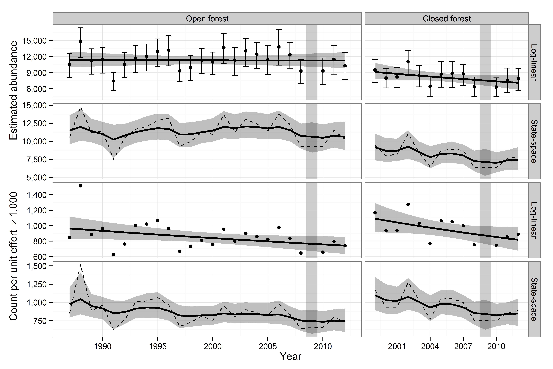
Figure S2. Trend with 95% Confidence band around a log-linear fit, and credible band around a state-space fit for forest birds at Hakalau Forest National Wildlife Refuge, Hawai‘i. The top two rows are fit to detection-corrected abundance estimates, the lower two rows are fit to the uncorrected count index. Dots are the detection-corrected abundances estimated by DISTANCE, with bootstrap uncertainties around the estimates. The same estimates are represented by the dotted line in the state-space panel. Notice how the uncertainty of the state-space fit increases in 2009, the missing year in the series indicated with a vertical grey bar.

‘Ōma‘o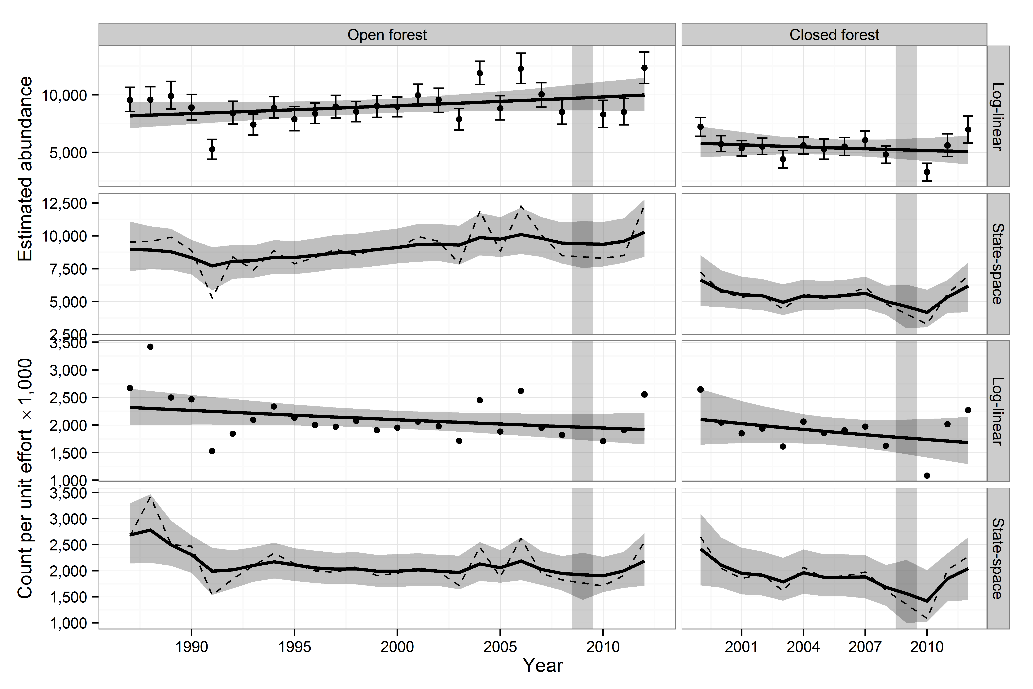
Figure S2. Continued.
Hawai‘i ‘Amakihi
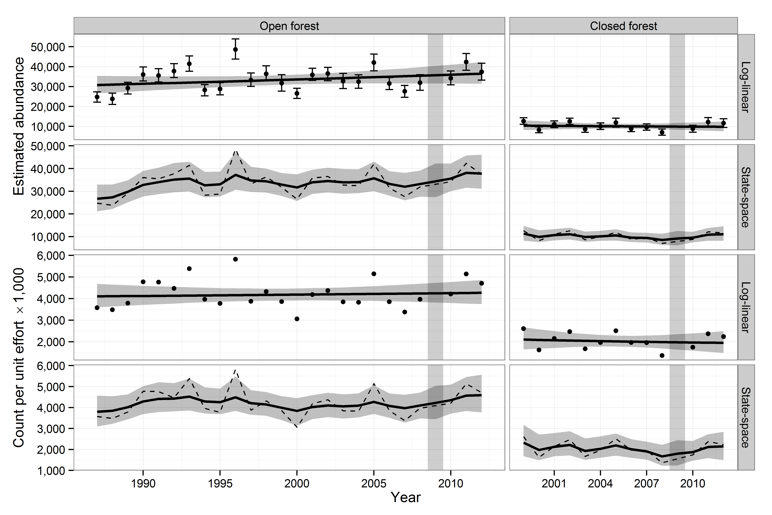
Figure S2. Continued.
‘Akiapōlā‘au
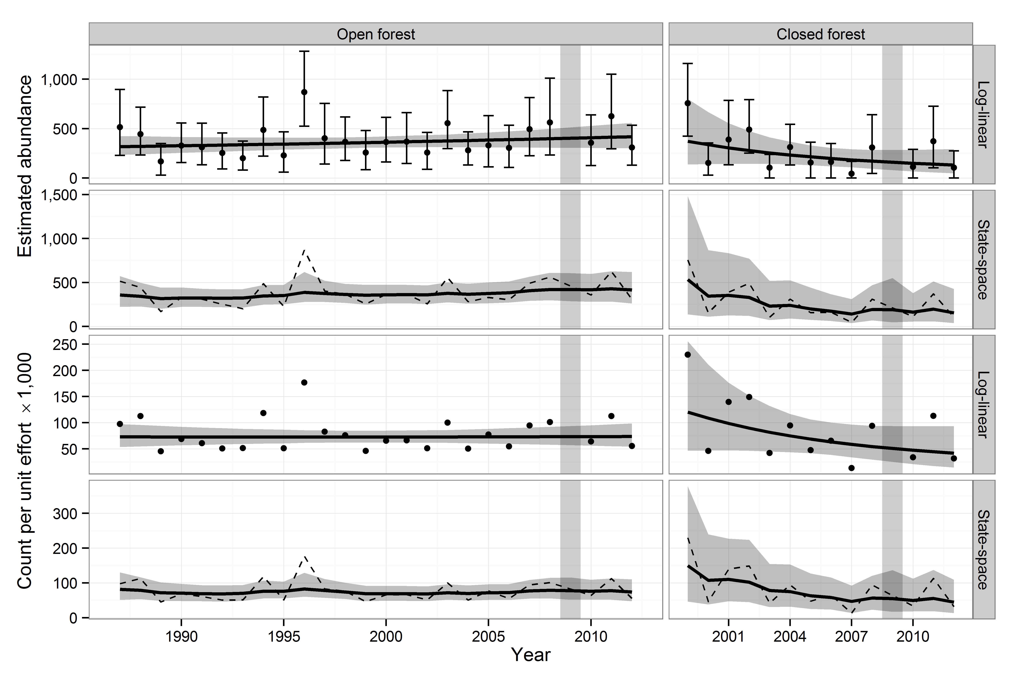
Figure S2. Continued.
Hawai‘i Creeper
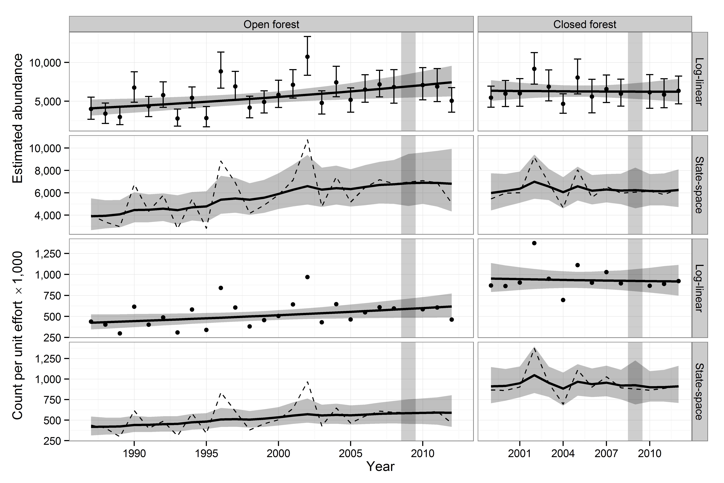
Figure S2. Continued.
Hawai‘i ‘Ākepa
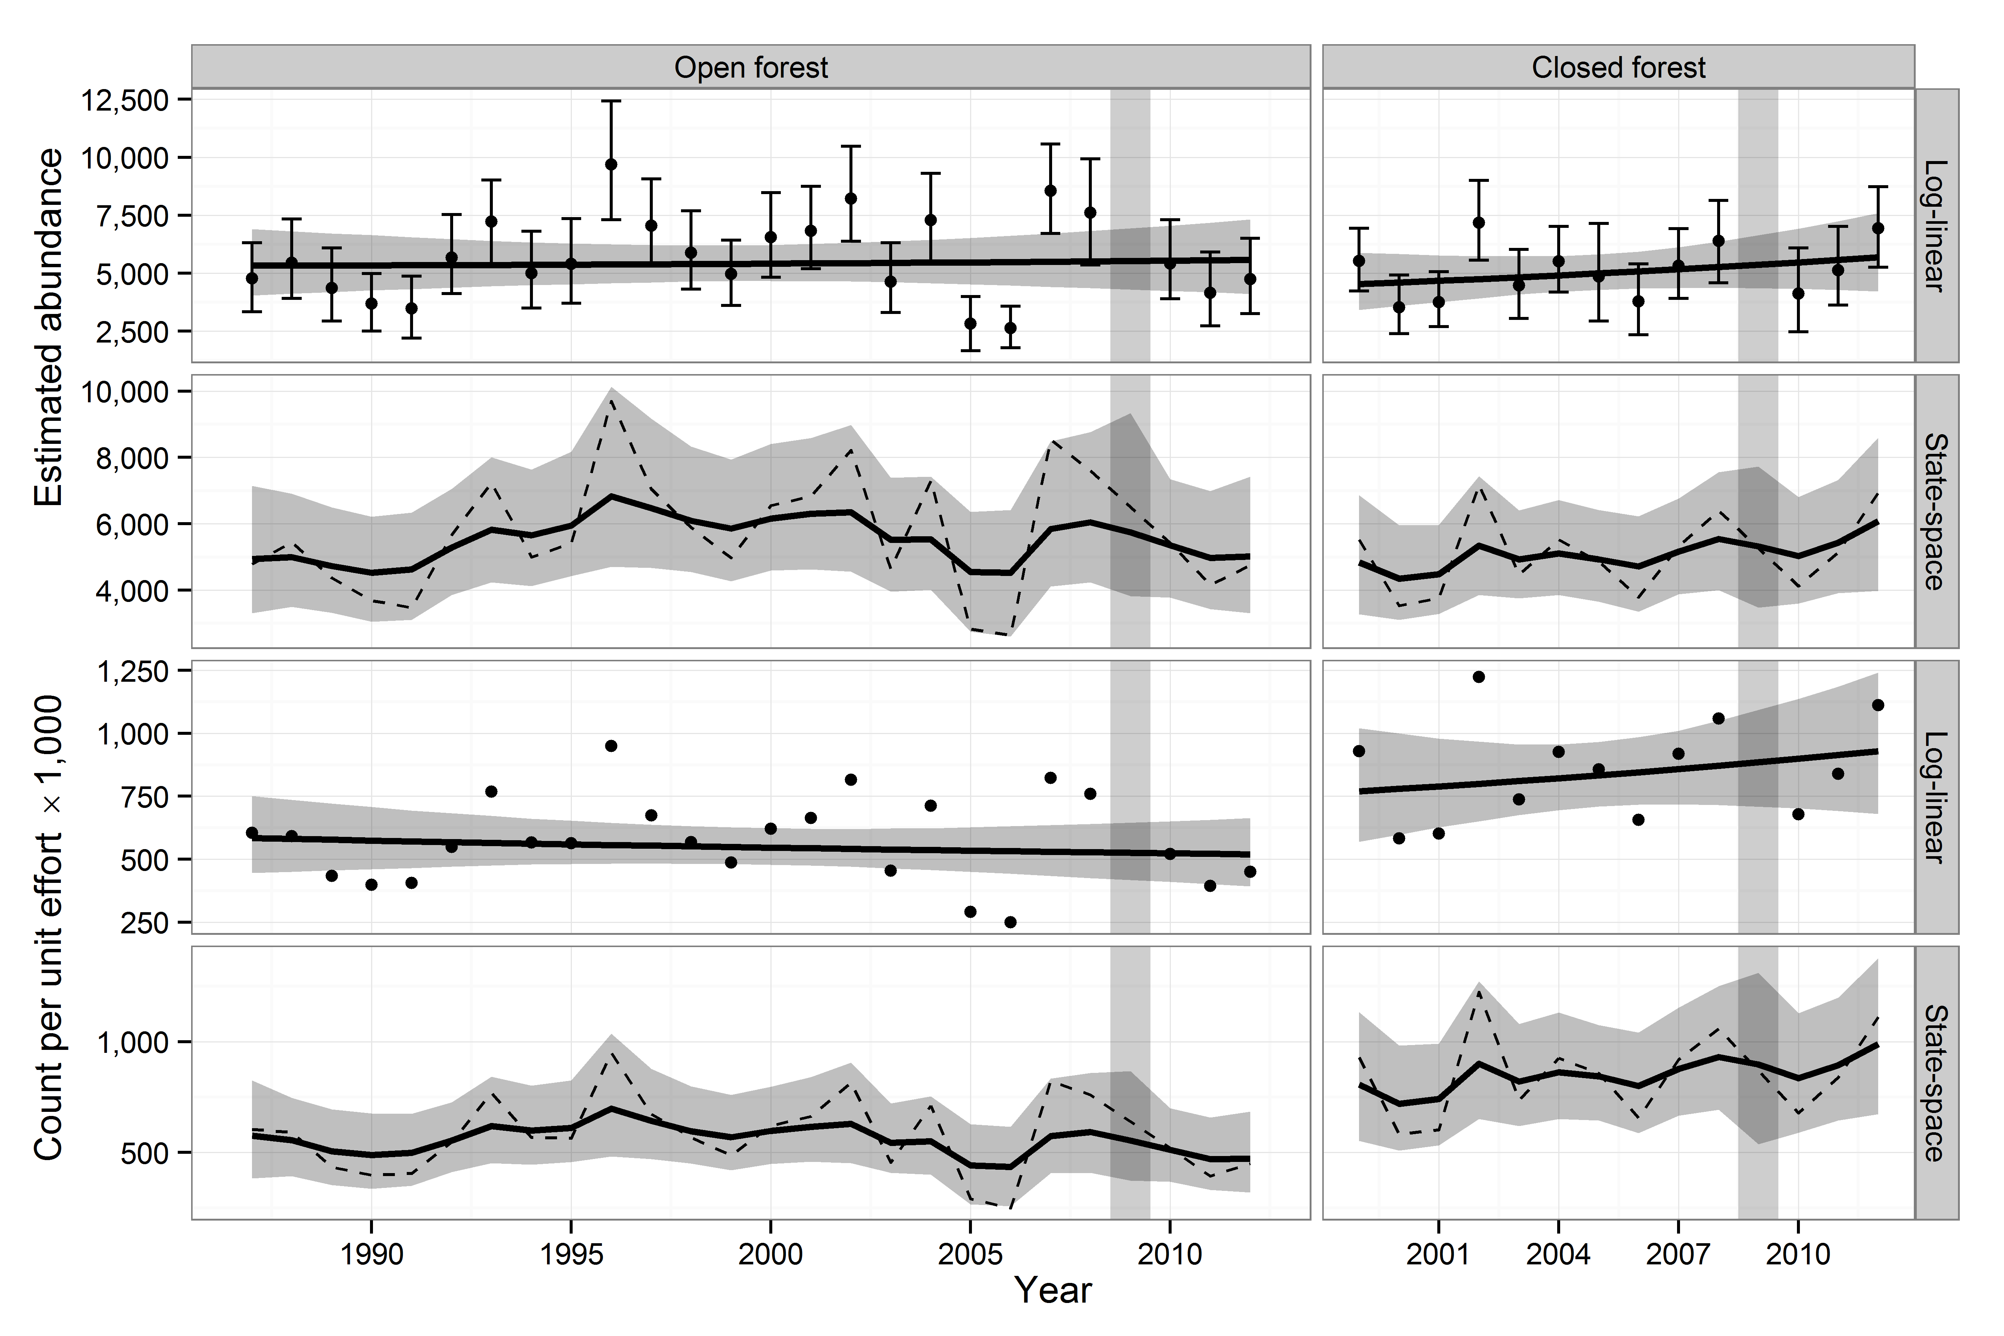
Figure S2. Continued.
‘I‘iwi
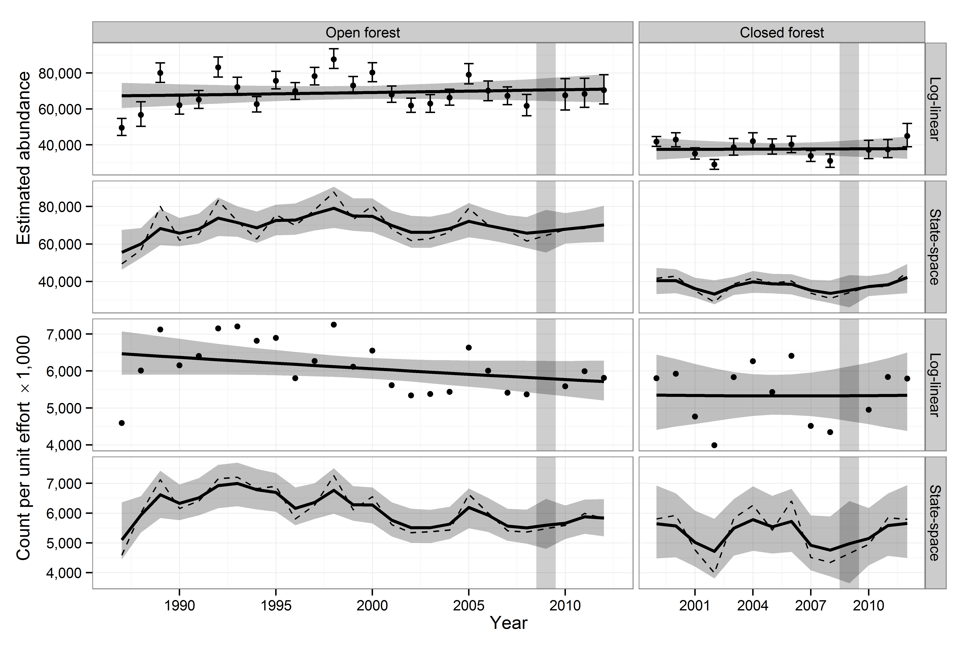
Figure S2. Continued.
‘Apapane
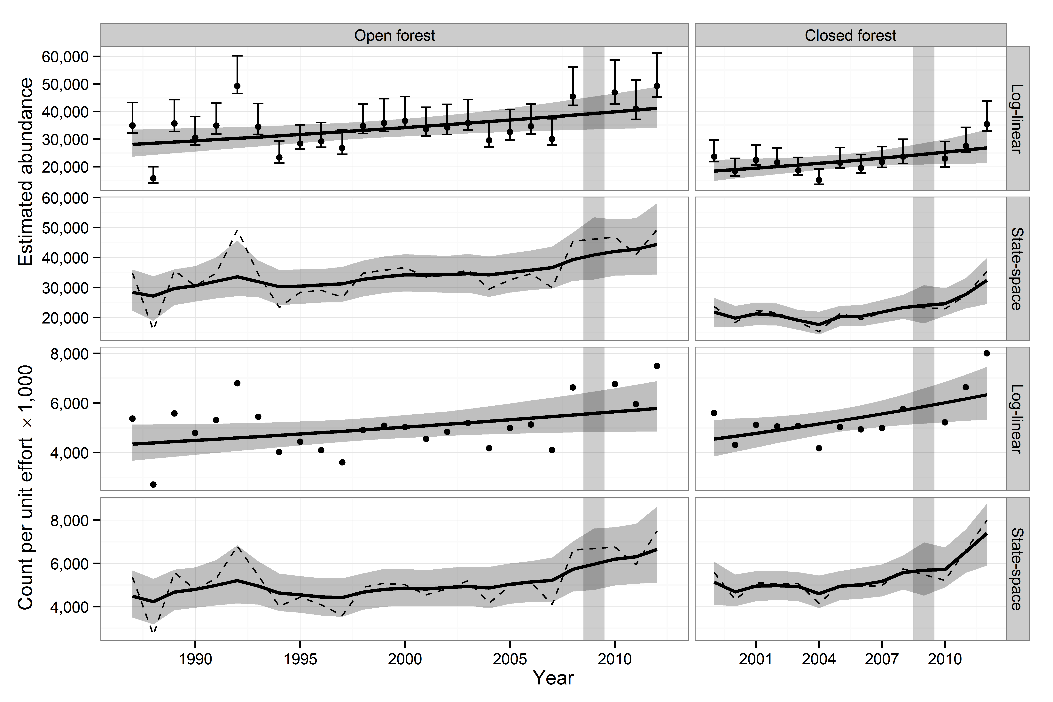
Figure S2. Continued.
Red-billed Leiothrix
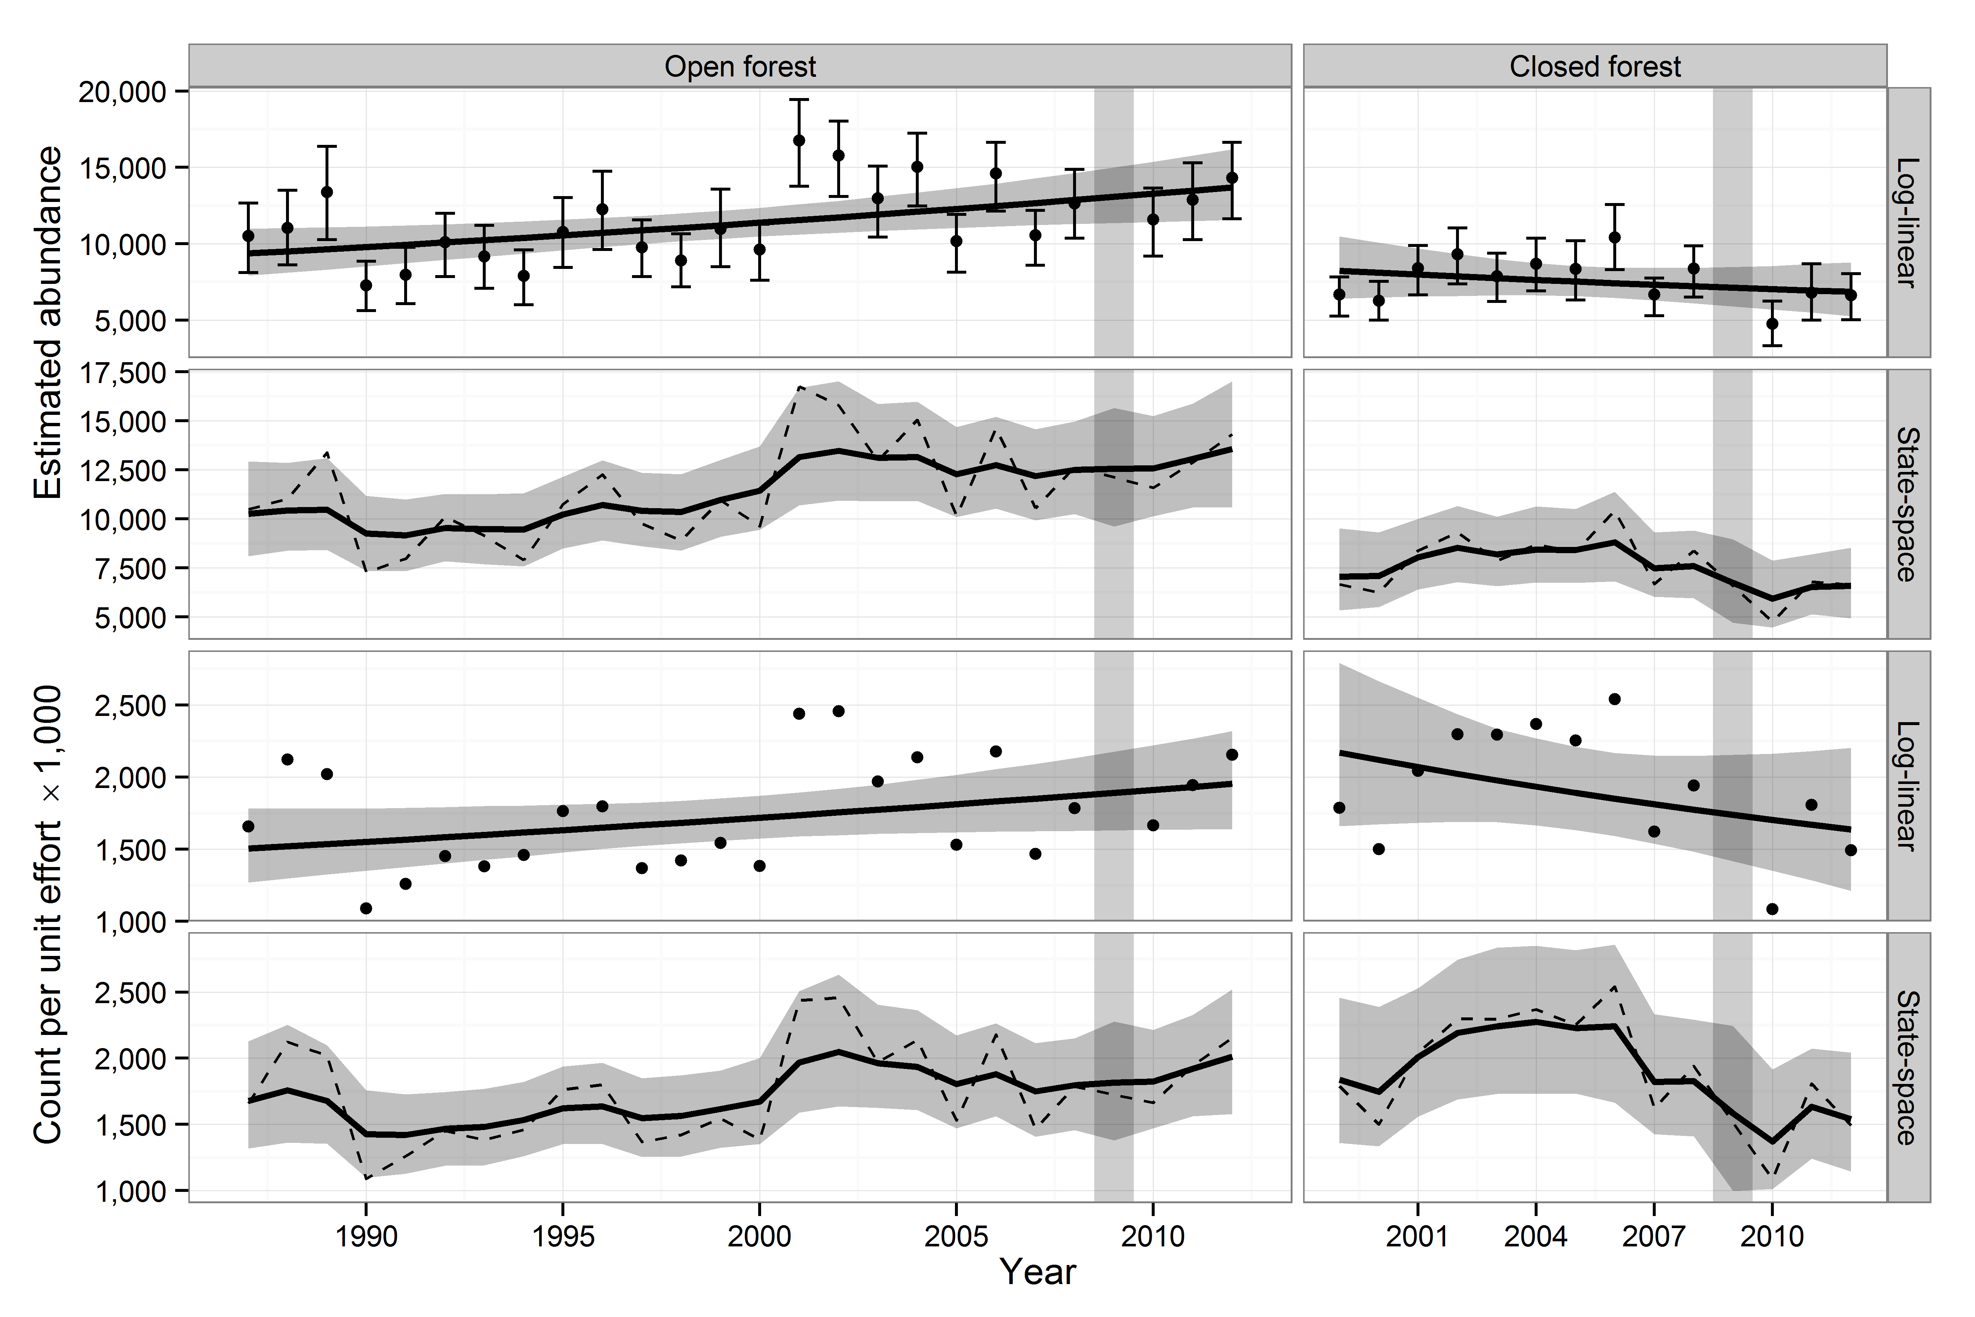
Figure S2. Continued.
Japanese White-eye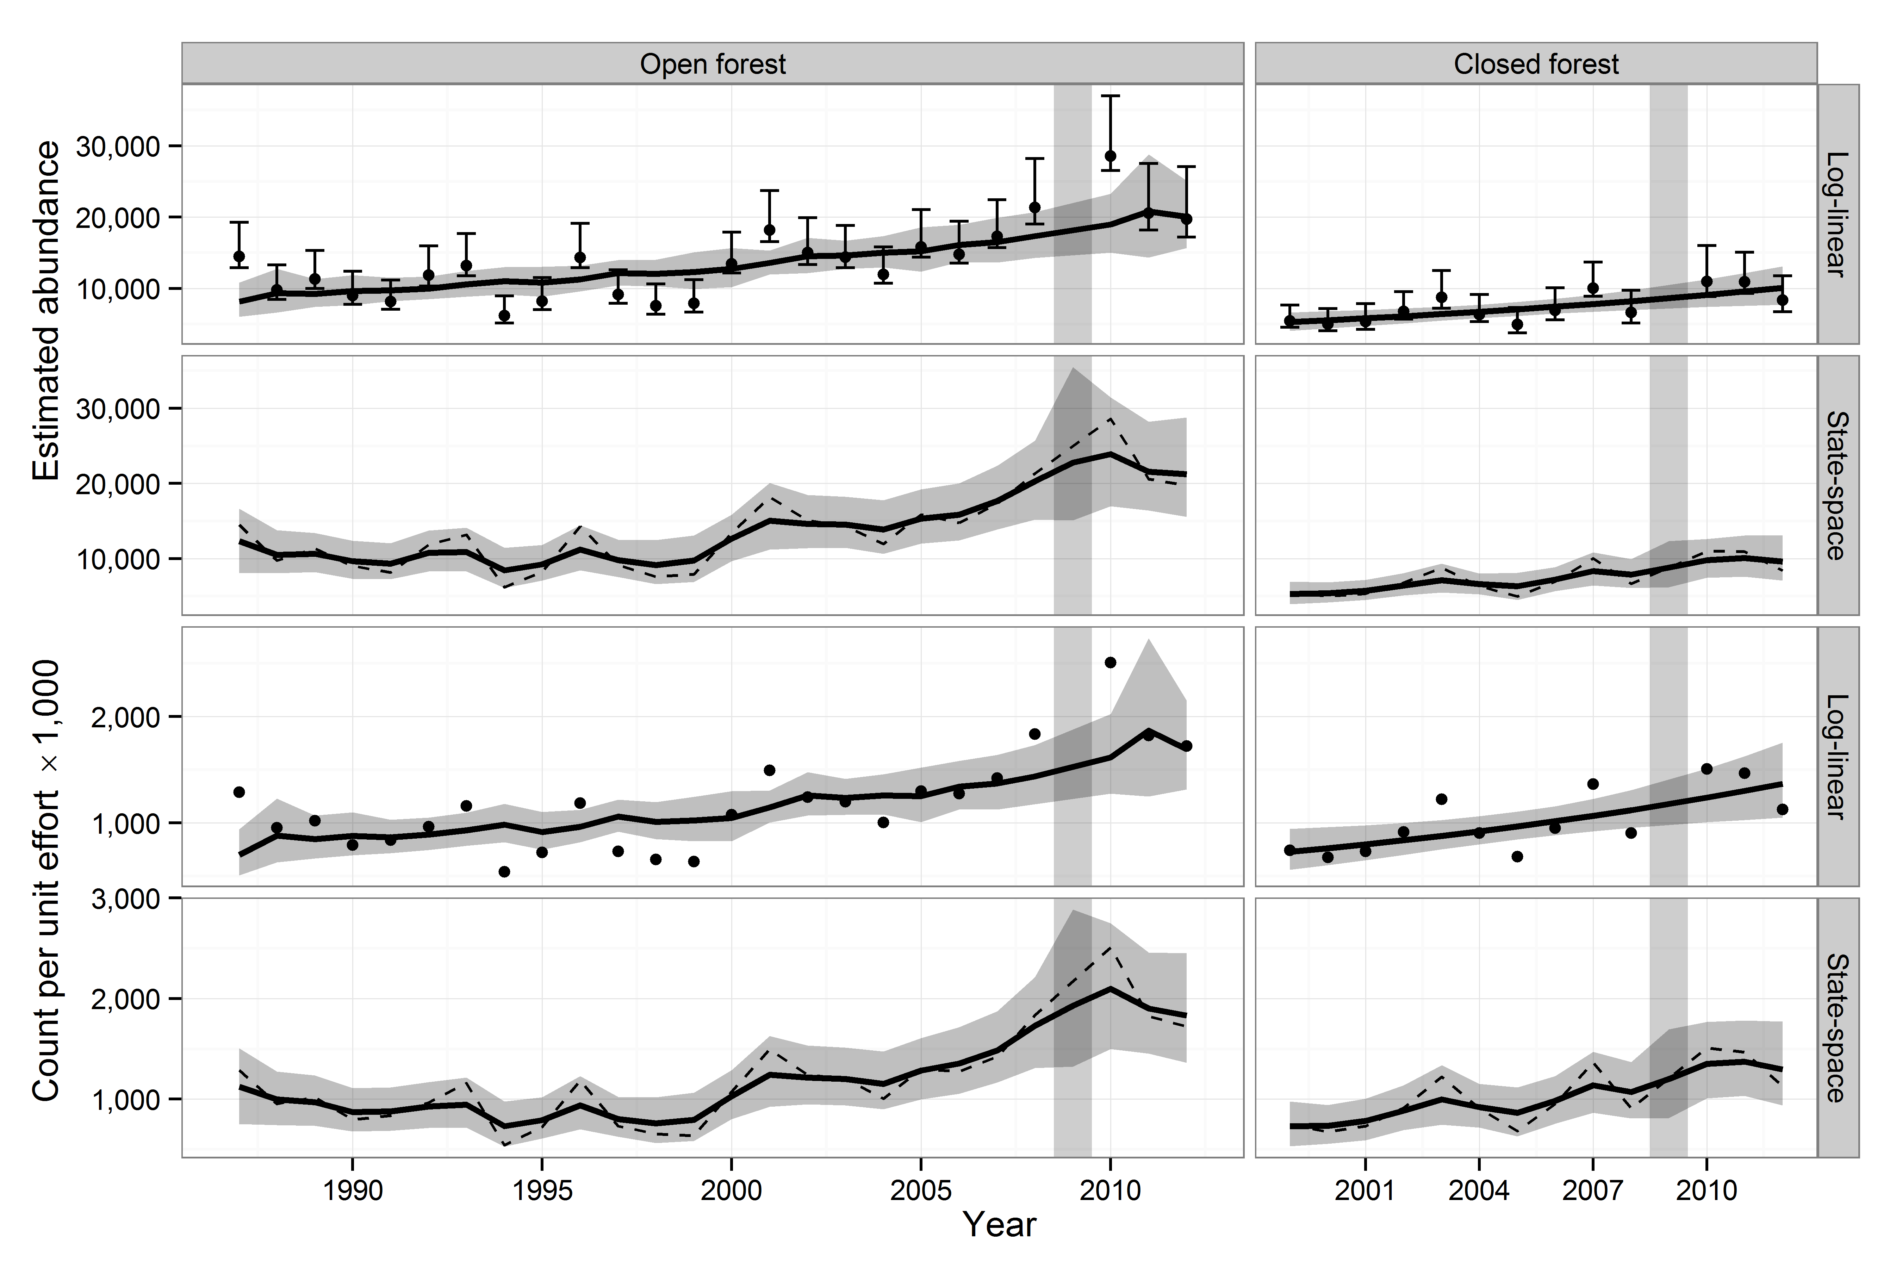
Figure S2. Continued.
Table S5. Geometric mean, minimum and maximum population size changes (lambda) from one year to the next for both the uncorrected counts and detection-corrected abundance (Distance) estimates derived from variance non-partitioned log-linear regression and their corresponding state-space corrected population estimates.
 |  | Open forest |  |  |  |  |  | Closed forest
 |  | Non-partitioned |  |  | State-space |  |  | Non-partitioned |  |  | State-space
Species |  | Count | Distance |  | Count | Distance |  | Count | Distance |  | Count | Distance
Hawai‘i ‘Elepaio | Geometric mean | 0.99 | 1.00 |  | 0.99 | 1.00 |  | 0.98 | 0.98 |  | 0.98 | 0.98
 | Maximum | 1.79 | 1.41 |  | 1.05 | 1.04 |  | 1.38 | 1.35 |  | 1.13 | 1.07
 | Minimum | 0.58 | 0.65 |  | 0.93 | 0.94 |  | 0.74 | 0.73 |  | 0.87 | 0.89
‘Ōma‘o | Geometric mean | 1.00 | 1.01 |  | 0.99 | 1.01 |  | 1.02 | 1.03 |  | 1.00 | 1.01
 | Maximum | 1.43 | 1.59 |  | 1.10 | 1.08 |  | 1.86 | 1.71 |  | 1.30 | 1.23
 | Minimum | 0.62 | 0.59 |  | 0.86 | 0.92 |  | 0.77 | 0.79 |  | 0.87 | 0.89
Hawai‘i ‘Amakihi | Geometric mean | 1.01 | 1.02 |  | 1.01 | 1.01 |  | 0.96 | 0.97 |  | 0.99 | 0.99
 | Maximum | 1.54 | 1.69 |  | 1.07 | 1.12 |  | 1.36 | 1.38 |  | 1.10 | 1.12
 | Minimum | 0.67 | 0.68 |  | 0.94 | 0.93 |  | 0.62 | 0.65 |  | 0.88 | 0.90
‘Akiapōlā‘au | Geometric mean | 1.00 | 1.00 |  | 1.00 | 1.01 |  | 0.92 | 0.92 |  | 0.91 | 0.91
 | Maximum | 3.47 | 3.81 |  | 1.07 | 1.11 |  | 6.71 | 7.05 |  | 1.28 | 1.47
 | Minimum | 0.40 | 0.38 |  | 0.93 | 0.92 |  | 0.20 | 0.20 |  | 0.68 | 0.61
Hawai‘i Creeper | Geometric mean | 1.00 | 1.01 |  | 1.01 | 1.02 |  | 1.01 | 1.01 |  | 1.00 | 1.00
 | Maximum | 2.48 | 3.13 |  | 1.07 | 1.10 |  | 1.60 | 1.73 |  | 1.10 | 1.09
 | Minimum | 0.44 | 0.44 |  | 0.97 | 0.97 |  | 0.69 | 0.68 |  | 0.92 | 0.92
Hawai‘i ‘Ākepa | Geometric mean | 1.00 | 1.01 |  | 1.00 | 1.01 |  | 1.06 | 1.06 |  | 1.03 | 1.03
 | Maximum | 3.29 | 3.24 |  | 1.29 | 1.28 |  | 2.03 | 1.91 |  | 1.18 | 1.15
 | Minimum | 0.41 | 0.39 |  | 0.82 | 0.82 |  | 0.60 | 0.62 |  | 0.91 | 0.92
‘I‘iwi | Geometric mean | 1.01 | 1.01 |  | 1.00 | 1.01 |  | 0.99 | 0.99 |  | 0.99 | 0.99
 | Maximum | 1.31 | 1.41 |  | 1.15 | 1.13 |  | 1.46 | 1.33 |  | 1.17 | 1.13
 | Minimum | 0.84 | 0.78 |  | 0.92 | 0.94 |  | 0.70 | 0.82 |  | 0.85 | 0.89
‘Apapane | Geometric mean | 1.01 | 1.01 |  | 1.01 | 0.98 |  | 1.04 | 1.04 |  | 1.03 | 1.03
 | Maximum | 2.06 | 2.26 |  | 1.10 | 1.07 |  | 1.27 | 1.41 |  | 1.14 | 1.18
 | Minimum | 0.50 | 0.45 |  | 0.93 | 0.90 |  | 0.77 | 0.78 |  | 0.92 | 0.89
Red-billed Leiothrix | Geometric mean | 1.01 | 1.02 |  | 1.01 | 1.01 |  | 1.04 | 1.05 |  | 1.01 | 1.02
 | Maximum | 1.76 | 1.74 |  | 1.20 | 1.12 |  | 1.66 | 1.43 |  | 1.19 | 1.12
 | Minimum | 0.54 | 0.54 |  | 0.84 | 0.91 |  | 0.64 | 0.64 |  | 0.81 | 0.85
Japanese White-eye | Geometric mean | 1.00 | 1.00 |  | 1.01 | 1.02 |  | 0.99 | 0.99 |  | 1.03 | 1.04
 | Maximum | 1.69 | 1.74 |  | 1.28 | 1.25 |  | 1.44 | 1.45 |  | 1.14 | 1.14
 | Minimum | 0.47 | 0.47 |  | 0.78 | 0.82 |  | 0.66 | 0.66 |  | 0.94 | 0.94

