Supplementary Material

Seasonal abundance and breeding habitat occupancy of the Orinoco Goose (Neochen jubata) in western Brazilian Amazonia

WHALDENER ENDO, TORBJØRN HAUGAASEN and CARLOS A. PERES

Contents
Figure S1. Goslings with parents, at two distinct development stages: downy juvenile (bottom) and fledgling juvenile stage (top).

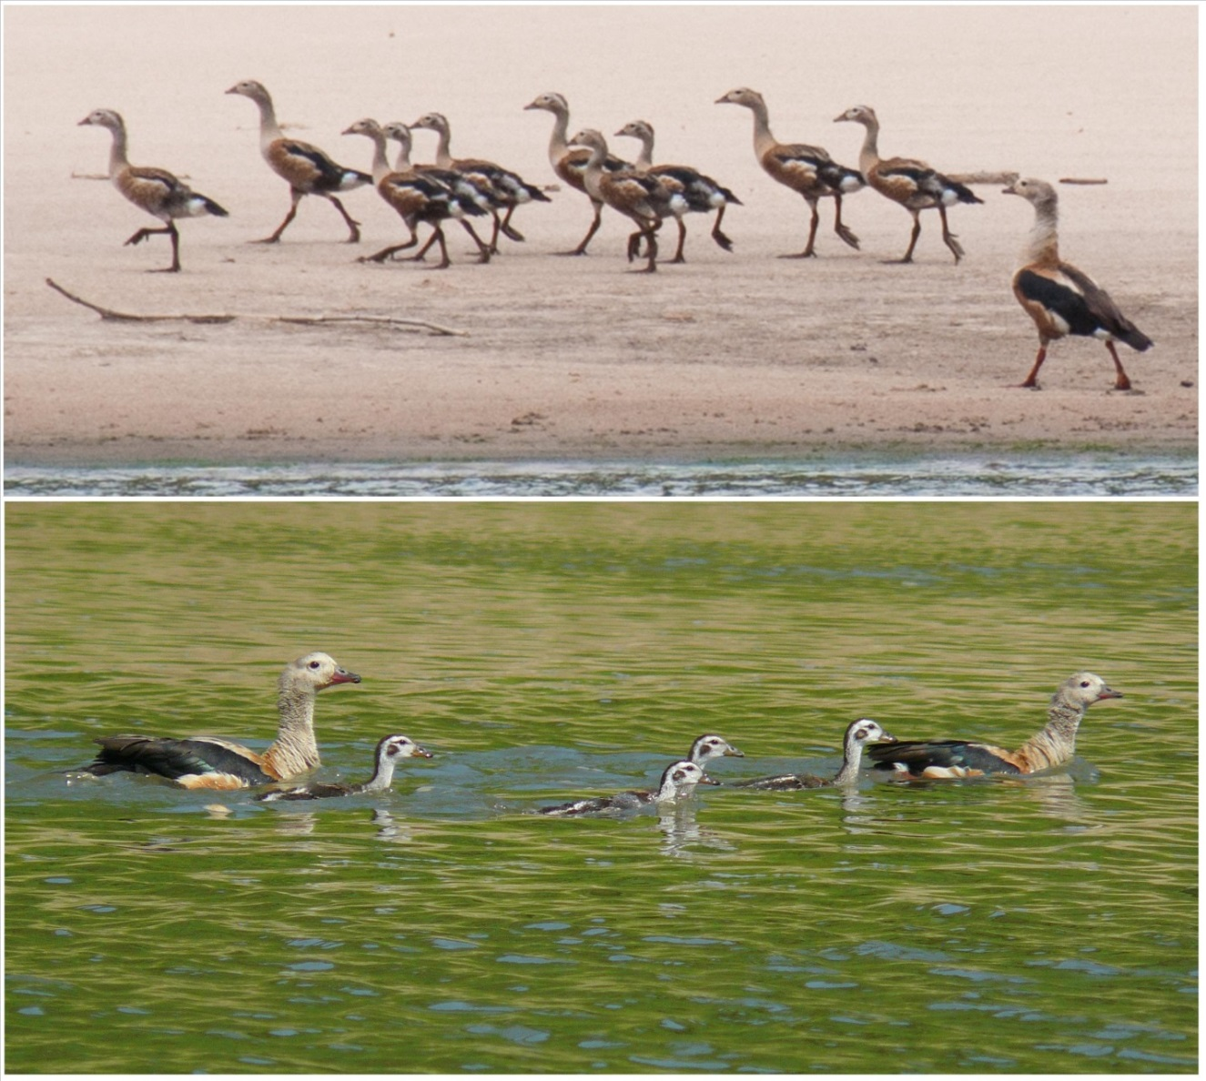

Figure S1. Goslings with parents, at two distinct development stages: downy juvenile (bottom) and fledgling juvenile stage (top).

