Supplementary material A: Consent form to be signed by participant’s parent
Dear parents,
I am a researcher from the University of Pompeu Fabra, Barcelona, Spain and I am doing research on the use of technology to enhance foreign language learning. X School in Bulgaria was chosen to collaborate with X School in Spain because both institutions are innovative and are open to the use of interactive tools in the classroom.
With this letter I would like to ask for your permission for your child to participate in this project. The participation does not pose any kind of risk. Children will participate in an intercultural project, doing computer-based activities with their peers in Bulgaria/Spain, which will be video recorded. I guarantee the ethical and responsible use of the data collected in this research and that it will only be used for the analysis of the research. I can also assure you that the information will not be used for any public purposes and in case that the results and conclusions of this study are to be published the identity of the participants will be protected by using pseudonyms and never their real names.
If you have any questions or doubts regarding the project, please do not hesitate to contact me through my email address: yordanka.chimeva@gmail.com.
Yordanka Chimeva
Researcher
I, ……………………………………………………………………………… parent of ……………………………………………………………….., a student from ………… class from X School, Bulgaria/Spain, give permission for my child to participate in the research study described above, called ‘The use of videoconferencing to enhance interaction and intercultural competence in foreign language education’. The researcher in this project is Yordanka Chimeva, doctoral student from the University of Pompeu Farbra, Barcelona.
Thank you very much for your participation
Supplementary material B: Hierarchical cluster analysis of students’ use of interactional strategies. Statistically significant (p value < 0.05) clusters are enclosed in grey.
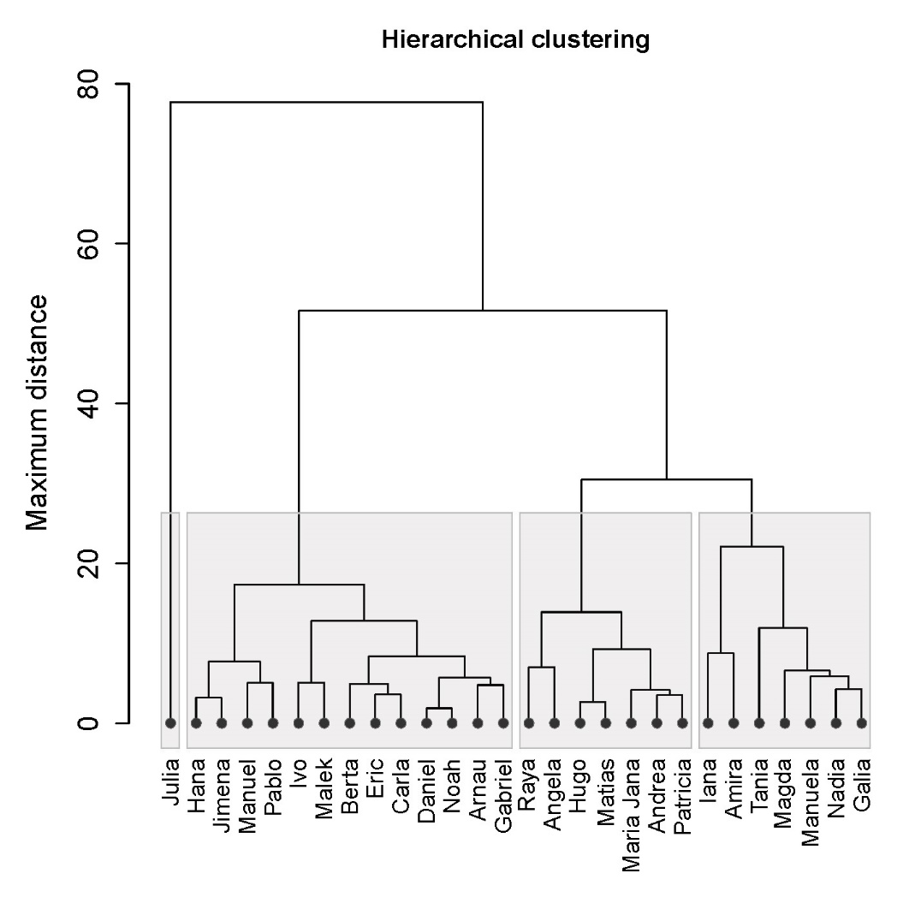
Supplementary material C: Number of times that participants from the Bulgarian school used each interactional feature within their total time of communication and relative frequencies per hour
Bulgarian School Student’s name and id number | Fem./  Male | Total time of commun. in min. | Interactional features
 |  |  | Emotive lexical choices |  | Alignment |  | Boulomaic modality |  | Audio-visual resources |  | Question types
 |  |  |  |  |  |  |  |  |  |  | General inquiry questions |  | Follow-up questions |  | Personal opinion questions
 |  |  | № of  uses | Rel. freq. per hour | № of  uses | Rel. freq. per hour | № of  Uses | Rel. freq. per hour | № of  uses | Rel. freq. per hour | № of  Uses | Rel. freq. per hour | № of  uses | Rel. freq. per hour | № of  uses | Rel. freq. per hour
1.Maria Jana | F | 179´ | 61 | 20.45 | 45 | 15.08 | 11 | 3.69 | 10 | 3.35 | 41 | 13.74 | 57 | 19.11 | 5 | 1.68
2.Daniel | M | 174´ | 25 | 8.62 | 26 | 8.97 | 0 | 0.00 | 13 | 4.48 | 78 | 26.90 | 26 | 8.97 | 0 | 0.00
3.Tania | F | 173´ | 99 | 34.34 | 60 | 20.81 | 20 | 6.94 | 27 | 9.36 | 54 | 18.73 | 67 | 23.24 | 11 | 3.82
4.Raya | F | 131´ | 60 | 27.48 | 37 | 16.96 | 4 | 1.83 | 7 | 3.21 | 42 | 19.24 | 30 | 13.74 | 2 | 0.92
5.Iana | F | 123´ | 51 | 24.88 | 23 | 11.22 | 3 | 1.46 | 3 | 1.46 | 68 | 33.17 | 33 | 16.10 | 1 | 0.45
6.Nadia | F | 70´ | 30 | 25.71 | 11 | 9.43 | 0 | 0.00 | 2 | 1.72 | 29 | 24.86 | 32 | 27.43 | 1 | 0.96
7.Ivo | M | 68´ | 11 | 9.71 | 4 | 3.53 | 0 | 0.00 | 0 | 0.00 | 21 | 18.53 | 16 | 14.12 | 0 | 0.00
8.Galia | F | 58´ | 29 | 30.00 | 12 | 12.41 | 1 | 1.03 | 2 | 2.07 | 21 | 21.72 | 26 | 26.90 | 2 | 2.07
9.Magda | F | 49´ | 25 | 31.61 | 11 | 13.47 | 0 | 0.00 | 3 | 3.67 | 21 | 25.71 | 27 | 33.06 | 0 | 0.00
10.Manuela | F | 25´ | 10 | 24.00 | 6 | 14.40 | 0 | 0.00 | 2 | 4.80 | 11 | 26.40 | 11 | 26.40 | 2 | 4.80
TOTAL № of uses: |  | 1050´ | 401 |  | 245 |  | 39 |  | 69 |  | 386 |  | 325 |  | 24
MEAN of rel. freq. per hour: |  |  |  | 23.58 |  | 12.63 |  | 1.50 |  | 3.41 |  | 22.90 |  | 20.91 |  | 1.46

Supplementary material D: Number of times that participants from the Spanish public School used each interactional feature within their total time of communication and relative frequencies per hour
Spanish public School Student’s name and id number | Fem./  Male | Total time of commun. in min. | Interactional features
 |  |  | Emotive lexical choices |  | Alignment |  | Boulomaic modality |  |  | Audio-visual resources |  |  | Question types
 |  |  |  |  |  |  |  |  |  |  |  |  | General inquiry questions |  | Follow-up questions |  | Personal opinion questions
 |  |  | № of  uses | Rel. freq. per hour | № of  uses | Rel. freq. per hour |  | № of  uses | Rel. freq. per hour | № of  uses | Rel. freq. per hour | № of  uses |  | Rel. freq. per hour | № of  uses | Rel. freq. per hour | № of  uses | Rel. freq. per hour
11. Angela | F | 170´ | 59 | 20.82 | 34 | 12.00 |  | 0 | 0.00 | 3 | 1.06 | 36 |  | 12.71 | 19 | 6.71 | 0 | 0.00
12.Manuel | M | 100´ | 20 | 12.00 | 16 | 9.60 |  | 0 | 0.00 | 0 | 0.00 | 25 |  | 15.00 | 17 | 10.20 | 0 | 0.00
13.Eric | M | 90´ | 21 | 14.00 | 15 | 10.00 |  | 0 | 0.00 | 5 | 3.33 | 30 |  | 20.00 | 14 | 9.33 | 0 | 0.00
14.Malek | M | 66´ | 12 | 10.91 | 6 | 5.45 |  | 0 | 0.00 | 2 | 1.82 | 26 |  | 23.64 | 17 | 15.45 | 0 | 0.00
15.Hugo | M | 60´ | 23 | 23.00 | 7 | 7.00 |  | 0 | 0.00 | 3 | 3.00 | 18 |  | 18.00 | 17 | 17.00 | 0 | 0.00
16.Amira | F | 41´ | 23 | 33.66 | 9 | 13.17 |  | 1 | 1.46 | 1 | 1.46 | 19 |  | 27.80 | 8 | 11.71 | 1 | 1.46
17.Hana | F | 27´ | 3 | 6.67 | 3 | 6.67 |  | 0 | 0.00 | 0 | 0.00 | 9 |  | 20.00 | 2 | 4.44 | 0 | 0.00
18.Jimena | F | 25´ | 4 | 9.60 | 4 | 9.60 |  | 0 | 0.00 | 0 | 0.00 | 7 |  | 16.80 | 2 | 4.80 | 0 | 0.00
19.Carla | F | 21´ | 5 | 14.29 | 4 | 11.43 |  | 0 | 0.00 | 0 | 0.00 | 8 |  | 22.86 | 2 | 5.71 | 0 | 0.00
20.Noah | M | 12´ | 2 | 10.00 | 2 | 10.00 |  | 0 | 0.00 | 1 | 5.00 | 5 |  | 25.00 | 2 | 10.00 | 0 | 0.00
21.Berta | F | 12´ | 3 | 15.00 | 3 | 15.00 |  | 0 | 0.00 | 0 | 0.00 | 4 |  | 20.00 | 2 | 10.00 | 0 | 0.00
22.Julia | F | 7´ | 1 | 8.57 | 1 | 8.57 |  | 0 | 0.00 | 0 | 0.00 | 9 |  | 77.14 | 2 | 17.14 | 0 | 0.00
TOTAL № of uses: |  | 630´ | 176 |  | 104 |  |  | 1 |  | 15 |  | 190 |  |  | 92 |  | 1
MEAN of rel. freq. per hour: |  |  |  | 14.88 |  | 9.87 |  |  | 0.12 |  | 1.31 |  |  | 24.91 |  | 10.21 |  | 0.12
Supplementary material E: Number of times that participants from the Spanish private Language School used each interactional feature within their total time of communication and relative frequencies per hour
Spanish language School Student’s name and id number | Fem./  Male | Total time of commun. in min. | Interactional features
 |  |  | Emotive lexical choices |  | Alignment |  | Boulomaic modality |  | Audio-visual resources |  |  | Question types
 |  |  |  |  |  |  |  |  |  |  |  | General inquiry questions |  | Follow-up questions |  | Personal opinion questions
 |  |  | № of  uses | Rel. freq. per hour | № of  uses | Rel. freq. per hour | № of  uses | Rel. freq. per hour | № of  uses | Rel. freq. per hour |  | № of  uses | Rel. freq. per hour | № of  uses | Rel. freq. per hour | № of  uses | Rel. freq. per hour
23.Andrea | F | 123´ | 50 | 24.39 | 29 | 14.15 | 2 | 0.98 | 9 |  | 4.39 | 26 | 12.68 | 35 | 17.07 | 2 | 0.98
24.Patricia | F | 115´ | 40 | 20.87 | 21 | 10.96 | 5 | 2.61 | 5 |  | 2.61 | 26 | 13.57 | 35 | 18.26 | 3 | 1.57
25.Matias | M | 98´ | 34 | 20.82 | 12 | 7.35 | 0 | 0.00 | 8 |  | 4.90 | 25 | 15.31 | 27 | 16.53 | 0 | 0.00
26.Pablo | M | 66´ | 10 | 9.09 | 5 | 4.55 | 2 | 1.82 | 4 |  | 3.64 | 13 | 11.82 | 7 | 6.36 | 0 | 0.00
27.Arnau | M | 25´ | 4 | 9.60 | 4 | 9.60 | 0 | 0.00 | 2 |  | 4.80 | 10 | 24.00 | 2 | 4.80 | 0 | 0.00
28.Gabriel | M | 9´ | 2 | 13.33 | 1 | 6.67 | 0 | 0.00 | 0 |  | 0.00 | 4 | 26.67 | 1 | 6.67 | 0 | 0.00
TOTAL № of uses: |  | 436´ | 140 |  | 72 |  | 9 |  | 28 |  |  | 104 |  | 107 |  | 5
MEAN of rel. freq. per hour: |  |  |  | 16.35 |  | 8.88 |  | 0.90 |  |  | 3.39 |  | 17.34 |  | 11.62 |  | 0.42

Supplementary material F: Discussion topics in the Bulgaria – Spanish public School project
Session | Discussion topics
Session 1 | Getting to know each other – talk about you, your family and friends, free time activities and hobbies.
Session 2 | Talk about your daily routines – when you get up, go to school, have breakfast, lunch and dinner, when you do sport, play games, etc. Talk about your school life – what are your favourite subjects and teachers, when you have a break, how many hours a day you spend at school.
Session 3 | Typical customs, traditions and celebrations – explain very well and with details what it is, when, how and why a tradition is celebrated.
Session 4 | Typical food and drinks – explain about the typical food and drinks of your country. Think of something that is unique and only eaten in your country. Explain it with details and say if you eat it during a specific occasion or holiday.
Session 5 | Talk about the typical games that you play, how you play them and with whom. Talk about popular fairytales.

Supplementary material G: Discussion topics in the Bulgarian – Spanish private Language School project
Session | Discussion topics
Session 1 | Getting to know each other – talk about routine, family, school life, free time activities and hobbies.
Session 2 | Typical food, drinks and traditions – prepare images to show to your partner and make sure to explain very well and with details what it is, when, how and why a tradition is celebrated.
Session 3 | Movies, Music, Education, Future plans and careers – talk about your favourite movies and music:  Share three songs from YouTube with your partner the day before the meeting and be sure to explain during the meeting why you chose each of these songs:  (1) A song that you listen to when you are in a great mood  (2) A popular song that you do not personally like  (3) A song that you think fits a stereotype of Spain/Bulgaria  Talk about the education in your country – what you like and don’t like about it and what you would change if you could. Talk about your future plans and careers and why you have chosen it.
Session 4 | Diversity in your country  Every country is made up of many different types of individuals, families, communities, geographic locations, ethnicities, languages, ages, interest groups, and careers – and so many more ways that we are different within our country’s borders. Your activity is to help your partner understand the diversity within your country:  (1) Choose ONE way of categorizing the diversity in your country (e.g., ethnic diversity, geographic diversity, or language diversity)  (2) Describe the different groups. Be sure to give examples. Some examples will probably be stereotypes, and some will be counterexamples to the stereotypes. Give as much information as you can in the time you have.
Session 5 | Volunteering, Fashion and Travelling

Supplementary material H: Pre-project questionnaire
/English version/
- What is your name?
- How old are you?
- In which country were you born?
- How long have you been living in Bulgaria/Spain?
- What is your mother tongue?
- Do you speak any other languages? Which ones? Who do you speak these languages with?
- What language do you speak with your family?
- Where are your parents from?
- Do you have family or friends who are not Spanish/Bulgarian? Which language do you speak with them?
- Have you visited other countries? Which ones? For how long?
- What are your hobbies and interests?
- What do you expect from the project?
- What do you know about the Spain/Bulgaria?
Supplementary material I: Post-project questionnaire
/English version/
- Did you like the project? What exactly did you like?
- What did you not like about it? What would you change?
- How did you feel during the conversations? Why did he feel that way?
- When he didn't understand your partner, what did he do?
- What were your expectations before the project? Did these expectations come true?
- What was different from what you expected? Did anything surprise y
- What did you learn about their culture?
- What similarities and differences did you find between you and the Spanish children?
- Do you think your English will improve after this project? How / what exactly?
- What has this project contributed to you personally?
- If this is the second project in which you participate, what differences and similarities do you find between the two? What did you like more and what did you not like?
Thank you for your participation!
Supplementary material J: Pre-project interview
Interview protocol :
Thank you for coming. I appreciate the time you’ve taken to come in for this talk. The purpose of it, other than giving me a chance to know each of you a little better, is also to find out more about English teaching in Spain/Bulgaria, which helps my research project. Do you mind if I have the tape recorder running?
- Do you like learning languages? What languages do you speak?
- How did you practice your oral English?
- Have you travelled to other countries? Where? Did you speak any other language there?
- If you were given a choice between one-to-one videoconferencing sessions with native speakers or videoconferencing interaction with other English learners, which one would you choose? Please explain why?
- What do you expect from the experience?
- What topics do you want most to discuss with the other students?
- What aspects of your English do you expect to be improved after the videoconferencing sessions?
- What do you expect to learn about the participants from Spain/Bulgaria?
- Do you think it is a good way to learn English? Why (not)?
- Do you think videoconferencing should be incorporated in your language classes? Why? Why not? How?
- Is it important for you to see your partner on the screen? How do you think it could help you? Why is it important? Why not?
- What do you think is the best way to learn English?

Supplementary material K: Post-project interview
Interview protocol
Thank you for coming. I appreciate the time you've taken to come in for this talk. The purpose of it, other than giving me a chance to know each of you a little better, is also to find out more about English teaching in Spain/Bulgaria, which helps my research project . Do you mind if I have the tape recorder running?
- What is your opinion about the project? What was the best and the worst part of using videoconferencing in these sessions?/What did you enjoy most/least about the project?
- What did you learn from it?
- Is it a good way to learn English? Why (not)?
- Do you think your English improved as a result of participating in this online learning project? What aspects have you felt improved in your English? Which ones do you think didn’t improve? If Not, why not?
- How did you feel about the task (i.e. did you enjoy it, find it boring, dislike it, learn a lot from doing it, etc.)? Please briefly explain your answer. (Always pros and cons!!!!!)
- How would you compare learning in this way with participating in more conventional language classes?
- Do you think it is better or worse than the activities you do in your classroom? What activities did you like/not like?
- Do you think videoconferencing should be incorporated in your language classes? Why? Why not? How?
- During the sessions did you sometimes not understand what the other student was saying?
What did you do?
- Did you at any time pretend you understood your partner?
- Did you feel uncomfortable/nervous?
- Do you think talking with the students online was similar to talking in real life? In what sense?
- When you noticed a mistake made by your partner did you sometimes correct him/her? How did you correct him/her?
- Did you worry about making mistakes while you were speaking?
- When you were curious about something, would you ask your partner about it? If not, why not?
- Did you find some common things between you and your partners when doing the task? What? Did you find any differences in the way you and your partners did the task? What?
- Did you find it difficult to describe and talk about your home culture to your partner? Why? What was difficult to talk about?
- Was there anything that you explained about your culture that was not understood? Why do you think this happened?
- Was it important for you to see your partner on the screen? How did it help you? Why was it important? Why not?
- Do you think this project was successful? What made it successful?
- What would you do to improve the videoconferencing sessions?

This was the provisional title of the thesis which later underwent changes.
All participants were provided with a consent form and conducted the interviews and questionnaires in their native language, Spanish or Bulgarian respectively. Here, we provide only the English version.
All interviews were semi-structured and did not follow a strict order or content of the questions.
The questions for the pre-project interview were adapted from Xiao’s ( 2007) study.
The post-project interviews were semi-structured and did not follow a strict order or content of the questions.
The questions for the post-project interview were adapted from (Xiao, 2007) study.

