Supplementary material

Questionnaire used in this study: adapted from Portalla & Chen (2010)
Portalla, T., & Chen, G. M. (2010). The Development and Validation of the Intercultural Effectiveness Scale. Intercultural Communication Studies, 19 (3), p. 36
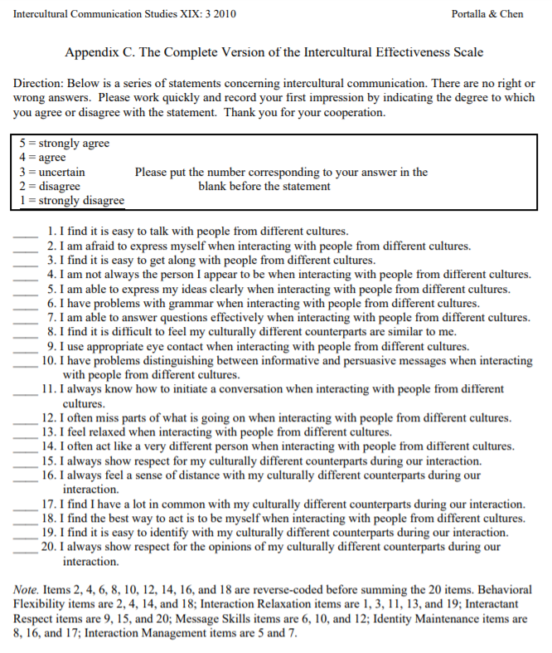

Diary prompts used in this study
Diary 1
D1Q1: Have you ever used online technologies before to communicate or work with people from other cultures? If so, give a concrete example.
D1Q2: How would you describe your cultural background?
D1Q3: What do you hope to achieve or learn from this virtual exchange?
Diary 2
D2Q1: What do you feel you have learnt about your own and your partners’ national and educational cultures?
D2Q2: Do you think you or your partners have any stereotyped views of each other’s cultures? If so, describe them? Have you discussed them or just noticed them? What do you think lies behind these stereotypes?
D2Q3: After working together on this first task, what are your initial impressions of your virtual partners?
Diary 3
D3Q1: How do you feel about the interactions with your virtual partners so far? What are you finding easy or difficult? What steps do you think you could take to improve the interactions?
D3Q2: What have you learnt about the topics that you investigated? What cultural differences and similarities did you notice between the way your topic is dealt with in the two contexts?
D3Q3: Have you learned anything about your own or your partners’ culture that you didn’t expect?
Diary 4
D4Q1: How do you feel about working in an intercultural team?
D4Q2: Describe any challenges you faced in your group work. What do you think the causes were? How did you try to solve them?
D4Q3: Has this project affected in any way how you will use online tools and environments in your own teaching career in the future?
D4Q4: After having collaborated with your partner/s in designing different online tasks, what is the most important thing you feel you have learned about how online tools and environments should be used for teaching? Give a concrete example.
D4Q5: Please describe how doing this course collaboratively with international partner(s) impacted your learning experience?
D4Q6: Given your online interactions with students from another country, describe any key changes that occurred in how you view the world?
D4Q7: What was the most important thing you learned from this experience?
D4Q8: Is there anything that has positively affected your telecollaborative exchange experience? If so, please describe this in the textbox below
D4Q9: Is there anything that has negatively affected your telecollaboration experience? If so, please describe this in the textbox below.

Results of the text search query in NVIVO 11 for ‘learn*’ among cluster 1 (high perceived IE gain)
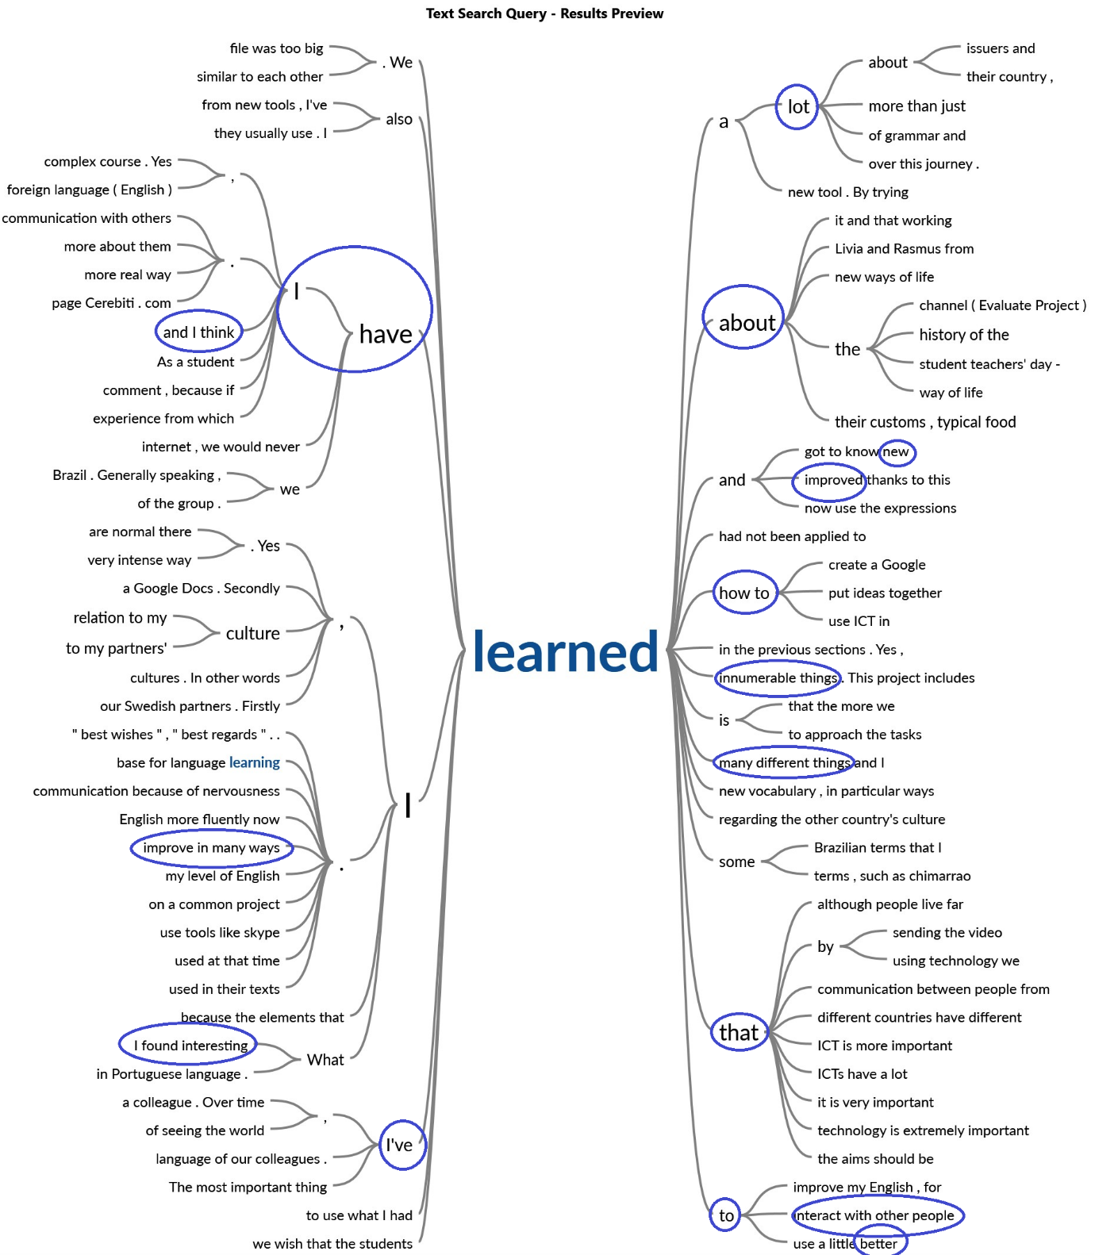

Results of the text search query in NVIVO 11 for ‘learn*’ among cluster 3 (low perceived IE gain)
