Appendix I. PRISMA flowchart of the process of selecting papers published before January 19, 2022
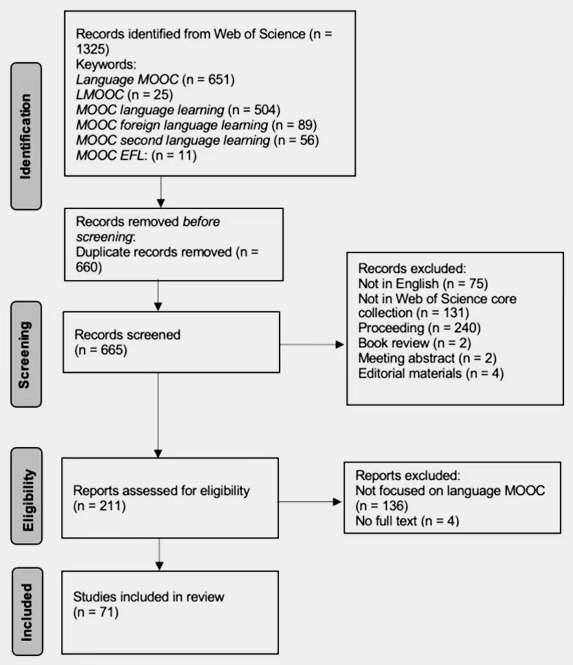
Appendix II. Full list of the reviewed studies (n = 71)
No | Author | Year | Title | Publication
1 | Agonács & Matos | 2019 | Understanding language MOOC learners: The issue of capability development. | International Journal of Emerging Technologies in Learning (IJET)
2 | Agonács et al. | 2020 | Are you ready? Self-determined learning readiness of language MOOC learners. | Education and Information Technologies
3 | Agonács et al. | 2019 | On the path to self-determined learning: A mixed methods study of learners’ attributes and strategies to learn in language MOOCs | International Journal of Learning Technology
4 | Appel, & Pujolà | 2021 | Designing speaking interaction in LMOOCs: An eTandem approach | ReCALL
5 | Azitov et al. | 2021 | The impact of MOOC aggregators on the development of language education | Rev. EntreLínguas
6 | Bárcena et al. | 2020 | An approximation to inclusive language in LMOOCs based on appraisal theory | Open Linguistics
7 | Bárkányi | 2021 | Motivation, self-efficacy beliefs, and speaking anxiety in language MOOCs | ReCALL
8 | Beaven et al. | 2014 | Motivation in a Language MOOC: Issues for Course Designers | Language MOOCs: Providing learning, transcending
9 | Castrillo | 2014 | Language teaching in MOOCs: The integral role of the instructor | Language MOOCs: Providing learning, transcending boundaries
10 | Castrillo & Sedano | 2020 | Joining forces toward social inclusion: Language MOOC design for refugees and migrants through the lens of maker culture | CALICO Journal
11 | Chacón-Beltrán | 2017 | The role of MOOCs in the learning of languages: Lessons from a beginners’ English course | Porta Linguarum Revista Interuniversitaria de Didáctica de Las Lenguas Extranjeras
12 | Chacón-Beltrán | 2018 | Vocabulary learning strategies outside the classroom context: What adults learn in a technology-based learner-centred environment | The Language Learning Journal
13 | Chacón-Beltrán & Echitchi | 2021 | Who wants to learn English online for free? | Journal of Language and Education
14 | Colibaba et al. | 2018 | Medlang MOOC–an innovative palliative care learning tool. Innovative approaches and teaching methodologies | Foreign language teaching in Romanian higher education
15 | Ding & Shen | 2019 | Delving into learner autonomy in an EFL MOOC in China: A case study | Computer Assisted Language Learning
16 | Doğan et al. | 2018 | Who is the English as a second language speaker in this MOOC? | International Journal of Information and Education Technology
17 | Duru et al. | 2019 | A case study on English as a second language speakers for sustainable mooc study | Sustainability
18 | Eremeeva et al. | 2017 | MOOSLE-EE : Massive open online social learning environment for English Elearning system | Revista San Gregorio
19 | Estebas-Vilaplana & Solans | 2020 | The role of a pronunciation LMOOC in higher education studies | Journal of Interactive Media in Education
20 | Fang | 2018 | Japanese informatization teaching model based on MOOC | International Journal of Emerging Technologies in Learning (IJET)
21 | Friðriksdóttir | 2019 | The effect of tutor-specific and other motivational factors on student retention on Icelandic Online | Computer Assisted Language Learning,
22 | Friðriksdóttir | 2021 | The effect of content-related and external factors on student retention in LMOOCs | ReCALL
23 | Fuchs | 2020 | Cultural and contextual affordances in language MOOCs: Student perspectives | International Journal of Online Pedagogy and Course Design
24 | García Alonso & Samy | 2018 | Applicability of ICT-supported language teaching in contexts of social integration and international cooperation | Círculo de Lingüística Aplicada a La Comunicación,
25 | Ge et al. | 2021 | Investigating the design strategies of EFL learning videos from the perspective of social presence | The Asia-Pacific Education Researcher
26 | Godwin-Jones | 2014 | Global reach and local practice: The promise of MOOCs | Language Learning & Technology
27 | Hashim et al. | 2018 | The designing of adaptive self-assessment activities in second language learning using Massive Open Online Courses (MOOCs) | International Journal of Advanced Computer Science and Applications,
28 | Hsu | 2021a | A grounded theory exploration of language Massive Open Online Courses (LMOOCs): Understanding students’ viewpoints | Sustainability
29 | Hsu | 2021b | What makes good LMOOCs for EFL learners? Learners’ personal characteristics and Information System Success Model | Computer Assisted Language Learning
30 | Jitpaisarnwattana et al. | 2021 | Understanding the roles of personalization and social learning in a language MOOC through learning analytics | Online Learning
31 | King et al. | 2018 | Experiences of Timorese language teachers in a blended Massive Open Online Course (MOOC) for Continuing Professional Development (CPD) | Open Praxis
32 | Kormos & Nijakowska | 2017 | ). Inclusive practices in teaching students with dyslexia: Second language teachers’ concerns, attitudes and self-efficacy beliefs on a massive open online learning course | Teaching and Teacher Education
33 | Koukis & Jimoyiannis | 2019 | MOOCS for teacher professional development: Exploring teachers’ perceptions and achievements | Interactive Technology and Smart Education
34 | Lebedeva | 2021 | Instructional Design of Skill-Balanced LMOOC: A case of the Russian language MOOC for beginners | JUCS - Journal of Universal Computer Science
35 | Liang & Pang | 2019 | An innovative English teaching mode based on massive open online course and Google collaboration platform | International Journal of Emerging Technologies in Learning (IJET)
36 | Lopez | 2019 | When bilingualism goes beyond one's expectations: The learning of cognates amongst adult EFL students | Estudios de Lingüística Inglesa Aplicada
37 | Luo | 2019 | The influence of teaching learning techniques on students’ long-term learning behavior | Computer Assisted Language Learning
38 | Luo & Ye | 2021 | What makes a good-quality language MOOC? An empirical study of criteria to evaluate the quality of online language courses from learners’ perspectives | ReCALL
39 | Mabuan | 2018 | Confessions of a moocer: An autoethnographic inquiry on online distance education | Turkish Online Journal of Distance Education
40 | Mac Lochlainn et al. | 2020a | Diversity, exclusion and inclusion: A case study of welcome online & minority language representation in MOOCs | Journal of Multilingual and Multicultural Development
41 | Mac Lochlainn et al. | 2020b | The soul behind the screen: Understanding cultural enrichment as a motivation of informal MOOC learning | Distance Education
42 | Mac Lochlainn et al. | 2021 | Clicking, but connecting? L2 learning engagement on an ab initio Irish language LMOOC | ReCALL
43 | Martín-Monje et al. | 2018 | Understanding online interaction in language MOOCs through learning analytics | Computer Assisted Language Learning
44 | Martín-Monje & Ventura | 2016 | Enhancing specialized vocabulary through social learning in language MOOCs | Technology-enhanced language learning for specialized domains: Practical applications and mobility
45 | Mat Daud et al. | 2018 | A MOOC for literature integrated language classroom: Pedagogical suggestions for the development of higher order thinking skills (HOTS) | Arab World English Journal
46 | Mellati & Khademi | 2020 | MOOC-based educational program and interaction in distance education: Long life mode of teaching | Interactive Learning Environments
47 | Meri-Yilan | 2020 | The online interface and social inclusion: A MOOC study in Turkey | Journal of Interactive Media in Education
48 | Moreno & Traxler | 2016 | Mall-based MOOCs for language teachers: Challenges and opportunities | MonográfIco
49 | Orsini-Jones et al. | 2017 | Chinese English teachers’ perspectives on “distributed flip MOOC blends” | International Journal of Computer-Assisted Language Learning and Teaching
50 | Phi | 2017 | Becoming autonomous learners to become autonomous teachers: Investigation on a MOOC blend | International Journal of Computer-Assisted Language Learning and Teaching
51 | Read & Bárcena | 2020 | Toward a framework for language MOOCs and mobile assisted language learning | Propósitos y Representaciones
52 | Read & Bárcena | 2021 | The role of activeness for Potentiating learning in LMOOCs for vulnerable groups | Journal of Interactive Media in Education
53 | Rodrigo | 2014 | Accessibility in language MOOCs | Language MOOCs: Providing learning, transcending boundaries
54 | Rubio | 2014 | Teaching Pronunciation and Comprehensibility in a Language MOOC | Language MOOCs: Providing learning, transcending boundaries
55 | Rubio et al. | 2016 | Language MOOCs: Better by design | Technology-enhanced language learning for specialized domains: Practical applications and mobility
56 | Sallam et al. | 2020 | Research trends in language MOOC studies: A systematic review of the published literature (2012-2018) | Computer Assisted Language Learning
57 | Shalatska | 2018 | The efficiency of MOOCs implementation in teaching English for professional purposes | Information Technologies and Learning Tools
58 | Shen | 2021 | An investigation of learners’ perception of an online intercultural communicative competence (ICC) training model | International Journal of Emerging Technologies in Learning (IJET)
59 | Sokolik | 2014 | What constitutes an effective language MOOC? | Language MOOCs: Providing learning, transcending boundaries
60 | Sokolik | 2016 | Academic writing in MOOC environments: Challenges and rewards | Technology-enhanced language learning for specialized domains: Practical applications and mobility
61 | Teixeira, A. M. & Mota | 2014 | A proposal for the methodological design of collaborative language MOOCs | Language MOOCs: Providing learning, transcending boundaries
62 | Uchidiuno et al. | 2018 | Going global: Understanding English language learners’ student motivation in English-language moocs | International Journal of Artificial Intelligence in Education
63 | Wang et al. | 2018 | Enhancing beginner learners’ oral proficiency in a flipped Chinese foreign language classroom | Computer Assisted Language Learning
64 | Wang et al. | 2021 | Blended learning for Chinese university EFL learners: Learning environment and learner perceptions | Computer Assisted Language Learning
65 | Wang | 2019 | Massive open online course platform blended English teaching method based on Model-View-Controller framework | International Journal of Emerging Technologies in Learning (IJET)
66 | Wright & Furneaux | 2021 | ‘I am proud of myself’: Student satisfaction and achievement on an academic English writing MOOC | International Journal of Computer-Assisted Language Learning and Teaching
67 | Xu et al. | 2020 | System design of Pintrich’s SRL in a supervised-PLE platform: A pilot test in higher education | Interactive Learning Environments
68 | Xue & Dunham | 2021 | Using a SPOC-based flipped classroom instructional mode to teach English pronunciation | Computer Assisted Language Learning
69 | Zancanaro & Domingues | 2018 | Massive Open Online Courses (MOOC) for teaching Portuguese for foreigners: A case study | Turkish Online Journal of Distance Education
70 | Zeng et al. | 2020 | Using learning analytics to understand collective attention in language MOOCs | Computer Assisted Language Learning
71 | Zhang & Zhang | 2017 | Construction and application of MOOC-based college English micro lesson system | International Journal of Emerging Technologies in Learning (IJET)

Appendix ⅡI. Descriptions of codes
Element | Description
Country | Country or countries in which the research was conducted
Language | The target language(s) taught in the focal LMOOC(s)
Language ability level | AP, intermediate, elementary, etc.
Language skill | Integrated skills, speaking, vocabulary, pronunciation, reading, writing, listening, and cultural-related content
Research method | Mixed-methods, qualitative, or quantitative
Specific population | General, refugee, adult learners, etc.
Specific purpose | General, English for specific purposes, or English for academic purposes
Data collection | Survey, interview, tracking data, student comments, course grades, observation, discussion-forum posts, simulation data, instructor reflection, and collection of course materials
Data analysis | Descriptive statistics, thematic analysis, inferential statistics, content analysis, learning analytics, and grounded-theory analysis
Theoretical framework | Open-coded

Appendix IV. Stopwords for LDA
1 2 3 4 5 6 7 752 1187 172 2017 2019 as also not this paper study the article of for research on in by to were is it we their that so are an some a out with was no but and people journal be however self our uk do two three may might should within between any moreover only will although or have has had from which use how what more at who can show they these into need such most both second though thereby five since mooc moocs lmooc lmoocs learning st

