Appendices
Appendix A
Appendix A1. 10 most frequent CSs in three environments
Zoom | Frequency |  |  | Second Life | Frequency |  |  | Face-to-face | Frequency |  | Rank
 | N | % |  |  | N | % |  |  | N | %
Umming &  erring | 920 | 27.05 |  | Umming & erring | 605 | 25.54 |  | Umming &  erring | 777 | 25.04 | 1
Self-repetition | 522 | 15.34 |  | Self-repetition | 344 | 14.52 |  | Self-repetition | 407 | 13.12 | 2
Fillers | 243 | 7.14 |  | Emojis & Gestures | 154 | 6.50 |  | Error repair | 214 | 6.89 | 3
Error repair | 234 | 6.88 |  | Fillers | 146 | 6.16 |  | Unfilled pauses | 188 | 6.06 | 4
Use of all-  purpose words | 214 | 6.29 |  | Use of all-  purpose words | 138 | 5.82 |  | Use of all-  purpose words | 170 | 5.48 | 5
Appropriacy repair | 160 | 4.70 |  | Error repair | 133 | 5.61 |  | Stuttering | 159 | 5.12 | 6
Unfilled pauses | 127 | 3.73 |  | Appropriacy  repair | 122 | 5.15 |  | Fillers | 138 | 4.44 | 7
Tip-of-the-tongue  phenomenon | 108 | 3.17 |  | Different-  repair | 84 | 3.54 |  | Appropriacy  repair | 132 | 4.25 | 8
Restructuring | 106 | 3.11 |  | Tip-of-the-  tongue phenomenon | 77 | 3.25 |  | Different-  repair | 114 | 3.67 | 9
Different-  repair | 98 | 2.88 |  | Restructuring | 68 | 2.87 |  | Nonverbal  strategy markers | 88 | 2.83 | 10

Appendix A2. Strategy distributional pattern among environments per strategy
Strategy / Environment | Zoom | Second Life | Face-to-face | N | % | Rank
Taxonomy of Dörnyei & Kormos (1998)
Message replacement | 13 | 7 | 12 | 32 | 0,36 | 26
Message abandonment | 14 | 20 | 23 | 57 | 0,64 | 20
Message reduction | 11 | 3 | 7 | 21 | 0,23 | 32
Code-switching | 43 | 22 | 37 | 102 | 1,14 | 16
Approximation | 11 | 2 | 5 | 18 | 0,20 | 34
Use of all-purpose words | 214 | 138 | 170 | 522 | 5,88 | 5
Complete omission | 10 | 13 | 15 | 38 | 0,42 | 23
Foreignizing | 0 | 0 | 0 | 0 | 0 | 46
Grammatical word coinage | 2 | 0 | 3 | 5 | 0,05 | 41
Literal translation | 7 | 4 | 11 | 22 | 0,24 | 31
Restructuring | 106 | 68 | 75 | 249 | 2,80 | 10
Circumlocution | 7 | 9 | 23 | 39 | 0,43 | 22
Semantic word coinage | 0 | 1 | 0 | 1 | 0,01 | 45
Indirect appeal for help | 3 | 3 | 29 | 35 | 0,39 | 24
Direct appeal for help | 5 | 2 | 7 | 14 | 0,15 | 36
Grammatical substitution | 2 | 3 | 0 | 5 | 0,05 | 41
Grammatical reduction | 1 | 1 | 3 | 5 | 0,05 | 41
Tip-of-the-tongue phenomenon | 108 | 77 | 44 | 229 | 2,58 | 11
Use of similar-sounding words | 0 | 0 | 0 | 0 | 0 | 46
Mumbling | 12 | 6 | 7 | 25 | 0,28 | 29
Unfilled pauses | 127 | 63 | 188 | 378 | 4,26 | 7
Umming and erring | 920 | 605 | 777 | 2302 | 25,95 | 1
Sound lengthening (drawling) | 57 | 32 | 44 | 133 | 1,49 | 14
Fillers | 243 | 146 | 138 | 527 | 5,94 | 4
Self-repetition | 522 | 344 | 407 | 1273 | 14,35 | 2
Other-repetition | 1 | 0 | 1 | 2 | 0,02 | 44
Error repair | 234 | 133 | 214 | 581 | 6,55 | 3
Appropriacy repair | 160 | 122 | 132 | 414 | 4,66 | 6
Different-repair | 98 | 84 | 114 | 296 | 3,33 | 9
Rephrasing repair | 9 | 9 | 9 | 27 | 0,30 | 27
Comprehension checks | 7 | 10 | 16 | 33 | 0,37 | 25
Own-accuracy checks | 8 | 8 | 11 | 27 | 0,30 | 27
Asking for repetition | 13 | 13 | 7 | 33 | 0,37 | 25
Asking for clarification | 10 | 8 | 7 | 25 | 0,28 | 29
Asking for confirmation | 16 | 18 | 15 | 49 | 0,55 | 21
Expressing non-understanding | 1 | 3 | 4 | 8 | 0,09 | 39
Interpretive summary | 7 | 2 | 1 | 10 | 0,11 | 37
Guessing | 3 | 1 | 1 | 5 | 0,05 | 41
Other-repair | 1 | 2 | 13 | 16 | 0,18 | 35
Feigning understanding | 1 | 0 | 0 | 1 | 0,01 | 45
Strategies in other taxonomies
Slip of the tongue (Faerch & Kasper, 1983) | 0 | 1 | 1 | 2 | 0,02 | 44
Asking persistence  questions (Dörnyei & Scott, 1995) | 1 | 0 | 1 | 2 | 0,02 | 44
Continuation signals (Smith, 2001) | 3 | 0 | 4 | 7 | 0,07 | 40
Unsolicited assistance / implicit (Smith, 2001) | 1 | 1 | 2 | 4 | 0,04 | 42
Self-confirmation (Dörnyei & Scott, 1995) | 2 | 3 | 0 | 5 | 0,05 | 41
Onomatopoeia (Smith, 2001) | 1 | 3 | 14 | 18 | 0,20 | 34
Facilitating flow of conversation (Bejarano et al., 1997) | 4 | 1 | 3 | 8 | 0,09 | 39
Paraphrase (Tarone, Cohen & Dumas, 1976) | 7 | 7 | 2 | 16 | 0,18 | 35
Over-explicitness (waffling) (Dörnyei & Scott, 1997) | 6 | 1 | 3 | 10 | 0,11 | 37
Verbal strategy markers (Dörnyei & Scott, 1997) | 13 | 2 | 5 | 20 | 0,22 | 33
Seeking information or an opinion (Bejarano et al., 1997) | 39 | 30 | 27 | 96 | 1,08 | 17
Responding (Bejarano et al., 1997) | 32 | 37 | 10 | 79 | 0,89 | 19
Nonverbal strategy  markers (Dörnyei & Scott, 1995) | 33 | 0 | 88 | 121 | 1,36 | 15
Framing (Smith, 2001) | 92 | 49 | 55 | 196 | 2,20 | 12
Emojis /Gestures (Smith, 2001) | - | 154 | - | 154 | 1,73 | 13
Giving assistance (Bejarano et al., 1997) | 14 | 4 | 31 | 49 | 0,55 | 21
Use of simile (Chen, 1990) | 0 | 0 | 2 | 2 | 0,02 | 44
Strategies found in this study
Use of synonyms | 2 | 1 | 1 | 4 | 0,04 | 42
Lexical retrieval / Word search | 32 | 12 | 50 | 94 | 1,05 | 18
Phonological code-switching | 1 | 0 | 8 | 9 | 0,10 | 38
Lexical wavering | 1 | 0 | 2 | 3 | 0,03 | 43
Lexical substitution | 7 | 5 | 12 | 24 | 0,27 | 30
Managing the turns | 4 | 6 | 4 | 14 | 0,15 | 36
Recap of previous turns | 3 | 4 | 1 | 8 | 0,09 | 39
Unasked-for help | 7 | 4 | 28 | 39 | 0,43 | 22
Insertion | 5 | 2 | 19 | 26 | 0,29 | 28
Stuttering | 84 | 59 | 159 | 302 | 3,40 | 8
Total | 3401 | 2368 | 3102 | 8870 | 100 | -

Appendix B
List of CSs Identified in This Study with Definitions and Examples (Presented According To The Problem Types and Categories / Subcategories in Dörnyei & Kormos’s (1998) Taxonomy
Problem source | Problem solving mechanism + subcategory | CS | Description | Example
Resource deficit | Lexical PSM +Lexical retrieval / Word search | Word search | A speaker who cannot remember the word he/she plans to use in her message or has problems in articulating the word due to lack of L2 linguistic resources, starts searching for a suitable word.  During his/her search, the speaker may pause, use fillers, use body language, or ask for indirect / direct help. | Exp.1. (IUCstd58/31:46/B3-F2F)  A: But maybe just use you know, uhh (snapping fingers) volunteer parents.  Exp.2. (IUCstd47/23:59/B3-F2F)  A: And for the vocabulary learning, can we use the uhmm (looking up) HP Reveal thing (making eye contact with the interlocutors.)?
Perceived deficiency in the interlocutor’s performance | Meaning negotiation | Unasked-for help | The interlocutor provides assistance to the speaker who has difficulty expressing himself/herself in L2, even if the speaker does not ask for indirect or direct help. In some cases, the interlocutor gives assistance to the speaker by taking the opportunity of his/her pause or slow speech even if there wasn’t an obvious problem. | Exp.1. (IUCstd56/43:57/B3-F2F)  A: I mean because they are university students so we are expecting them to be respectful to uh [each-] Yeah.  B: [Each other].  Exp.2. (IUCstd71/04:58/B6-SL)  A: Yeah that- that can count too I mean if they can- if it’s a machine that everyone can [access ] so, why not.  B: [use, yes]
Resource deficit | Phonological PSM | Phonological code-switching | The speaker speaks in L2 but uses a specific L2 word in a sentence with that word’s L1 or L3 pronunciation. That word has to be currently available in L1 or L3 as well for the phonological code-switching strategy to occur. | Exp.1. (IUCstd56/12:26/B3-F2F)  A: It’s the first prototype of projections.  (Utters the word “prototype” with its Turkish pronunciation.)  Exp.2. (IUCstd56/25:12/B3-F2F)  A: Yeah. And I thi- I think it was anonym huh? (Utters the word “anonym” with its Turkish pronunciation.)
Communication enhancing (not caused by a communication problem) | Similar to social interaction strategies of Bejarano et al. (1997: 206) | Managing the turns | When a person’s speech is interrupted or left unfinished, the next speaker gives his/her turn to the person to complete his/her speech. | Exp.1. (IUCstd54/04:51/B3-SL)  A:Yes IUCstd58.  B:I'm sorry?  A:Uh, you were saying something.  Exp.2. (IUCstd1/56:45/A1-Zoom)  A: Uhhm IUCstd10 were you going to say anything?  B: [Well-  A: [Did I interrupt you? okay.  B: No, no, to … to use their inner speech actually, we can…
Communication enhancing (not caused by a communication problem) | - | Use of synonyms | Right after uttering a word, the speaker uses that specific word’s synonym for emphasis. | Exp.1. (IUCstd65/08:24/B3-SL)  A: They obviously have the real usage of English not a constructed use of English. So I think students will benefit from seeing the actual, real use of English.  Exp.2. (IUCstd58/02:29/B3-F2F)  A: They- they are like uuhh they are used to access the information really fast, really quick and …
Communication enhancing (not caused by a communication problem) | Similar to social interaction strategies of Bejarano et al. (1997: 206) | Recap of previous turns | The speaker summarizes what has been discussed about the subject up to that point and wraps up the subject. | Exp.1. (IUCstd10/10:10/A1-F2F)  A: For summary of first question, wherever technology goes, education goes with it.  Exp.2. (IUCstd27/27:28/A7-SL)  A: So you're saying authentic materials help people uh, help students feel more confident when they use the language?  Everybody: Yes.  A: Okay.
Resource deficit | Lexical PSM | Lexical wavering | Due to L2 resource deficits or accidentally retrieving another word by mistake, the speaker experiences a hesitation between the improperly articulated word and the original target word until he/she is able to come up with the target word. | Exp.1. (IUCstd51/45:22/B4-F2F)  A: …… humanoid robots in teaching le- learn- teaching English yeah in D. Hoca's project …. .  Exp.2. (IUCstd14/48:25/A3-Zoom)  A: Uh should, can, I don't know how to say should make the students to use their cognitive things.
Resource deficit | Lexical PSM | Lexical substitution | Since the speaker has linguistic difficulties with the word he/she is currently saying or retrieves a more appropriate alternative of that word, he/she interrupts his/her speech and continues with the more appropriate alternative to the context or the synonym of it he/she is more linguistically confident about. This strategy is not a repair strategy as the speaker's reason for using this strategy is not based on any wrong or incomplete use. | Exp.1. (IUCstd71/27:31/B6-SL)  A: …because it is fun like that, it is uhh something new for everyb-everyone.  Exp.2. (IUCstd55/09:19/B4-F2F)  A: Yeah, like edu- mm learning happens with teacher and the learners.
Communication enhancing (not caused by a communication problem) | Similar to social interaction strategies of Bejarano et al. (1997: 206) | Insertion | The speaker interrupts his/her speech and shares an additional information that comes to his mind at that moment related to the subject in order to express himself/herself better and / or to facilitate the understanding of the listeners, and continues from where he/she interrupted. The speaker can insert this additional information when he/she is in the middle of a sentence or between two sentences. | Exp.1. (IUCstd37/44:50/A7-Zoom)  A: Even if they're able to speak like I'm talking about good situation here, even if they are able to speak and understand, it's just mechanical, not not natural.  Exp.2. (IUCstd49/19:40/B4-F2F)  A: Like, uh I also in my u-the school, I graduated, and I understand why they do it, they have got WhatsApp groups, and they have got all the numbers of the parents…
Resource deficit | Phonological PSM + Phonological retrieval | Stuttering | The speaker involuntarily repeats the first one or more phones or syllables of a word until it was pronounced properly. | Exp.1. (IUCstd71/28:18/B6-F2F)  A: So the CLL mater-materials for the English uhh teaching is also transforming.  Exp.2. (IUCstd14/14:44/A3-SL)  A: So is there anyone to contribute to the qu- que- question?
Note. The parts where the CSs appeared in the participants’ speech are highlighted in the example column.
Appendix C
Data transcription samples for each of the 10 strategy found in this study

Appendix C1. Use of Stuttering Strategy (F2F, Group A3)

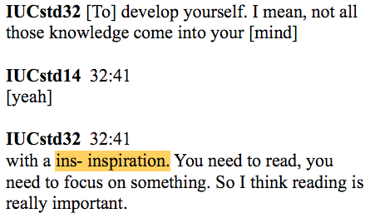

Appendix C2. Use of Lexical Retrieval / Word Search Strategy (F2F, Group B3)

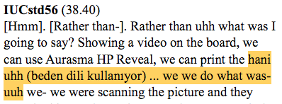

Appendix C3. Use of Unasked-for Help Strategy (Zoom, Group B6)
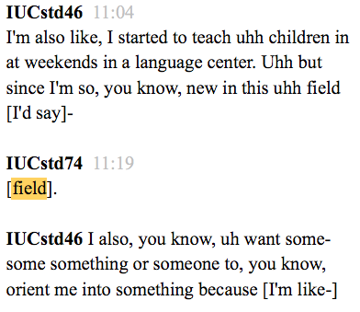

Appendix C4. Use of Insertion Strategy (Zoom, Group A7)

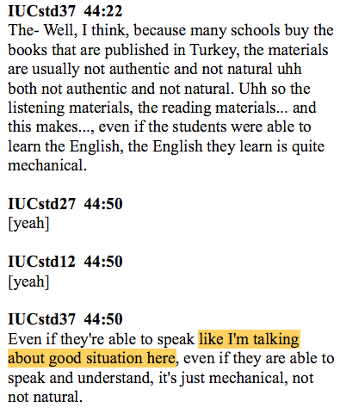

Appendix C5. Use of Lexical Substitution Strategy (F2F, Group B4)

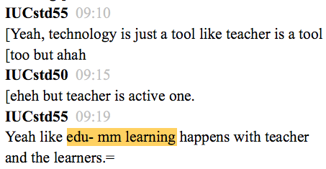

Appendix C6. Use of Managing The Turns Strategy (F2F, Group B3)

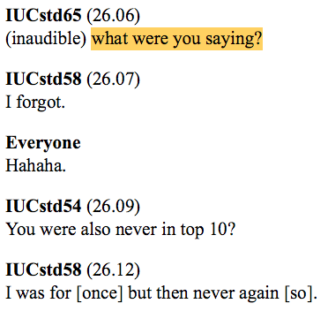

Appendix C7. Use of Recap of Previous Turns Strategy (Second Life, Group B3)
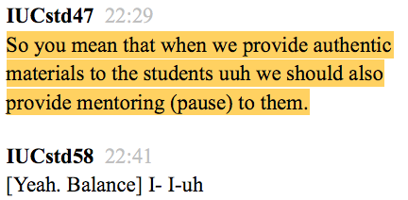

Appendix C8. Use of Lexical Wavering Strategy (F2F, Group B6)
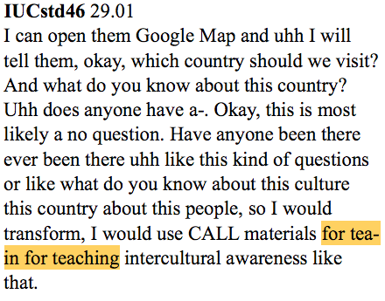

Appendix D
New strategies

Appendix D1. The Stuttering Strategy

Dörnyei & Kormos’s (1998) taxonomy:
- L2 resource deficits
- Lexical PSM
- Grammatical PSM
- Phonological PSM
3.1. Phonological retrieval
a. Tip-of-the-tongue phenomenon
b. Stuttering
- Processing time pressure

Appendix D2. The Lexical Retrieval / Word Search Strategy

Dörnyei & Kormos’s (1998) taxonomy:
- L2 resource deficits
- Lexical PSM
  - Content reduction
  - Substitution
  - Substitution plus
  - Macro reconceptualization
  - Micro reconceptualization
  - Appeals for help
  - Lexical retrieval / Word search
a. Word search
- Grammatical PSM

Appendix D3. The Unasked-for Help Strategy

Dörnyei & Kormos’s (1998) taxonomy:
- L2 resource deficits
- Processing time pressure
- Perceived deficiencies in one’s own language output
- Perceived deficiencies in the interlocutor’s performance
1.Meaning Negotiation
a. Asking for repetition
b. Asking for clarification
c. Expressing non-understanding
d. Asking for confirmation
e. Interpretive summary
f. Guessing
g. Other-repair
h. Feigning understanding
i. Unasked-for help

Appendix D4. The Lexical Substitution Strategy

Dörnyei & Kormos’s (1998) taxonomy:
- L2 resource deficits
1. Lexical PSM
1.1. Content reduction
1.2. Substitution
a. Code-switching
b. Approximation
c. Use of all-purpose words
d. Complete omission
e. Lexical substitution
1.3. Substitution plus

Appendix D5. The Phonological Code-switching Strategy

Dörnyei & Kormos’s (1998) taxonomy:
- L2 resource deficits
1. Lexical PSM
2. Grammatical PSM
3. Phonological and Articulatory PSM
3.1. Phonological retrieval
3.2. Phonological and articulatory substitution
a. Use of similar-sounding words
b. Phonological code-switching
3.3. Phonological and articulatory reduction

Appendix D6. The Lexical Wavering Strategy

Dörnyei & Kormos’s (1998) taxonomy:
- L2 resource deficits
1. Lexical PSM
1.1. Content reduction
1.2. Substitution
a. Code-switching
b. Approximation
c. Use of all-purpose words
d. Complete omission
e. Lexical substitution
f. Lexical wavering
1.3. Substitution plus

Appendix E
Example Task
TASK 3 - Technology & Professional Development
Instructions:
*Please discuss the questions below based on your own experience as a student and pre-service teacher. Also, you can make references to the suggested readings below and other sources that you have read so far.
*It is important that the discussions are supported with your own ideas and not with memorized sentences from the sources.
*Optimal period of time that should be spent on this task is between 30 to 40 minutes in total. Please try to make time for all the questions.
*Please try not to hold the floor too long and remember that this is a discussion environment where everyone needs to contribute, discuss, and argue.
*Suggested readings for Task 3: Reinders & White (2010), Mann (2005).
You can refer to Reinders & White (2010) for the questions below.
1) How do you think technology shaped the ELT materials?
2) Do you think technology totally supplanting the coursebook is a good idea? Why?
3) Do you think using CALL materials is advantageous in language teaching? Why?
4) “Technology does not make good teaching, good teachers do.”
To what extent do you agree with the quotation above? Why?
5) Besides getting to know how to make use of technology and adapt CALL materials, how can a teacher further their development in their profession? As a group, discuss and come up with at least five things teachers can do (You can refer to Mann, 2005 for this question). The five things on your list don’t have to be about technology!
6) Have you ever used technology for language teaching purposes?
- If yes, could you exemplify how you used it and what sort of technology you adapted?
- If not, how can you make use of technology in your classes when you become a teacher?

7) Consider that you are participating in an undergraduate student conference where you are asked to give a talk and inspire the pre-service teachers in using CALL materials in class. Title of your talk is “How would you make use of CALL materials to transform your teaching?”. Brainstorm with your group and decide what would be the highlights of your presentation and what you want to talk about (it could be about anything you learned somewhere, you read, you experienced, you did or designed. It could even be about any specific web tools that you think are useful).
Optional reading:
Kessler G. (2018) Technology and the future of language teaching. Foreign Language Annals, 51: 205–218. https://doi.org/10.1111/flan.12318

The 10 most frequent strategies are highlighted in yellow. The strategies that were never used are highlighted in gray.

