The usefulness of graphic illustrations in online dictionaries
Anna Dziemianko
Adam Mickiewicz University in Poznań, Poland (danna@amu.edu.pl)
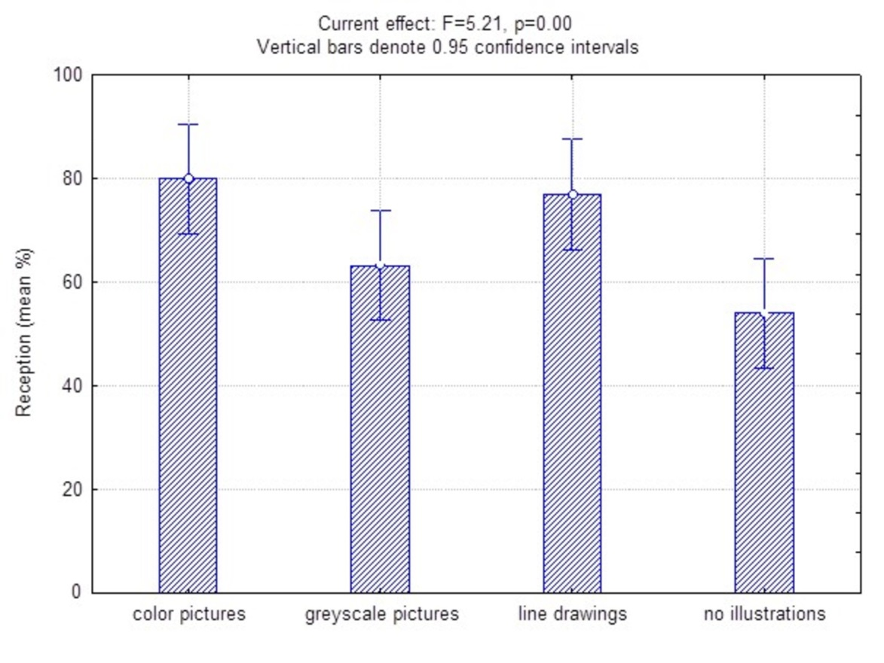
Figure 6. Reception accuracy by experimental condition
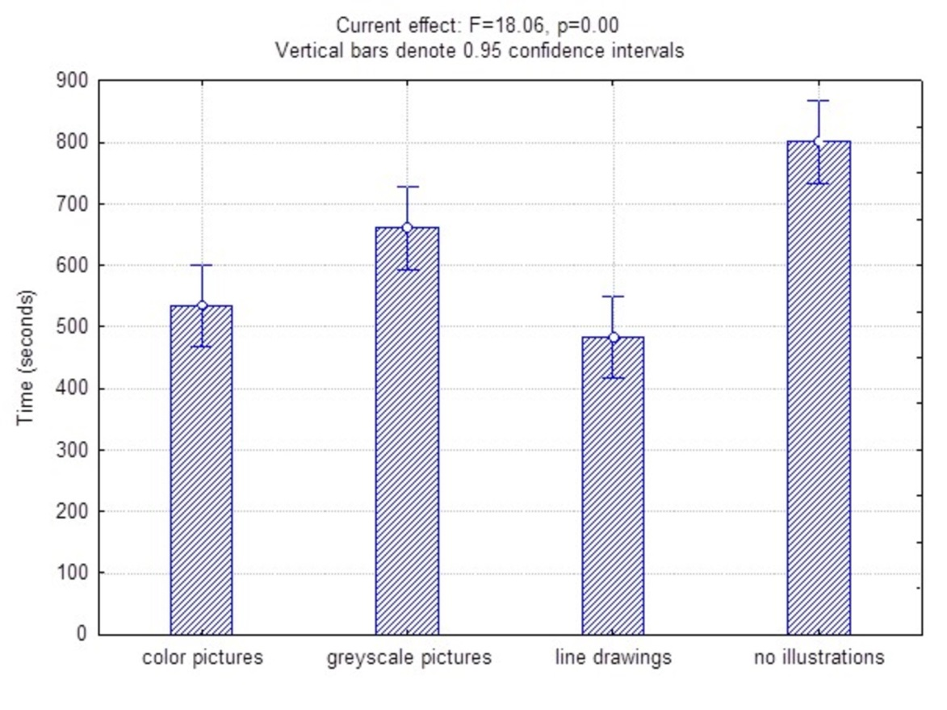
Figure 7. Reception time by experimental condition
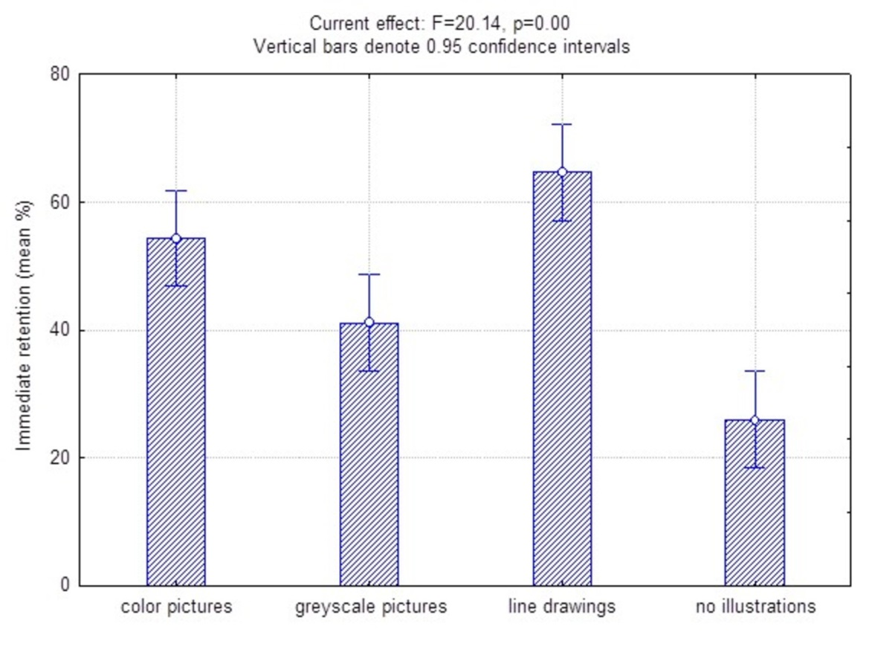
Figure 8. Immediate retention by experimental condition
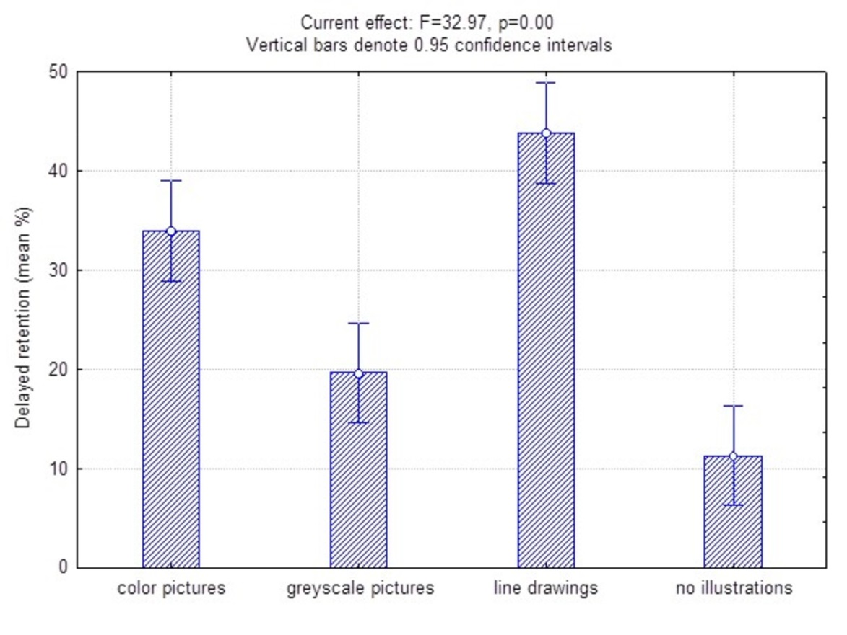
Figure 9. Delayed retention by experimental condition
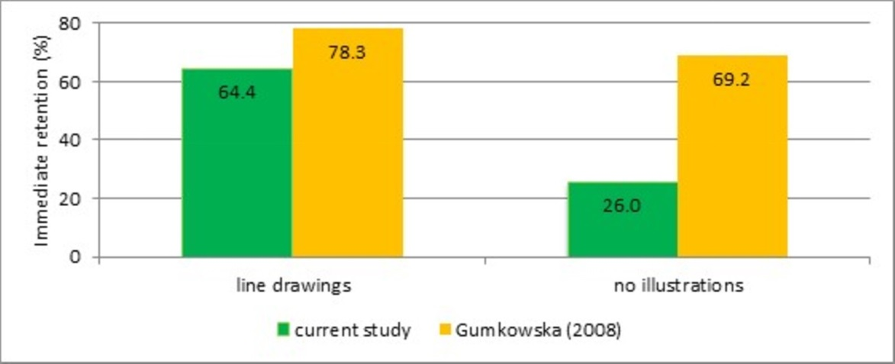
Figure 10. Immediate retention in the current study and in Gumkowska (2008)
Appendices
Appendix A. Test items
acorn, bulrush, cask, dandelion clock, dill, fly agaric, growth ring, mound, mountain ash, pinwheel, potty, sash, spinning wheel, stingray, stump

Appendix B. The entry and the receptive task for acorn (picture in color)
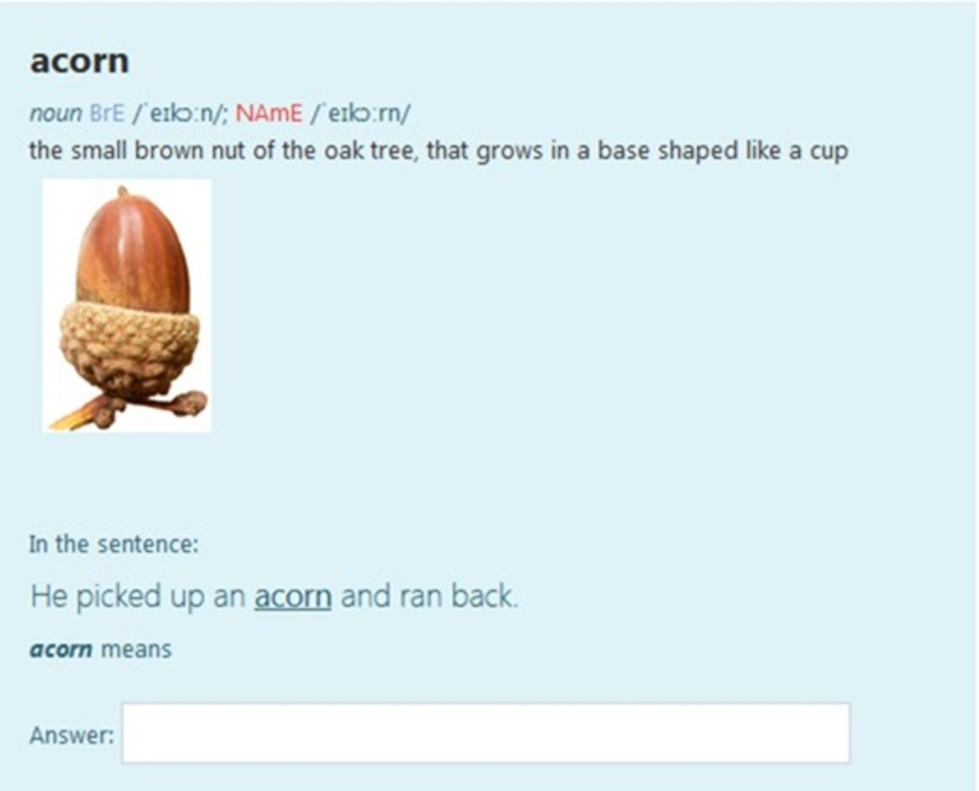
Appendix C. The entry and the receptive task for acorn (picture in greyscale)
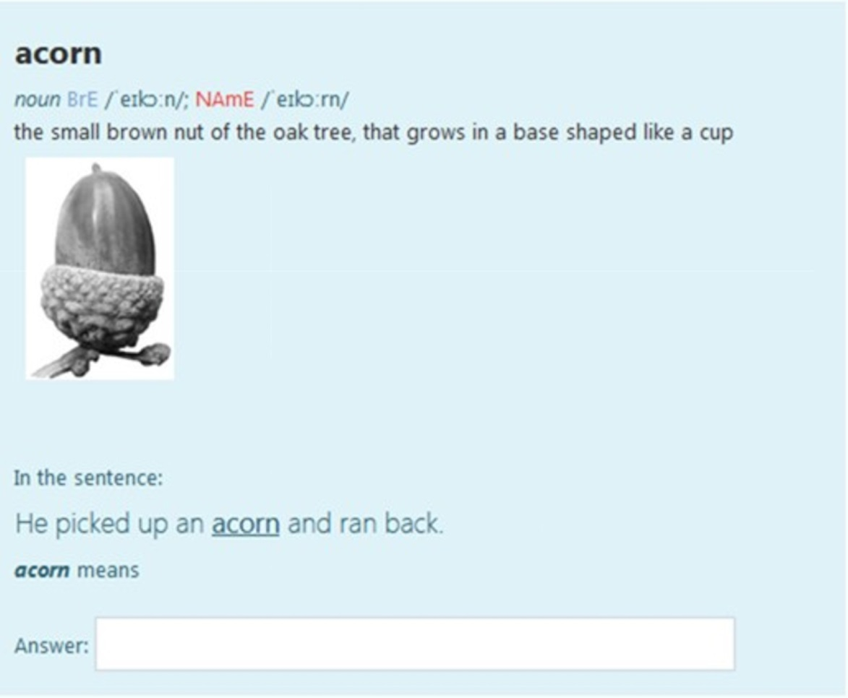
Appendix D. The entry and the receptive task for acorn (line drawing)
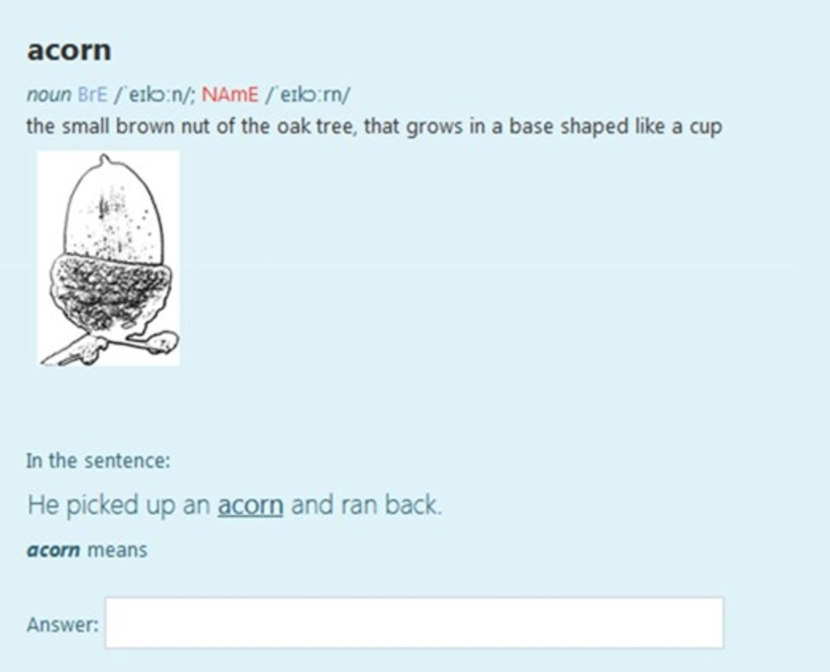
Appendix E. The entry and the receptive task for acorn (no illustration)
