Supplementary material
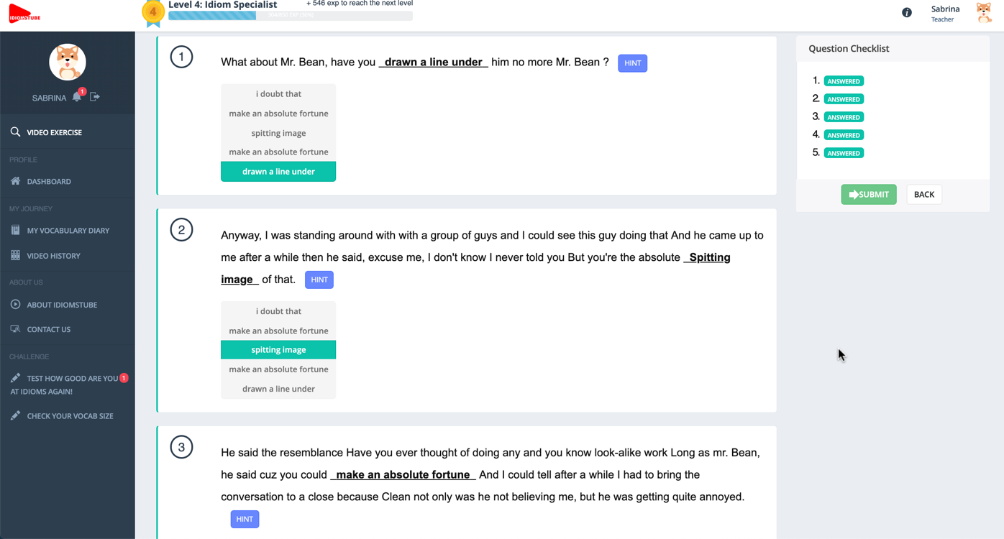
Figure 4. The fill-in-the-blank exercise. IdiomsTube automatically generates cloze exercises to raise learners’ awareness of the ways in which the noteworthy FEs are used in context in the video. Learners may click the Hint button to return to the exact scene in which the noteworthy FE occurs. The multiple-choice questions are auto-marked.
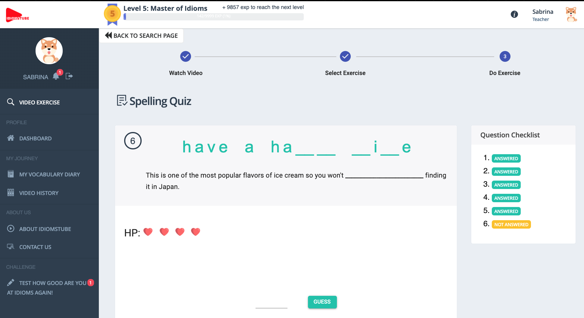
Figure 5. The spelling exercise. IdiomsTube automatically generates spelling exercises to raise learners’ awareness of the orthographic form of the FEs used in the videos just watched.
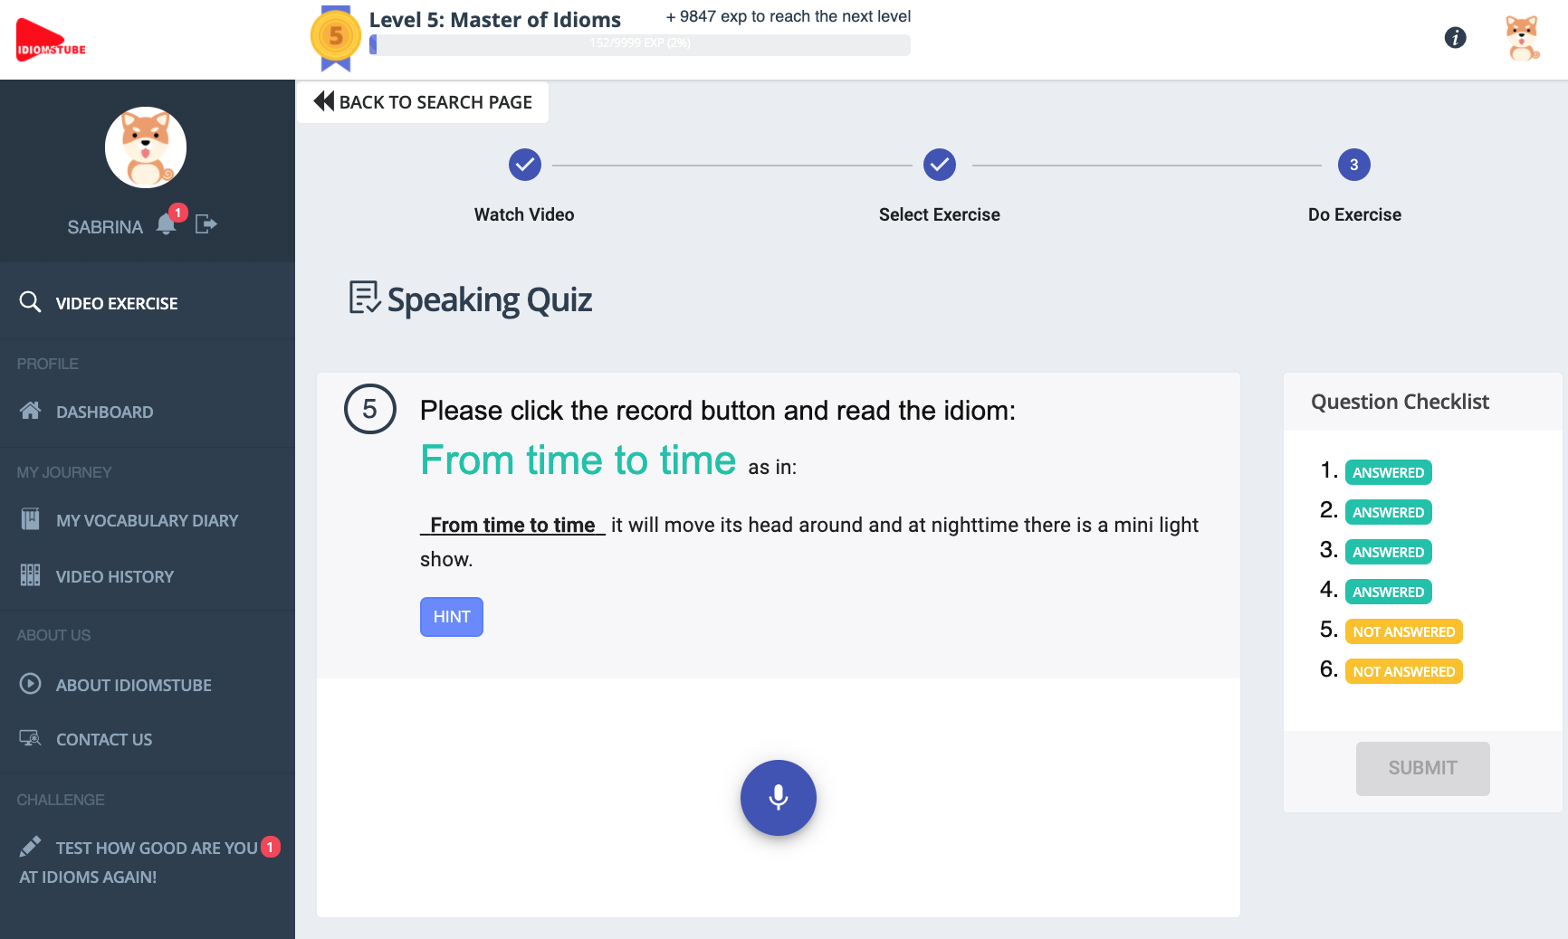
Figure 6. The pronunciation exercise. Learners are required to read aloud the FEs in each video one by one. Learners may click the Hint button to return to the exact scene in which the noteworthy FE occurs.
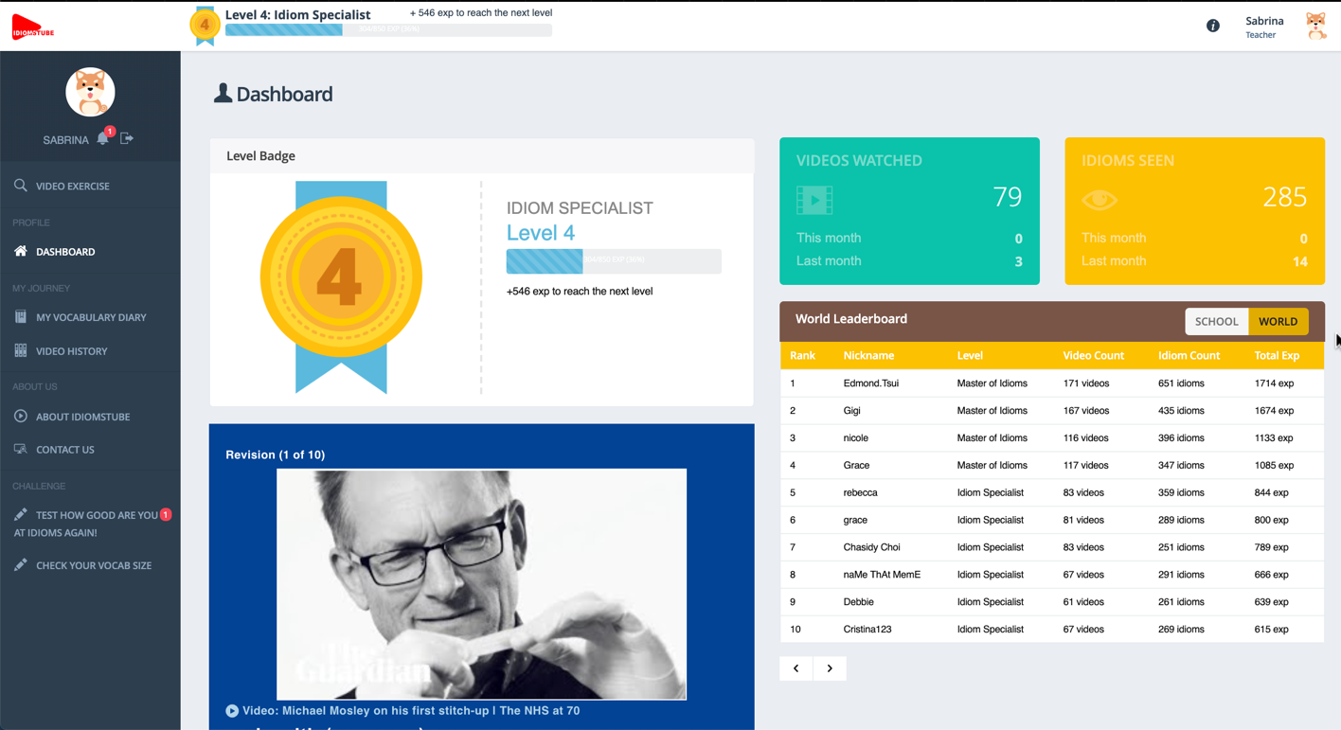
Figure 7. The learning progress summary (see top right corner) and the revision flashcards (see the box at the bottom).
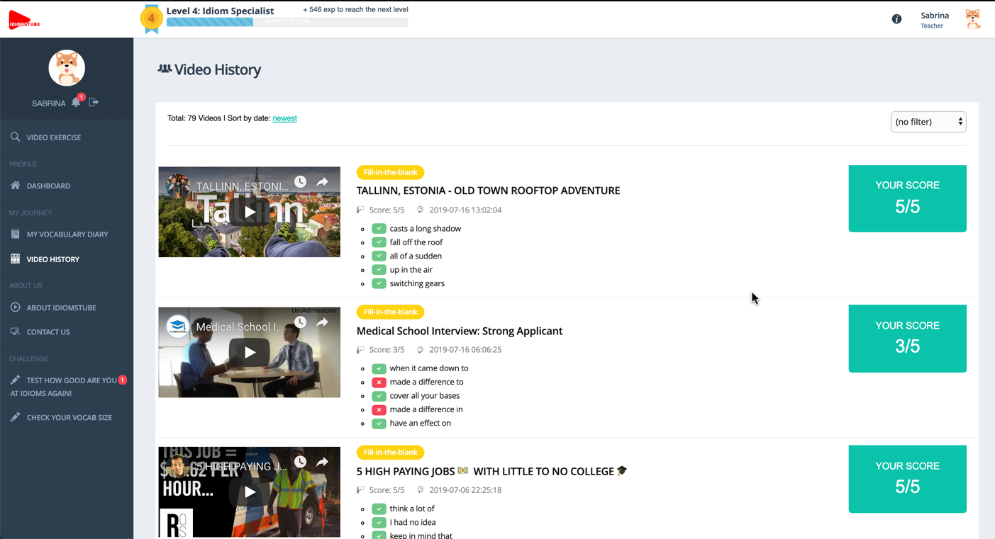
Figure 8. The video history page. Learners may see a list of previously watched videos, the FEs used in each video, and their scores in each exercise.
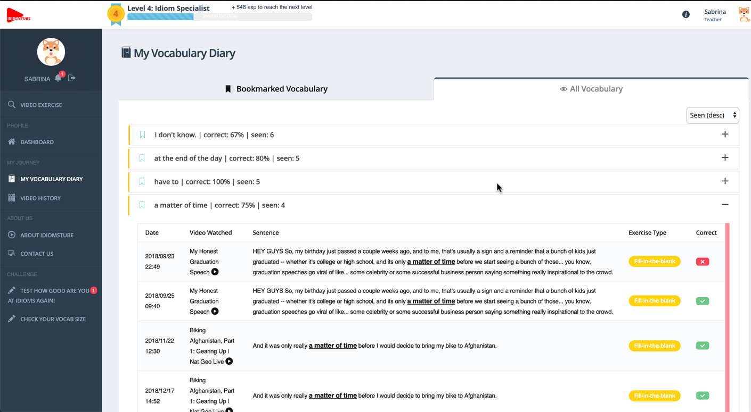
Figure 9. A summary of noteworthy FEs learned. Learners may see the context in which each learned FE was used in any previously watched videos and play back the specific scenes.
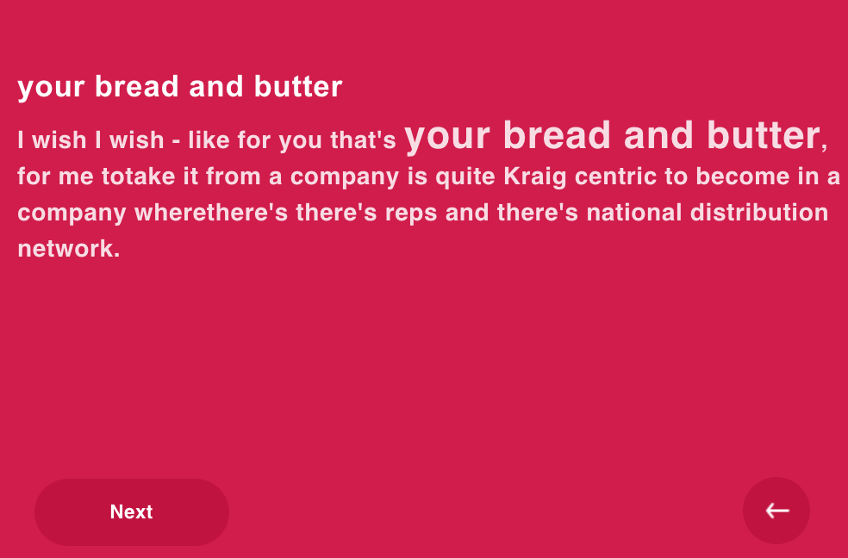
Figure 10. Both sides of the revision flashcards. Every time a learner logs in, the system will automatically compile a stack of 10 flashcards for revision. Each flashcard reminds the learner of an FE learned from a previously watched video. The flip side of the card shows an example of how the FE was used in context in the video.
Figure 11. Video recommendations generated by the system. Learners get instant video recommendations that match their EFL English proficiency.
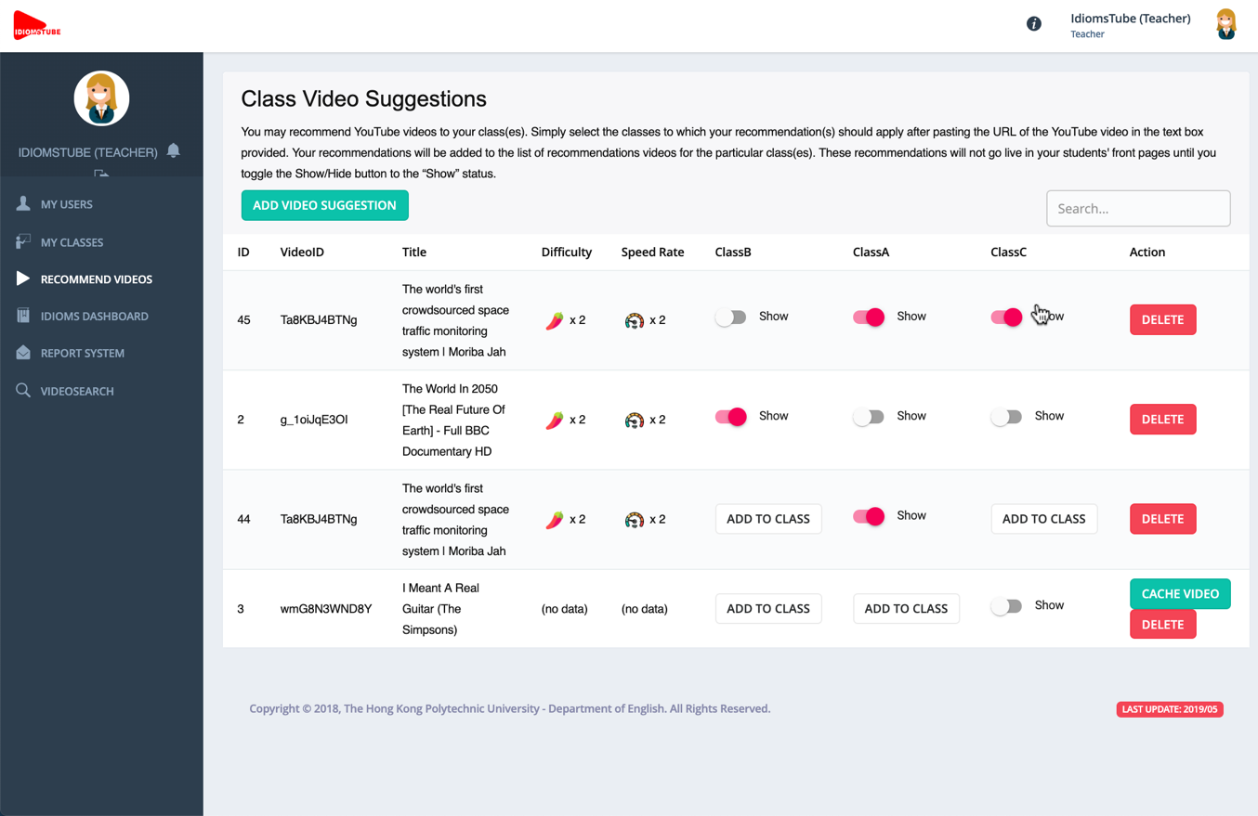
Figure 12. Teacher’s video recommendations. Teachers may recommend noteworthy YouTube videos to their own students via the IdiomsTube Teacher’s interface (see section 3.3).
Figure 13. Examples of gamification features. The leaderboard (left) and badges and honour title (right).
Figure 14. IdiomsTube Teacher’s interface 1. Teachers can organise all their classes using the IdiomsTube Teacher’s interface
Figure 15. IdiomsTube Teacher’s interface 2. Teachers may see a summary of the performance of the whole class (including the number of videos watched and the number of FEs learned) and each student’s level of participation each week.
Figure 16. IdiomsTube Teacher’s interface 3. Teachers may see a list of videos that the class has seen and how many students have seen each video. This piece of information may facilitate the teacher’s classroom teaching preparation.
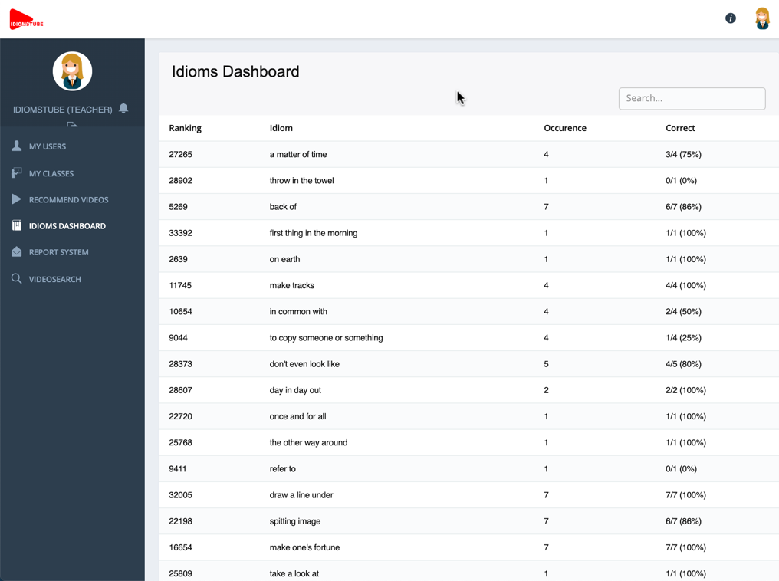
Figure 17. IdiomsTube Teacher’s interface 4. Teachers may see a list of FEs that the class has seen and how many students have seen the FEs. This piece of information may facilitate the teacher’s classroom teaching preparation.
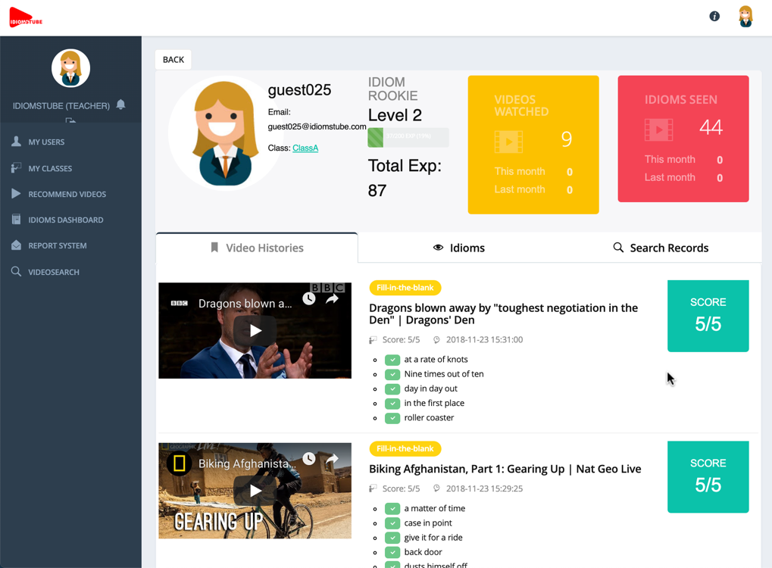
Figure 18. IdiomsTube Teacher’s interface 5. Teachers may click to see an individual student’s participation history including how many and which FEs have been learned through which video and the experience points the student has earned.
Figure 19. IdiomsTube Teacher’s interface 6. Teachers may click to see an individual student’s video search history to get an idea about what kind of video topics interests the student. This is useful information for the teacher’s classroom teaching preparation.

