Supplementary material
Appel, C. & Pujolà, J.-T. (2021) Designing speaking interaction in LMOOCs: An eTandem approach.
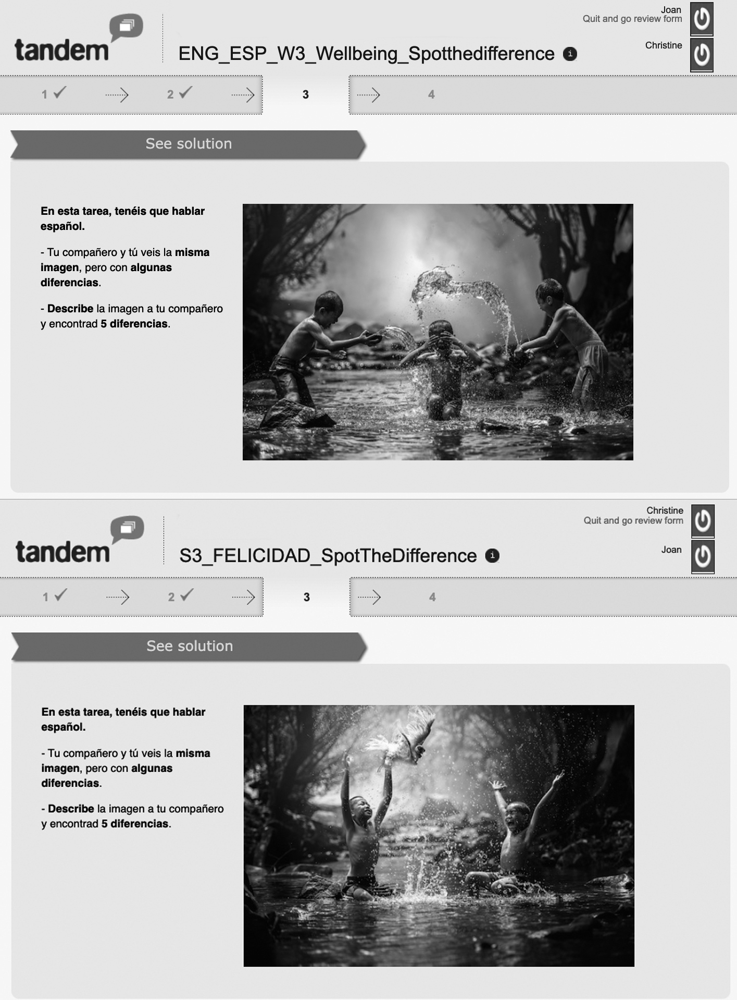
Figure 4. Example of close/convergent task (spot the difference)
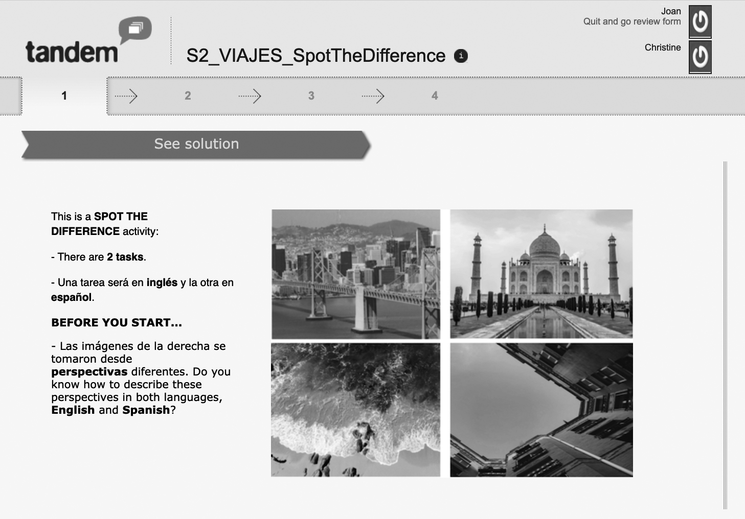
Figure 5. Initial task: Activating a tandem frame of mind
Figure 6. Example of a problem-solving task
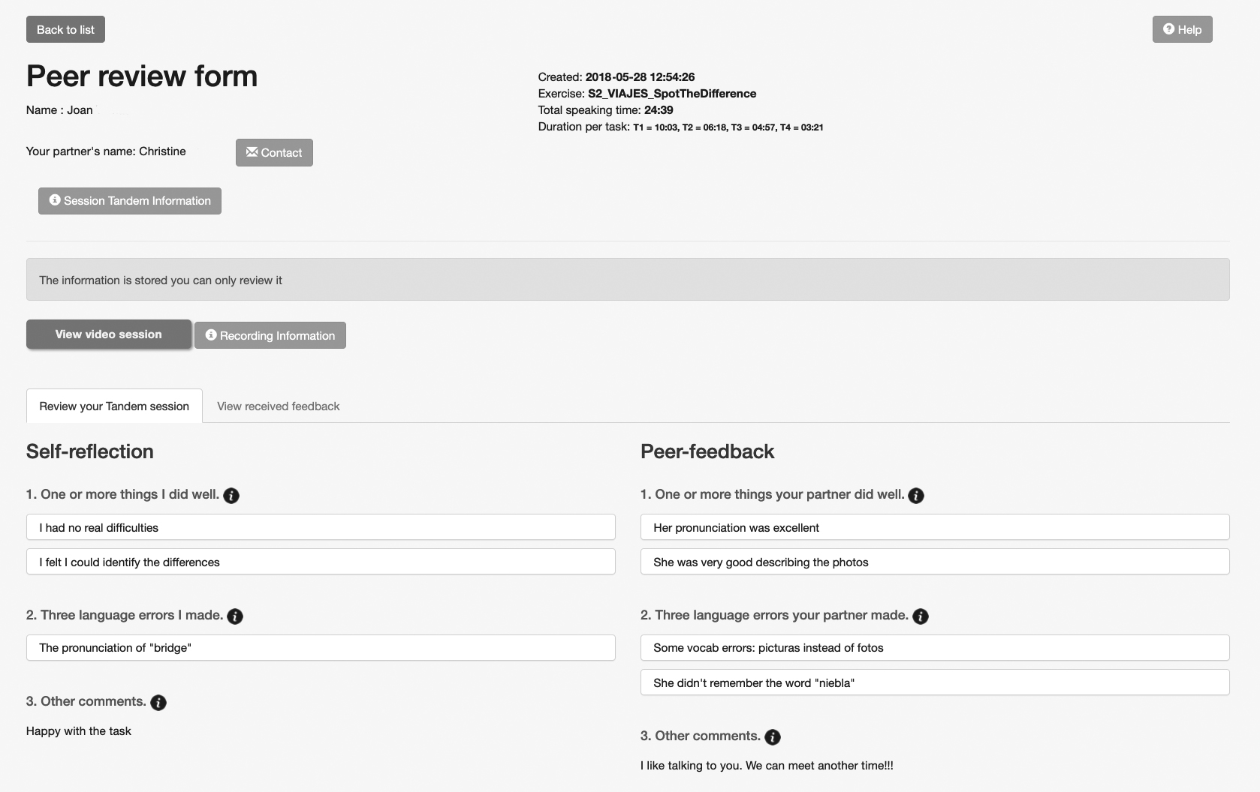
Figure 7. Peer review form: Self-reflection and peer-feedback

