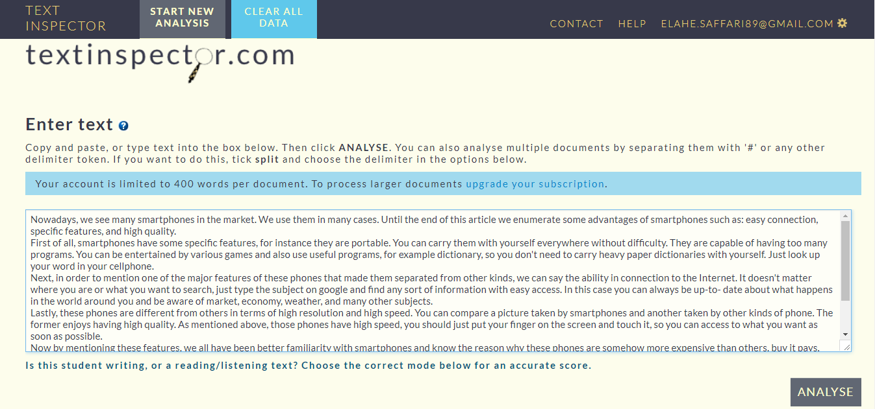

**Figure 1.** Screenshot of *Text Inspector*

**Figure 2.** Screenshot of lexical diversity profile score

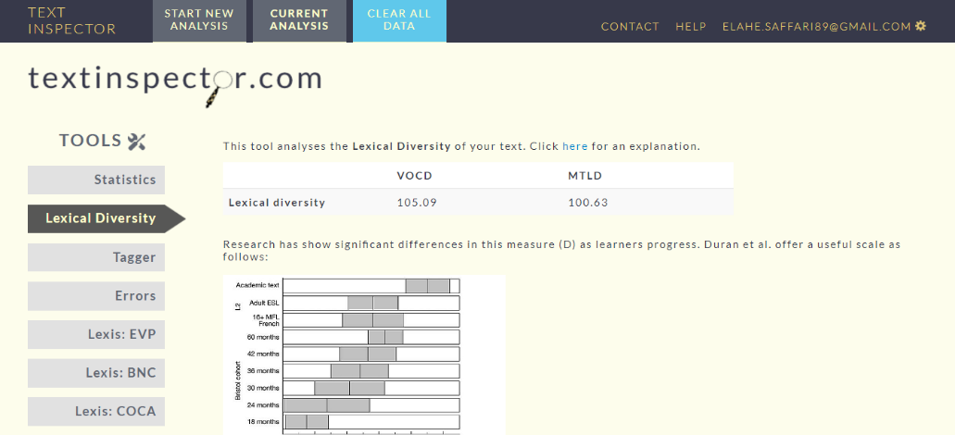

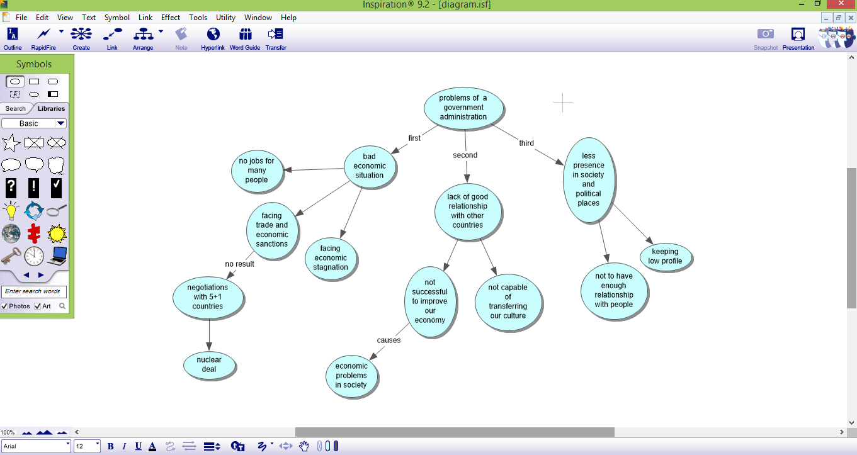

**Figure 3.** Screenshot of a hierarchical concept map within a diagram view