Supplementary materials
A mixed-methods study of tailor-made animated cartoons in teaching punctuation in EFL writing
Arif Bakla
Cumhuriyet University, Turkey (arifbakla@gmail.com)
A. The web link to the animated cartoons used in the treatment group
You can find the animated cartoons in the following YouTube channel. These movies were uploaded to this channel after the study was over. Please click here to access the channel.
B. A sample PPT used the control group
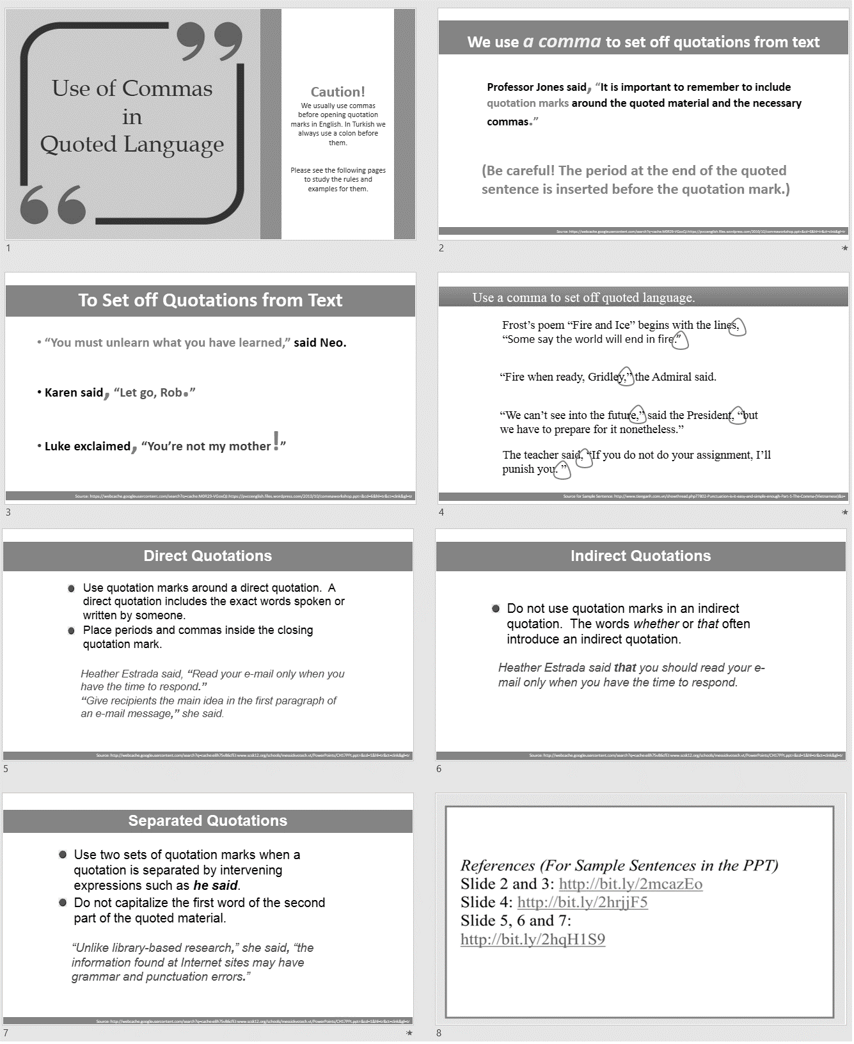
Note. This PPT presentation was selected as a sample as it was short enough to fit into a single page. Please click on the image to view the actual PPT presentation in a slide sharing site.
C. Sample SCORM exercises that the entire study group completed
1. A Sample Rewriting Activity (Use of Comma with While and Whereas)
2. A Sample Multiple-Choice Activity (Punctuation of Conjunctive Adverbs)
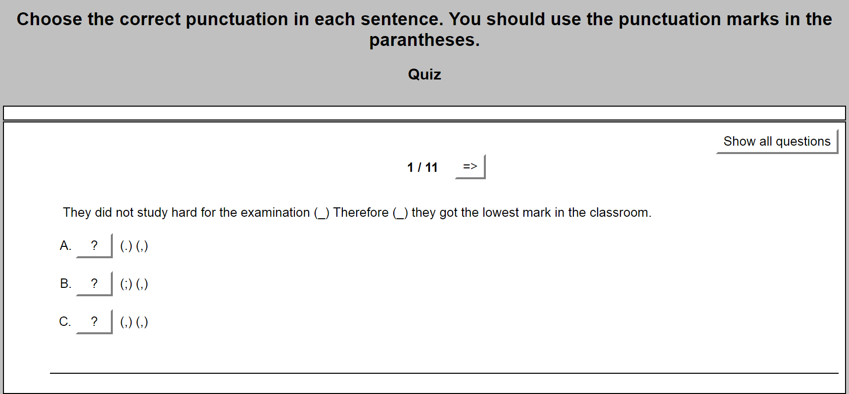

3. A Sample Gap-fill Activity (for Revision)
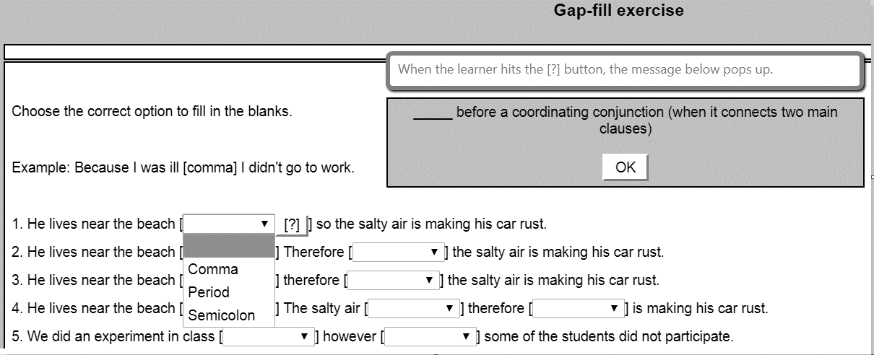
Reference: http://bit.ly/2ABzqog
4. A Sample Sentence Combining Activity (for Revision)
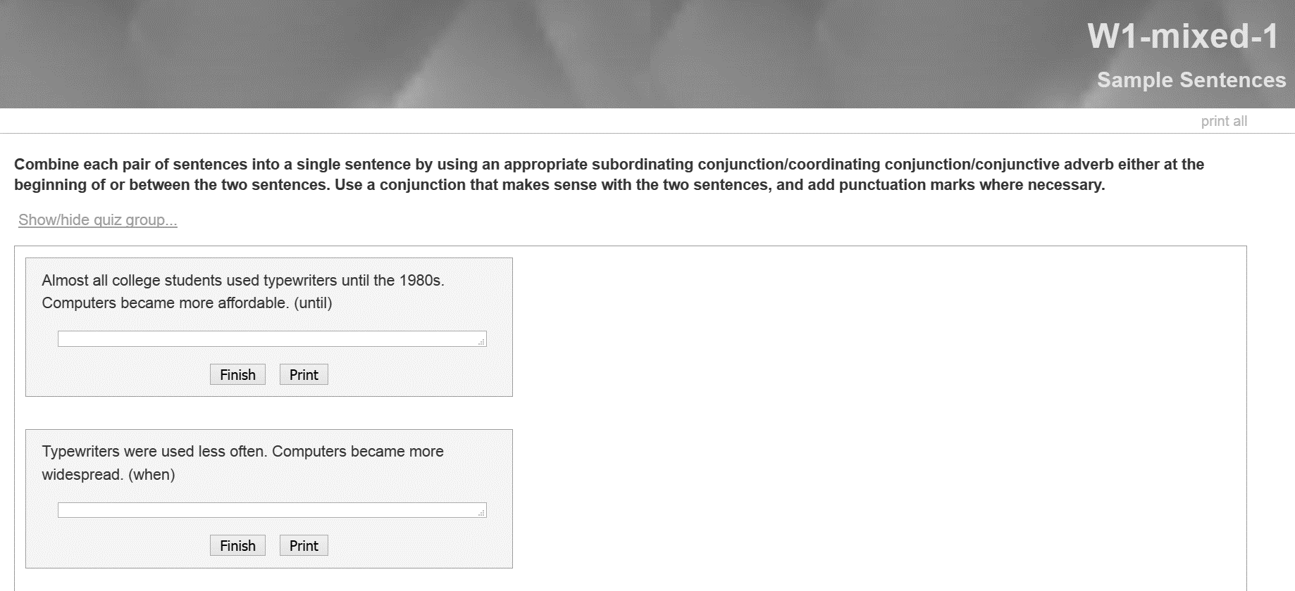
Note. There were more items in all of these exercises, but the screenshots show only several of the items in each.

D. The punctuation test
Decide whether the following sentences are correctly punctuated or not. If the punctuation of the sentence is CORRECT, choose option A. If the punctuation of the sentence is INCORRECT, choose option B, and WRITE the correctly punctuated version of the sentence in the space provided. There may be more than one error per sentence.
Note: While correcting the errors, you don’t have to write the whole sentence. See the example below.

Example:
I like apples bananas and cherries.
A) Correctly punctuated B) Incorrectly punctuated
Correction: …apples, bananas…

1. Dr. Smith who has studied genetic diseases for the last seven years is a distinguished scientist with quite a few interesting discoveries.
A) Correctly punctuated
B) Incorrectly punctuated
……………………………………………

2. He refused his girlfriends’ offer to go out at night; for he had been ill for the last few days due to cold weather.
A) Correctly punctuated
B) Incorrectly punctuated
……………………………………………

3. Dorothy is planning to talk to her father about her boyfriend. Yet; she is afraid that he might get angry without listening to a single word.
A) Correctly punctuated
B) Incorrectly punctuated
……………………………………………

4. The singer had an accident on the way to the concert hall. She therefore arrived there half an hour later than expected.
A) Correctly punctuated
B) Incorrectly punctuated
……………………………………………

5. The police had already seen the thief in the dark; before he had the chance to get out of the building.
A) Correctly punctuated
B) Incorrectly punctuated
……………………………………………

6. My brother has been abroad for the last two months; so, we have missed him a lot.
A) Correctly punctuated
B) Incorrectly punctuated
……………………………………………

7. One of his friends gave him a lift; while he was going home on foot.
A) Correctly punctuated
B) Incorrectly punctuated
……………………………………………

8. The little girl wanted to buy a present for her mother, however she did not have enough money to buy something nice.
A) Correctly punctuated
B) Incorrectly punctuated
……………………………………………

9. James is an extremely lazy kid; while his friends are hardworking students.
A) Correctly punctuated
B) Incorrectly punctuated
……………………………………………

10. If you see him at the office tomorrow tell him to call me as soon as possible.
A) Correctly punctuated
B) Incorrectly punctuated
……………………………………………

11. There were twenty-nine students in the class. 20 of them did not do the homework. The result was that the students who failed to fulfill their duties were punished by the teacher.
A) Correctly punctuated
B) Incorrectly punctuated
……………………………………………

12. Archimedes once cried, “I have found it”!
A) Correctly punctuated
B) Incorrectly punctuated
……………………………………………
13. Some people might want to get a video recording of this social gathering. People, who want to get it, must pay €10.
A) Correctly punctuated
B) Incorrectly punctuated
……………………………………………

14. He spent the whole afternoon in his friend’s house; they talked about good old days.
A) Correctly punctuated
B) Incorrectly punctuated
……………………………………………

15. He had some problems with some of his relatives. Nevertheless; he used to visit them on special occasions.
A) Correctly punctuated
B) Incorrectly punctuated
……………………………………………

16. The weather is very cold, you should wear thick clothes.
A) Correctly punctuated
B) Incorrectly punctuated
………………………………………………

17. I would like to have some more cake to eat but I am afraid of getting weight.
A) Correctly punctuated
B) Incorrectly punctuated
……………………………………………

18. He is highly qualified for the job advertised in today’s paper, so he can obviously get it if he applies for it.
A) Correctly punctuated
B) Incorrectly punctuated
……………………………………………

19. After Leslie came to one of the classes in the beginning of the term she never appeared again until the end of the term.
A) Correctly punctuated
B) Incorrectly punctuated
……………………………………………
20. Nobody seemed willing to listen to his story, therefore, he decided not to tell it.
A) Correctly punctuated
B) Incorrectly punctuated
……………………………………………

21. You should study very hard for your school lessons; if you want to be a successful student.
A) Correctly punctuated
B) Incorrectly punctuated
……………………………………………

22. The teacher told the students. “If you want to be a leader, you must have charisma.”
A) Correctly punctuated
B) Incorrectly punctuated
……………………………………………

23. I dream of living in a densely populated metropolitan area. Whereas; my brother wants to live in a small village.
A) Correctly punctuated
B) Incorrectly punctuated
……………………………………………

24. Since the old lady has some trouble sleeping nowadays, she went to bed late last night. Furthermore; she took some sleeping pills.
A) Correctly punctuated
B) Incorrectly punctuated
……………………………………………

25. David went to the stadium, although he knew for certain that it was impossible to get in without a ticket.
A) Correctly punctuated
B) Incorrectly punctuated
……………………………………………

26. I did lots of activities during the holiday. For example; I went swimming almost every day.
A) Correctly punctuated
B) Incorrectly punctuated
……………………………………………

27. I would like to study math at university; because it is one of my best subjects.
A) Correctly punctuated
B) Incorrectly punctuated
……………………………………………

28. The employees, who have come early in the morning, will have two days off at the weekend. What about latecomers? They will have to work then.
A) Correctly punctuated
B) Incorrectly punctuated
………………………………………………

29. Brigitte decided to visit her uncle next week. Because, she has missed him very much.
A) Correctly punctuated
B) Incorrectly punctuated
……………………………………………

30. My friend has two interesting habits: First; he always watches the reflection of TV on a mirror. Second; he always talks to himself.
A) Correctly punctuated
B) Incorrectly punctuated
……………………………………………

Answer Key
- Dr. Smith, who studies genetic diseases for the last seven years,
- … night, for he had been ill …
- … boyfriend. Yet, she …
- She, therefore, arrived there …
- … dark before he had the chance …
- … for the last two months, so… (or a full stop before so and a comma after it)
- … a lift while he was going home on foot.
- … for her mother; however, she … (or a full stop before however and capitalization)
- James is an extremely lazy kid, while his friends are hardworking students.
- If you see him at the office tomorrow, …
- Correctly punctuated
- Archimedes once cried, “I have found it!”
- People who want to get it must pay €10.
- Correctly punctuated
- … relatives. Nevertheless, he used to visit …
- The weather is very cold; you should wear … (Alternatively, a conjunction could be used between the two sentences.)
- … more cake to eat, but I am afraid of …
- Correctly punctuated
- … beginning of the term, she never …
- …l isten to his story. Therefore, he decided not to tell it (Alternatively, a semicolon before therefore and no capitalization)
- … school lessons if you want to be …
- The teacher told the students, “If …
- … metropolitan area, whereas my brother …
- … last night. Furthermore, she took …
- David went to the stadium although …
- For example, I went swimming …
- … at university because it is …
- The employees who come early in the morning will have …
- … visit her uncle next week because …
- First, he always … Second, he always …

E. Additional notes on qualitative data analysis
Various qualitative validation techniques were used to increase the trustworthiness of the data collection, analysis and reporting. First, the research design and whole process of data collection were discussed with two colleagues to put into practice peer debriefing (Creswell, 2012). At the same time, to promote dependability, external auditing was used to see how the research design, findings and pedagogical implications looked from the perspective of outsiders (Given, 2008; Creswell, 2012). Two researchers, both of whom were familiar with mixed-methods research (from ELT and social sciences instruction), were involved in this process. They were asked to examine the results and implications of the study to help the researcher identify problems or unclear issues. In this way, the researcher was able to address issues arising from both methodological considerations and comprehensibility. In addition, all six interview participants were asked to check the transcripts to see if their words were transcribed correctly and if there should be any additions or any significant data were left out. To promote confirmability of the study, data security was ensured. Finally, to ensure transferability, the researcher described the procedures, characteristics of the participants and presented all other details, so that readers could compare and contrast this experience with other cases.
During the data collection and analysis, the researcher considered several ethical issues, such as seeking informed consent and data security to ensure confidentiality, privacy and anonymity.

