Supplementary Material
The Temple of Quetzalcoatl, Teotihuacán: new data on the origins of the sacrificial victims
T. Douglas Price, Michael Spence, Fred J. Longstaffe, and Christine D. White

Oxygen Isotopes in Bone and Enamel Phosphate
The procedure was originally described in White et al. (2002) and the reader is referred to that publication. Bone was analyzed in the stable isotope laboratory at McMaster University (Stuart-Williams et al. 1998), and enamel in the stable isotope laboratory at The University of Western Ontario. Previous analysis of bone from Teotihuacan has indicated that postmortem alteration, or diagenesis, has not affected δ¹⁸O (Stuart-Williams et al. 1998). Calculation of the Crystallinity Index (CI) (Shemesh 1990) for the bone and enamel samples indicated that diagenesis had not significantly altered the original biogenic values in the samples.
The general baseline range for δ¹⁸O_{p} with VSMOW standard at Teotihuacán is suggested to be 14 to16‰ (White et al. 2002). This range is based on enamel samples from the barrio of Tlajinga at Teotihuacán where most of the individuals appear to be locally born. Modern teeth from nearby Mexico City have an average value of 15‰ (Levinson et al. 1987). These values differ from other locations in Mexico and Guatemala contemporary with Teotihuacán (Table S1).
Table S1. Oxygen isotope ratios and altitude, average annual temperature, and average annual rainfall for several major archaeological sites in Mesoamerica. (adapted from White et al. 2002)
Site | Location | Altitude m asl | Temp °C | Rainfall (mm) | δ¹⁸O_{p ‰}  VSMOW
Rio Azul | Lowland Guatemala | <99 | 27.5 | 1500 | 19.9
Altun Ha | Coastal Belize | 10 | 25 | 1625 | 18.7
Kaminaljuyú | Highland Guatemala | 1500 | 21 | 1000 | 16.7
Tzintzuntsan | Michoacan | 1940 | 17.5 | 750 | 16.2
Monte Albán | Valley of Oaxaca | 1900 | 15.6 | 650 | 13.0
Teotihuacán | Highland Mexico | 2300 | 12.7 | 700 | 15.3
Quetzalcoatl | Highland Mexico |  |  |  | 15.5
Trophies | Highland Mexico |  |  |  | 16.1

Fig. S1 shows a plot of δ¹⁸O_{p} values for various areas of Mesoamerica, including Teotihuacán and the Temple of Quetzalcoatl and demonstrates that distinctive values for this oxygen isotope ratio characterize different parts of the region.
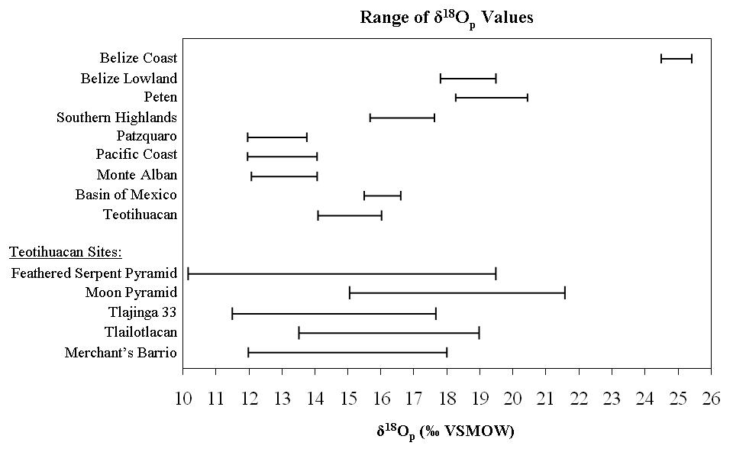
Fig. S1. Plot of the range of δ¹⁸O_{p} values for various areas of Mesoamerica. From White et al. (2007), with permission.

Oxygen Isotopes in Tooth Enamel
Oxygen isotope ratios vary geographically in surface water and rainfall. The oxygen isotope ratio in the human skeleton reflects that of body water, and ultimately of consumed water (Kohn 1996, Luz et al. 1984, Luz and Kolodny 1985), which in turn predominantly reflects local rainfall. The oxygen isotope composition of freshwater is greatly affected by enrichment or depletion of ¹⁸O relative to ¹⁶O in water due to evaporation and precipitation (e.g. Dansgaard 1964). Major geographic factors affecting rainfall oxygen isotope composition, then, are latitude, elevation, amount of precipitation, and distance from the source (e.g., an ocean). In rainwater, H₂O, H₂¹⁸O has a greater mass than H₂¹⁶O, and requires more energy to evaporate and to stay in the atmosphere. As this moisture moves over land from its original oceanic source, the first precipitation contains more ¹⁸O, and as the clouds move inland (and to higher elevations), the rain becomes progressively depleted of ¹⁸O. Thus, oxygen isotope ratios have potential to vary geographically and provide information on past human movement.
The oxygen isotope composition of ancient human skeletal remains can be measured in both tooth enamel and bone. Oxygen is incorporated into dental enamel during the early life of an individual and it remains unchanged through adulthood. Thus, oxygen isotopes have the potential to be used to investigate human mobility and provenience (Bowen and Revenaugh 2003). Oxygen isotopes are conventionally reported as the per mil difference in the ratio of ¹⁸O to ¹⁶O between a sample and a standard in parts per thousand (‰). This value is designated as δ¹⁸O. This value can be measured in either carbonate (CO₃)⁻² or phosphate (PO₄)⁻³ contained in the apatite that comprises the mineral fraction of tooth and bone. Less sample is needed for carbonate, preparation is less demanding, and some researchers suggest that the results between laboratories are more comparable (e.g., Bryant et al. 1995, Sponheimer and Lee-Thorp 1999, Chenery et al. 2012). The standard used is commonly VSMOW (Vienna Standard Mean Ocean Water) for phosphate, or VPDB (Vienna PDB) for carbonate oxygen.
While the δ¹⁸O values for carbonate and phosphate oxygen are commonly referenced using different standards, they are easily made comparable: δ¹⁸O_{C(VPDB)} = (0.97 x δ¹⁸O_{C (VSMOW)}) -29.98 (Coplen et al. 1983). Methodologies for both δ¹⁸O_{p} and δ¹⁸O_{c} are summarized in sections that follow below. These δ¹⁸O values for carbonate and phosphate oxygen using different standards are comparable though calculation.
Chenery et al. (2012) defined the relationship between the δ¹⁸O value of drinking water and δ¹⁸O in enamel carbonate as δ¹⁸O_{C =} (δ¹⁸O_{DW} + 48.634) /1.59 relative to standard mean ocean water (VSMOW). Measurements made using a Pee Dee Belemnite (PDB) standard must be further corrected: δ¹⁸O_{C(VPDB)} = (0.97 x δ¹⁸O_{C(SMOW)}) -29.98. Thus, as an example a drinking water value of -6.0‰_{(SMOW)} yields an enamel carbonate δ¹⁸O_{C(VPDB}) value of approximately -4.0‰.
Values of δ¹⁸O_{C (VPDB)} have been measured at a number of sites arcross Mesoamerica and there is significant variation that can be used top help identify non-local individuals. Fig. S2 shows a box-and-whisker plot of δ¹⁸O_{C (VPDB)} values for a series of sites. Large-scale differences can be seen between much of central Mexico and the lowlands of the Yucatan, Guatemala, and Belize. In addition, the Peten area of northern Guatemala appears to have a distinctive δ¹⁸O signal.
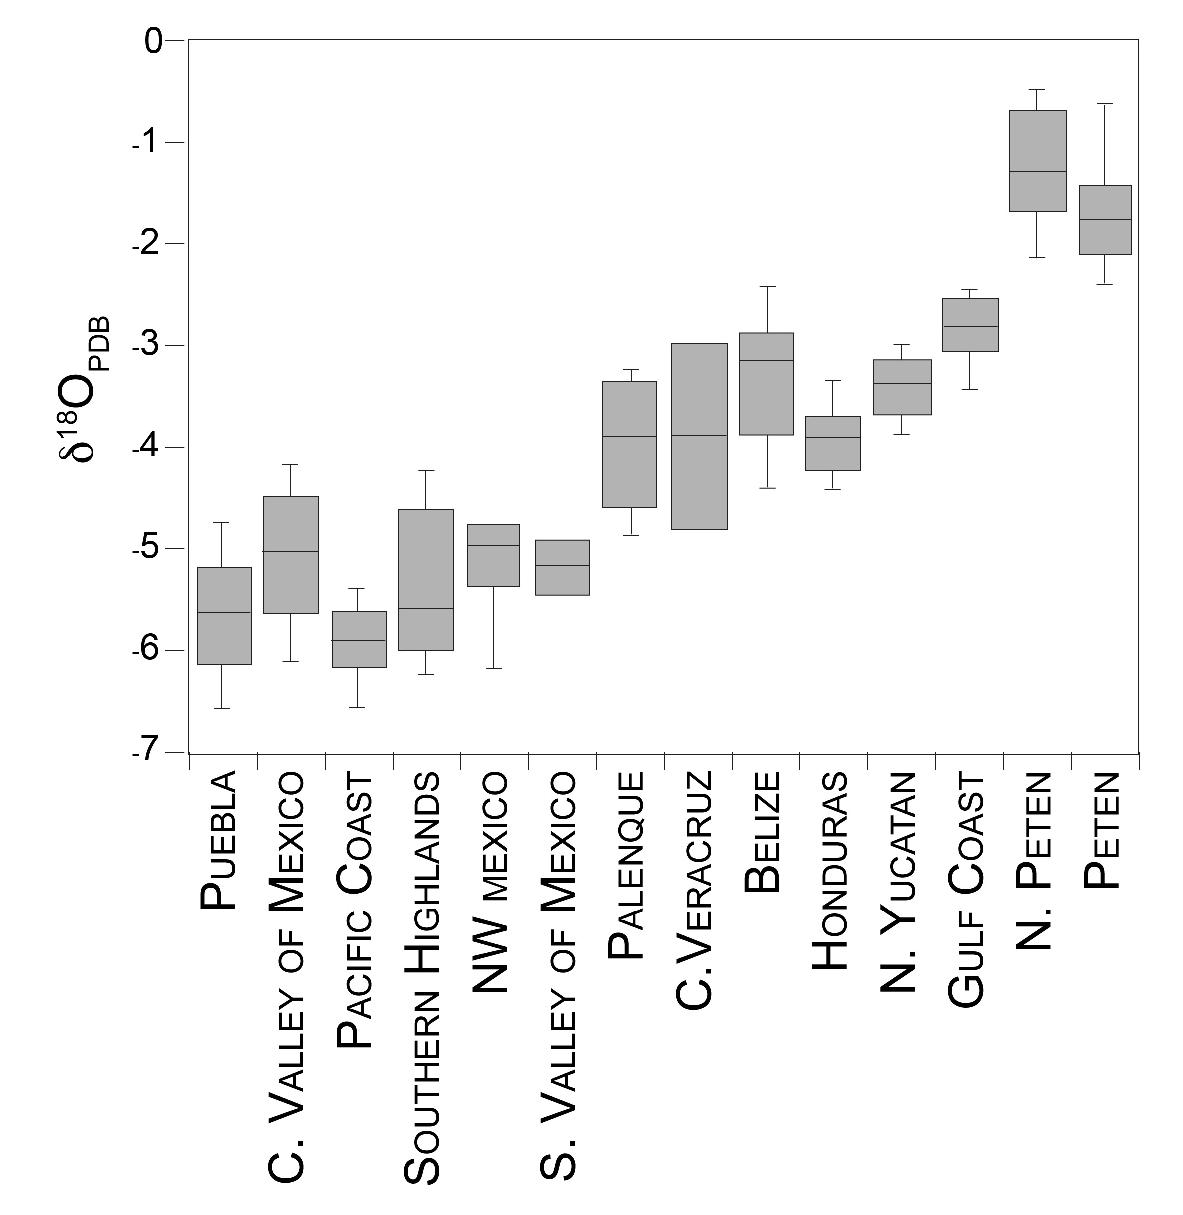
Fig. S2. δ¹⁸O in enamel carbonate at selected sites across Mesoamerica.
Carbon Isotopes in Tooth Enamel
Most paleodiet work using carbon isotopes has focused on the collagen component of the skeleton. Carbon also is present in the mineral, or carbonate, portion of bioapatite, which contains related information on diet (e.g., Ambrose and Norr 1993, Krueger and Sullivan 1984, Lee-Thorp et al.1989). This is particularly valuable for enamel, as it contains very little collagen, making its analysis extremely difficult. Tooth enamel also largely forms during childhood. While bone collagen from adult individuals provides a record of adult diet, tooth enamel can provide a record of early childhood diet, depending on the tooth that is sampled.
Another important difference between collagen and the structural carbonate components of bioapatite lies in the source of the carbon. Experimental studies have demonstrated that collagen carbon comes largely from dietary protein while apatite carbon more accurately reflects the isotopic composition of the total diet (e.g., Ambrose and Norr 1993).
Carbon isotope ratios between ¹³C and ¹²C are reported relative to the reference material VPDB, and reported as δ¹³C in per mil (‰). For the samples described in the present study, the teeth were chemically cleaned following the procedure described by Balasse et al. (2002). Enamel samples were placed in approximately 2 mL of 2-3% (v/v) solution of bleach for 8 hours and rinsed three times with deionized water, centrifuging the tubes between each aliquot. Then, 0.1 mL/mg of 0.1 M acetic acid was added to each tube for exactly 4 hours, and the samples were rinsed again with three aliquots of deionized water before being freeze-dried for analysis. Analysis was performed in the Environmental Isotope Laboratory (Department of Geosciences, University of Arizona) using a Kiel device attached to a Finnigan MAT252 ratio mass spectrometer. Samples are reacted with dehydrated 70°C phosphoric acid to release CO₂, which is then analyzed for both its carbon and oxygen isotope compositions. External precision, as calculated from repeated measurements of standard reference materials (NBS-18 & NBS-19), is ±0.08‰ for δ¹³C and ±0.1‰ for δ¹⁸O.
Strontium Isotopes in Tooth Enamel
Strontium isotope analysis provides a robust means for examining human mobility in the past and tracing first generations of migrants. The principle is straightforward. The strontium isotope ratio of ⁸⁷Sr/⁸⁶Sr varies among different kinds of rocks. Because the ⁸⁷Sr forms through a radiogenic process as a product of decay from rubidium-87 over time, older rocks with more rubidium have a higher ⁸⁷Sr/⁸⁶Sr ratio, while younger rocks with less rubidium are at the opposite end of the range with low ratios (e.g., Montgomery et al. 2006). Sediments reflect the ratio of their parent material. The amount of ⁸⁷S in nature varies but is roughly 7% of total strontium and ⁸⁶Sr is 10% (⁸⁷Sr/⁸⁶Sr ⋍ 0.7). This ratio normally varies from about 0.704 in young rocks with low Rb to >0.730 in high-Rb rocks that are billions of years old.
Strontium moves into humans from rocks and sediment through the food chain (Price 1989, Price et al. 2002, Sillen and Kavanagh 1982). Most measurements of human enamel fall in the range of 0.704 to 0.725. This ratio in enamel then generally reflects the underlying geology where one was born when the enamel formed. If an individual moves to a new location in a different geologic context, or is buried in a new place, the enamel ⁸⁷Sr/⁸⁶Sr will differ from that of the new location, allowing the designation of that individual as a non-local.
There are several published summaries of the method (e.g., Bentley 2006, Montgomery 2010, Price and Gestsdóttir 2006, Slovak and Paytan 2011). Analytical methods are described in detail in a number of publications (e.g., Frei and Price 2012, Price et al. 1994, Sjögren et al. 2009, Slovak and Paytan 2011). Numerous examples of the application of strontium isotope ratios to archaeological questions have been published (e.g., Benson et al. 2003, Hedman et al. 2009, Knudson et al. 2008, Montgomery et al. 2003, Price et al. 2011, Wright 2005).
For the samples described in the present study, teeth were cleaned with a dental drill equipped with a carbide burr (to remove any visible dirt or contamination). A sample was then taken from the tooth crown using a dental drill equipped with a circular saw. Approximately one quarter to one half of the tooth crown is removed. Remaining dentin was removed from the tooth fragment using a dental drill with a carbide burr, leaving the blue-white enamel. In some cases, fragments of enamel were removed from the base of the crown. Enamel was then ground to powder and weighed.
Measurement of strontium isotope ratios was done at the Geochronology and Isotope Geochemistry Lab at the University of North Carolina-Chapel Hill under the direction of Paul Fullagar. Samples were dissolved in nitric acid and the strontium fraction purified by ion selective chromatography (Eichrom Sr resin), prior to analysis by TIMS on a VG Sector 54 mass spectrometer run in dynamic mode. Internal precision in the laboratory is consistently around 0.0007% standard error (or 1σ=0.00006 in the ratio of a particular sample). Long-term, repeated measurements of SRM-987 are around 0.710260—an acceptable difference from the recognized value of 0.710250—and raw sample values from individual runs are standardized to the recognized value of SRM-987.
An essential issue in strontium isotope analysis involves determination of the local strontium isotope signal for the area in which a burial is found. In fact, levels of strontium isotopes in human tissue may vary from the actual geological background for a number of reasons (e.g., Maurer et al. 2012, Price et al. 2002, Sillen et al. 1998). Factors include differential weathering of minerals in rock, atmospheric dust, and the deposition of aeolian, alluvial, or glacial sediments on top of bedrock geology. Complex geological areas may have several different sources of ⁸⁷Sr/⁸⁶Sr contributing to human diets. Coastal populations are impacted by several phenomena. Marine foods, for example, have a constant strontium isotope ratio of 0.7092. The same ratio, 0.7092, may also be introduced by salt spray and rainfall in coastal areas. For these reasons, it is necessary to measure bioavailable levels of ⁸⁷Sr/⁸⁶Sr to ascertain local strontium isotope ratios.
The geology of the Central Highlands of Mexico is complex. A mixture of recent volcanic high mountain ranges, the Sierra Madre Occidental (SMOc) and the Sierra Madre Oriental (SMOr), dominate the Central Mexican mountains. The eastern ranges are predominantly Paleozoic sedimentary rocks of marine origin that are likely to have ⁸⁷Sr/⁸⁶Sr values close to average Paleozoic seawater (0.708). The western ranges are predominantly young rhyolitic and andesitic volcanic rocks with somewhat lower ⁸⁷Sr/⁸⁶Sr values (avg. 0.7058, Torres-Alvarado et al. 2000).
Between the SMOc and SMOr lies the Mexican Altiplano, which has sedimentary deposits derived from the surrounding Cordillera and thus should have intermediate ⁸⁷Sr/⁸⁶Sr (0.706-0.707). The Cordillera and the Altiplano are bounded on the south by the east-west trending Mexican Volcanic Belt (MVB), for which ⁸⁷Sr/⁸⁶Sr values average 0.7040 (Torres-Alvarado et al. 2000). There is a crude west-to-east trend with lower values in the western volcanic rocks (0.704) through the intermediate Altiplano (0.706) to the higher values of the marine sediment (0.708) with the highest ⁸⁷Sr/⁸⁶Sr in the youngest sediments along the Gulf Coast (.709). This resembles the south to north trend of the Maya area but is less pronounced.
The eastern zone of marine sedimentary rocks is much more compressed than in the Maya region and contains older Paleozoic rocks, during which time marine ⁸⁷Sr/⁸⁶Sr did not vary monotonically, making it difficult to infer ⁸⁷Sr/⁸⁶Sr from the gross geology. Farther south is a region of more complex geology, the Sierra Madre del Sur (SMS), with Cenozoic volcanic rocks, Mesozoic sedimentary rocks, and more ancient metamorphic rocks. ⁸⁷Sr/⁸⁶Sr for the SMS volcanic rocks averages 0.7041, but we can expect substantial local variability due to the heterogeneous regional geology. The lowest Sr/⁸⁶Sr values found in Mesoamerica are in the basaltic Quaternary volcanics of the Tuxtla Mountains of Veracruz, in the range of 0.703-0.704.
For Mesoamerica, we have collected numerous samples for analysis and collated other published material to create a large database for baseline ⁸⁷Sr/⁸⁶Sr in the Central Highlands of Mexico and the Maya region (Price et al. 2008). We also have substantial data from a number of large centers elsewhere in Mesoamerica. In addition, Schaaf et al. (2012) collected ⁸⁷Sr/⁸⁶Sr data from soil, plants, and rocks at 16 archaeological sites in the Central Highlands and Veracruz coast (Fig. S3). The ratios reported by Schaaf et al. (2012) generally confirm the low ⁸⁷Sr/⁸⁶Sr values in the volcanic areas of the Central Highlands. Higher values above 0.705 are recorded in Veracruz and Puebla with a surprising anomaly soil value at 0.715 from Puebla.
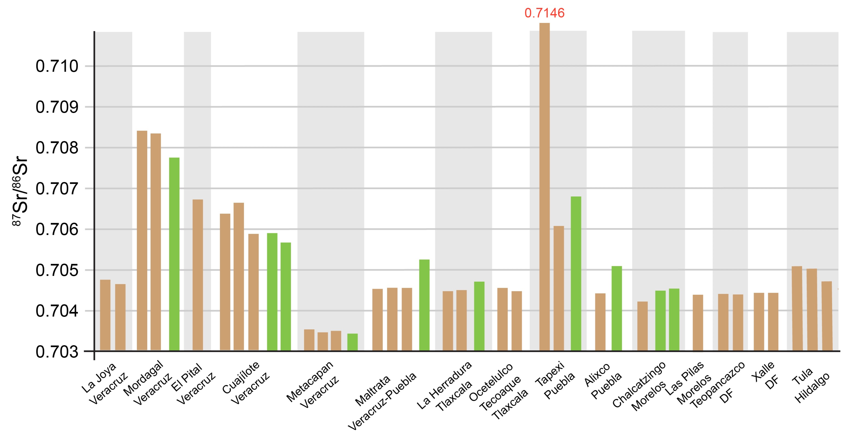
Fig. S2. A bar graph of ⁸⁷Sr/⁸⁶Sr values in soil (brown) and plants (green) from 15 sites in Veracruz and the Central Highlands (Schaaf et al. 2013).
The ⁸⁷Sr/⁸⁶Sr values from our samples and from Schaff et al. (2012) are provided on the map that is Fig. S4. In essence, the background ⁸⁷Sr/⁸⁶Sr levels are fairly well known in Central Mexico for those areas with substantial population in the prehispanic period.
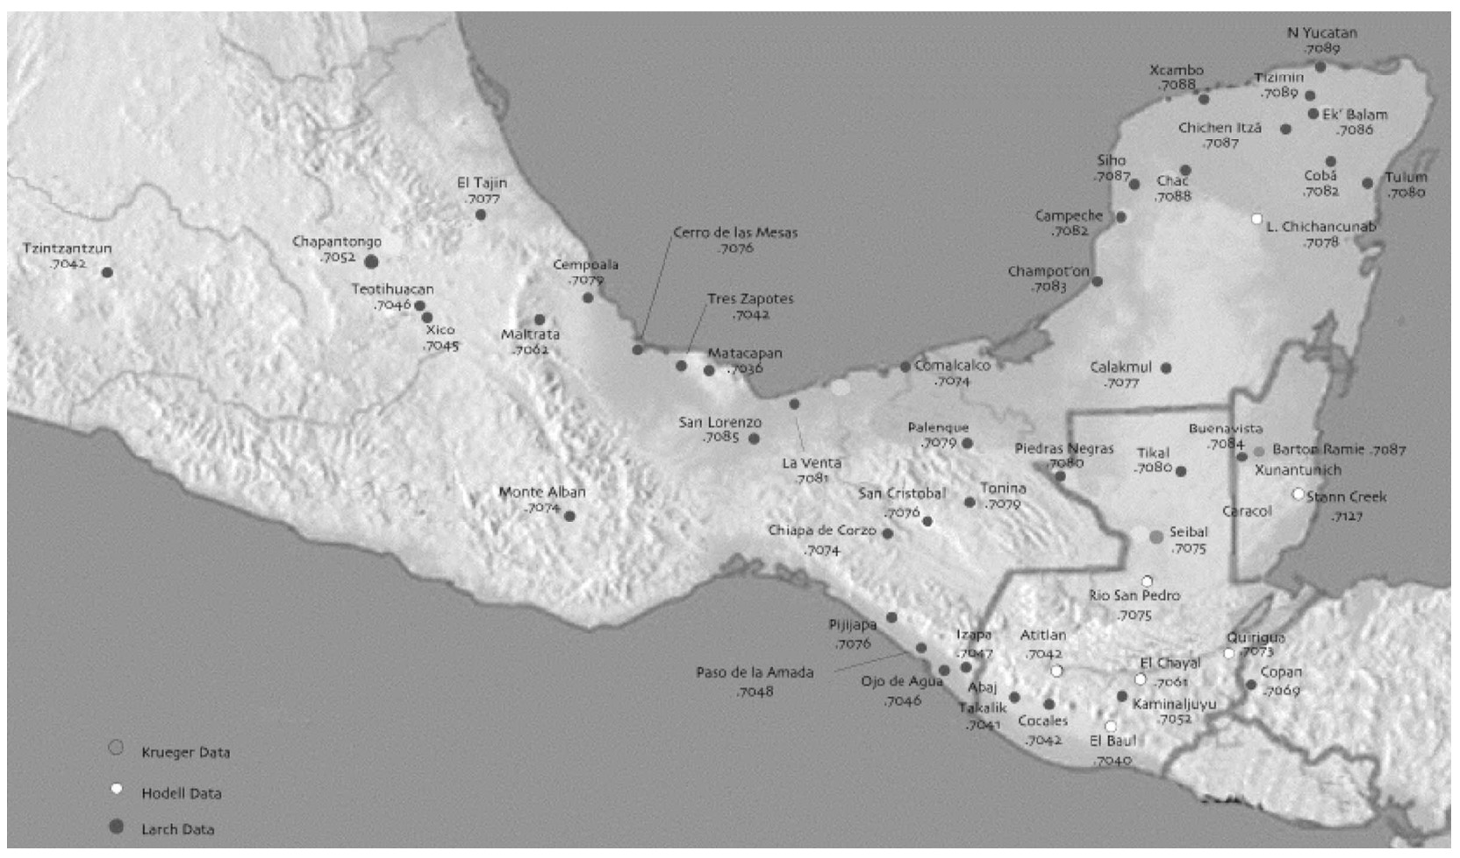
Fig. S3. Map of ⁸⁷Sr/⁸⁶Sr values from various sites and other locations across Mesoamerica.

References

Ambrose, S.H., and L. Norr. 1993. Isotopic composition of dietary protein and energy versus bone collagen and apatite: purified diet growth experiments. In Molecular Archaeology of Prehistoric Human Bone, J.B. Lambert and G. Grupe (eds.), pp. 1-37. Berlin: Springer.
Balasse M., S.H. Ambrose, A.B. Smith, and T.D. Price. 2002. The Seasonal Mobility Model for Prehistoric Herders in the South-western Cape of South Africa Assessed by Isotopic Analysis of Sheep Tooth Enamel. Journal of Archaeological Science 29: 917–932.
Benson, L.V., E.M. Hattori, H.E. Taylor et al. 2006. Isotope sourcing of prehistoric willow and tule textiles recovered from western Great Basin rock shelters and caves: proof of concept. Journal of Archaeological Science 33:1588–1599.
Bentley, R.A. 2006. Strontium Isotopes from the Earth to the Archaeological Skeleton: A Review. Journal of Archaeological Method and Theory 13: 135-187.
Bowen, Gabriel J. and Justin Revenaugh. 2003. Interpolating the isotopic composition of modern meteoric precipitation. Water Resources Research 39: 1299-1311.
Bryant, J., P. Koch, P. Froelich, W. Showers, and B. Genna. 1996. Oxygen isotope partitioning between phosphate and carbonate in mammalian apatite. Geochimica et Cosmochimica Acta 60: 5154–5148.
Chenery, Carolyn A., Vanessa Pashley, Angela L Lamb, Hilary J. Sloane, and Jane A. Evans. 2012. The oxygen isotope relationship between the phosphate and structural carbonate fractions of human bioapatite. Rapid Communications in Mass Spectrometry 26: 309-319.
Coplen, T.B., C. Kendall, and J. Hopple. 1983. Comparison of isotopic reference samples. Nature 302: 236- 238.
Dansgaard, W. 1964. Stable isotopes in precipitation. Tellus 16: 466–46
Hedman, K.M., B.B. Curry, T.M. Johnson, P.D. Fullagar, and T.E. Emerson. 2009. Variation in strontium isotope ratios of archaeological fauna in the midwestern United States: A preliminary study. Journal of Archaeological Science 36: 64–73.
Knudson, K.J. 2008. Tiwanaku influence in the south central Andes: strontium isotope analysis and Middle Horizon migration. Latin American Antiquity 19: 3–24.
Kohn, Matthew J. 1996. Predicting animal δ18O: Accounting for diet and physiological adaptation Geochimica et Cosmochimica Acta 60: 4811-4829.
Krueger, H.W., and C.H. Sullivan. 1984. Models for carbon isotope fractionation between diet and bone. In Stable Isotopes in Nutrition, edited by J.R. Turnland and P.E. Johnson, pp. 205-220. American Chemical Society Symposium Series, No 258.
Lee-Thorp, J.A., J.C. Sealy, and N.J. van der Merwe. 1989. Stable carbon isotope ratio differences between bone collagen and bone apatite, and their relationship to diet. Journal of Archaeological Science 16: 585 – 599.
Levinson, Alfred A., Boaz Luz, and Yehoshua Kolodny. 1987. Variations in Oxygen Isotopic Compositions of Human Teeth and Urinary Stones. Applied Geochemistry 2: 367-371.
Luz, B., and Y. Kolodny. 1985. Oxygen isotope variations in phosphate of biogenic apatites. IV. mammal teeth and bones. Earth and Planetary Science Letters 72: 29-36.
Luz, B., Y. Kolodny, and M. Horowitz. 1984. Fractionation of oxygen isotopes between mammalian bone-phosphate and environmental drinking water. Geochimica et Cosmochimica Acta 48: 1689-1693.
Maurer, Anne-France, Stephen J.G. Galer, Corina Knipper, Lars Beierlein, Elizabeth V. Nunn, Daniel Peters, Thomas Tütken, Kurt W. Alt, and Bernd R. Schöne. 2012. Bioavailable 87Sr/86Sr in different environmental samples — Effects of anthropogenic contamination and implications for isoscapes in past migration studies. Science of the Total Environment 433: 216–229.
Montgomery, J. 2010. Passports from the past: Investigating human dispersals using strontium isotope analysis of tooth enamel. Annals of Human Biology 37: 325-346.
Montgomery, J., J.A. Evans, and T. Neighbour. 2003. Sr isotope evidence for population movement within the Hebridean Norse community NW Scotland. Journal of the Geological Society 160, 649-653.
Montgomery, J., J.A. Evans, and G. Wildman. 2006. Sr-87/Sr-86 isotope composition of bottled British mineral waters for environmental and forensic purposes. Applied Geochemistry 21: 1626-1634.
Price, T. Douglas 1989. The Chemistry of Prehistoric Bone. Cambridge: Cambridge University Press.
Price, T. Douglas, Gisela Grupe, and Peter Schröter. 1994. Reconstruction of migration patterns in the Bell Beaker Period by stable strontium isotope analysis. Applied Geochemistry 9: 413-417.
Price, T. Douglas, James H. Burton, and Robert A. Bentley. 2002. Characterization of Biologically Available Strontium Isotope Ratios for the Study of Prehistoric Migration. Archaeometry 44:117–135.
Price, T. Douglas, and Hildur Gestsdóttir. 2006. The first settlers of Iceland: an isotopic approach to colonization. Antiquity 80: 130–144.
Price, T. Douglas, Andres Dobat, Niels Lynnerup, and Pia Bennike. 2011. Who was in Harold Bluetooth’s army? Strontium isotope investigation of the cemetery at the Viking Age fortress at Trelleborg, Denmark. Antiquity 85: 476-489.
Schaaf, Peter, Gabriela Solis, Linda R. Manzanilla, Teodoro Hernandez, Becket Lailson, and Peter Horn. 2012. Isotopos de estroncio aplicados a estudios de migracion humana en el centro de barrio de Teopancazco, Teotihuacán. In Estudios arqueométricos del centro de barrio de teopancazco en Teotihuacán, L.R. Manzanilla (ed.), pp. 347-423. Mexico: INAH.
Shemesh, Aldo. 1990. Crystallinity and Diagenesis of Sedimentary Apatites. Geochimica et Cosmochimica Acta 54: 2433-2438.
Sillen, A., and M. Kavanagh. 1982. Strontium and paleodietary research: a review. Yearbook of Physical Anthropology 25: 67-90.
Sillen A, G. Hall, S. Richardson, et al. 1998. 87Sr/86Sr ratios in modern and fossil food-webs of the Sterkfontein valley: implications for early hominid habitat preference. Geochimica et Cosmochimica Acta 62: 2463–2478.
Sjögren, Karl-Göran, T. Douglas Price, and Torbjörn Ahlström. 2009. Megaliths and mobility in south-western Sweden. Investigating relations between a local society and its neighbours using strontium isotopes. Journal of Anthropological Archaeology 28: 85-101.
Slovak, N.M., and A. Paytan. 2011. Applications of Sr Isotopes in Archaeology. Advances in Isotope Geochemistry 5: 743-768.
Sponheimer, Matt, and Julia A. Lee-Thorp. 1999. Oxygen Isotopes in Enamel Carbonate and their Ecological Significance. Journal of Archaeological Science 26: 723–728.
Stuart-Williams, Hilary LeQ., Henry P. Schwarcz, Christine D. White, and Michael W. Spence. 1998. The Isotopic Composition and Diagenesis of Human Bone from Teotihuacan and Oaxaca, Mexico. Palaeogeography, Palaeoclimatology, Palaeoecology 126: 1-14.
Torres-Alvarado, Ignacio S., Surendra P. Verma, and Gerardo Carrasco-Nuñez. 2000. Compilation of radiogenic isotope data in Mexico and their implications. Proc. Indian Acad. Sci. (Earth Planet. Sci.), 109: 67-78.
White, Christine D., Fred J. Longstaffe, and Kimberley R. Law. 2001. Revisiting the Teotihuacan Connection at Altun Ha: Oxygen Isotope Analysis of Tomb f-8/1. Ancient Mesoamerica 12: 65-72.
White, Christine D., Michael W. Spence, Fred J. Longstaffe, Hilary Stuart-Williams, and Kimberley R. Law. 2002. Geographic Identities of the Sacrificial Victims at the Feathered Serpent Pyramid: Implications for the Nature of State Power. Latin American Antiquity 13: 217–236.
White, Christine D., T. Douglas Price, and Fred J. Longstaffe. 2007. Residential histories of the human sacrifices at the Moon Pyramid, Teotihuacán: Evidence from oxygen and strontium isotopes. Ancient Mesoamerica 18: 159–172 .
Wright, Lori E. 2005. Identifying immigrants to Tikal, Guatemala: Defining local variability in strontium isotope ratios of human tooth enamel. Journal of Archaeological Science 32: 555-566.

