Appendix 1. Distribution of (A) testosterone and (B) estrone hormone sensitivity strength, and (C) hormone sensitivity profiles.
- Distribution of testosterone-sensitivity strength
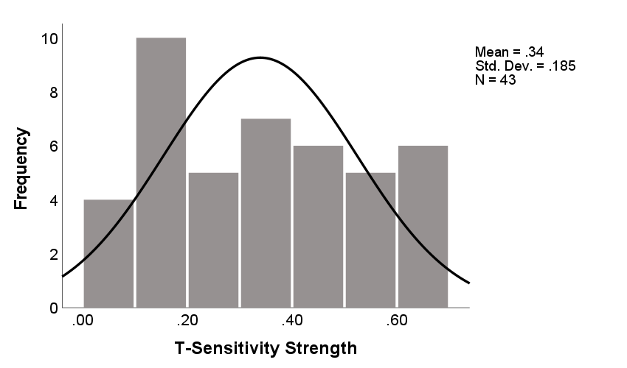
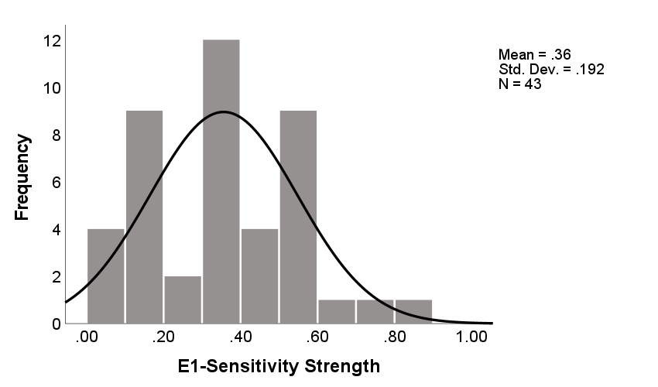
- Distribution of estrone-sensitivity strength

- Distribution of hormone-sensitivity profiles
Hormone Sensitivity Profile | Testosterone (%) | Estrone (%)
Withdrawal-Sensitive | 16.3 | 27.9
Increase-Sensitive | 16.3 | 20.9
Change-Sensitive | 23.3 | 16.3
Insensitive | 44.2 | 34.9

