Appendix – Supplementary methods and results

1. Supplementary methods
1.1. Measures used to calculate resilient psychosocial functioning
The Mood and Feelings questionnaire (MFQ; 66) is a 33 item self-report questionnaire measuring depressive symptoms within the past two weeks. Responses are rated on a 3-point Likert scale (i.e., “Not true,” “Sometimes,” and “True”). Higher MFQ sum scores indicate more severe depressive symptomology. At baseline, internal consistency of the MFQ is excellent (Cronbach’s alpha = 0.91 - 0.93).
The Revised Children’s Manifest Anxiety Scale (RCMAS; 67) is a 49 item self-report questionnaire which assesses global anxiety with five subscales: physiological anxiety, worry, social anxiety, defensiveness, and inconsistent responding index. Responses range on a 4-point Likert scale from “Never” to “Always,” with higher sum scores indicating higher levels of anxiety. Internal consistency of the RCMAS was excellent at baseline (Cronbach’s alpha = 0.94).

The Short Leyton Obsessional Inventory (S-LOI; 68) is an 11-item questionnaire which assesses obsessional/anxious symptomology indicative of adolescent obsessive-compulsive disorder (OCD). The S-LOI comprises three subscales: compulsions, obsessions/incompleteness, and cleanliness. Responses range from “Never” to “Always” on a 4-point Likert scale. Higher sum scores denote higher levels of obsessional symptoms. Internal consistency of the S-LOI is good (Cronbach’s alpha = 0.84).

The Child Behavior Checklist (CBCL; 69) is an 11 item self-report questionnaire which screens for symptoms of antisocial behavior conceptually grounded in DSM-IV conduct disorder (CD) items. Responses were on a 4-point Likert scale from “Never” to “Always.” In our analysis, endorsement of the two highest responses in agreement were combined. At baseline, the internal consistency of the CBCL was good (Cronbach’s alpha = 0.74).

The Kessler Psychological Distress scale (K10; 70) is a 10-item questionnaire which yields a global measure of distress encompassing both anxious to depressive symptomology. Responses range on a 5-point Likert scale from “None of the time” to “All of the time.” The higher one scores on the K10, the more psychological distress is indicated. Internal consistency at baseline of the K10 was high (Cronbach’s alpha = 0.89).

The Antisocial Process Screening Device (APSD; 71) is a 20-item scale measuring psychopathic personality traits. Possible responses on the ASPD are “Not at all true,” “Somewhat true,” and “Certainly true”; with higher sums scores on the ASPD indicating higher levels of psychopathy. Internal consistency of the ASPD is good (Cronbach’s alpha = 0.73).

The Child and Adolescent Dispositions Scale (CADS-Y; 72) measures three dispositional traits: sympathy for others, negative emotional responsivity, and positive reactivity to risk and novelty which may predispose one to CD. Participants were asked to rate how closely they are described by an item, with responses ranging on a 4-point Likert scale from “Not at all” to “Very much/Very often.” Internal consistency at baseline for sum scores of the three dimensions was good (alphas = 0.78, 0.72, 0.77, respectively).

The Inventory of Callous-Unemotional Traits (ICU; 73) is a 24-item scale which comprises three trait subscales (i.e., callousness, uncaring, unemotional) intended to measure indications of psychopathy. Participants are asked to rate of a 4-point Likert scale ranging from “Never/Almost Never” to “Always/Almost Always” how closely the statements related to these personality traits described them. Higher scores indicated higher levels of psychopathy. Internal consistency of the ICU is good (Cronbach’s alpha = 0.82).

The Schizotypal Personality Questionnaire (SPQ; 74) is a 74-item scale which measures nine subscales of schizotypy (i.e., ideas of reference, excessive social anxiety, odd beliefs or magical thinking, unusual perceptual experiences, odd or eccentric behaviour, no close friends, odd speech, constricted affect, and suspiciousness) in non-clinical samples. Response choices are dichotomized “Yes”/“No.” A higher sum score on the SPQ indicates more schizotypal symptomology. The SPQ has high internal consistency (Cronbach’s alpha = 0.91).

The Barratt Impulsivity Scale (BIS-11; 75) is a 30-item scale measuring the behavioural/personality components of impulsivity (i.e., attentional, motor, and non-planning). With response choices ranging from “Rarely/Never” to “Always,” participants were requested to select the a choice which most closely resembles how they behave. Higher scores on the BIS suggest higher levels of impulsiveness. Internal consistency for the BIS is generally good (Cronbach’s alpha range= 0.79 - 0.83).

The Warwick-Edinburgh Mental Well Being Scale (WEMWBS; 76) has 14 items used to address mental wellbeing. Participants were to answer how accurately each statement described their experiences within the last two weeks. On a 5-point Likert scale, responses ranged from “none of the above” to “all of the above.” Here, higher scores on the WEMWBS indicate greater mental well-being. Internal consistency for the WEMWBS is excellent at baseline (population sample Cronbach’s alpha = 0.91).

1.2. Measures used to calculate childhood family adversity
The Measure of Parenting Style (MOPS; 77) is a 12 item self-report measure that assesses perceived parenting styles across three domains; abuse, indifference, over-control. Participants were asked to rate both their mother’s and father’s parenting behaviour on 15 statements, on a 4-point scale. The full response range is “not true at all”, “slightly true”, “moderately true”, “extremely true”. The ‘abuse’ scale consisted of 5 items, asking whether maternal/paternal behaviours were verbally abusive, unpredictable, physically violent, elicited feelings of danger, or elicited feelings of lack of safety. The ‘overly controlling’ scale consisted of 4 items where maternal/paternal behaviour was overprotective, over controlling, critical, or made the participant feel guilty. Finally, the ‘indifference’ scale assessed 6 items of maternal/paternal behaviour where the parent was ‘ignoring, uncaring, rejecting, uninterested in, would forget about, or would leave the participant on his/her often. Sum scores to responses in these items were calculated with higher scores representing more abusive, over controlling, or indifferent behaviour reported. Internal consistency was good for the maternal subscales (Cronbach’s alpha maternal over control = 0.70, indifference = 0.86, abuse = 0.78). For paternal parenting, the internal consistency at baseline ranged from acceptable (Cronbach’s alpha paternal over control = 0.65) to excellent (Cronbach’s alphas paternal abuse = 0.88, paternal indifference = 0.93).

The Alabama Parenting Questionnaire (APQ; 78) measures parenting practices. We used the 9-item short-form and added the ‘Corporal Punishment’ (3 items) and ‘Involvement’ scale (3 items). Participants were asked to rate how typical each item occurred or used to occur in their family home on a five-point scale ranging from “never”, “almost never”, “sometimes”, “often” to “always”. We calculated sum scores for the five subscales: Corporal Punishment, Positive Parenting, Inconsistent Discipline, Poor Supervision, and Involvement, with higher scores reflecting higher frequency of the behaviour. Thus, high scores can indicate positive parenting (i.e., involvement, positive parenting), or negative parenting (i.e., inconsistent discipline, poor supervision, corporal punishment). Internal consistency at baseline was acceptable (Inconsistent discipline & poor supervision: Cronbach’s alpha’s > 0.62), and good (Positive parenting, Involvement, Corporal Punishment Cronbach’s Alpha’s > 0.71).

1.3. Regional changes in unadjusted cortical thickness as a function of resilience
To investigate the impact of the statistical correction of regional CT values for age and gender, we re-estimated structural networks using raw CT values (uncorrected for the potentially confounding variables above). All other steps involved in structural network construction were consistent with the procedure described in the main text. Briefly, we used Pearson correlations on raw CT values (uncorrected for age and gender) to construct structural networks for overlapping subsets of participants (“windows”) ordered by increasing resilience. Next, we used bootstrapping to threshold the networks. Using this method, and for each window, an equal number of participants were resampled with replacement to construct 1000 bootstrapped structural networks. We then examined whether there were significant relations between each pair of regions across all bootstrapped networks. Consistent relationships between a pair of regions (at p < .001 FDR-adjusted at the pair level) were retained and the remaining relationships were discarded. We then assessed network topology focusing on degree only.

2. Supplementary Results
2.1. Supplementary tables
Table S1. Correlation Resilient functioning scores from the 5 imputed datasets.
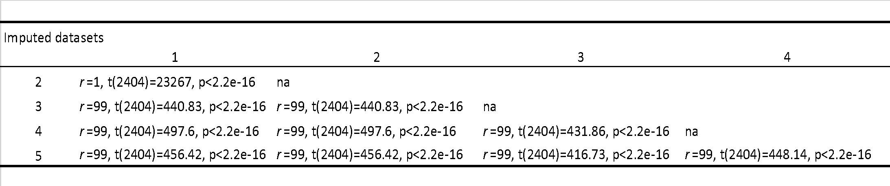

Table S2. Raw cortical thickness correlated with resilient functioning (uncorrected).
Region | X | Y | Z | ß
Left banks of the superior temporal sulcus | -53 | -50 | 8 | -2.5
Left lingual | -7 | -77 | -1.6 | -2
Right medial orbitofrontal | -7 | 53 | -11 | -2.5
Left parahipocampal | -22 | -25 | -25 | -3
Left paracentral | -9 | -21 | 49 | -5
Left postcentral | -16 | -36 | 71 | -2
Left superior parietal | -32 | -47 | 59 | -2
Left superior parietal | -21 | -61 | 62 | -3
Left supramarginal | -54 | -47 | 39 | -3
Left supramarginal | -55 | -33 | -37 | -3.5
Left temporal pole | -32 | -11 | -35 | -3.6
Right fusiform | 35 | -8 | -36 | 2
Right inferior temporal | 52 | -33 | -25 | -3
Right lateral occipital | 43 | -79 | -11 | -2
Right lateral occipital | 29 | -87 | -12 | -3
Right lateral occipital | 42 | -84 | -1 | -3
Right paracentral | 5 | -17 | 61 | -1
Right pericalcarine | 15 | -71 | 8 | -2
Right precentral | 54 | 6 | 24 | -4.8
Right precentral | 23 | -16 | 66 | -3.4
Right rostral middle frontal | 32 | 30 | 38 | -2.3
Right superior frontal | 19 | 3 | 60 | -3.2

Table S3. Socio-demographics and descriptives of psychosocial functioning and childhood family adversity subscales.
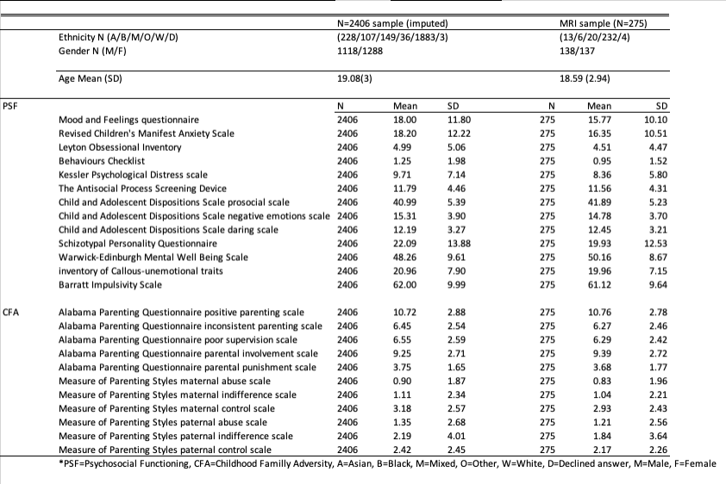2.2. Supplementary figures
Figure S1. Scree plots of eigen values for each component in both PCA’s
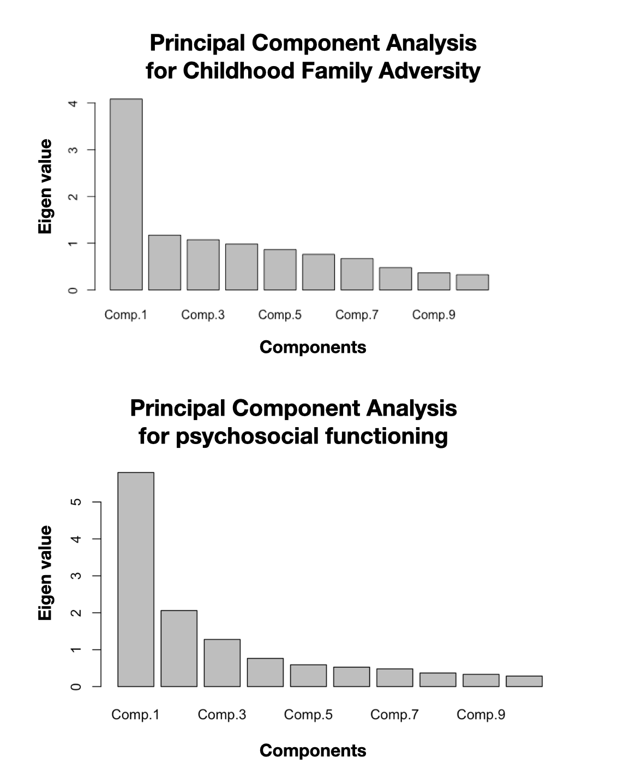

Figure S2. Homogeneity in resilient functioning-distribution of the participants.
A) Distribution of resilient functioning in the participants; B) Resilient functioning-gaps between consecutive participants; C) Association between resilient functioning and scanning location. D) Correlation between resilient functioning and age; E) Association between resilient functioning and socioeconomic status; F) Association between resilient functioning and gender. CBU=Cognition and brain science unit; UCL=University college London; WBIC=Wolfson brain imaging center; SES=Socioeconomic status.
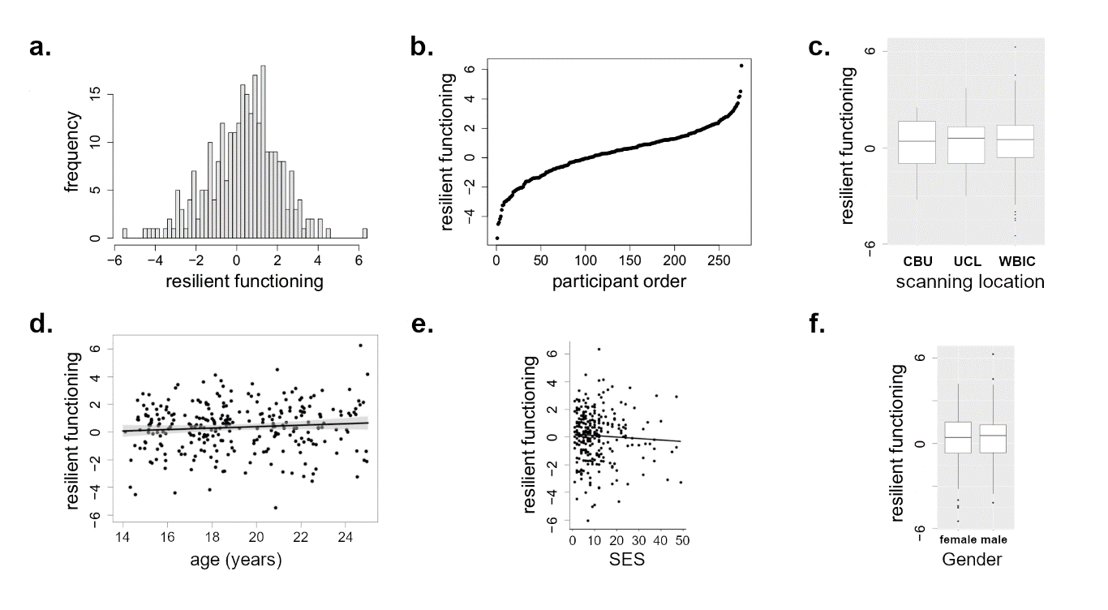
Figure S3. Convergence indices for the relation between resilient functioning and nodal degree based on cortical thickness measures uncorrected for age and gender.
Positive (red) and negative (blue) correlations between resilient functioning and node degree cortical thickness measures uncorrected for age and gender.
