Appendix

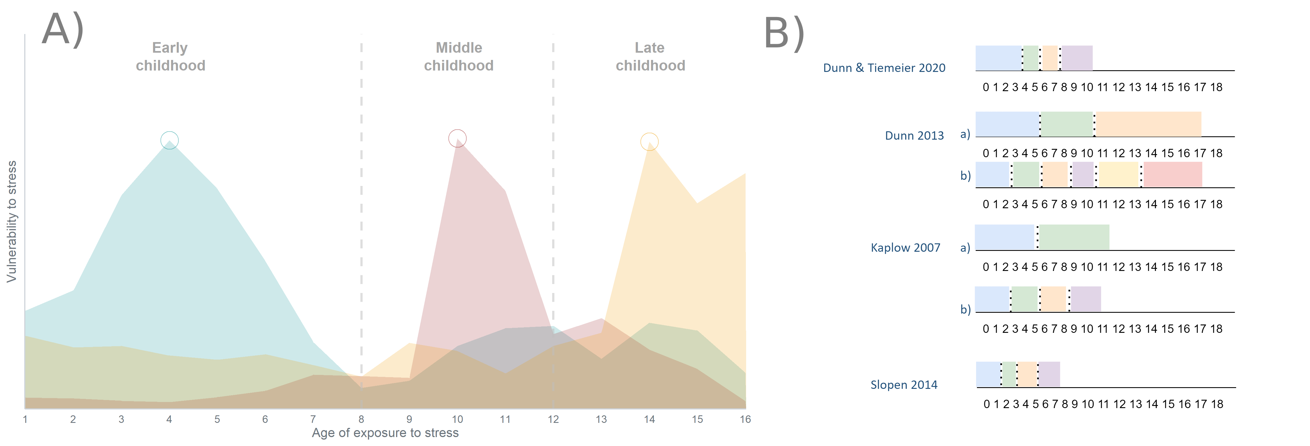Appendix Figure 1. A) Neurovulnerability to stress across key brain structures according to age of exposure to stress as theorized by neurological research. Figure based on simulated data to adapt from Kirsch, Nemeroff and Lippard (2020). B) Age groups used in adversity literature to categorize adverse life events according to when they happened.

Appendix Table 1. Detailed counts and percentages of each adverse life event (ALE) which combined and summed produce a total ALE score
Adverse life event | n (%)
Moved homes | 546 (60.0%)
Switched schools | 246 (27%)
Hospitalized | 412 (45.3%)
Mother seriously ill | 426 (47.1%)
Mother hospitalized | 441 (48.5%)
Father seriously ill | 253 (28.0%)
Father hospitalized | 184 (20.2%)
Sibling seriously ill | 149 (16.4%)
Close friend seriously ill | 23 (2.5%)
Death in the family | 25 (2.8%)
Death outside the family | 7 (2.4%)
Parental divorce | 285 (31.4%)
Extended living outside of household | 23 (2.5%)
Physical violence | 209 (23.0%)
Sexual abuse | 49 (5.4%)

Combining substance use instruments: To combine measurements from the three instruments and end up with a total substance count score, we first dichotomized the responses from the SRED instrument. The response options were “Never”, “Once”, “2-3 times”, “4-6 times” and “7 or more times”. Responses which were not “Never” were recoded as “yes” having used the substance. Second, we used questions from the MINI-KID, which inquired whether the adolescent used one of 6 drugs over the past year with the intention of getting high. Those included marijuana, inhalants, stimulants, hallucinogens, cocaine or narcotics. The response was binary “yes/no” coded. The MINI-KID also provided a question on alcohol, which asked if the adolescent drank 3 or more glasses of alcohol in within 3 hours in a single day and if this happened more than 3 times in the past year. If the adolescent responded affirmative to all alcohol questions, the interviewer coded alcohol usage as “yes”. Third, we used three questions referring to substance use based on a questionnaire used in the TRAILS study. They inquired if adolescents ever smoked, drank a glass of alcohol or took any drugs. The possible responses are again binary “yes/no”. The questions about overlapping substances were collapsed across questionnaires, so that if an adolescent responded with a “yes” on any one questionnaire for a given substance, they are coded as having taken the substance. For example, if an adolescent responds with a “no” on the SRED but “yes” on the MINI-KID, the response is coded as “yes”. For the TRAILS question on “other drugs”, the response was only coded as “yes” if no other drug was taken. The final count variable was a sum of number of substances the adolescent responded “yes” to. Appendix Figure A below (not referred to in main text) illustrates which instruments contained information about which substance and respective frequency counts of substance use for each:
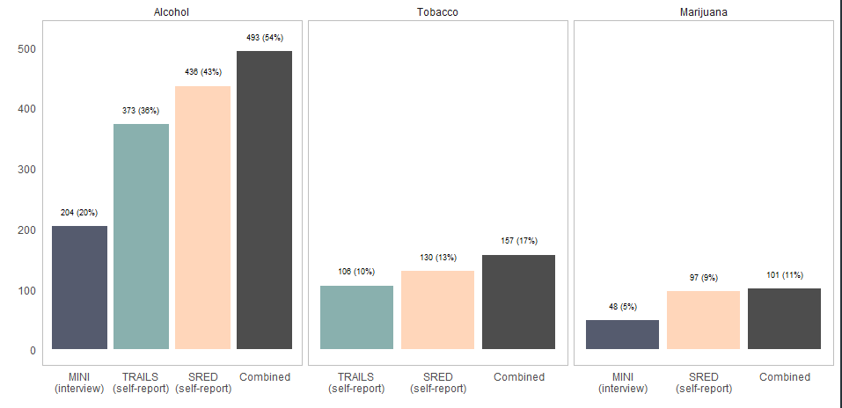
Appendix Figure A. Frequency counts for substances which were measured using multiple instruments. Presented in black the combined value obtained from all instruments which was used in the final analysis.

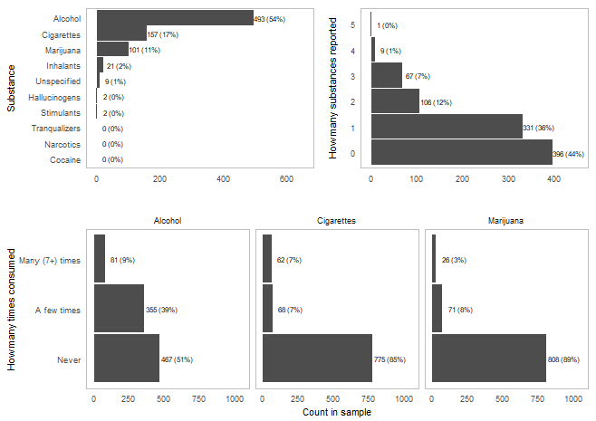
Appendix Figure 2. Counts and percentages of number and frequency of substances used by adolescents in the current sample

Appendix Table 2. Incidence rate ratio (IRR) Poisson coefficient estimates from modelling the effect of broad adverse life events (ALE) on number of substances used
 | Bivariate model |  |  |  | Adjusted model |  |  | Split by age periods model
 | IRR |  | 95% CI | p-value | IRR | 95% CI | p-value | IRR | 95% CI | p-value
ALE lifetime | 1.07 |  | [1.03, 1.12] | < .001 | 1.03 | [0.98, 1.07] | 0.255
ALE before 3 |  |  |  |  |  |  |  | 1.01 | [0.92, 1.10] | 0.890
ALE 4 To 8 |  |  |  |  |  |  |  | 0.98 | [0.91, 1.06] | 0.626
ALE 9 To 12 |  |  |  |  |  |  |  | 1.01 | [0.94, 1.08] | 0.784
ALE Older Than 12 |  |  |  |  |  |  |  | 1.05 | [0.97, 1.14] | 0.193
Age, years |  |  |  |  | 1.37 | [1.26, 1.50] | < .001 | 1.37 | [1.26, 1.49] | < .001
Sex (Female) ¹ |  |  |  |  | 0.94 | [0.82, 1.08] | 0.405 | 0.94 | [0.82, 1.09] | 0.415
National origin  (Non-Dutch) ¹ |  |  |  |  | 0.88 | [0.73, 1.07] | 0.201 | 0.88 | [0.73, 1.06] | 0.177
Urbanicity of living environment (Rural)¹ |  |  |  |  | 1.18 | [0.99, 1.41] | 0.065 | 1.17 | [0.98, 1.40] | 0.081
Urbanicity of living environment (Suburban) |  |  |  |  | 1.03 | [0.85, 1.25] | 0.768 | 1.03 | [0.85, 1.25] | 0.727
Household income (€1600 - 2399)¹ |  |  |  |  | 1.08 | [0.83, 1.41] | 0.569 | 1.09 | [0.84, 1.42] | 0.532
Household income (€2400 - 4399) |  |  |  |  | 0.95 | [0.75, 1.20] | 0.673 | 0.96 | [0.75, 1.21] | 0.706
Household income (>€4400) |  |  |  |  | 0.88 | [0.68, 1.15] | 0.364 | 0.88 | [0.68, 1.15] | 0.365
Parental BSI score |  |  |  |  | 1.16 | [0.77, 1.74] | 0.474 | 1.16 | [0.77, 1.74] | 0.475
Parental drug score |  |  |  |  | 1.43 | [1.00, 2.04] | 0.050 | 1.40 | [0.98, 2.00] | 0.061
¹Reference category for sex is “male”; for national origin “Dutch”; for urbanicity “urban”; for househiold “<€1600”

Appendix Table 3. Incidence rate ratio (IRR) Poisson coefficient estimates from modelling the effect of physical adverse life events (ALE; consisting of sexual and physical abuse) on number of substances used
 | Bivariate model |  |  |  | Adjusted model |  |  | Split by age periods model
 | IRR |  | 95% CI | p-value | IRR | 95% CI | p-value | IRR | 95% CI | p-value
Physical ALE lifetime | 1.27 |  | [1.11, 1.45] | < .001 | 1.18 | [1.03, 1.35] | 0.019
Physical ALE before 3 |  |  |  |  |  |  |  | 0.60 | [0.33, 1.08] | 0.086
Physical ALE 4 To 8 |  |  |  |  |  |  |  | 1.23 | [0.95, 1.58] | 0.110
Physical ALE 9 To 12 |  |  |  |  |  |  |  | 0.92 | [0.73, 1.17] | 0.503
Physical ALE Older Than 12 |  |  |  |  |  |  |  | 1.35 | [1.13, 1.62] | 0.001
Age |  |  |  |  | 1.38 | [1.27, 1.50] | < .001 | 1.36 | [1.25, 1.48] | < .001
Sex (Female) ¹ |  |  |  |  | 0.95 | [0.82, 1.09] | 0.443 | 0.92 | [0.80, 1.07] | 0.283
National origin  (Non-Dutch) ¹ |  |  |  |  | 0.89 | [0.73, 1.07] | 0.207 | 0.88 | [0.73, 1.07] | 0.193
Urbanicity of living environment (Rural)¹ |  |  |  |  | 1.18 | [0.99, 1.41] | 0.068 | 1.19 | [1.00, 1.42] | 0.052
Urbanicity of living environment (Suburban) |  |  |  |  | 1.03 | [0.85, 1.25] | 0.741 | 1.06 | [0.88, 1.29] | 0.521
Household income  (€1600 – 2399)¹ |  |  |  |  | 1.10 | [0.84, 1.43] | 0.499 | 1.08 | [0.83, 1.40] | 0.583
Household income  (€2400 – 4399) |  |  |  |  | 0.95 | [0.75, 1.21] | 0.700 | 0.94 | [0.75, 1.19] | 0.635
Household income (>€4400) |  |  |  |  | 0.89 | [0.68, 1.16] | 0.384 | 0.88 | [0.67, 1.14] | 0.327
Parental BSI score |  |  |  |  | 1.14 | [0.76, 1.71] | 0.508 | 1.17 | [0.79, 1.75] | 0.428
Parental drug use, any |  |  |  |  | 1.42 | [1.00, 2.02] | 0.051 | 1.37 | [0.97, 1.93] | 0.076
¹Reference category for sex is “male”; for national origin “Dutch”; for urbanicity “urban”; for SES “<€1600”

Appendix Table 4. Incidence rate ratio (IRR) Poisson coefficient estimates from sensitivity analysis model. Physical adverse life events (ALE) consisting of physical or sexual abuse were dummy coded as occurring for the first time in a given age period window and compared on number of substances used
 | IRR | 95% CI | p-value
Earliest ALE before 3¹ | 0.72 | [0.38, 1.35] | 0.302
Earliest ALE 4 To 8 | 1.29 | [0.99, 1.68] | 0.063
Earliest ALE 9 To 12 | 0.97 | [0.75, 1.25] | 0.811
Earliest ALE Older Than 12 | 1.52 | [1.22, 1.91] | < .001
Age | 1.36 | [1.25, 1.48] | < .001
Sex (Female) ² | 0.93 | [0.80, 1.07] | 0.303
National origin  (Non-Dutch) ² | 0.88 | [0.73, 1.06] | 0.185
Urbanicity of living environment (Rural)² | 1.19 | [1.00, 1.42] | 0.054
Urbanicity of living environment (Suburban) | 1.07 | [0.88, 1.30] | 0.488
Household income (€1600 – 2399)² | 1.07 | [0.82, 1.39] | 0.628
Household income (€2400 – 4399) | 0.94 | [0.75, 1.19] | 0.617
Household income (>€4400) | 0.87 | [0.67, 1.14] | 0.321
Parental BSI score | 1.15 | [0.77, 1.71] | 0.500
Parental drug use | 1.41 | [1.00, 1.99] | 0.050
¹Reference category for earliest adverse life events dummy variable is “Never experienced an adverse life event”
²Reference category for sex is “male”; for national origin “Dutch”; for urbanicity of living environment “urban”; for SES “<€1600”

Appendix Table 5. Incidence rate ratio (IRR) Poisson coefficient estimates from sensitivity analysis model. Count of physical adverse life events (ALE) consisting of physical or sexual abuse were coded as occurring either in the past two years or earlier to assess the effect of abuse recency
 | IRR | 95% CI | p-value
Physical ALE earlier than past two years | 1.06 | [0.38, 1.35] | 0.448
Physical ALE in the past two years | 1.39 | [0.99, 1.68] | 0.002
Age | 1.38 | [1.27, 1.50] | < .001
Sex (Female) ¹ | 0.94 | [0.82, 1.09] | 0.349
National origin  (Non-Dutch) ¹ | 0.87 | [0.73, 1.05] | 0.106
Urbanicity of living environment (Rural) ¹ | 1.17 | [0..98, 1.39] | 0.070
Urbanicity of living environment (Suburban) | 1.03 | [0.85, 1.25] | 0.598
Household income (€1600 – 2399) ¹ | 1.13 | [0.85, 1.49] | 0.439
Household income (€2400 – 4399) | 1.00 | [0.79, 1.28] | 0.970
Household income (>€4400) | 0.91 | [0.69, 1.22] | 0.513
Parental BSI score | 1.20 | [0.80, 1.81] | 0.324
Parental drug use | 1.39 | [0.97, 2.00] | 0.100
¹Reference category for sex is “male”; for national origin “Dutch”; for urbanicity of living environment “urban”; for SES “<€1600”

Appendix Table 6. Odds ratio (ORR) ordered logistic regression coefficient estimates from modelling the effect of physical adverse life events (ALE; consisting of sexual and physical abuse) on frequency of alcohol, tobacco and marijuana use
 | Alcohol use |  |  | Tobacco use |  |  | Marijuana use
 | OR | 95% CI | p-value | OR | 95% CI | p-value | OR | 95% CI | p-value
Physical ALE before 3¹ | -1.86 | [-3.76, -0.50] | 0.019 | -0.02 | [-1.91, 1.35] | 0.983 | -0.61 | [-3.58, 1.16] | 0.577
Physical ALE 4 To 8 | 0.39 | [-0.19, 0.96] | 0.182 | 0.46 | [-0.33, 1.17] | 0.222 | 0.86 | [ 0.03, 1.62] | 0.032
Physical ALE 9 To 12 | -0.03 | [-0.50, 0.44] | 0.906 | 0.13 | [-0.58, 0.76] | 0.704 | -0.02 | [-0.90, 0.75] | 0.962
Physical ALE Older Than 12 | 0.37 | [-0.15, 0.88] | 0.164 | 0.33 | [-0.39, 0.99] | 0.339 | 0.67 | [-0.08, 1.36] | 0.065
Age | 0.55 | [ 0.36, 0.75] | < .001 | 0.25 | [-0.01, 0.51] | 0.063 | 0.80 | [ 0.49, 1.12] | < .001
Sex (Female) ² | 0.02 | [-0.26, 0.31] | 0.863 | 0.27 | [-0.14, 0.69] | 0.2 | -0.29 | [-0.79, 0.20] | 0.252
National origin  (Non-Dutch) | 0.40 | [ 0.05, 0.75] | 0.024 | 0.47 | [-0.01, 0.94] | 0.051 | 0.32 | [-0.27, 0.89] | 0.278
Urbanicity of living environment (Rural) ² | 0.13 | [-0.24, 0.50] | 0.486 | -0.16 | [-0.77, 0.40] | 0.583 | -0.08 | [-0.81, 0.58] | 0.826
Urbanicity of living environment (Suburban) | 0.54 | [ 0.00, 1.09] | 0.053 | 0.25 | [-0.51, 1.05] | 0.521 | -0.13 | [-1.00, 0.74] | 0.764
Household income (€1600 – 2399) ² | 0.22 | [-0.26, 0.71] | 0.365 | -0.02 | [-0.69, 0.71] | 0.963 | -0.24 | [-0.96, 0.54] | 0.537
Household income (€2400 – 4399) | 0.05 | [-0.49, 0.59] | 0.866 | 0.06 | [-0.69, 0.85] | 0.871 | -0.57 | [-1.46, 0.33] | 0.21
Household income (>€4400) | -0.21 | [-0.57, 0.15] | 0.258 | -0.16 | [-0.69, 0.35] | 0.558 | -0.04 | [-0.66, 0.55] | 0.908
Parental BSI score | 0.56 | [-0.21, 1.34] | 0.152 | -0.05 | [-1.20, 0.99] | 0.925 | -0.13 | [-1.51, 1.10] | 0.846
Parental drug use | 0.62 | [-0.14, 1.37] | 0.109 | 0.75 | [-0.30, 1.67] | 0.128 | 1.09 | [ 0.02, 2.04] | 0.031
¹Reference category for physical ALE in this analysis is “Never experienced a life event”
²Reference category for sex is “male”; for national origin “Dutch”; for urbanicity of living environment “urban”; for SES “<€1600”

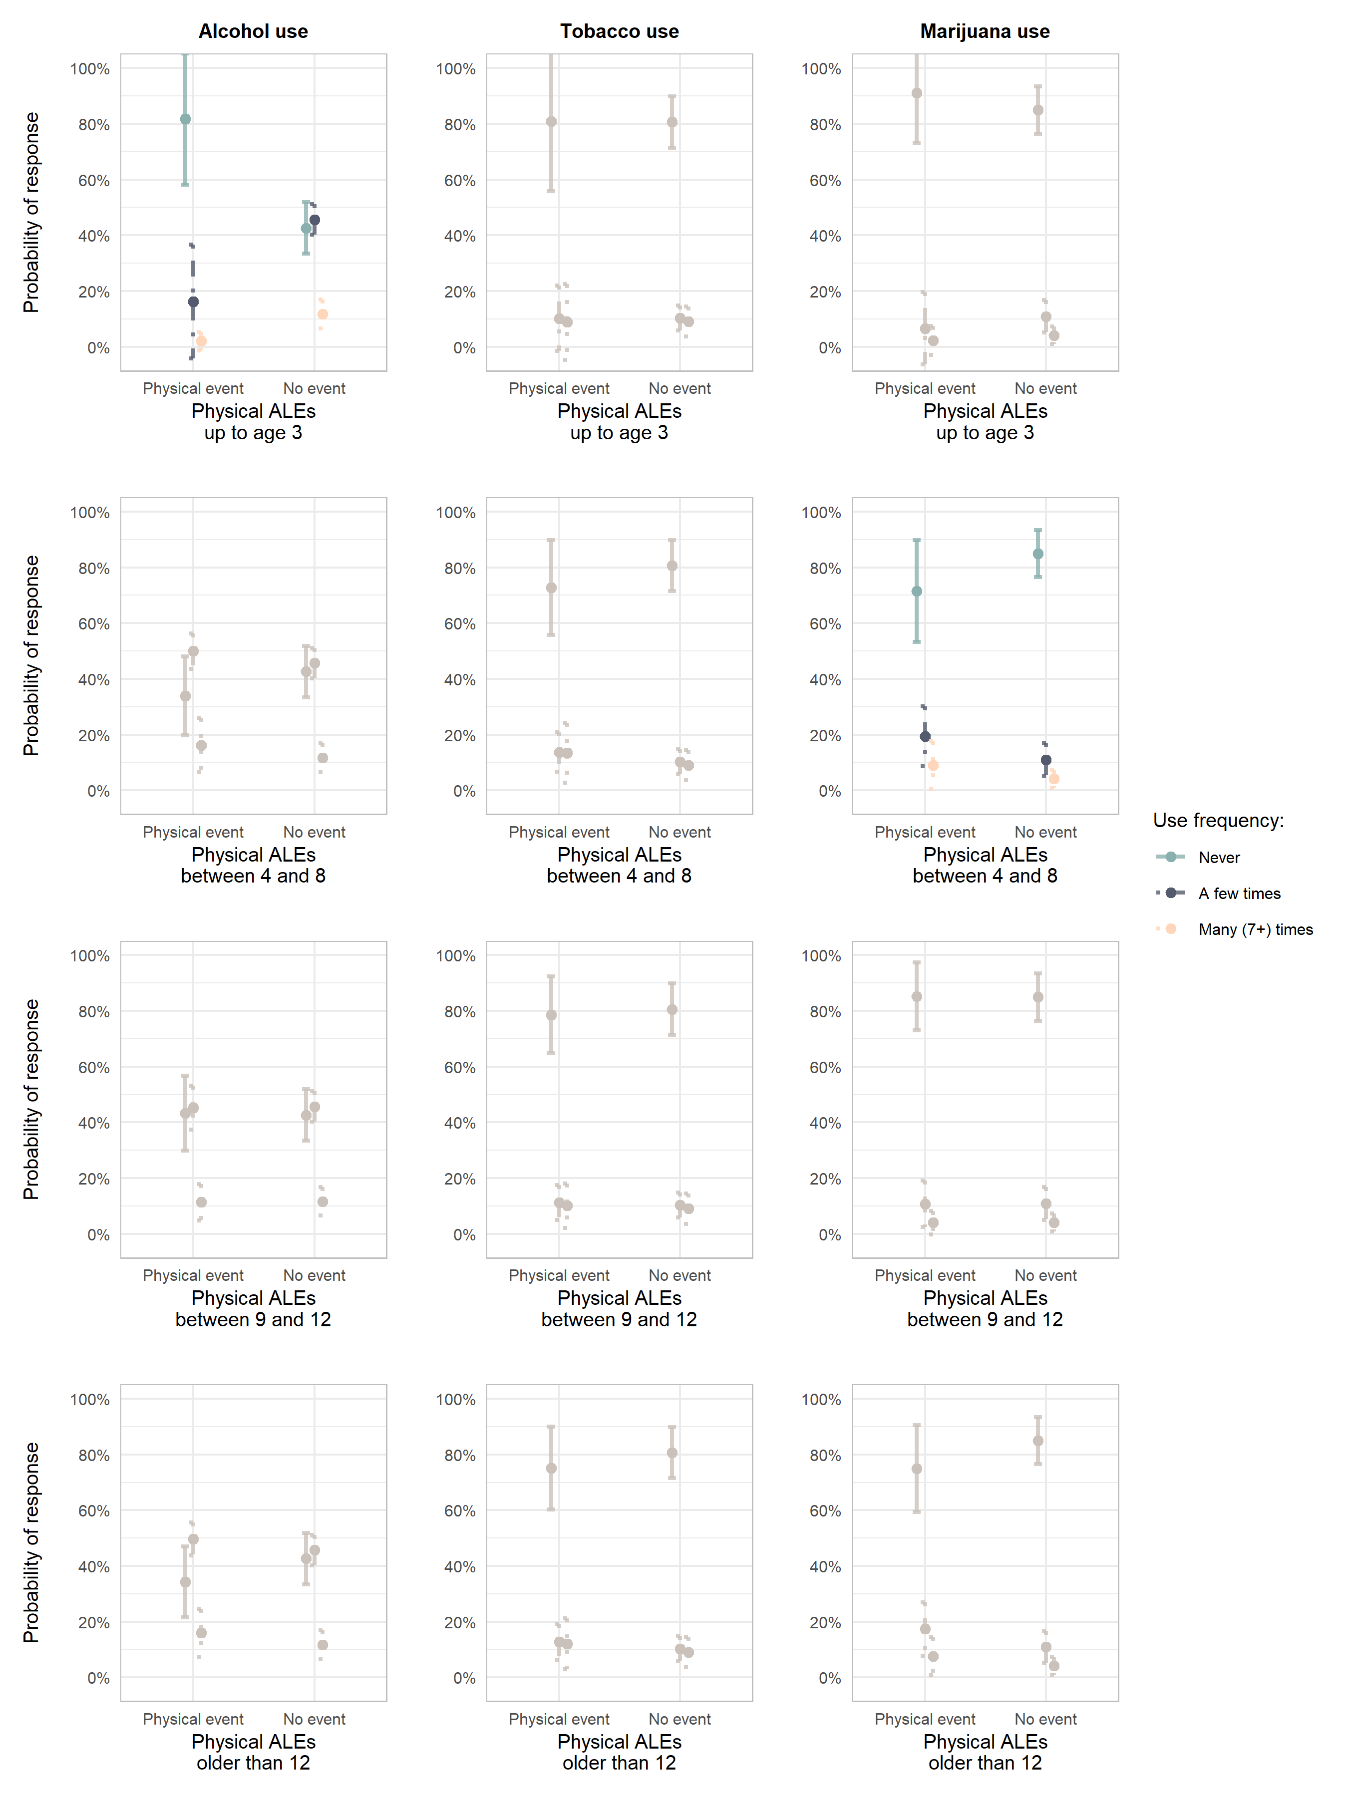
Appendix Figure 3. Estimated probabilities for substance use frequency responses (marijuana and alcohol) according to how many physical adverse life events have occurred in each age period. Presented in color age periods with significant effects on use frequency.

