Supplementary Material for:
Social interpretation inflexibility moderates emotional reactions to social situations in children and adolescents

Table of Contents
Section | Title
S1 | Demographic Information
S2 | Differential Drop-Out
S3 | Data Quality Assurance
S4 | Example Adolescent Emotional BADE Task Scenario
S5 | BADE Scenario Structure
S6 | BADE Task Scoring
S7 | Descriptive Statistics
S8 | Result Consistency: BADE Metrics
S9 | Potential Impact of the SARS-CoV-2 Pandemic
S10 | Exploratory Analyses Regarding Interactions between Age and Gender
S11 | Interactions between Age and BADE Metrics in the Prediction of Social Anxiety and Depression

SI Section S1. Demographic Information
Table S1.
Demographic Information
Demographic | Baseline Section Completers | Daily Diary Completers
N | 159 | 154
Age [M (SD)] | 12.83 (2.61) | 12.81 (2.60)
Gender Identity
Male | 78 | 76
Female | 77 | 75
Other | 4 | 3
Race
White/Caucasian | 136 | 132
Black/African American | 9 | 8
Asian | 16 | 16
Pacific Islander | 1 | 1
Middle Eastern/North African | 4 | 4
Native American/Alaska Native | 5 | 5
Other | 3 | 3
Hispanic | Yes: 17 | No: 142 | Yes: 16 | No: 138
Parents’ Living Arrangement
Together | 121 | 117
Together Part Time | 2 | 2
Not Together | 36 | 35
Number of Siblings
0 | 13 | 12
1 | 66 | 65
2 | 45 | 44
3 | 24 | 23
4 | 6 | 5
5 | 0 | 0
6 | 4 | 4
7+ | 1 | 1
Note. Individuals could opt not to answer demographic questions and were able to select more than one option for race/ethnicity. Demographic information refers to participants included in the final sample for analysis.

SI Section S2. Differential Drop-Out
Differential drop-out can threaten the generalizability of inferences drawn from longitudinal studies. Accordingly, we investigated whether participants who began the daily diary study differed systematically from those who completed it. Individuals who dropped out were more likely to be Native American or Alaska natives, and less likely to be White, χ(13) = 31.82, p = .003, than expected by chance. Accordingly, the results of the present study may generalize less well to Native American/Alaskan populations. Individuals who dropped out did not differ from completers on any other measured demographic or psychological variable.

SI Section S3. Data Quality Assurance
Participants were excluded if they answered fewer than two of three attention checks (spaced throughout the study) correctly. They were also excluded if they failed to report an age consistent with their birth year (i.e., that their birth year suggested an age within 1 year of their actual age). Four individuals were flagged by these requirements. Two metrics of response process, the intra-individual response variability, and the person-total correlation were also used to screen participants. The person-total correlation captures the covariance of the vector of participants’ responses to questionnaire items and the vector of all participants’ averaged responses. Assuming that most participants in the sample are attentive responders, outliers on this metric are individuals who may be employing an undesirable (ex: random, careless) response style. The intra-individual variability, which we calculated with the R package careless (version 1.2.1; Yentes & Wilhem, 2018), captures the extent to which participants’ responses to questionnaire items differ from one another. With this in mind, we excluded anyone who had a person-total correlation more than three standard deviations from the mean on the SASA or the CDI (five individuals flagged). These measures were chosen because they had sufficient length to allow for reliable calculation of correlation coefficients. We also excluded anyone who exhibited an intra-individual variability (IRV) in the Emotional BADE task that was within a 25% tail of the IRV score distribution, and that differed from the nearest (.25 or .75) quartile boundary by over 1.5 times the interquartile range (IQR) of the distribution (two participants with an especially low IRV flagged). This check reduces the possibility that highly patterned responding would influence the relation between interpretation inflexibility and other outcomes. A total of 11 participants were excluded by the combination of the above requirements. Outliers in remaining data were identified as in Hubert & Van Der Veeken (2008) and winsorized.

SI Section S4. Example Adolescent Emotional BADE Task Scenario
To aid readers in understanding the emotional BADE task, an example of a disconfirming-the-negative scenario is provided in the figure below. The statement numbers and explanation types are labelled in the figure. Lure explanations appear most plausible at first, and become less so as the scenario continues. Absurd explanations remain implausible throughout the scenarios. True explanations are moderately plausible at the start of the scenario, but become most plausible by its end. The -A and -B labels for the Lure explanations are arbitrary.
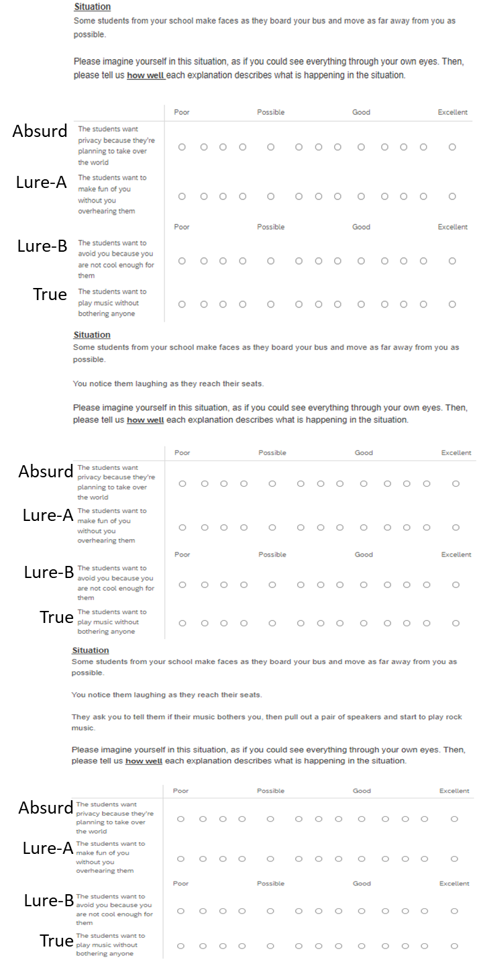

SI Figure S1. Example Adolescent Emotional BADE Task Scenario. Top: Scenario introduction and provision of a first statement. Middle: Provision of a second statement. Bottom: Provision of the final statement. Note that the Lure-A and Lure-B labels are arbitrary (there is no systematic difference between Lures with different labels).

SI Section S5. BADE Scenario Structure

Pilot Study
This section describes the results of a pilot study that informed the selection of scenarios for the Adolescent BADE task.
Participants
Participants were adolescents (ages 12-17) recruited at the 2021 Minnesota State Fair. Thirty-six participants passed all data quality checks and were included in the final sample. Their average age was 13.94 years, with a standard deviation of 1.85 years. There were 15 male and 21 female participants. The majority (33) of participants identified as White. The protocol was approved by the University of Minnesota IRB.
Open Science
This study was pre-registered (https://osf.io/39jkc). In our pre-registration, we noted that we would examine several hypotheses concerning the relations between interpretation inflexibility, emotion regulation, and depression or social anxiety. However, the SARS-CoV-2 pandemic rendered us unable to meet the recruitment threshold needed to test these hypotheses with adequate statistical power (our a-priori, pre-registered power analyses suggested that at least 100 participants were necessary for these tests, which is almost three times our sample size). As a result, these hypotheses are not tested in this sample. Instead, we focus our reporting on our pre-registered analyses exploring the structure of Adolescent Emotional BADE Task scenarios.
Procedure
Participants were randomly assigned to complete one of two sets of BADE task scenarios. Each set contained four disconfirming-the-negative scenarios and three disconfirming-the-positive scenarios. Participants were asked to complete a subset of BADE task scenarios, rather than the full set, to enhance recruitment in the state fair environment. Participants then completed (in random order) measures of co-rumination (a measure based on the Co-rumination Questionnaire; Davidson et al., 2014), the Social Anxiety Scale for Adolescents (SAS-A; Nelemans et al., 2019), a measure of depression (the Short Mood and Feelings Questionnaire; Angold et al., 1995), and a measure of co-dampening (the co-dampening subscale of the Co-dampening and Co-enhancing Questionnaire; Bastin et al., 2018).
Results
Descriptive Statistics
Participants’ mean score on the Mood and Feelings Questionnaire was 4.75, with a standard deviation of 5.09. More than half the sample (20 adolescents) scored above 4, the recommended cutoff for potential depression (Rhew et al., 2010). The relatively high level of possible depression in the sample may be due to the effects of the SARS-CoV-2 pandemic on youth (data were collected in late August / early September, 2021). The mean score on the SAS-A was 2.33, with a standard deviation of 0.76. While cutoff scores for the SAS-A have not been published, this score is comparable to that observed in large samples of adolescents (example: M=2.39, SD=0.77; Danneel et al., 2020).
Scenario Structures
The ideal pattern of BADE task scenario ratings is as follows: True explanations are initially moderately plausible, and end up being most plausible. Lure explanations are most plausible initially, but become progressively less so as scenarios continue. Absurd explanations remain relatively implausible throughout each scenario. The disconfirming-the-positive scenarios that clearly conform to this pattern are Lunch, Counsel, Advice, and Uninvited. The Date scenario and Fight scenario did not conform to the optimal pattern, as both featured True explanations that were considered as implausible as the Absurd option for at least one timepoint. The disconfirming-the-negative scenarios that clearly conformed to the optimal pattern included Math, Swimming, and Bus. The Sports scenario was marginal in that the True explanation was less plausible than only one Lure explanation. In the TikTok, Doctor, and Exam scenarios, the average plausibility of the True ratings initially exceeded that for Lure explanations.
Overall, this pilot study suggested that the Math, Swimming, Bus, Lunch, Counsel, Advice, and Uninvited scenarios could be used to derive metrics of interpretation bias and inflexibility, and provided some evidence in favor of also using the Sports scenario. The strong overlap between the set of scenarios with valid structures in this sample and in the sample we recruited for our main study suggests that our task will be consistently valid across studies of adolescents.

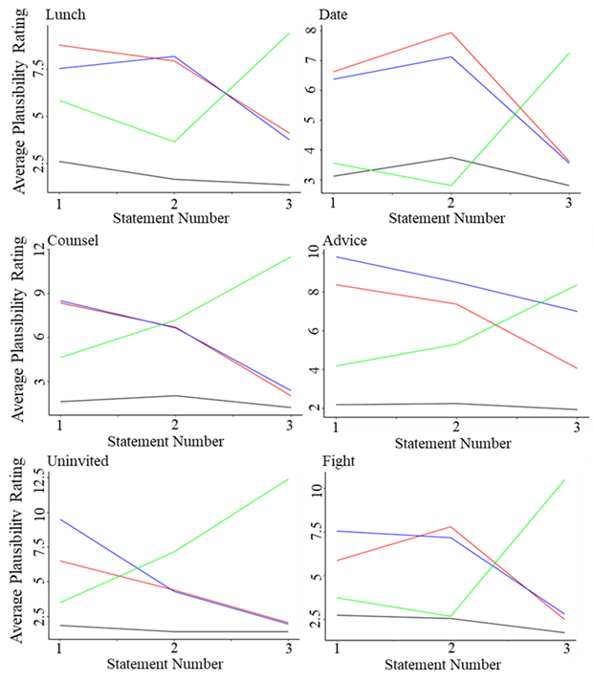
SI Figure S2. Scenario structure for disconfirming-the-positive scenarios. The trend for average ratings for each explanation type are represented in a different line color. Green=True, Red/Blue=Lure, Black=Absurd. Scenario names are given at the top-left of each panel.

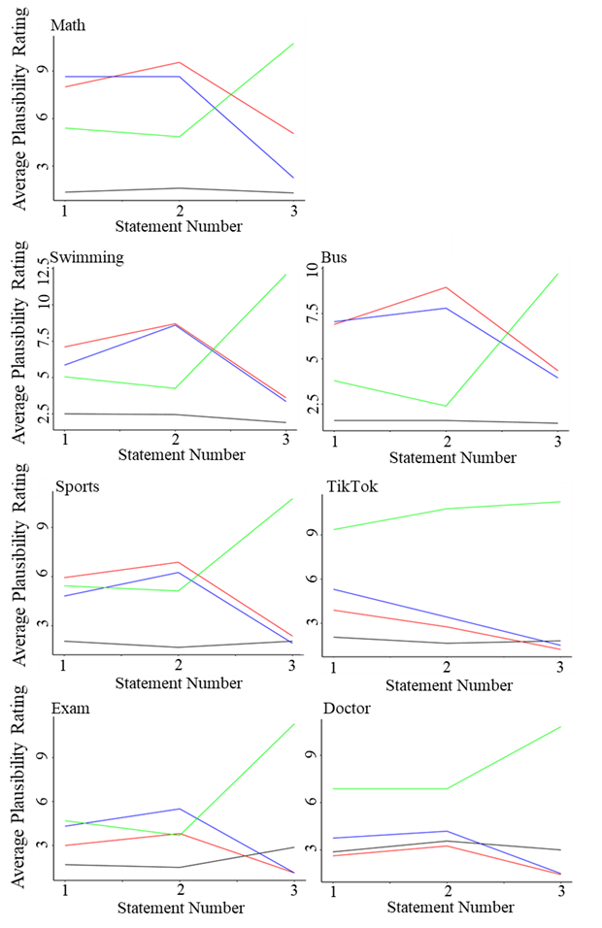
SI Figure S3. Scenario structure for disconfirming-the-negative scenarios. The trend for average ratings for each explanation type are represented in a different line color. Green=True, Red/Blue=Lure, Black=Absurd. Scenario names are given at the top-left of each panel. The TikTok, Doctor, and Exam scenarios do not conform to the correct structure.
Main Study
The Lunch, Date, Counsel, Advice, Uninvited, and Fight scenarios conformed to the ideal pattern for disconfirming-the-positive scenarios. The Math, Swimming, Bus, and Sports scenarios conformed to the ideal pattern for disconfirming-the-negative scenarios.

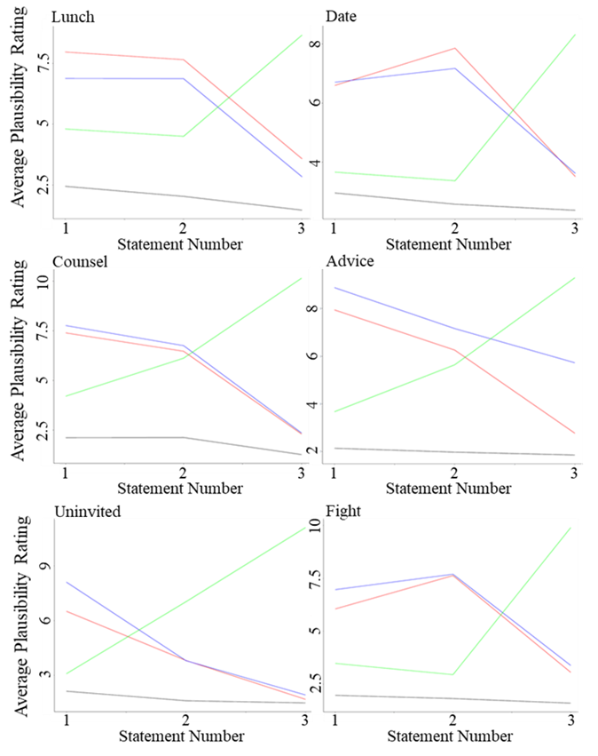

SI Figure S4. Scenario structure for disconfirming-the-positive scenarios. The trend for average ratings for each explanation type are represented in a different line color. Green=True, Red/Blue=Lure, Black=Absurd. Scenario names are given at the top-left of each panel.
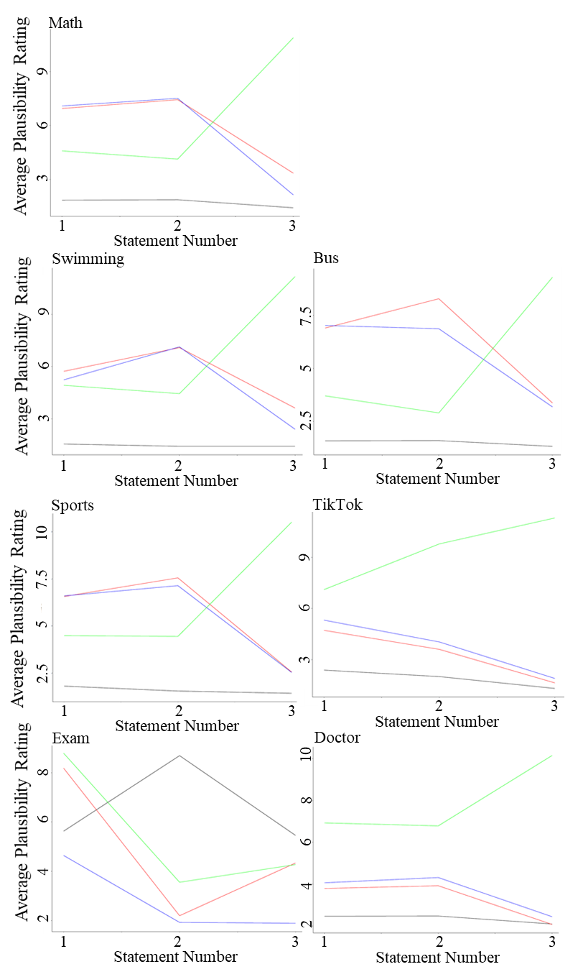
SI Figure S5. Scenario structure for disconfirming-the-negative scenarios. The trend for average ratings for each explanation type are represented in a different line color. Green=True, Red/Blue=Lure, Black=Absurd. Scenario names are given at the top-left of each panel. The TikTok, Doctor, and Exam scenarios do not conform to the correct structure.

SI Section S6. BADE Task Scoring
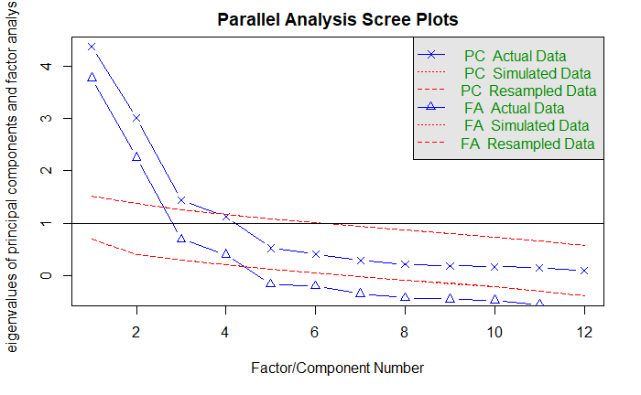
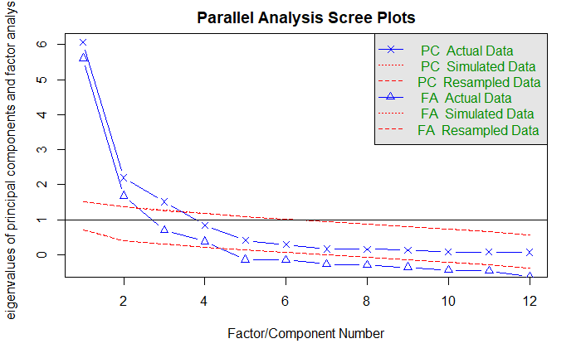
SI Figure S6. Parallel analysis (conducted with R’s Psych package) suggests that three principal components should be retained to describe variation in performance on disconfirming-the-negative scenarios (top) and disconfirming-the-positive scenarios (bottom).

SI Section S7. Descriptive Statistics
Table S2.
Internal Consistency and Descriptive Statistics of Study Measures – Baseline
Measure | M (SD) | Omega Total
Depression (CDI:S) | 3.19 (2.94) | .84
Social Anxiety (SAS-A) | 2.46 (0.94) | .94
Negative Interpretation Inflexibility (DNEG) | -0.03 (0.59) | --
Negative Interpretation Bias (DNEG) | -0.01 (0.88) | --
Positive Interpretation Bias (DNEG) | -0.01 (0.52) | --
Positive Interpretation Inflexibility (DPOS) | -0.02 (0.45) | --
Positive Interpretation Bias (DPOS) | 0.01 (0.62) | --
Negative Interpretation Bias (DPOS) | -0.02 (0.37) | --
Note. Descriptive statistics and internal consistencies for outlier filtered data. DNEG=disconfirming the negative scenarios. DPOS=disconfirming the positive scenarios.

Table S3.
Internal Consistency and Descriptive Statistics of Study Measures – Diary
Measure | M (SD) | Omega Total
Depression (CDI) | 3.29 (4.01) | .92
Positive Interpersonal Events | 0.75 (0.26) | .87
Negative Interpersonal Events | 0.50 (0.38) | .85
Note. Descriptive statistics and internal consistencies for outlier filtered data. DNEG=disconfirming the negative scenarios. DPOS=disconfirming the positive scenarios.

SI Section S8. Result Consistency: BADE Metrics
Our results were extremely similar when scoring the Emotional BADE Task via a variety of methods, including the method used in main-text (which was informed by PCA of adolescent BADE task data), the standard method for adults (which was informed by PCA of adult BADE task data), and PCA component scores derived from adolescent BADE task data. That is, our results cannot be easily explained by our choice of BADE task scoring method. To demonstrate the consistency of our results, we provide two examples below. The first example comes from the association of interpretation bias/flexibility with depression and social anxiety symptoms in our baseline data. These results can be compared to the table describing this association in main text. The second example comes from the relation between BADE components and age in our baseline data (see also, main text Table 4).

Table S4.
Multiple Linear Regression Model: Biased/Inflexible Interpretations’ Association with Symptoms of Depression and Social Anxiety in Baseline Data – Metrics Captured Using Principal Component Scores
Criterion | Type | Predictor | β | SE | t |  | p | 95%CI
Anxiety | DiscP | Positive Interpretation Inflexibility | 0.26 | 0.09 |  | 3.01 | .003 | [0.09 0.43]
 |  | Negative Interpretation Bias | 0.19 | 0.08 |  | 2.51 | .013 | [0.04 0.34]
 |  | Positive Interpretation Bias | -0.30 | 0.09 |  | 3.54 | .001 | [-0.47 -0.13]
 | DiscN | Negative Interpretation Inflexibility | 0.15 | 0.08 |  | 1.76 | .080 | [-0.02 0.32]
 |  | Negative Interpretation Bias | 0.13 | 0.08 |  | 1.63 | .106 | [-0.03 0.29]
 |  | Positive Interpretation Bias | 0.00 | 0.09 |  | <1 | .987 | [-0.17 0.17]
Depression | DiscP | Positive Interpretation Inflexibility | 0.24 | 0.09 |  | 2.70 | .008 | [0.06 0.41]
 |  | Negative Interpretation Bias | 0.07 | 0.08 |  | <1 | .372 | [-0.08 0.24]
 |  | Positive Interpretation Bias | -0.27 | 0.09 |  | 3.08 | .002 | [-0.45 -0.10]
 | DiscN | Negative Interpretation Inflexibility | 0.15 | 0.08 |  | 1.85 | .066 | [-0.01 0.32]
 |  | Negative Interpretation Bias | 0.14 | 0.08 |  | 1.76 | .081 | [-0.02 0.30]
 |  | Positive Interpretation Bias | -0.16 | 0.09 |  | 1.83 | .069 | [-0.32 -0.01]
Note. BOLD=significant. When predicting depression from disconfirming-the-positive scenarios: F(3,153)=4.19, p=.007, adjusted R²=.06. When predicting social anxiety from disconfirming-the-positive scenarios: F(3,153)=7.36, p<.001, adjusted R²=.11. When predicting depression from disconfirming-the-negative scenarios: F(3,153)=3.05, p=.031, adjusted R²=.04. When predicting social anxiety from disconfirming-the-negative scenarios: F(3,153)=1.88, p=.136, adjusted R²=.02.

Table S5.
Multiple Linear Regression Model: Biased/Inflexible Interpretations’ Association with Symptoms of Depression and Social Anxiety in Baseline Data – Metrics Captured Using Adult Scoring Method
Criterion | Type | Predictor | β | SE | t |  | p | 95%CI
Anxiety | DiscP | Positive Interpretation Inflexibility | 0.27 | 0.09 |  | 3.02 | .003 | [0.09 0.44]
 |  | Negative Interpretation Bias | 0.24 | 0.08 |  | 2.84 | .005 | [0.07 0.40]
 |  | Positive Interpretation Bias | -0.22 | 0.08 |  | 2.58 | 0.01 | [-0.38 -0.05]
 | DiscN | Negative Interpretation Inflexibility | 0.16 | 0.08 |  | 2.04 | .044 | [0.00 0.32]
 |  | Negative Interpretation Bias | 0.08 | 0.08 |  | 1.00 | .318 | [-0.08 0.25]
 |  | Positive Interpretation Bias | -0.04 | 0.08 |  | <1 | .655 | [-0.20 0.13]
Depression | DiscP | Positive Interpretation Inflexibility | 0.23 | 0.09 |  | 2.53 | .013 | [0.05 0.40]
 |  | Negative Interpretation Bias | 0.11 | 0.09 |  | 1.32 | .187 | [-0.05 0.28]
 |  | Positive Interpretation Bias | -0.22 | 0.09 |  | 2.65 | .009 | [-0.40 -0.06]
 | DiscN | Negative Interpretation Inflexibility | 0.14 | 0.08 |  | 1.81 | .072 | [-0.01 0.29]
 |  | Negative Interpretation Bias | 0.10 | 0.08 |  | 1.22 | .226 | [-0.06 0.26]
 |  | Positive Interpretation Bias | -0.18 | 0.08 |  | 2.27 | .024 | [-0.34 -0.02]
Note. BOLD=significant. When predicting depression from disconfirming-the-positive scenarios: F(3,155)=3.81, p=.011, adjusted R²=.05. When predicting social anxiety from disconfirming-the-positive scenarios: F(3,155)=6.21, p<.001, adjusted R²=.09. When predicting depression from disconfirming-the-negative scenarios: F(3,155)=3.74, p=.013, adjusted R²=.05. When predicting social anxiety from disconfirming-the-negative scenarios: F(3,155)=1.76, p=.157, adjusted R²=.01.

Table S6.
Multiple Linear Regression Model: Association of Age and Interpretation Bias/Inflexibility – Metrics Captured Using Principal Component Scores
Type | Criterion | Predictor | β | SE | t | p | 95%CI
DiscN | NII | Age | -0.03 | 0.08 | <1 | .639 | [-0.20 0.12]
 |  | Age² | 0.21 | 0.08 | 2.51 | .013 | [0.05 0.38]
 | NIB | Age | 0.09 | 0.08 | 1.12 | .266 | [-0.07 0.25]
 |  | Age² | -0.06 | 0.09 | <1 | .439 | [-0.24 0.10]
 | PIB | Age | -0.05 | 0.08 | <1 | .482 | [-0.21 0.10]
 |  | Age² | 0.29 | 0.08 | 3.52 | .001 | [0.13 0.46]
DiscP | PII | Age | -0.11 | 0.08 | 1.33 | .186 | [-0.26 0.05]
 |  | Age² | 0.22 | 0.08 | 2.66 | .009 | [0.06 0.39]
 | NIB | Age | 0.25 | 0.08 | 3.17 | .002 | [0.09 0.41]
 |  | Age² | -0.08 | 0.08 | <1 | .335 | [-0.25 0.08]
 | PIB | Age | -0.28 | 0.08 | 3.50 | .001 | [-0.43 -0.12]
 |  | Age² | 0.19 | 0.08 | 2.34 | .020 | [0.03 0.36]
Note. BOLD=significant. DiscP=disconfirming-the-positive scenarios. DiscN=disconfirming-the-negative scenarios. PII=Positive Interpretation Inflexibility. NII=Negative Interpretation Inflexibility. NIB=Negative Interpretation Bias. PIB=Positive Interpretation Bias. When predicting NII from age, F(3,154)=3.15, p=.046, adjusted R²=.03. When predicting PIB (DiscN) from age, F(3, 154)=6.19, p=.002, adjusted R²=.06. When predicting NIB (DiscN) from age, F(3, 154)<1, p=.463, adjusted R²=.00. When predicting PII from age, F(3, 154)=3.84, p=.024, adjusted R²=.02. When predicting PIB (DiscP) from age, F(3, 154)=7.46, p=.001, adjusted R²=.08. When predicting NIB (DiscP) from age, F(3, 154)=5.08, p=.007, adjusted R²=.05.

Table S7.
Multiple Linear Regression Model: Association of Age and Interpretation Bias/Inflexibility – Metrics Captured Using Adult Task Scoring Method
Type | Criterion | Predictor | β | SE | t | p | 95%CI
DiscN | NII | Age | -0.06 | 0.08 | <1 | .935 | [-0.16 0.15]
 |  | Age² | 0.22 | 0.08 | 2.65 | .009 | [0.06 0.39]
 | NIB | Age | 0.12 | 0.08 | 1.51 | .133 | [-0.04 0.28]
 |  | Age² | -0.14 | 0.09 | 1.60 | .113 | [-0.31 0.03]
 | PIB | Age | -0.05 | 0.08 | <1 | .504 | [-0.21 0.10]
 |  | Age² | 0.22 | 0.08 | 2.65 | .009 | [0.06 0.39]
DiscP | PII | Age | -0.09 | 0.08 | 1.11 | .269 | [-0.25 0.07]
 |  | Age² | 0.24 | 0.08 | 2.85 | .005 | [0.07 0.41]
 | NIB | Age | 0.34 | 0.08 | 4.44 | .001 | [0.19 0.49]
 |  | Age² | -0.20 | 0.08 | 2.51 | .013 | [-0.36 -0.04]
 | PIB | Age | -0.24 | 0.08 | 3.02 | .003 | [-0.40 -0.08]
 |  | Age² | 0.16 | 0.08 | 1.89 | .060 | [-0.01 0.32]
Note. BOLD=significant. DiscP=disconfirming-the-positive scenarios. DiscN=disconfirming-the-negative scenarios. PII=Positive Interpretation Inflexibility. NII=Negative Interpretation Inflexibility. NIB=Negative Interpretation Bias. PIB=Positive Interpretation Bias. When predicting NII from age, F(3,156)=3.63, p=.029, adjusted R²=.03. When predicting PIB (DiscN) from age, F(3,156)=3.53, p=.032, adjusted R²=.03. When predicting NIB (DiscN) from age, F(3,156)=1.99, p=.141, adjusted R²=.01. When predicting PII from age, F(3,156)=4.20, p=.017, adjusted R²=.04. When predicting PIB (DiscP) from age, F(3,156)=5.38, p=.006, adjusted R²=.05. When predicting NIB (DiscP) from age, F(3,156)=11.11, p<.001, adjusted R²=.11.

SI Section S9. Potential Impact of the SARS-CoV-2 Pandemic
Data were collected during the SARS-CoV-2 pandemic. The context of this study should be kept in mind when interpreting its results. Specifically, data were collected between June 2021 and March 2022. Importantly, at that stage of the pandemic there were authorized vaccinations for most of our participants (vaccines for children 12-15 years old were authorized May 2021; vaccines for children over the age of 5 years were authorized in October 2021 in the US) and the majority of in-person activities resumed starting the Summer of 2021, including school opening in person in CT US (where the study was conducted) starting September 2021. The SARS-CoV-2 Omicron variant was detected in the US in December 2021.
Early in the SARS-CoV-2 pandemic, researchers anticipated increases in depression and anxiety among youth due to factors including pandemic-related stress, the social withdrawal that accompanies physical distancing measures, disruption of family financial security, and grief associated with loss of close others (Bhatia, 2020; Guessoum et al., 2020). Consistent with this prediction, research generally suggests that the pandemic resulted in increased depression and anxiety symptoms (Barendse et al., 2021; Magson et al., 2021; Ravens-Sieberer et al., 2021). Studies looking at the impact of the pandemic on emotion more broadly found that it resulted in increased negative affect, particularly among youth who previously exhibited a stronger tendency toward maladaptive emotion regulation strategies, like rumination (Deng et al., 2021).
The potential effect of the pandemic on the variables of interest in our study naturally provokes questions regarding the generalizability of our results to non-pandemic contexts. Generalizability could be impacted if, for example, some effect of the SARS-CoV-2 pandemic moderated the relation between variables of interest. Ultimately, whether pandemics result in a unique set of relations between variables relevant to youth depression and anxiety is an unresolved empirical question.
Given that this question is unresolved, the similarities between our results and those of studies conducted prior to the pandemic are notable. For example, our study found an association between positive interpretation inflexibility and both depression and anxiety in youth, in accordance with our previous research on adults (Everaert et al., 2020). These findings offer preliminary support for the idea that the present study’s results are generalizable and do not apply only to the context of infectious disease outbreaks with significant public health responses. At the very least, our data offer a unique window into adolescents’ ability to parse ambiguous social situations during a high-stress, rapidly-evolving public-health emergency.

SI Section S10. Exploratory Analyses Regarding Interactions Between Age and Gender
As an additional, exploratory analysis, we used a series of multiple regression models to probe potential interactions between age and gender (predictors) in determining interpretation bias and inflexibility (criterion). These analyses revealed a significant interaction between age and gender in determining positive interpretation bias in disconfirming-the-negative scenarios (SI Figure S7, β=-0.24, t=3.02, p=.003. Examination of simple slopes suggested that this interaction was such that while our youngest females had stronger positive interpretation bias than our youngest males (when age = 1SD below the mean, β=0.30, p=.008), this difference disappeared in participants at the sample-average age (β=0.06, p=.435). In our oldest participants (when age = 1SD above the mean), there was a non-significant trend toward females having a lower positive interpretation bias than males (β=-0.18, p=.114). The main effects of age (β=-0.02, t<1, p=.824) and gender (β=0.06, t<1, p=.438) were not significant. This regression model was significant overall F(3,151)=3.26, p=.023, adjusted R²=.04.

There was also a significant interaction between age and gender in determining positive interpretation bias in disconfirming-the-positive scenarios, β=-0.17, t=2.22, p=.028. Examining the simple slopes, a similar pattern discussed above emerged: in the youngest participants (age 1SD below the mean), female gender was, at trend level, associated with greater positive interpretation bias (β=0.11, p=.074). This trend then disappeared in participants at the sample-mean age (β=0.08, p=.745). In the oldest participants (age 1SD above the mean), there was a non-significant trend toward lower positive interpretation bias in females (β=-0.15, p=.181). There was again no main effect of gender (β=0.03, t<1, p=.748), but there was a main effect of age (β=-0.22, t=2.80, p=.006). The regression model was again significant overall, F(3,151)=4.23, p=.007, adjusted R²=.06.

Finally, there was a significant main effect of age (β=0.29, t=3.87, p=.001) and gender (β=0.17, t=2.23, p=.027) on negative interpretation bias in disconfirming-the-positive scenarios. These effects were such that older individuals and females displayed more negative interpretation bias. The interaction of age and gender, however, was not significant (β=0.07, t<1, p=.367). The overall regression model was significant, F(3,151)=7.58, p<.001, adjusted R²=.11.

No other results were statistically significant.

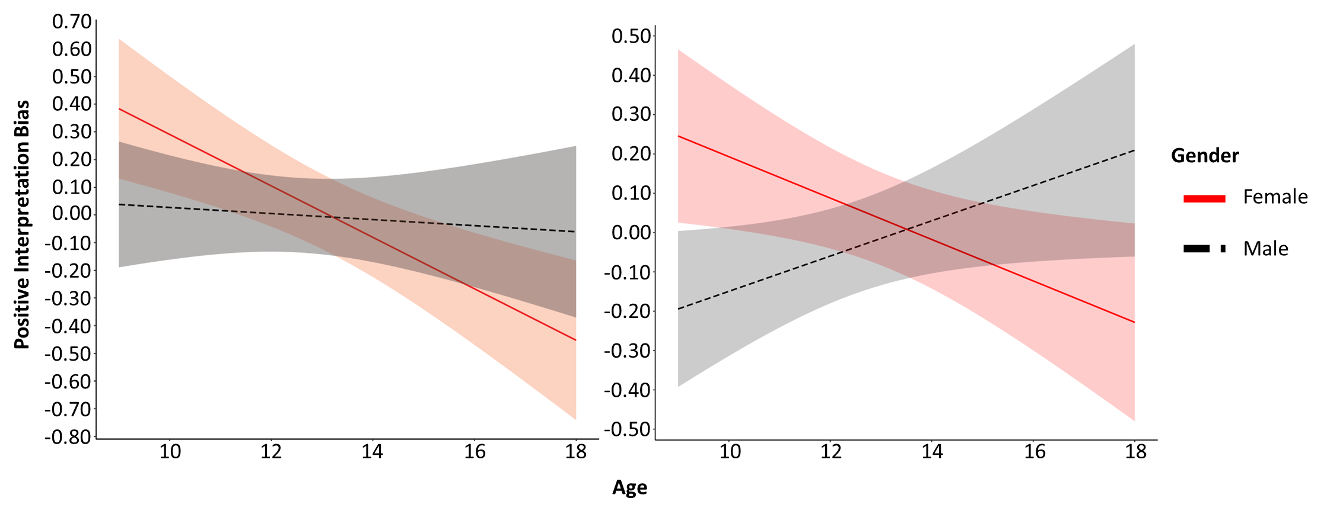
SI Figure S7. Exploratory analysis: age and gender interact in determining positive interpretation bias. The interaction is relatively consistent in disconfirming-the-negative (left) and disconfirming-the-positive (right) scenarios.

SI Section S11. Interactions between Age and BADE Metrics in the Prediction of Social Anxiety and Depression

Table S8. Multiple Linear Regression Model: Biased/Inflexible Interpretations’ Association with Symptoms of Depression and Social Anxiety in Baseline Data
Criterion | Type | Predictor | β | SE | t |  | p | 95%CI
Anxiety | DiscP | Positive Interpretation Inflexibility | 0.32 | 0.08 |  | 3.74 | .001 | [0.15 0.49]
 |  | Negative Interpretation Bias | 0.20 | 0.08 |  | 2.49 | .014 | [0.04 0.37]
 |  | Positive Interpretation Bias | -0.27 | 0.09 |  | 3.13 | .002 | [-0.43 -0.10]
 |  | Age | 0.14 | 0.08 |  | 1.74 | .084 | [-0.02 0.30]
 |  | Age * NII | -0.03 | 0.08 |  | <1 | .693 | [-0.18 0.12]
 |  | Age * NIB | 0.05 | 0.09 |  | <1 | .539 | [-0.12 0.22]
 |  | Age * PIB | 0.06 | 0.09 |  | <1 | .500 | [-0.12 0.25]
 | DiscN | Negative Interpretation Inflexibility | 0.17 | 0.08 |  | 2.07 | .040 | [0.01 0.33]
 |  | Negative Interpretation Bias | 0.04 | 0.08 |  | <1 | .618 | [-0.12 0.21]
 |  | Positive Interpretation Bias | -0.01 | 0.09 |  | <1 | .888 | [-0.18 0.16]
 |  | Age | 0.21 | 0.08 |  | 2.62 | .010 | [0.05 0.37]
 |  | Age * NII | 0.03 | 0.07 |  | <1 | .731 | [-0.12 0.17]
 |  | Age * NIB | 0.04 | 0.09 |  | <1 | .662 | [-0.14 0.21]
 |  | Age * PIB | 0.00 | 0.08 |  | <1 | .976 | [-0.16 0.15]
Depression | DiscP | Positive Interpretation Inflexibility | 0.23 | 0.09 |  | 2.59 | .011 | [0.05 0.40]
 |  | Negative Interpretation Bias | 0.07 | 0.08 |  | <1 | .398 | [-0.10 0.24]
 |  | Positive Interpretation Bias | -0.26 | 0.09 |  | 2.93 | .004 | [-0.43 -0.09]
 |  | Age | 0.19 | 0.08 |  | 2.31 | .022 | [0.03 0.35]
 |  | Age * NII | -0.02 | 0.08 |  | <1 | .813 | [-0.18 0.14]
 |  | Age * NIB | -0.12 | 0.09 |  | 1.32 | .188 | [-0.29 0.06]
 |  | Age * PIB | -0.02 | 0.10 |  | <1 | .856 | [-0.21 0.17]
 | DiscN | Negative Interpretation Inflexibility | 0.12 | 0.08 |  | 1.44 | .151 | [-0.04 0.28]
 |  | Negative Interpretation Bias | 0.05 | 0.08 |  | <1 | .667 | [-0.11 0.22]
 |  | Positive Interpretation Bias | -0.17 | 0.08 |  | 2.06 | .041 | [-0.34 -0.01]
 |  | Age | 0.23 | 0.08 |  | 2.86 | .005 | [0.07 0.38]
 |  | Age * NII | 0.02 | 0.07 |  | <1 | .775 | [-0.12 0.16]
 |  | Age * NIB | -0.06 | 0.09 |  | <1 | .462 | [-0.24 0.11]
 |  | Age * PIB | -0.04 | 0.08 |  | <1 | .592 | [-0.20 0.11]
Note. BOLD=significant. When predicting depression from disconfirming-the-positive scenarios: F(7,151)=2.66, p=.012, adjusted R²=.07. When predicting social anxiety from disconfirming-the-positive scenarios: F(7,151)=3.82, p<.001, adjusted R²=.11. When predicting depression from disconfirming-the-negative scenarios: F(7,151)=2.77, p<.001, adjusted R²=.07. When predicting social anxiety from disconfirming-the-negative scenarios: F(7,151)=1.84, p=.084, adjusted R²=.04.

Table S9. Multi-Level Model: Do Biased/Inflexible Interpretations Moderate the Instantaneous Association Between Interpersonal Events and Depression in Daily Dairy Data?
Model | Scenario Type | Event Type | Predictor | β | SE | t | p | 95%CI
(a) Two-Level Empty Model | NA | NA | Intercept | 0.30 | 0.03 | 11.83 | <.001 | [0.25 0.35]
Two-Level AR Model | (a) | Neg. | Intercept | 0.21 | 0.02 | 8.73 | <.001 | [0.17 0.26]
 | DiscN |  | Measurement Timepoint | 0.00 | 0.00 | 1.54 | .122 | [0.00 0.00]
 |  |  | Lagged, Trait-Level Depression | 0.00 | 0.03 | <1 | .996 | [-0.05 0.05]
 |  |  | Negative Interpretation Inflexibility | 0.04 | 0.02 | 1.73 | .086 | [-0.01 0.09]
 |  |  | Negative Interpretation Bias | 0.03 | 0.02 | 1.36 | .175 | [-0.01 0.08]
 |  |  | Positive Interpretation Bias | -0.03 | 0.02 | 1.39 | .168 | [-0.08 0.01]
 |  |  | Age | 0.05 | 0.02 | 2.16 | .032 | [0.01 0.10]
 |  |  | Age * NII | 0.01 | 0.02 | <1 | .591 | [-0.03 0.05]
 |  |  | Interpersonal Events – Negative | 0.15 | 0.01 | 13.91 | <.001 | [0.13 0.17]
 |  |  | Interpersonal Events – Negative*Age | 0.01 | 0.01 | 1.61 | .246 | [-0.01 0.03]
 |  |  | Interpersonal Events – Negative*NII | 0.03 | 0.01 | 2.87 | .004 | [0.01 0.05]
 |  |  | Interpersonal Events – Negative*NII*Age | -0.01 | 0.01 | <1 | .392 | [-0.03 0.01]
 | (b) | Neg. | Intercept | 0.21 | 0.02 | 8.68 | <.001 | [0.17 0.26]
 | DiscP |  | Measurement Timepoint | 0.00 | 0.00 | 1.54 | .124 | [0.00 0.00]
 |  |  | Lagged, Trait-Level Depression | 0.00 | 0.03 | <1 | .936 | [-0.05 0.05]
 |  |  | Positive Interpretation Inflexibility | 0.05 | 0.03 | 1.93 | .055 | [0.00 0.10]
 |  |  | Negative Interpretation Bias | 0.03 | 0.03 | 1.33 | .185 | [-0.01 -0.08]
 |  |  | Positive Interpretation Bias | -0.06 | 0.03 | 3.32 | .022 | [-0.11 -0.01]
 |  |  | Age | 0.04 | 0.03 | 1.63 | .106 | [-0.01 0.09]
 |  |  | Age*PII | -0.01 | 0.02 | <1 | .485 | [-0.06 0.03]
 |  |  | Interpersonal Events – Negative | 0.15 | 0.01 | 13.86 | <.001 | [0.13 0.17]
 |  |  | Interpersonal Events – Negative*Age | 0.02 | 0.01 | 1.48 | .139 | [0.00 0.04]
 |  |  | Interpersonal Events – Negative*PII | 0.04 | 0.01 | 4.13 | <.001 | [0.02 0.06]
 |  |  | Interpersonal Events – Negative*PII*Age | 0.02 | 0.01 | 1.81 | .071 | [0.00 0.04]
Note. BOLD=significant.

