S1. Testing Entropy of Maternal Mood
Currently, no published studies other than those referenced in the paper (Glynn et al., 2018; Howland et al., 2021) have used entropy of maternal mood. Therefore, we tested the feasibility and replicability of this method with data from a longitudinal study of Mexican heritage mothers living in Northern California (NICHD R01HD087367). We tested (1) discriminant validity with entropy of mother’s rating of neighborhood quality; and (2) convergent validity, the extent to which mood entropy was correlated with difficulties with emotion regulation and momentary measures of positive and negative mood variability. Sixty-four young Latina mothers (Mage=23.67, SD=2.54) completed mood questionnaires at a home visit and then completed a six-day ecologically momentary assessment (EMA) protocol of daily mood variability. During the home visit, mothers reported their depressive symptoms using the Center for Epidemiologic Studies Depression Scale (CESD; Radloff, 1977), their emotion dysregulation with the Difficulties in Emotion Regulation Scale (DERS; Kaufman et al., 2016), and ratings of neighborhood quality with the Neighborhood Quality Evaluation Scale (NQUA; Kim et al., 2008). After the home visit, mothers completed a six-day EMA protocol. Assessments were delivered three times a day for six days via a smartphone application (Metricwire^{R}) and included positive and negative emotions. Entropy for each questionnaire was calculated using an R function to calculate mood entropy (Glynn et al., 2018). EMA mood variability was calculated as the intraindividual standard deviation across 18 occasions for positive and negative emotions, after testing for time trends in the data.
Table S1 shows correlation coefficients and Bayes Factors of discriminant and convergent validity associations and Figures S1.1 and S1.2 show pairwise scatterplots. As seen in Fig. S1.1, mood entropy was not correlated with mothers’ evaluation of neighborhood quality. Further, mood entropy was correlated with daily mood variability. As seen in Fig. S1.1 and S1.2, emotion dysregulation and intraindividual standard deviation of negative and positive emotions were correlated with entropy of depressive symptoms (although BF was slightly lower than 3 for negative emotions, p = .03).
Table 1
Correlation coefficients and Bayes factors for the validity of mood entropy
 | CESD Entropy
 | R | BF
Neighborhood entropy | 0.18 | 0.74
DERS | 0.63 | >1000
IAV negative emotions | 0.28 | 2.58
IAV positive emotions | 0.36 | 13.90
Bayes Factors (BF) indicate the strength of evidence in favor of the alternative hypothesis. Bayes Factors ranging from 1 to 3 are considered “anecdotal”; Bayes factors ranging from 3 to 10 are considered “moderate”, and from >10 “strong” or “very strong” (Jarosz & Wiley, 2014). R is the Bayes correlation coefficient. CESD = Depressive symptoms. DERS = Emotion dysregulation. IAV = Intraindividual variability.

Figure S1.1. Pairwise scatterplots between depressive symptoms entropy and indices of neighborhood quality and emotion dysregulation.
Figure S1.2. Pairwise scatterplots between depressive symptoms entropy and intraindividual variability in negative and positive emotions acquired through ecologically momentary assessments.

S2. Testing the Feasibility of using State-Space-Grids to Measure Dyadic Unpredictability
In our manuscript, we proposed that contingency and variability may be considered simultaneously to represent dyadic unpredictability. As such, the degree of unpredictability is best represented by an interaction of low contingency and high variability; dyads with high behavioral variability coupled with a low probability of contingency of their behaviors
Figure 3.
Pairwise scatterplots between mood and neighborhood entropy
We attempted to assess the feasibility of this hypothesis using data representing behavioral variability and contingency in 100 mother-preschooler dyads from a low-risk community sample (Child age M= 3.42 yrs, 86% White, 79% married, median family income = $65,000) who completed a free play task, a clean-up task, and a puzzle task that escalated in difficulty (For more details about the sample, tasks, and measurements, see Lobo & Lunkenheimer, 2020; Data shared courtesy of the authors). Figure S2 presents a two-dimensional model of the relations between contingency and variability in this sample. Approximately 24.18% of mothers in this sample scored above the mean in variability, meaning that the number of dyadic transitions was higher than average, and below the mean in contingency, indicating a lower consistency between caregiver and child behavior. This lower-right quadrant of the figure could be seen as indicative of relative unpredictability. Of course, the degree of unpredictability increases as dyads move further above the mean for variability and further below the mean for contingency. Only 9% of mothers in this sample scored +0.5 SD in behavior variability, and -0.5 SD in contingency. Thus, only a small proportion of mothers fell into a profile potentially reflecting a high degree of unpredictability. Nevertheless, this is not entirely unexpected. Dyads tend to self-organize into predictable and integrated interactions even without explicit instructions to do so (Fogel, 2011; Lewis, 2011). Thus, dyadic unpredictability, operationalized as this combination of low contingency and high variability, should be expected to be atypical in this sample, although this does not diminish the importance of dyadic unpredictability’s implications for children’s development.
Figure S2. Scatterplot of the relations between dyadic behavioral variability (V) and contingency (C). Vertical and horizontal lines indicate the mean for variability and contingency, respectively. Low and high correspond to under and above the mean. High variability and low contingency could be considered an index of dyadic unpredictability..

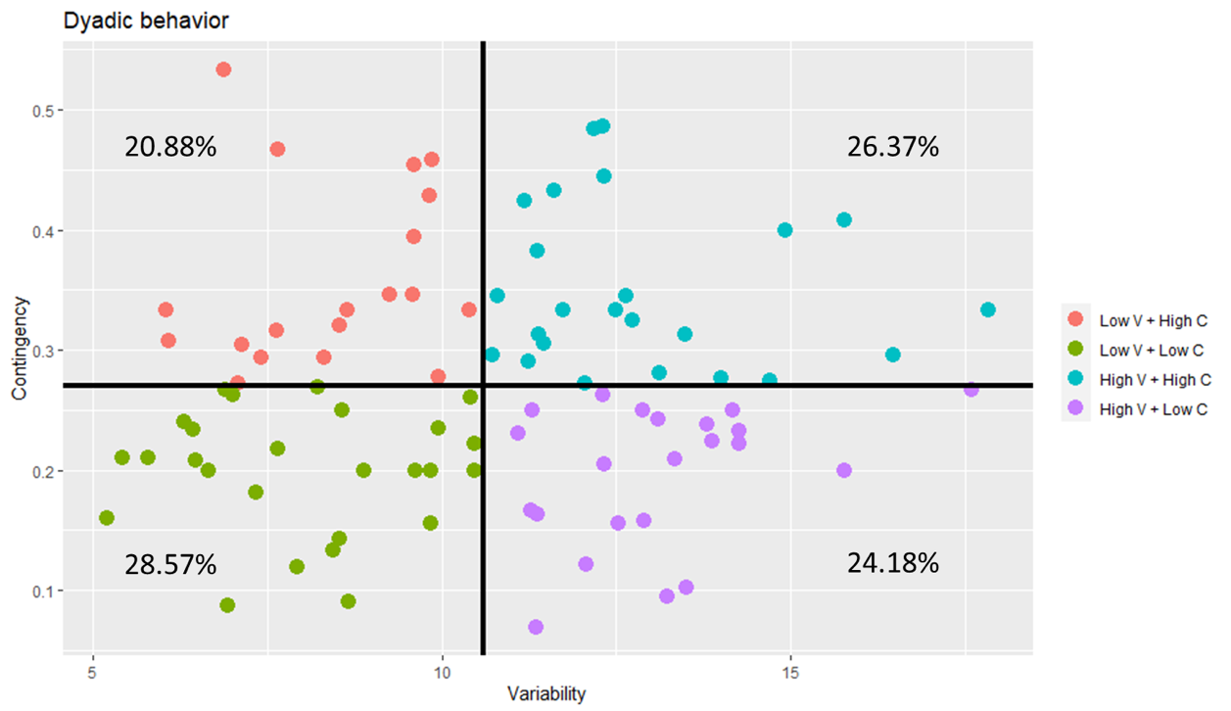
References
Fogel, A. (2011). Theoretical and applied dynamic systems research in developmental science. Child Development Perspectives, 5(4), 267–272. https://doi.org/10/fh7j29
Glynn, L. M., Howland, M. A., Sandman, C. A., Davis, E. P., Phelan, M., Baram, T. Z., & Stern, H. S. (2018). Prenatal maternal mood patterns predict child temperament and adolescent mental health. Journal of Affective Disorders, 228, 83–90. https://doi.org/10/gcv6vq
Howland, M. A.,, Sandman, C. A., Davis, E. P., Stern, H. S., Phelan, M., Baram, T. Z., & Glynn, L. M. (2021). Prenatal maternal mood entropy is associated with child neurodevelopment. Emotion, 21(3), 489–498. https://doi.org/10/gjqwbw
Jarosz, A. F., & Wiley, J. (2014). What Are the Odds? A Practical Guide to Computing and Reporting Bayes Factors. The Journal of Problem Solving, 7(1). https://doi.org/10/gdz7p5
Kaufman, E. A., Xia, M., Fosco, G., Yaptangco, M., Skidmore, C. R., & Crowell, S. E. (2016). The Difficulties in Emotion Regulation Scale Short Form (DERS-SF): Validation and Replication in Adolescent and Adult Samples. Journal of Psychopathology and Behavioral Assessment, 38(3), 443–455. https://doi.org/10/gdchbn
Kim, S. Y., Nair, R., Knight, G. P., Roosa, M. W., & Updegraff, K. A. (2008). Measurement Equivalence Of Neighborhood Quality Measures For European American And Mexican American Families. Journal of Community Psychology, 37(1), 1–20. https://doi.org/10/cp8cjq
Lewis, M. D. (2011). Dynamic Systems Approaches: Cool Enough? Hot Enough?: Dynamic Systems Approaches. Child Development Perspectives, 5(4), 279–285. https://doi.org/10/d8n9rn
Lobo, F. M., & Lunkenheimer, E. (2020). Understanding the parent-child coregulation patterns shaping child self-regulation. Developmental Psychology, 56(6), 1121–1134. https://doi.org/10/gjqwcz
Radloff, L. S. (1977). The CES-D Scale: A Self-Report Depression Scale for Research in the General Population. Applied Psychological Measurement, 1(3), 385–401. https://doi.org/10/b4z

We acknowledge that better measures exist to quantify the temporal dimension of variability (e.g., RMSSD; Wang et al., 2012), but these need complete data to be correctly computed. On average, mothers completed 12.42 reports out of a total of 18.

