Supplementary material 1
This is part 1 of the supplementary material for the article entitled “Direct and Indirect Associations Between Childhood Adversity and Emotional and Behavioural problems at Age 14: a Network Analytical Approach”. The supplement provides information regarding the following topics: 1) a description of the adverse experiences that were included in this study, 2) prevalence of missing data across the adverse experiences, 3) information on the intelligence measure, and 4) network models based on different hyperparameter values (0.25, 0.50, and 0.75, respectively) and the network model in which the abuse-related AEs were excluded.

Description of included adverse experiences
Bullying victimization. Information on bullying victimization was obtained with the item “I am often bullied” of the Youth Self-Report (YSR) questionnaire (Achenbach & Rescorla, 2001). Respondents were asked to indicate whether this statement was not true, (0), somewhat or sometimes true (1), or very true or often true (2) in the past six months. A score of two was considered indicative for bullying victimization.
Peer rejection. Information on bullying was obtained with the item ‘Other boys or girls do not like me’ of the YSR questionnaire (Achenbach & Rescorla, 2001). A score of two was considered indicative for being rejected by peers.
Parental mental health problems. Information on the occurrence of parental mental health issues was obtained through vignettes (Ormel et al., 2005; Sijtsema et al., 2014) describing depressive complaints, anxiety, problem behaviour, and psychotic complaints. Both parents indicated whether they had experienced any of the aforementioned mental health problems in the past year. Maternal and paternal mental health problems were collapsed into one parental mental health problem variable.
Parental addiction. Information on the occurrence of parental addiction was obtained through vignettes (Ormel et al., 2005; Sijtsema et al., 2014) describing alcohol, drug- and gambling addictions. Both parents indicated whether they had experienced any of the aforementioned addictions in the past year. Maternal and paternal addiction were collapsed into one parental addiction variable.
Parental physical illness. Information on the occurrence of parental illness (chronic- or acute physical illness) was obtained with the Developmental History Interview (DHI, composed by TRAILS). Parents were asked to indicate whether the child had experienced a severe physical illness of the mother or father. Maternal and paternal illness were collapsed into one parental illness variable.
Illness of a sibling. Information on the occurrence of an ill-struck sibling was also obtained through the DHI. Parents were asked to indicate whether a brother or sister of the participant had experienced a severe illness.
Conflicts within the household. Information on the occurrence of conflicts within the household was obtained with the Long-Term Difficulties (LTD) questionnaire (composed by TRAILS) (Bouma et al., 2008). Parents were asked whether people within the household (in which the child was not directly involved) had long-lasting conflicts with each other. Parents also indicated how old the child was when these conflicts started.
Death within the household. Information on the occurrence of a death within the family was obtained through the DHI. Parents were asked whether the child had experienced the death of anyone in their direct family (within or outside of the home environment), and when said death occurred. The type of family members considered in this study were limited to biological or adoptive parents and siblings.
Parental separation. Information on the occurrence of a divorce or separation between parents was obtained with the DHI (Oldehinkel et al., 2008). Parents were asked to indicate whether the child had experienced the separation or divorce of the parents, and how old the child was when this event occurred.
Financial difficulties. Information on the occurrence of financial difficulties was obtained with the LTD questionnaire (Amone-P’olak et al., 2009). Parents were asked whether the family had financial difficulties, and how old the child was when the financial difficulties started.
Parental unemployment. Information on the occurrence of parental unemployment was obtained with the DHI. Parents were asked to indicate whether either parent were unemployed and since when they were unemployed.
Emotional abuse. Information on the occurrence of sexual abuse was obtained with the Traumatic Youth Experiences questionnaire (TYE, composed by TRAILS) (Oldehinkel & Ormel, 2015). Respondents were asked to indicate whether either parent shouted, screamed or yelled at them, whether either parent called them stupid, lazy or anything similar or whether either parent cursed or swore at them before the age of 16 and how often this occurred. Answer categories included never, once or twice, sometimes, often and very often. Emotional abuse was said to have occurred when any one of the indicators of emotional abuse was said to occur often or very often.
Physical abuse. Information on the occurrence of physical abuse was obtained with the TYE questionnaire (Oldehinkel & Ormel, 2015). Respondents were asked to indicate whether either parent hit them with an object, whether either parent hit them (very) hard with their fist or kicked them, whether either parent hit them with bear hands, whether either parent shook or squeezed them, or whether either parent assaulted them (repeatedly beat them very hard) before the age of 16 and how often this occurred. Answer categories included never, once or twice, sometimes, often and very often. For assault, all answer categories, except from ‘never’, were classified as physical abuse. For the other indicators, often and very often were classified as physical abuse.
Sexual abuse. Information on the occurrence of sexual abuse was obtained with the TYE questionnaire (Oldehinkel & Ormel, 2015). Respondents were asked to indicate whether a family member, family acquaintance or a stranger either showed their genitals or masturbated before them, touched them in a sexual manner, coerced or forced them to touch the perpetrator in a sexual manner or had intercourse with them before the age of 16. Answer categories included never, yes this happened once before the age of 16 and yes this happened multiple times before the age of 16. Any occurrence was classified as sexual abuse.

Prevalence of missing data across the adverse experiences
Variables (N, %)
Bullying victimization | 78 (4.2)
Peer rejection | 92 (4.9)
Familial death | 0 (0.0)
Parental illness | 43 (2.3)
Parental mental health problems | 105 (5.6)
Parental addiction | 79 (4.2)
Sibling illness | 56 (3.0)
Parental unemployment | 432 (23.0)
Parental divorce | 33 (1.8)
Financial difficulties | 170 (9.0)
Familial conflicts | 173 (9.2)
Sexual abuse | 235 (12.5)
Emotional abuse | 234 (12.4)
Physical abuse | 240 (13.1)

Information on the intelligence measure
The intelligence (total IQ) was approximated with a deviation quotient based on the vocabulary and block design subtests from the Revised Weschler Intelligence Scales for Children (WISC-R) (Sattler, 1992; Silverstein, 1975). The following formula was used to derive the deviation quotient, using the normal standard scores (M = 10, SD = 3) in line with the WISC-R manual and age-adjusted:
Deviation Quotient = (15/Sc) (Xc – 20) + 100
Where :

Sc = standard deviation of composite score > 3 √(2 + 2∑Rjk)
Xc = composite score (sum of subtest scaled scores)
Mc = 20
Ss = 3
N = 2
∑Rjk = sum of the correlations between component subtests

Network of adverse experiences and emotional and behavioural problems (hyperparameter 0.25)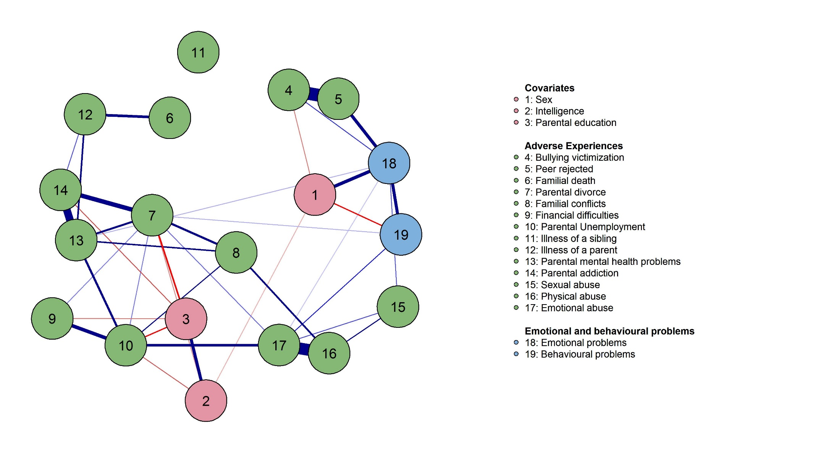

Communities of nodes in the network of adverse experiences and emotional and behavioural problems (hyperparameter 0.25)
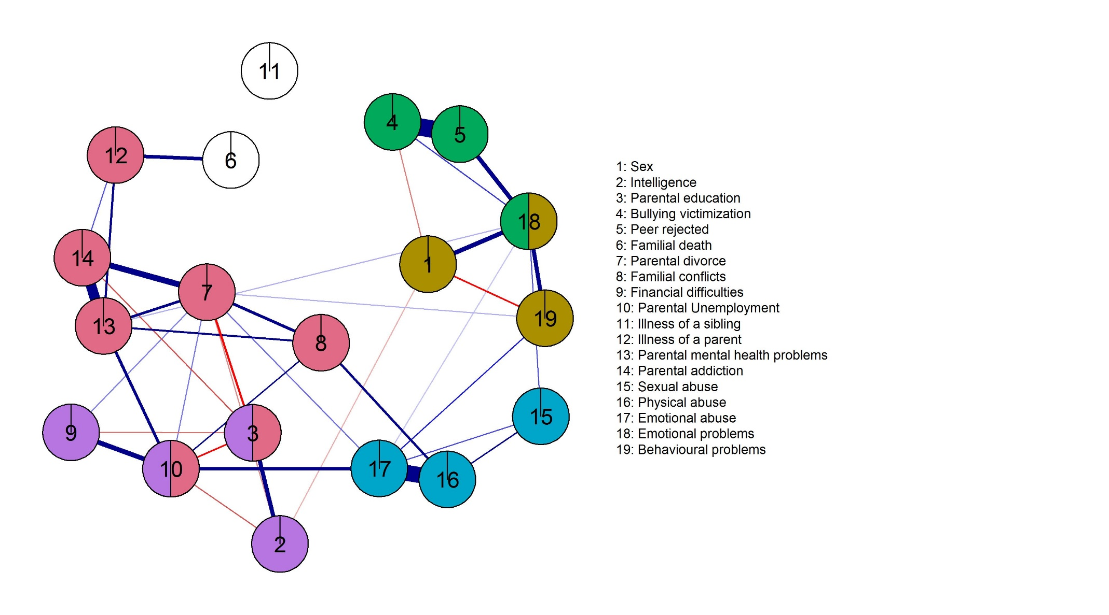
Network of adverse experiences and emotional and behavioural problems (hyperparameter 0.50)
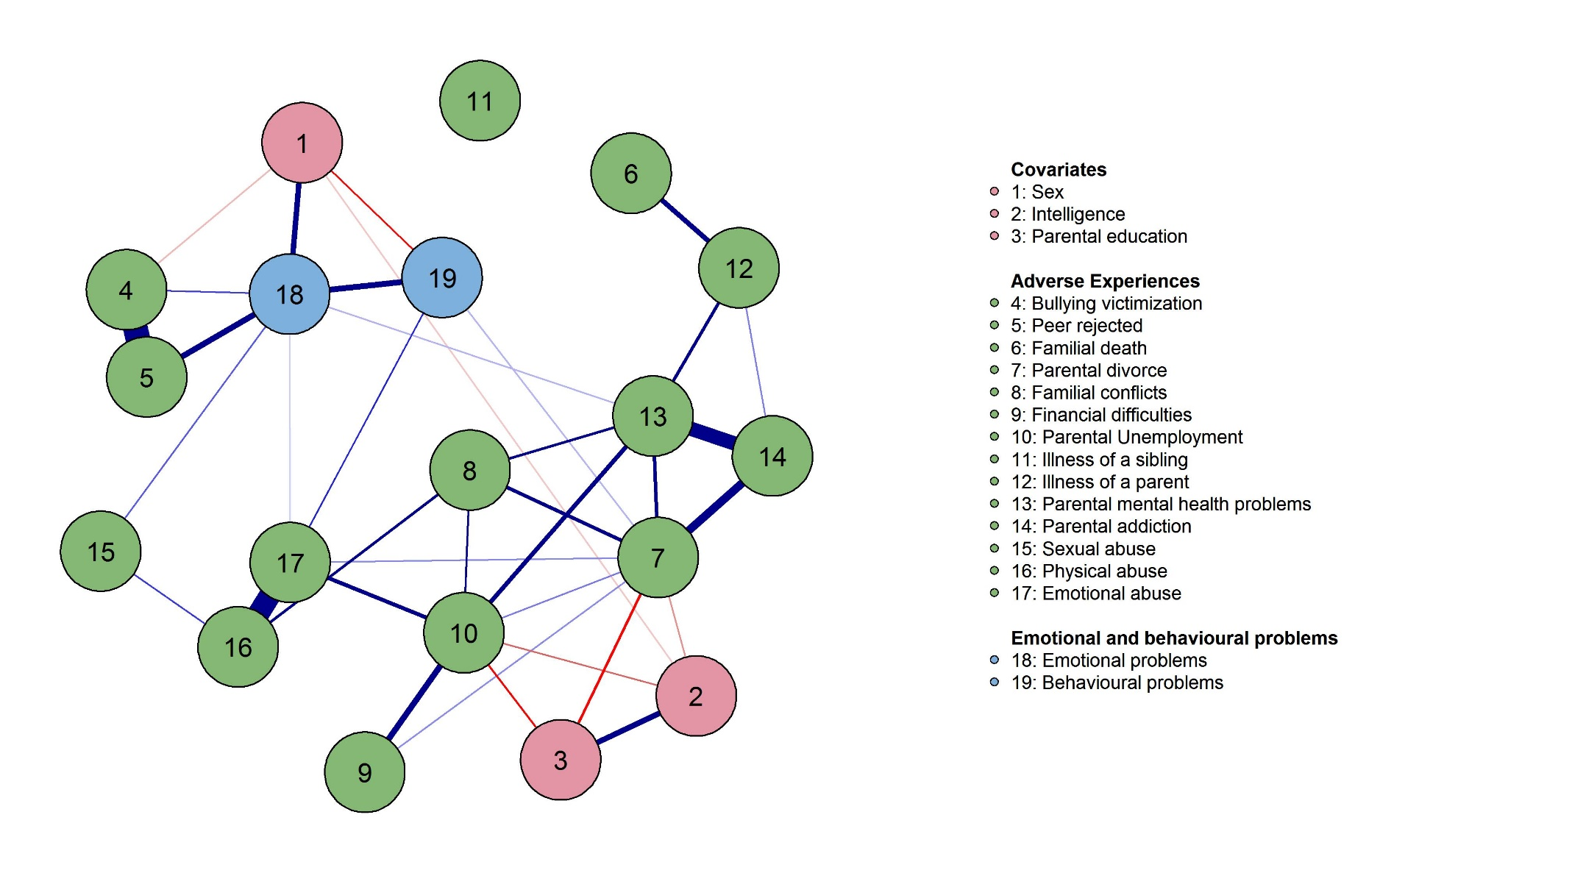

Communities of nodes in the network of adverse experiences and emotional and behavioural problems (hyperparameter 0.50)
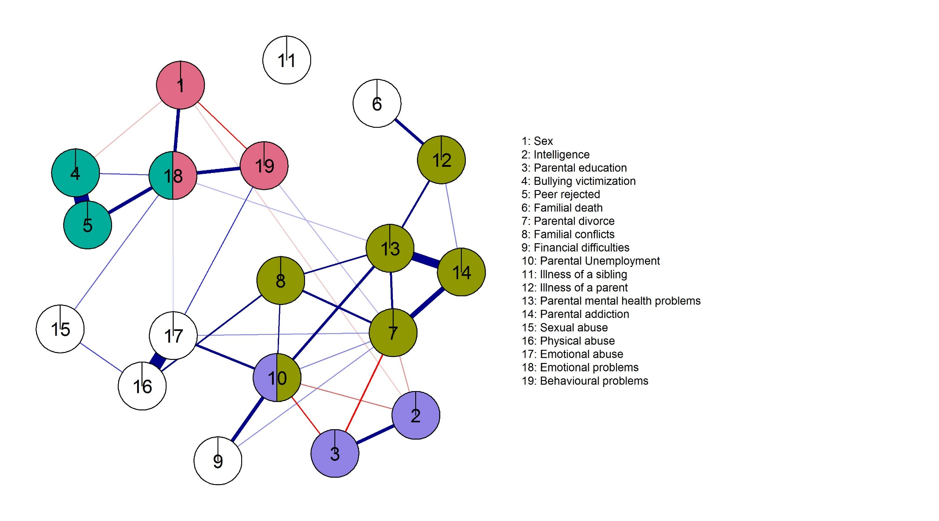
Network of adverse experiences and emotional and behavioural problems (hyperparameter 0.75)
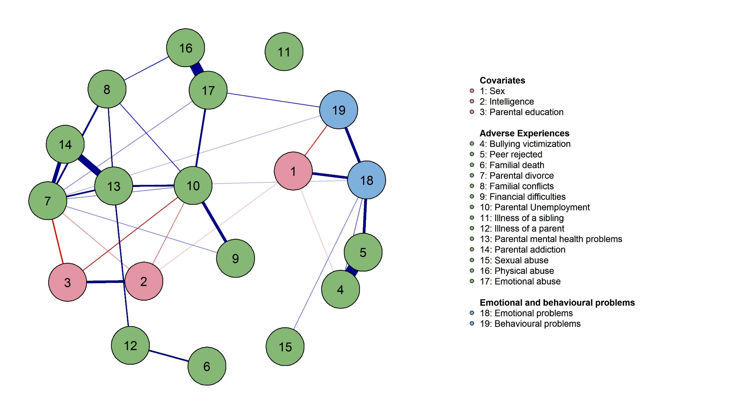

Communities of nodes in the network of adverse experiences and emotional and behavioural problems (hyperparameter 0.75)
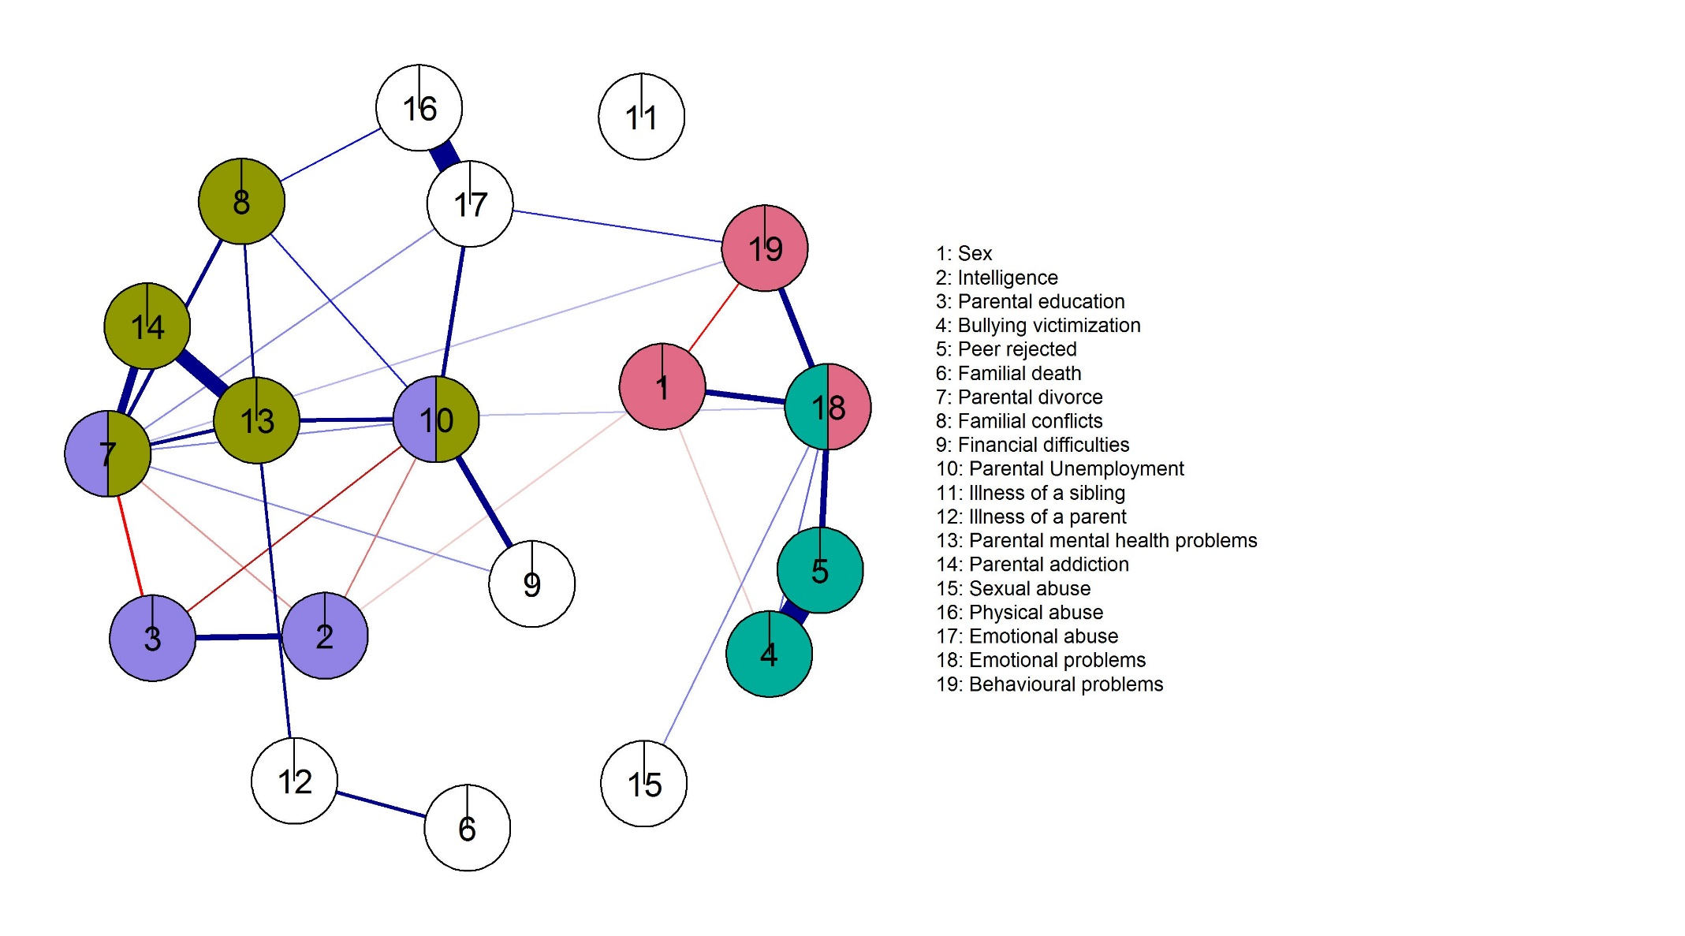

Network of adverse experiences and emotional and behavioural problems (without abuse-related AEs)
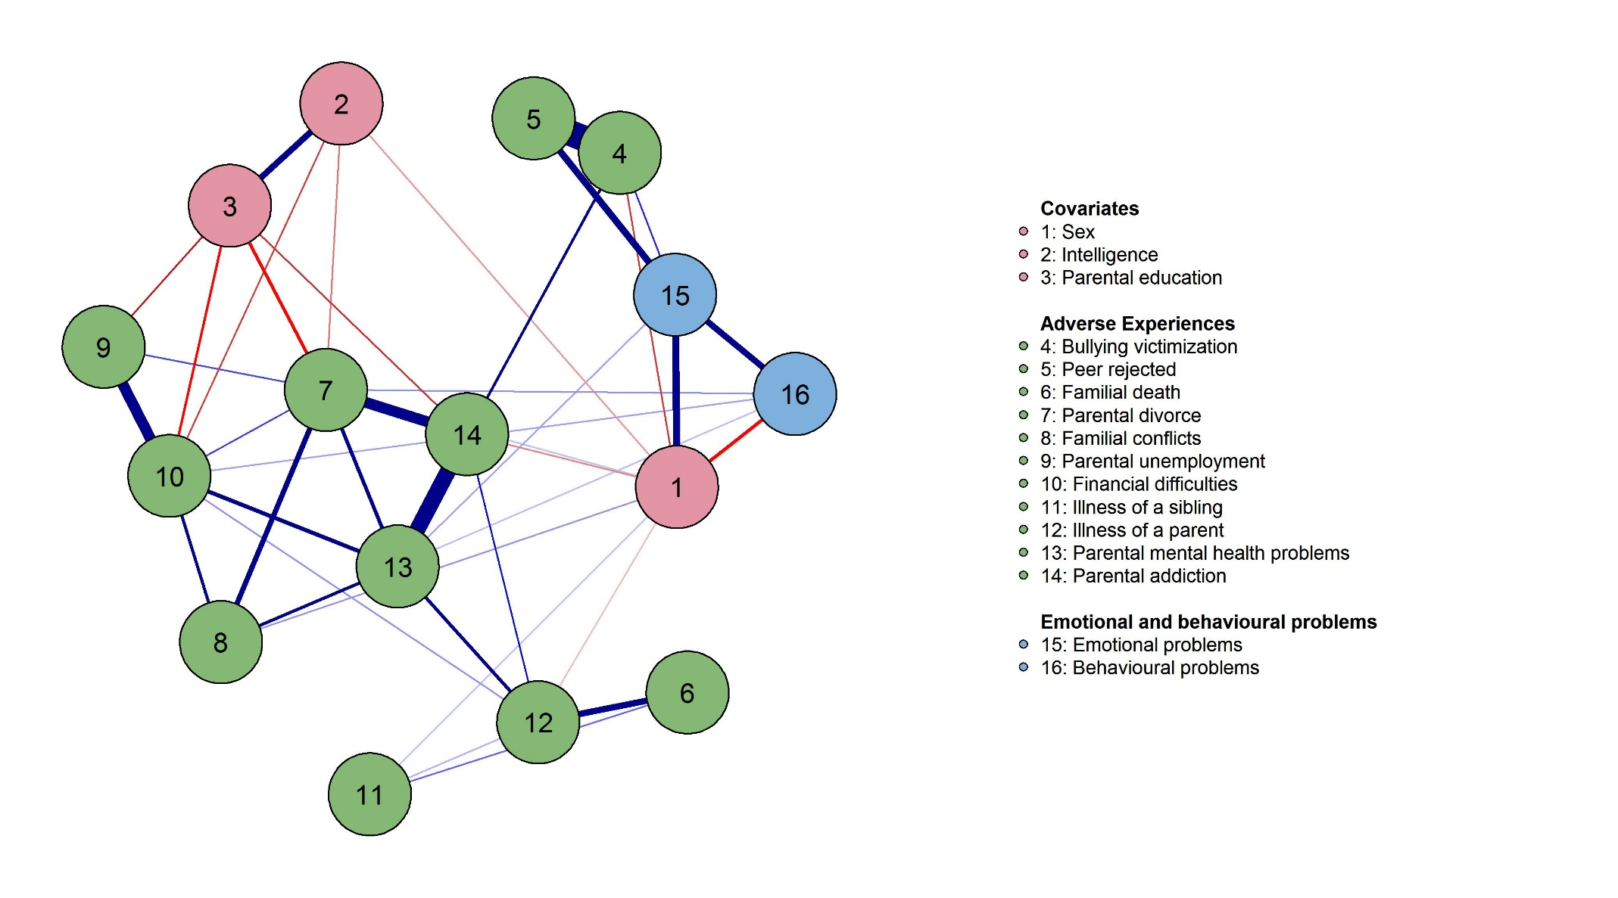

References
Achenbach, T. M., & Rescorla, L. A. (2001). Manual for the ASEBA school-age forms & profiles. In Manual for the ASEBA school-age forms & profiles : an integrated system of multi-informant assessment. University of Vermont, Research Center for Children, Youth & Families.
Amone-P’olak, K., Ormel, J., Huisman, M., Verhulst, F. C., Oldehinkel, A. J., & Burger, H. (2009). Life Stressors as Mediators of the Relation Between Socioeconomic Position and Mental Health Problems in Early Adolescence: The TRAILS Study. Journal of the American Academy of Child and Adolescent Psychiatry, 48(10), 1031–1038. https://doi.org/10.1097/CHI.0b013e3181b39595
Bouma, E. M. C., Ormel, J., Verhulst, F. C., & Oldehinkel, A. J. (2008). Stressful life events and depressive problems in early adolescent boys and girls: The influence of parental depression, temperament and family environment. Journal of Affective Disorders, 105(1–3), 185–193. https://doi.org/10.1016/j.jad.2007.05.007
Oldehinkel, A. J., & Ormel, J. (2015). A longitudinal perspective on childhood adversities and onset risk of various psychiatric disorders. European Child & Adolescent Psychiatry, 24(6), 641–650. https://doi.org/10.1007/s00787-014-0540-0
Oldehinkel, A. J., Ormel, J., Veenstra, R., De Winter, A. F., & Verhulst, F. C. (2008). Parental Divorce and Offspring Depressive Symptoms: Dutch Developmental Trends During Early Adolescence. Journal of Marriage and Family, 70(2), 284–293. https://doi.org/10.1111/j.1741-3737.2008.00481.x
Ormel, J., Oldehinkel, A. J., Ferdinand, R. F., Hartman, C. A., De Winter, A. F., Vollebergh, W. A. M., Minderaa, R. B., Buitelaar, J. K., & Verhulst, F. C. (2005). Internalizing and externalizing problems in adolescence: general and dimension-specific effects of familial loadings and preadolescent temperament traits. Psychological Medicine, 35, 1825–1835. https://doi.org/10.1017/S0033291705005829
Sattler, J. M. (1992). Assessment of children (revised an). J.M. Sattler.
Sijtsema, J. J., Oldehinkel, A. J., Veenstra, R., Verhulst, F. C., & Ormel, J. (2014). Effects of structural and dynamic family characteristics on the development of depressive and aggressive problems during adolescence. The TRAILS study. European Child & Adolescent Psychiatry, 23, 499–513. https://doi.org/10.1007/s00787-013-0474-y
Silverstein, A. B. (1975). Validity of WISC-R short forms. Journal of Clinical Psychology, 31(4), 696–697. https://doi.org/10.1002/1097-4679(197510)31:4<696::AID-JCLP2270310429>3.0.CO;2-M

